Instruction for use

**Heart**Save **myPAD** Trainer

English

24800 EN

Revision: A

Release Date: 07/2025

Masthead

Publisher

Manufacturer Primedic (Jiangsu) Medical Technology Co.,Ltd.

Address No.1 Baisheng Road, Development Zone, Danyang, Jiangsu, China

Tel. 86-511-86900833

Fax 86-511-86900851

Postal code 212300

Web www.primedic.com

Metrax GmbH

Address: Rheinwaldstr. 22, 78628 Rottweil, GERMANY

[info@primedic.com](mailto:info@primedic.com)

+49 (0) 741 2570

Proprietary note

The manufacturer reserves all rights to these operating instructions. Without approval from the manufacturer, these operating instructions may not be duplicated or made accessible to third parties. The same applies to individual parts or excerpts of these operating instructions.

Non-compliance with this gives rise to a right to claim damages and can have consequences under criminal law (refer to ISO 16016).

Document 24800

Revision A

Date of issue 07/2025

These instructions for use may be changed by the manufacturer without further notice.

Contents

[1 Introduction HeartSave myPAD Trainer 5](#_Toc204770833)

[1.1 Foreword 5](#_Toc204770834)

[1.2 Validity 5](#_Toc204770835)

[1.3 Intended use 5](#_Toc204770836)

[1.4 Disclaimers 5](#_Toc204770837)

[1.5 Safety notice 5](#_Toc204770838)

[2 Device description 5](#_Toc204770839)

[2.1 Description of device details 5](#_Toc204770840)

[2.2 Language button 10](#_Toc204770841)

[2.3 Child button 10](#_Toc204770842)

[3 Preparation before starting device 10](#_Toc204770843)

[3.1 Unpack 10](#_Toc204770844)

[3.2 Prepare battery 10](#_Toc204770845)

[3.2.1 Battery installation 10](#_Toc204770846)

[3.2.2 Battery removal 10](#_Toc204770847)

[4 Using HeartSave myPAD trainer 11](#_Toc204770848)

[4.1 Switch on the trainer 11](#_Toc204770849)

[4.2 Connect electrode cables with pads 11](#_Toc204770850)

[4.3 Inserting electrodes 11](#_Toc204770851)

[4.4 Apply auxiliary pads (optional) 11](#_Toc204770852)

[4.4.1 Steps for applying the auxiliary pads 12](#_Toc204770853)

[4.4.2 Function of auxiliary pads 12](#_Toc204770854)

[4.5 Apply electrodes 12](#_Toc204770855)

[4.6 Analysing rhythm 13](#_Toc204770856)

[4.6.1 Start the analysis 13](#_Toc204770857)

[4.6.2 Interrupt the analysis 13](#_Toc204770858)

[4.7 Simulate defibrillation 13](#_Toc204770859)

[4.7.1 Shock advised – Simulation: Shock recommended 14](#_Toc204770860)

[4.7.2 No shock advised – Simulation: No shock recommendation 14](#_Toc204770861)

[4.8 CPR – Cardiopulmonary Resuscitation 14](#_Toc204770862)

[4.8.1 CPR with respiration 14](#_Toc204770863)

[4.8.2 CPR without respiration 14](#_Toc204770864)

[4.8.3 CPR feedback sensor (optional) 15](#_Toc204770865)

[4.9 Switch off the Trainer 15](#_Toc204770866)

[5 Product repair and maintenance 16](#_Toc204770867)

[5.1 Device Maintenance 16](#_Toc204770868)

[5.2 Electrode pads maintenance 16](#_Toc204770869)

[5.3 Battery maintenance 16](#_Toc204770870)

[5.4 Programming the trainer 17](#_Toc204770871)

[6 Disposal 17](#_Toc204770872)

[7 Technical specification 17](#_Toc204770873)

[8 Warranty 18](#_Toc204770874)

[Appendix A: Index Diagram 20](#_Toc204770875)

[Appendix B: Pictograms 20](#_Toc204770876)

# Introduction HeartSave myPAD Trainer

## Foreword

Dear User,

Thank you for selecting HeartSave myPAD Trainer. The HeartSave myPAD Trainer you have acquired is not a defibrillator but only used for training purposes and must not be used on patients.

Realistic training scenarios are provided to simulate the use of HeartSave myPAD defibrillator in a real emergency case.

A HeartSave myPAD Trainer is clearly identified by "TRAINING ONLY" printed on the surfaces and the nameplate.

Keep these operating instructions near the device so that you consult any queries which may arise.

For questions regarding the device or other PRIMEDIC products, we are happy to help.

## Validity

The descriptions in these operating instructions refer to the HeartSave myPAD Trainer.

## Intended use

The HeartSave myPAD Trainer may only be used as described and under the conditions as below:

* HeartSave myPAD Trainer is not a medical device
* HeartSave myPAD Trainer is only used for training purpose

## Disclaimers

Liability claims in the event of damages to people or property are excluded if they are based on one or more of the following reasons:

* Using the device in a manner for which it was not intended.
* Improper use and maintenance of the device.
* Operating the device with the protective covers removed or when there is obvious damage to cables and/or electrodes.
* Non-compliance with the instructions in this operating instructions regarding operation, maintenance and repair of the equipment.
* Using accessories and spare parts from other manufacturers.
* Unauthorized repairs or constructional changes to the device.

## Safety notice

|  |  |
| --- | --- |
| wh_schwarz_transparent.pngWARNING | Device should be only charged (for battery) at places which easy to disconnect mains power supply. |

|  |  |
| --- | --- |
| wh_schwarz_transparent.pngWARNING | Highest volume may harm user auditory. Keep ears away from the trainer speaker. |

# Device description

## Description of device details

|  |
| --- |
| 图片5 |
| Fig. 1 Front view  (1) On/Off switch  (2) Device operation indicator  When indicator is green: device switched on as ready for operation  (3) Electrodes placing indicator  (4) Electrodes placing guidance  (5) Child button  (6) Language button  (7) Charging indicator (only for re-chargeable battery)  When battery is low, charging indicator blinks red.  When battery is charging, indicator blinks yellowish green.  When battery capacity is ready for operation or fully charged, indicator displays yellowish green without blinking.  (8) Status display (only simulates the display of normal status)  (9) No touching patient indicator  (10) Shock button  (11) LCD display |
| 1 |
| Fig. 2 Back View  (1) Rechargeable lithium battery |
|  |
| Fig. 3 Bottom View  (1) Charging Socket  (2) Rechargeable Lithium Battery |
| 1747048950821 |
| Fig. 4 Side View   1. Electrode Socket 2. Speaker |

1

2

4

6

7

3

10

10

9

8

5

Fig. 5 Remote Control

1. Power off Button – Switch off the trainer
2. Standard Training Modes

There are 6 standard training models in total. Different training scenarios can be selected by pressing 1-6 keys on the remote control. The Scenarios 1 through 3 operate in fully automated mode and scenarios 4 through 6 operate in semi-automated mode. The table below shows the preset profiles that can be used.

1. 30:2 CPR Mode Switch for child mode
2. 15:2 CPR Mode Switch for child mode
3. Play/Pause Button

During operation, this button can be used to pause the sequence and the voice prompts. Press this button again to continue the training mode.

1. Simulation: Electrodes are connected to the manikin

When the standard-training-electrodes are connected, press the button no. 6 to advice the machine that the electrodes are attached and start the rhythm analysis.

1. Simulation: Electrodes are disconnected from the trainings model – only activated when electrodes are connected
2. Simulation: Shock recommendation – only activated when electrodes are connected
3. Simulation: No shock recommendation – only activated when electrodes are connected
4. Volume +/- Key

| **Scenario number** | **Description** | **Sequence** |
| --- | --- | --- |
| 1  fully-automated mode | Result of each analysis:   1. Shock recommended 2. No shock recommended 3. No shock recommended 4. No shock recommended 5. No shock recommended 6. No shock recommended | * Defibrillation * Two minutes CPR * No defibrillation * Two minutes CPR * Rest no defibrillation |
| 2  fully-automated mode | Result of each analysis:   1. Shock recommended 2. Shock recommended 3. No shock recommended 4. No shock recommended 5. No shock recommended 6. No shock recommended | * Defibrillation * Two minutes CPR * Defibrillation * Two minutes CPR * Rest no defibrillation |
| 3  fully-automated mode | Result of each analysis:   1. No shock recommended 2. Shock recommended 3. No shock recommended 4. Shock recommended 5. No shock recommended 6. Shock recommended | * No defibrillation * Two minutes compression-only CPR * Defibrillation * Two minutes compression-only CPR * Rest repeat sequence above |
| 4  semi-automated mode | Result of each analysis:   1. Shock recommended 2. No shock recommended 3. No shock recommended 4. No shock recommended 5. No shock recommended 6. No shock recommended | * Defibrillation * Two minutes CPR * No Defibrillation * Two minutes CPR * Rest no defibrillation |
| 5  semi-automated mode | Result of each analysis:   1. Shock recommended 2. Shock recommended 3. No shock recommended 4. No shock recommended 5. No shock recommended 6. No shock recommended | * Defibrillation * Two minutes CPR * Defibrillation * Two minutes CPR * Rest no defibrillation |
| 6  semi-automated mode | Result of each analysis:   1. No shock recommended 2. Shock recommended 3. No shock recommended 4. Shock recommended 5. No shock recommended 6. Shock recommended | * No defibrillation * Two minutes compression-only CPR * Defibrillation * Two minutes compression-only CPR * Rest repeat sequence above |

## Language button

You can press the language button during operation until target language selected. The HeartSave myPAD trainer optionally supports up to 6 languages. When language button pressed, the selected language is also acoustic prompted.

## Child button

By pressin the child button, the HeartSave myPAD trainer switches to child mode. The default CPR compression are changed to 15 for each cycle. Optionally, this CPR instructions could be also changed to 30 chest compressions with button 3 on the remote control.

# Preparation before starting device

## Unpack

When you receive the package, check the packaging and device. In case of any visible damage, please contact the manufacturer or your distributor immediately. Provide serial number of the device and a description of the damage.

## Prepare battery

The device uses a rechargeable lithium-ion battery. If your battery is not installed, please install the battery into battery slot of the device.

### Battery installation

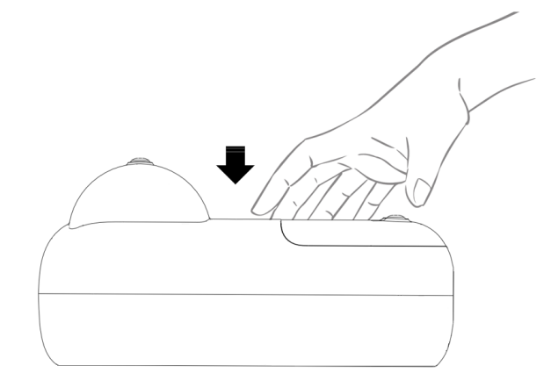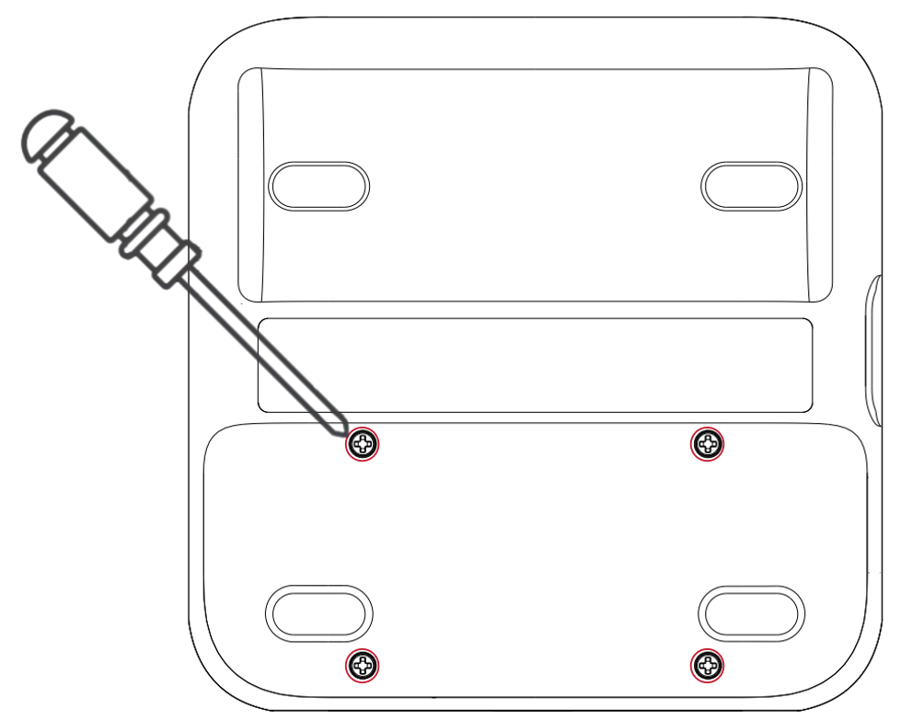

Fig. 6 Insert the battery

Steps:

* Put the device top down on a soft flat surface.
* Place the battery in the direction of the arrow into the device until it reaches its end position as shown in Fig. 6.
* Tight 4 screws with provided screwdriver until fully fixed.

### Battery removal

Fig. 7 Remove the battery

To replace a new battery, you need to remove the battery from device with following steps.

Steps:

* Put the device top down on a flat surface.
* Use provided screwdriver to remove 4 screws from the battery.
* Pull the battery with the direction of the arrow out of the slot slightly.

# Using HeartSave myPAD trainer

## Switch on the trainer

The trainer can be switched on via pressing the power button of device.

## Connect electrode cables with pads

The trainer adapts with training electrodes which includes cable and pads.

Connect the cable with training electrode pads according to Fig. 8.

1

2

Fig. 8 Connect cables with pads

1. Pads connector
2. Cable connector

## Inserting electrodes

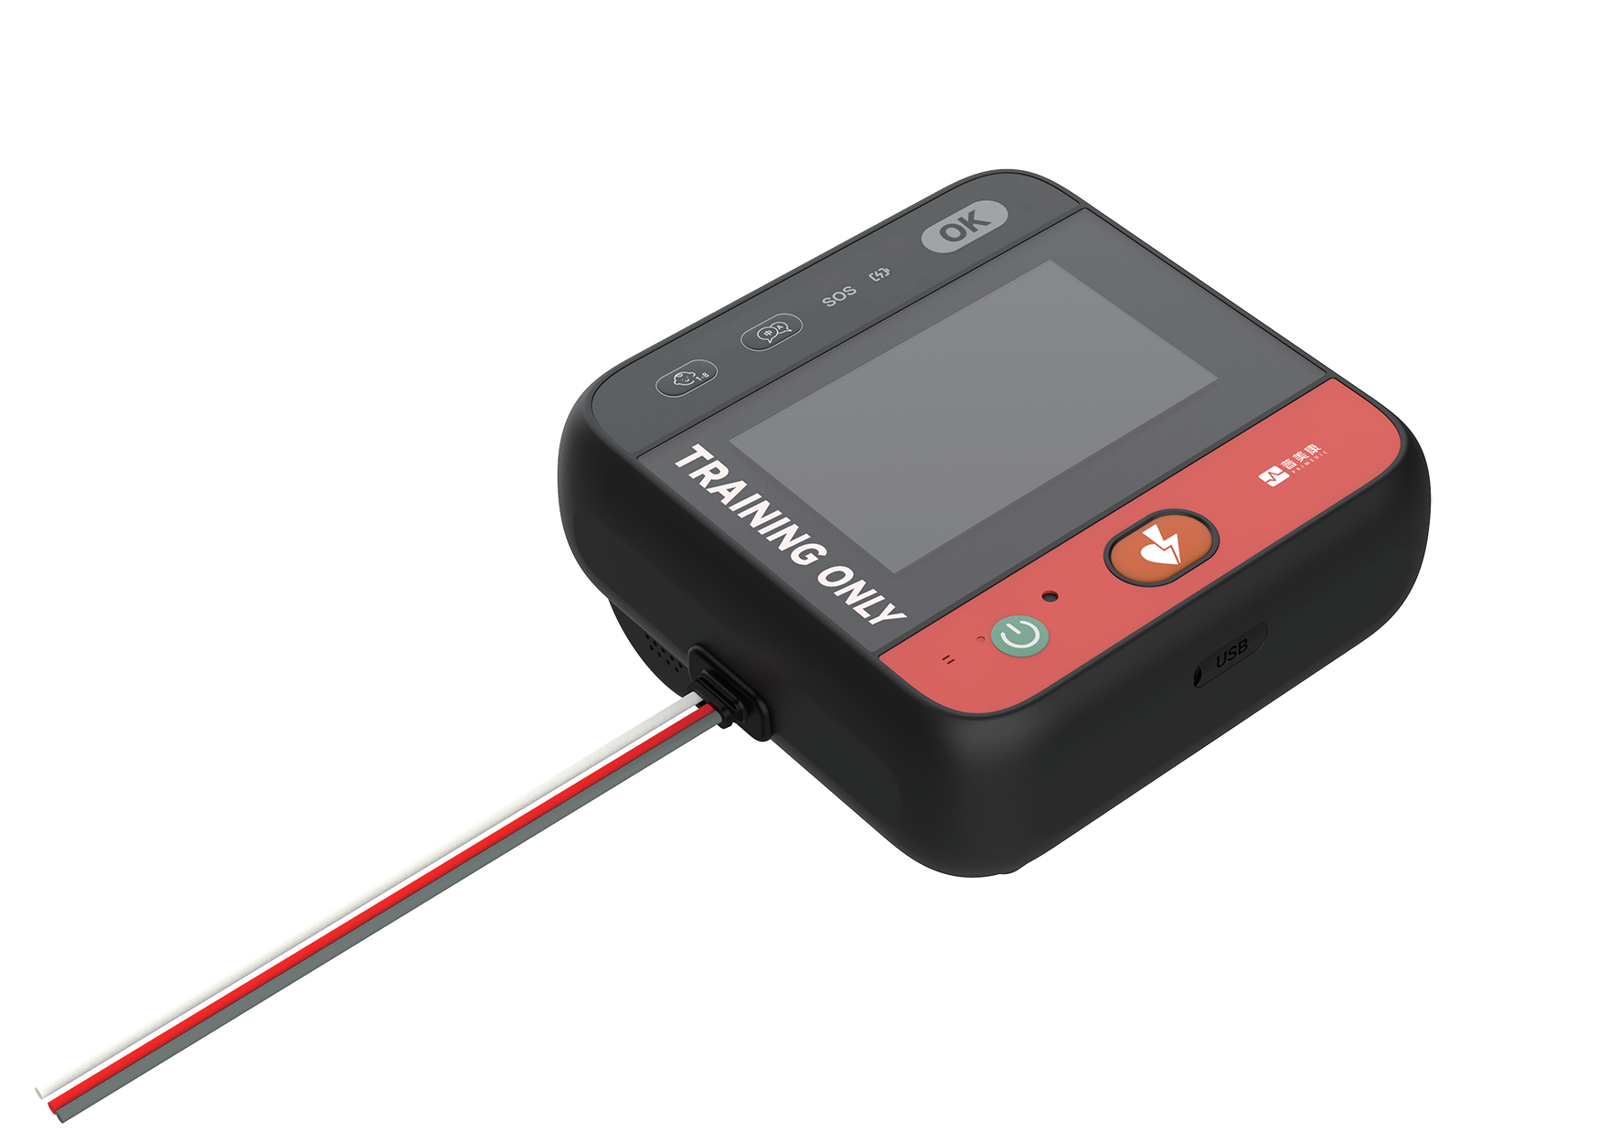

Fig. 9 Inserting electrodes

Steps:

* After hearing the prompt "Insert electrodes" insert the electrodes plug into the socket as shown above.

## Apply auxiliary pads (optional)



Fig. 10 Application of auxiliary pads to an adult manikin

Ein Bild, das Entwurf, Zeichnung, Lineart, weiß enthält.

Fig. 11 Application of auxiliary pads to a child manikin

To place the auxiliary pads on manikin, the position should be according to Fig. 10 and Fig. 11.

### Steps for applying the auxiliary pads

Steps:

* Open auxiliary pads pouch.
* Remove the protection foil from Auxiliary pads and place the auxiliary pads onto specified position.
* Press electrodes carefully to ensure good contact with manikin.
* The auxiliary pads could be also left on manikin surface, to avoid removal after training every time.

### Function of auxiliary pads

* Contact Detection: auto-detect whether trainer pads are attached during the training.
* Position Guidance: Provides visual instructions for trainer pads placement.

## Apply electrodes



Fig. 12 Application of electrodes to an adult manikin

Ein Bild, das Entwurf, Zeichnung, Lineart, weiß enthält.

Fig. 13 Application of electrodes to a child manikin

HeartSave myPAD trainer will give a voice prompt to guide you applying electrodes to the manikin.

**< Apply electrodes as shown >**

**< Remove all clothing from patient's chest, unpack electrodes and apply them to patient's bare chest as shown >**

Steps:

* Open the pouch to take out the training electrodes.
* For models without auxiliary electrodes, place the training electrodes on the corresponding positions of the manikin as shown in the illustration on the training electrodes. For models with auxiliary electrodes, first attach the auxiliary electrodes to the positions indicated for training electrodes in the illustration and then place the training electrodes on the auxiliary electrodes.

|  |  |
| --- | --- |
| NOTE | * + - * The training electrode pads are shared for both children and adults, as shown in the figure above.       * The training electrode pads have similar looking to real defibrillators in appearance but do not give high-voltage shocks. Please note training electrode pads are for training purposes ONLY and must not be connected to a defibrillator for emergency use.       * Do not bend or stretch the electrode cables or pads.       * For auxiliary electrode pads, first attach the auxiliary electrode pads to the manikin, and then place the training electrode pads over the auxiliary electrode pads. |

## Analysing rhythm

### Start the analysis

In case of electrodes connected, there are two options to start the analysis:

* Connect electrode connector to the trainer. The analysis starts when training electrodes attached with auxiliary electrodes.
* Press button 6 (Fig. 5) on the remote control to start the analysis.
* Place electrodes onto auxiliary pads (optional).

When analysis starts you will hear the voice prompts:

**< Analysing rhythm >**

**< Don’t touch the patient >**

### Interrupt the analysis

In case of analysis starts, there are several options to interrupt the analysis:

* Interrupt the analysis by disconnect one pad
* Press button 7 (Fig. 5) on the remote control
* Remove the electrodes connector from device socket.

## Simulate defibrillation

The result of the analysis refers to the selected scenario on the remote control.

### Shock advised – Simulation: Shock recommended

When press button 8 (Fig.5 Remote Control), the current scenario is interrupted and simulate a shock recommendation immediately not depending on the before chosen scenario. There will be an analysis right after pressing the button and the trainer will always recommend a shock for the next sequences.

|  |  |
| --- | --- |
| NOTE | Only available when trainer electrodes are connected. |

### No shock advised – Simulation: No shock recommendation

When press button 9 (Fig.5 Remote Control), the current scenario is interrupted and simulate a no shock recommendation immediately not depending on the before chosen scenario. There will be an analysis right after the pressing the button and the trainer will always recommend no shock for the next sequences.

|  |  |
| --- | --- |
| NOTE | Only available when trainer electrodes are connected. |

## CPR – Cardiopulmonary Resuscitation

|  |  |
| --- | --- |
| NOTE | For auxiliary electrode pads: If the electrode plug is disconnected during CPR, the CPR process will be interrupted, and the device will prompt **< Stop chest compression>**. If CPR is initiated due to unattached electrode pads and the pads are subsequently attached, the CPR process will also be interrupted, and the device will prompt **< Stop chest compression>**. |

### CPR with respiration

This chapter is applied for scenario 1, 2, 4 and 5 on remote control.

The duration of the CPR is approx. 120s consists of chest compressions and rescue breaths. Adult and child should follow different compression recommendations as below.

**Adult mode**

30:2 Adult CPR Mode, following the standard CPR procedure.

Device prompts:

**< Begin CPR >**

**< Give 30 chest compressions >**

**< Give two rescue breaths >**

The above steps are repeated 5 times, then proceed to section 4.6.1.

**Child mode**

15:2 Paediatric CPR Mode, also possible to switch to 30 compressions.

Device prompts:

**< Begin CPR >**

**< Give 15 chest compressions >**

**< Two rescue breaths>**

The above steps are repeated 7 times, then proceed to section 4.6.1

### CPR without respiration

This chapter is applied for scenario 3 and 6 on remote control.

The duration of the CPR is approx. 120s consists of chest compressions.

**Adult mode**

30:2 Adult CPR Mode, following the standard CPR procedure.

Device prompts:

**< Begin CPR >**

**< Give 2-minute chest compressions >**

**< Stop check compression >**

The above steps are repeated 5 times, then proceed to section 4.6.1.

**Child mode**

15:2 Paediatric CPR Mode, also possible to switch to 30 compressions.

Device prompts:

**< Begin CPR >**

**< Give 2-minute chest compressions >**

**< Stop check compression >**

The above steps are repeated 7 times, then proceed to section 4.6.1

### CPR feedback sensor (optional)

When CPR feedback sensor applied, during CPR, the compression frequency and depth will be prompted acoustically or visually. There will be prompts for no compressions, bad compressions, or good compressions. The compression quality is calculated based on the average measurement from 1-15 compressions of each cycle.

The compression frequency between 100 and 120 compressions per minute is considered acceptable, and compression depth should between 50mm and 60mm according to ERC guideline.

**Voice prompts when CPR sensor applied with the device**

**< Press faster >** If the average compression frequency is too slow, the device will prompt

**< Press slower >** If the average compression frequency is too fast, the device will prompt

**< Press harder >** If the average compression depth is too shallow, the device will prompt

**< Press lighter >** If the average compression depth is too deep, the device will prompt

**< Use CPR sensor to improve CPR quality >** If CPR sensor is not used, the device will prompt

**< Compression quality good, keep it up >** If all compressions with good quality, the device will prompt

**Fig. 14** **Position for CPR Feedback Sensor**

## Switch off the Trainer

The trainer can be switched off via:

* Pressing the power button of the device
* Pressing “On/Off” button on the remote control

# Product repair and maintenance

## Device Maintenance

* Please clean the main unit with a soft cloth with water or neutral detergent.
* Do not use gasoline to clean the trainer.
* Please do not let liquids such as water flow into the device.
* Do not store the trainer in places exposed to direct sunlight, high temperature, humidity, dust and corrosive gases. Please refer to chapter 7.

## Electrode pads maintenance

* The electrode pads should be kept clean to avoid dust, oil and dirt.
* Please do not scratch the adhesive surface.
* Please do not clean the electrodes with water or other liquids.
* Do not store the electrodes in places exposed to direct sunlight, high temperature, humidity, dust and corrosive gases.

Ein Bild, das Zeichnung, Entwurf, Cartoon, Darstellung enthält.

**Fig. 15 Training Electrode Pads**

(1) Training Electrode Pads with protective film for repeated use during simulation.

(2) Electrode Plug

## Battery maintenance

* Do not charge/discharge over the specified current.
* Do not short circuit the battery pins, it may cause permanent damage.
* Do not burn or destroy the battery.
* Store batteries in a cool and dry place.
* Keep away from children.

|  |  |
| --- | --- |
| NOTE | Rechargeable battery maintenance instruction  Periodic charging and discharging - If the battery is planned to store for a long period (> 6 months), it is recommended to fully discharge the battery and recharge it once every half year. |

2

1

Fig. 16 Power-Adapter

(1) Power socket plug

(2) Charging cable plug

## Programming the trainer

To trainer provides a possibility to update the software or configuration. To update the software or configuration, you need to prepare:

* 1 x USB drive
* 1 x Type-C to USB adapter

USB drive must follow specifications below:

* Capacity no greater than 32GB
* Format: FAT32
* USB 2.0 / USB 2.0 card reader

Procedure for USB drive updates:

* Insert the USB drive into the Type-C to USB adapter port, then connect the Type-C end of the adapter cable to the corresponding port on the AED trainer.
* Connect the power adapter securely to the trainer’s charging port
* Power on the AED trainer.
* Once the display is activated, press and hold the **language button** until the program update interface appears / language button flashes.
* Wait for the update process to complete.

|  |  |
| --- | --- |
| NOTE | During the update process, the language button flashes.  **When programming completed**  Language button light remains on, or the device restarts automatically.  **When programming failed**  Language button light switches off. |

# Disposal

At the end of the service life of the device, please hand it over to a local recycling company. Proper disposal of this device is conductive to environmental protection.

# Technical specification

|  |  |
| --- | --- |
| **DEVICE** |  |
| Power supply | 7.2V 2950mAh  (rechargeable lithium battery) |
| Residual current when switched off | ≤10μA (max) |
| Rated current during operation | ≤ 500mA |
| Power Adapter | Input: AC 100–240V, 50/60Hz, 0.5A Max.  Output: DC 15V 0.8A |
| Main device | DC12 V, ≤1 A |
| Dimensions (L x W x H) | 151 ± 2mm x 151 ± 2mm x 73cm ± 2cm |
| Weight | 1.0kg ± 0.2kg |
| Power adapter of battery | Input: AC 100-240V, 50/60Hz  Output DC 15V 0.8A |
|  |  |
| **DISPLAY** |  |
| Type | color LCD |
| Dimensions | 4.3 inch |
| Resolution | 480 × 272 pixels |
|  |  |
| **REMOTE CONTROL** |  |
| Power supply | DC 3.0V (AAA battery x 2) |
| Residual current when switched off | 5uA (max) |
| Rated current during operation | 15mA (max) |
|  |  |
| **ENVIRONMENT SPECIFICATION** |  |
| Operating conditions |  |
| Temperature | -10°C – 55°C |
| Relative humidity | ≤ 95% RH |
| Air pressure | 86kPa – 106kPa |
| Altitude | < 2000m from sea level |
|  |  |
| **STORAGE CONDITIONS** |  |
| Temperature | -20°C – 60°C |
| Relative humidity | ≤ 95%RH |
| Air pressure | 70kPa – 106kPa |

# Warranty

Primedic (Jiangsu) Medical Technology Co.,Ltd. undertakes a 2-year warranty period for this equipment from the date of purchase. Please keep the purchase certificate properly.

During this period, the company will exclude defects and malfunctions of this equipment due to materials or production free of charge. At the company's option, repair or replacement will be used for maintenance.

The fulfilment of the warranty responsibility does not extend the original warranty period. Warranty and legal guarantee requirements do not apply to these situations: the usability has not been greatly affected, natural wear and tear (such as electrode pads consumables), or caused by wrang or wrang operation, excessive use and special external force influences other than those specified in the manual damage, and the purchaser or a third party has not modified or repaired the equipment in accordance with the regulations.

Other contractual or non-contractual demands on the company are excluded, unless these demands are based on deliberate acts, negligent acts or mandatory legal liability principles.

lf you need warranty, please send the equipment, purchase certificate (such as a copy of the invoice) and warranty card to your seller or our company.

After the warranty period, the company will continue to provide you with after-sales service but will charge a certain fee accordingly.

# Appendix A: Index Diagram

[Fig. 1 Front view 6](#_Toc204709438)

[Fig. 2 Back View 6](#_Toc204709439)

[Fig. 3 Bottom View 7](#_Toc204709440)

[Fig. 4 Side View 7](#_Toc204709441)

[Fig. 5 Remote Control 7](#_Toc204709442)

[Fig. 6 Insert the battery 10](#_Toc204709443)

[Fig. 7 Remove the battery 10](#_Toc204709444)

[Fig. 8 Connect cables with pads 11](#_Toc204709445)

[Fig. 9 Inserting electrodes 11](#_Toc204709446)

[Fig. 10 Application of auxiliary pads to an adult manikin 12](#_Toc204709447)

[Fig. 11 Application of auxiliary pads to a child manikin 12](#_Toc204709448)

[Fig. 11 Application of electrodes to an adult manikin 12](#_Toc204709449)

[Fig. 12 Application of electrodes to a child manikin 13](#_Toc204709450)

[Fig. 14 Position for CPR Feedback Sensor 15](#_Toc204709451)

[Fig. 15 Training Electrode Pads 16](#_Toc204709452)

[Fig. 16 Power-Adapter 17](#_Toc204709453)

# Appendix B: Pictograms

|  |  |
| --- | --- |
| 4257f6258c02a296aa05b74ab6968a9 | General warning sign |
| V:\Symbole\Gebrauchsanweisung lesen.JPG | Refer to instruction manual/booklet. |
| 图片1 | No dispose of product in domestic refuse |
| Bildzeichen | Recyclable |
|  | Serial number |
|  | Manufacturer |
|  | Manufacturing Date |
| Fragile Icons - Free SVG & PNG Fragile Images - Noun Project | Fragile items |
|  | This side up |
|  | Keep dry |
|  | No rotation at transport |