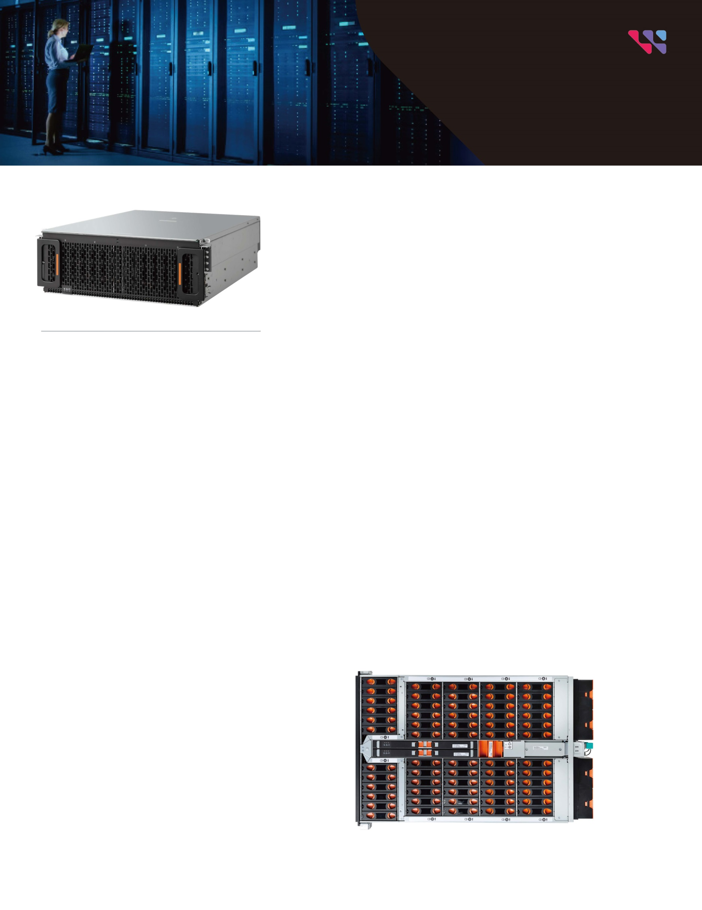

**Ultrastar® Data60 Storage Platform**

The Next Generation Platform for Software-Defined Storage

**Designed for High Density and Flexibility**

The Ultrastar Data60 is a key element of next-generation disaggregated storage and software-defined storage (SDS) systems, delivering high density and the flexibility to balance performance with cost. The Ultrastar Data60 provides up to 1.56PB1 of raw storage2 in a compact and efficient form factor. Western Digital HelioSeal ® drives ensure cool running, quiet operation, and high reliability.

**Building on 50+ Years of Storage Design Experience**

Conventional dense disk shelves frequently suffer from performance degradation due to induced vibration from adjacent drives. Traditional platforms also have cooling challenges as the cooling air passes over successive rows of drives, losing effectiveness as it gets heated up along the airflow path. Developing storage devices and platforms side-by-side, we address these challenges through Silicon to Systems Design, a set of technologies developed based on a holistic view of devices, platform, and their interactions. The first two of these innovative technologies are IsoVibe™ and ArcticFlow™. IsoVibe reduces vibration-induced performance degradation, while ArcticFlow overcomes the cooling issues by introducing cool air into the middle of the platform. Both these technologies contribute to long-term reliability, enabling our five-year limited warranty on the entire platform.

**Designed for the Enterprise and the Cloud**

This platform addresses the demanding storage needs of large enterprise customers, storage OEMs, cloud service providers and resellers/integrators that require dense, shared HDD storage. The Ultrastar Data60 provides the flexibility to specify the HDD combinations to balance capacity, performance and cost.

**Features**

• Up to 60 Ultrastar HDDs (SAS or SATA)

• Up to 1.56PB1 of raw storage2 in 4U

• Up to 4 units may be daisy-chained for a total raw capacity of 6.24PB

• Patented IsoVibe technology ensures maximum performance even in heavy workloads

• Improved cooling from innovative ArcticFlow technology

• Choose dual-port SAS for high availability or single-port SATA for low cost

• Up to 12 x 12Gb/s SAS-3 host connections

• Enterprise-grade redundant and hot- swappable PSUs, IO Modules, and fans

• Rack-mounted top cover for quick and easy service

**Western Digital**

Product Brief



**Western Digital®**

February 2023

© 2023 Western Digital Corporation or its affiliates. All rights reserved. Western Digital, the Western Digital design, the Western Digital logo, ArcticFlow, HelioSeal, IsoVibe, and Ultrastar are registered trademarks or trademarks of Western Digital Corporation or its affiliates in the US and/or other countries. All other marks are the property of their respective owners. Please visit our website, westerndigital.com/platforms for additional information on product specifications. Pictures shown may vary from actual products. References in this publication to Ultrastar products, programs or services do not imply that they will be made available in all countries.

5601 Great Oaks Parkway

San Jose, CA 95119, USA

[www.westerndigital.com](http://www.westerndigital.com/)

|  |  |
| --- | --- |
| IsoVibe | IsoVibe Patented Vibration Isolation Technology  Precise cuts in the baseboard provide a suspension for the drives in the chassis, isolating them from transmitted vibration. The result is that consistent performance is maintained, even when all the drives are working hard. |
| ArcticFlow | Innovative ArcticFlow Thermal Zone Cooling Technology  By introducing cool air into the center of the chassis, drives operate at lower and more consistent temperatures than conventional systems. This results in lower fan speeds, reduced vibration, lower power consumption, quieter operation and ultimately higher reliability. |
| Resource Manager | Western Digital Resource Manager  A GUI-based tool that enables real-time monitoring and management of the platform and provides a consolidated dashboard displaying the most critical information. Other views allow platform configuration, health monitoring and maintenance. |

|  |  |
| --- | --- |
| Specifications | |
| Max. Drives | 60 x 3.5in drive bays |
| Drive Interface | 12Gb/s SAS  6Gb/s SATA |
| Available Drive Capacities | HDD up to 22TB CMR or 26TB SMR |
| Host Interface | Dual redundant I/O Modules (IOM),  6 Mini-SAS HD ports per IOM |
| Weight | Product without drives: 27.3kg / 60lbs  Product with 60 HDDs: 79.4kg / 175lbs |
| LED Indicators | Front/Rear: Power, ID, Fault  Drive: Activity, Fault |
| Physical Dimensions | Height: 175mm / 6.89in  Width: 447mm / 17.61in  Depth: 712mm / 28.03in  Depth in Rack: Max of 890mm / 35.04in w/dual CMA—includes 2 SAS cables |
| Management | SCSI Enclosure Services  Redfish (out of band, via RJ45) |
| Power | Dual 1600W or 1800W, 80+ Platinum  200-240V AC input, auto ranging, 50-60Hz |
| Cooling | 4 main enclosure fans, front-to-rear system cooling with zero-loss backflow prevention  1 IO module fan  Dual PSUs with built-in fans |
| Environmental | Operating Temperature: 5°C to 35°C  Non-op Temperature: -40 to 70°C  Humidity: 5 to 85% relative humidity  Operating Altitude: -300m to 3048m / -984 ft to 10,000 ft  Sound Power: < 7.2Bels @ 23±2°C |
| Serviceability | Cable-free hot-swappable IOM, power supply, fans and drives |
| 1 One terabyte (TB) is equal to one trillion bytes and one petabyte (PB) is equal to 1,000 TB. Actual user capacity may be less due to operating environment.  2 Ultrastar Data60 total raw capacity of 1.32PB using 22TB CMR HDDs and 1.56PB using 26TB SMR HDDs. | |

**Ultrastar® Data60**