Setting up TCG Ruby with Sedutil

Abstract

This document describes setting up an Ultrastar® DC SN640 or DC SN840 NVMe™ TCG Ruby compliant SSD by means of a tool called sedutil. This will introduce the basics of the TCG Ruby specification, Western Digital’s implementation, and some key operations on ranges. This document will also introduce the tool ‘sedutil’ and use sedutil to identify TCG Ruby drives, set passwords, set bands, and lock and unlock drives.

This document is not a discussion of TCG Ruby encryption details. More information can be downloaded from the Trusted Computing Group website. See notes at the end of the document.

TCG Ruby

The purpose for TCG Ruby is to provide an up-to-date enterprise Security Subsystem Class (SSC) to support NVMe datacenter drives with simplified implementation and integration.

It is part of the broader Opal SSC (such as Pyrite and Opalite) and has protocol compatibility with the Opal family. However, TCG Ruby is slightly more limited in what it supports as some features are not considered relevant to an Enterprise drive. For example, preboot authentication support is optional.

Western Digital’s specific implementation of the TCG Ruby specification (see below a comparison about Opal v2.01 and TCG Ruby) makes it very similar to Opal, but preboot authentication is not supported. 1, 2

|  |  |  |
| --- | --- | --- |
| **Feature** | **Opal V2.01** | **TCG Ruby** |
| **Activation and Life Cycle** | Yes | Yes |
| **Number of Admin, Users** | 4 Admin, 8 Users | 1 Admin, 2 Users |
| **Min Number of Required Logical Block Addressing (LBA) Ranges** | Global Range +8 | Global Range (+8 on Western Digital drives) |
| **Min Datastore Size** | 10MB | 128 KB |
| **Min MBR Table Size** | 128MB | Optional: 128MB if supported |
| **Configurable Access Control** | Yes | Yes |
| **PSID** | Yes | Yes |
| **Media Encryption** | Required | Required |
| **Crypto Erase** | Revert, Revert SP, GenKey methods for device and locking range level erase granularity | Same as Opal |

The Logical Block Addressing (LBA) Ranges, are spans of LBAs into which the drive can be partitioned and that share the same encryption details. Some rules apply:

1. Ranges cannot overlap, except for Range0 which, by definition is the global range that encompass the whole capacity of the drive.

2. Once a range is set up by defining the start LBA and the LBA count, it can be locked to writes or reads/writes.

3. Any lock shall be enabled before the lock settings are effective: disabling the ‘lock enable’, disables locking, though the range stays in place.

4. A range can be crypto erased by re-keying which will change the encryption key for that range.

SID is the entity that can be used to authenticate to the drive and freeze or remove other entities initially.

Admin1 is the administrator of all the ranges: it can operate on any range and perform any change. User1 and User2 are entities whose access capability is configurable. For instance they might be enabled to operate only on some specific ranges, or not be enabled to erase the data but only lock reads or writes on those ranges.

Downloading and Compiling the Sedutil Tool

The first step is to download the tools from the GitHub and compile them. The test in this document was performed on Linux® Ubuntu 18.04.03 (it needs the kernel switch *libata_tpm* set at boot time), but the specific tool versions should also work on Windows and FreeBSD. Windows compilation would require VSC 2015 or later.

The commands to download and compile are below: please note git will create a directory called sedutil in any directory it is run from. If different is needed, please check the git manual for help.

*git clone* [*https://github.com/amotin/sedutil.git*](https://github.com/amotin/sedutil.git)

*autoreconf -i*

*./configure*

*make*

*(make install) // not required if you do not want to have the tool installed system wide*

At the end of the process the tool will be compiled, and there will be an executable called *sedutil-cli* on the source directory. The executable *sedutil-cli* may be installed system wide the last command was issued.

Taking Control of the Drive

The next step is to scan the drives in the system and check for compliant drives. In this example the drive is compliant with the TCG Ruby standard, and this is identified with a small r close to the drive, as in Figure 1.

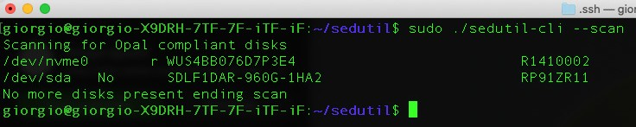

Figure 1. Scanning drives in the system

The drive can be queried for its supported features, see Figure 2 below: note the logical block size is 512bytes for the Ultrastar DC SN640 or DC SN840 with TCG Ruby.

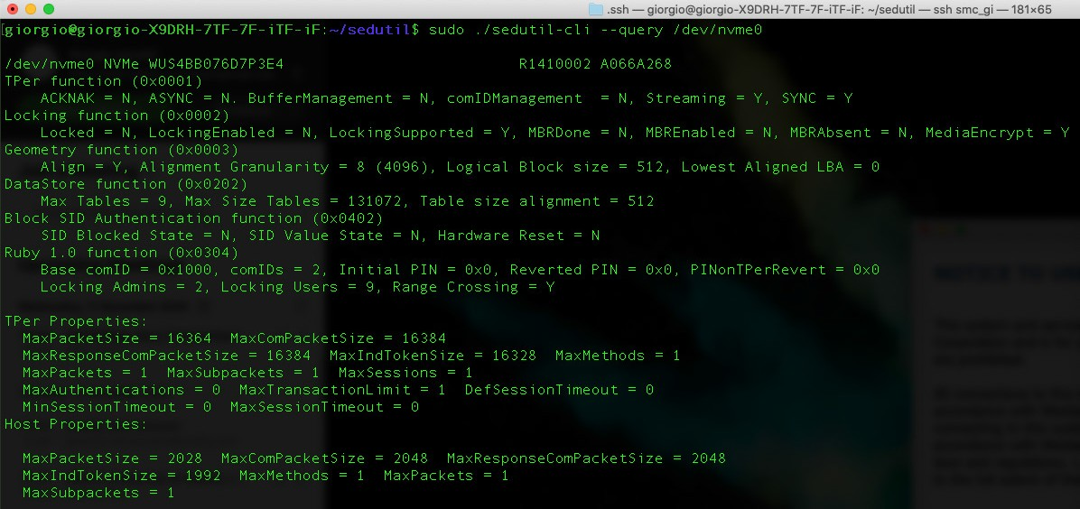

Figure 2. Query of Ultrastar DC SN640 drive model

Taking control of the drive is a process called “Take Ownership”. This will change the default passwords (SID and admin1), initially set to an electronically readable value referred as MSID, to your password.

With sedutil this involves issuing the command in Figure 3, changing the password, in this example, to “test”:

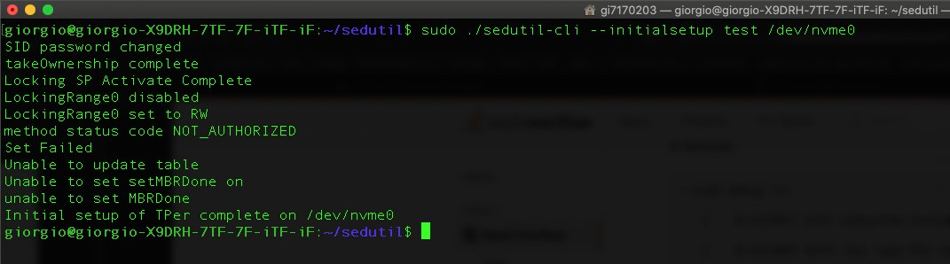

Figure 3. Taking ownership

The error message shown in Figure 3 comes from the fact the TCG Ruby implementation is not supporting MBR boot, and can safely be ignored. Note that both admin1 and SID passwords are changed. All the commands below use the admin1 password and eventually SID and admin1 can be changed one by one.

At this stage encryption has been initialized and the passwords are now different from their default values. It is good practice to change the SID and Admin1 passwords to different values after the initial setup. This can be accomplished with:

*--setSIDPassword <SIDPassword> <newSIDPassword> <device>*

*--setPassword <oldpassword> admin1 <newPassword> <device>*

Note that except for *revertTPer* command which returns the drive to default values, and the *PSIDrevert* which uses the PSID printed on drive’s label, any command uses the admin1 password.

Setting up Bands and Locking

A TCG Ruby compliant device has at least one global band (called band0) and optionally more. In Western Digital’s implementation up to 8 bands are supported. You can list the bands and their status with the command

*--listlockingranges*, shown in Figure 4.

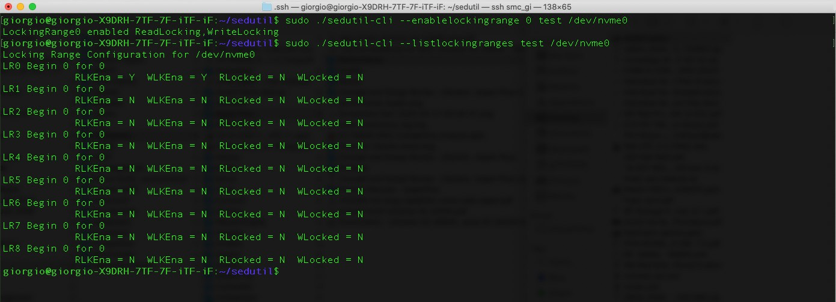

Figure 4. Listing and enabling global range

Locking a band is a 2-step process: reads or reads/writes needs to be locked (reflected in *RLocked*, *WLocked*), as well as write and read locks need to be enabled (reflected in *RLKEna* and *WLKEna*). Setting a lock but not enabling it, will result in no lock.

Figure 4 demonstrates enabling the global range (with the option *--enablelockingrange* and using our password “test”) and then lists the status of the bands.

In this case the 8 bands are undefined, and the global band has been enabled.

Next is an example of setting up one band, specifically band 1.

Bands are defined as starting from a block number (512bytes in our case, see the query at the beginning for the specific value for each drive type) and extending from that block for a certain number of blocks. Bands cannot overlap except for the global band, which by definition extends over the entire capacity.

Figure 5 demonstrates setting up band1 from block 0 for 2000 blocks using the option *-- setuplockingrange <band#> <from block #> <to block #>.* The password in Figure 5 is “test”:

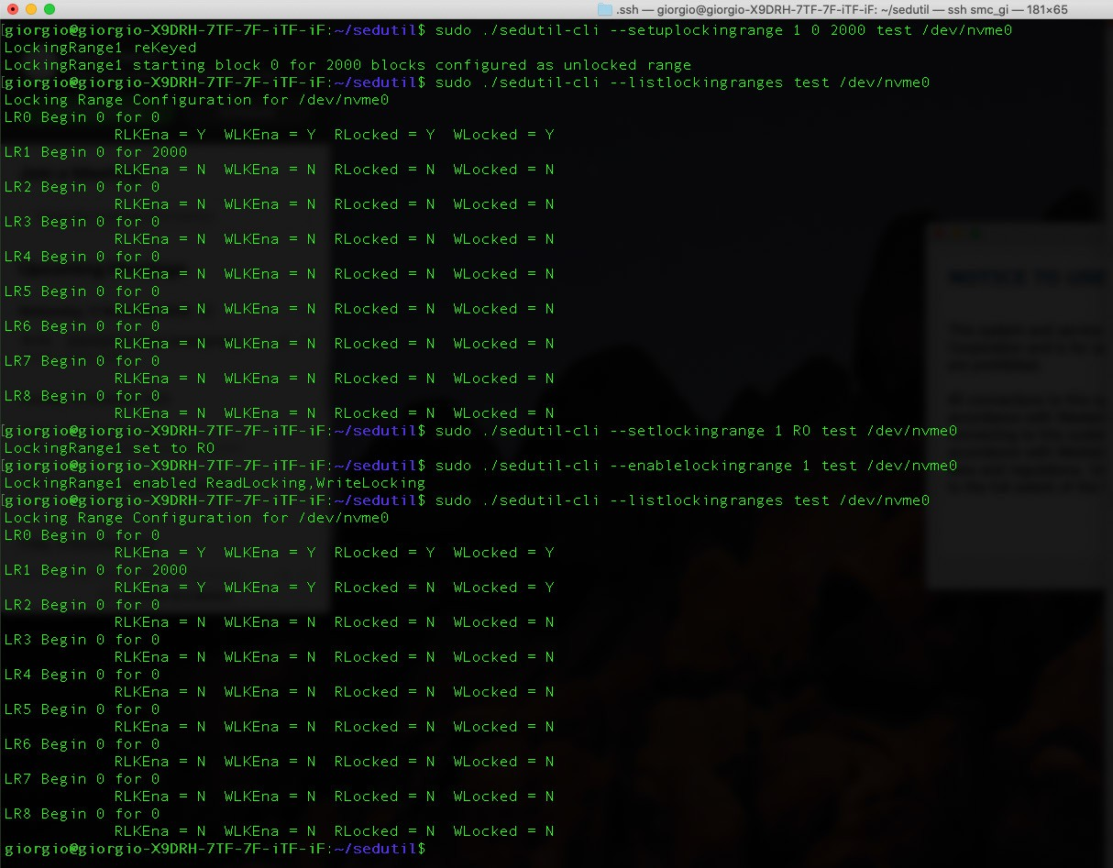

Figure 5. Setting up band1

At this point, band 1 (or locking range) is set and write locked (*WLocked=Y*). –This example uses the *--setlockingrange* option with the RO (read only) switch. It is also possible to enable the full lock if needed, using the LK switch, and to remove it, using RW.

Testing the Locked Drive

The locked drive can be tested, and only when the lock is disabled can it be written. This is demonstrated in Figure 6.

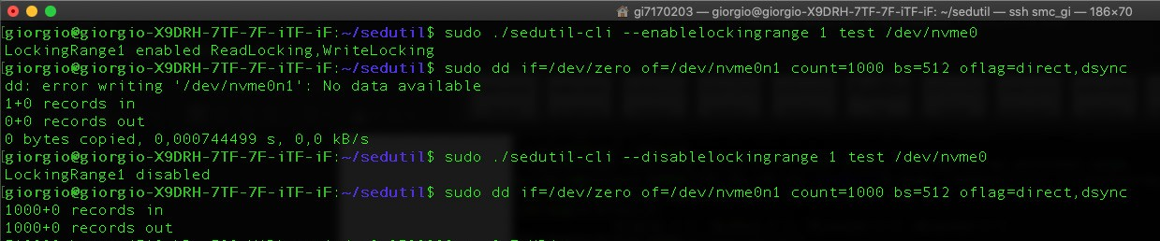

Figure 6. Enabling and disabling locking

The list of operations performed are:

1. Enable locking (although only the write lock was selected with this command we enable both the lock and setting up the lock).

2. Try to write to the drive with dd. The command fails.

3. Disable locking.

4. Write to the device and succeed.

Finally the locking range can be rekeyed which will change the encryption key for that specific band. This will properly erase the band since the original key is changed and cannot be recovered.

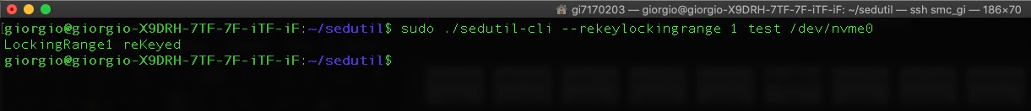

Figure 7. Rekey locking range 1

Reverting to Defaults

You can revert to defaults without erasing the drive with *--revertNoErase*, as shown in Figure 8.

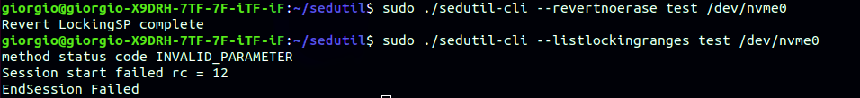

Figure 8. Revertnoerase command

Reverting to Defaults in Case the SID Password is Lost

It is always possible to reset the drive to defaults if you forget your password, albeit losing all data by means of the PSID password, that is written on the disk’s label (Figure 8), and that cannot be read electronically from the drive.

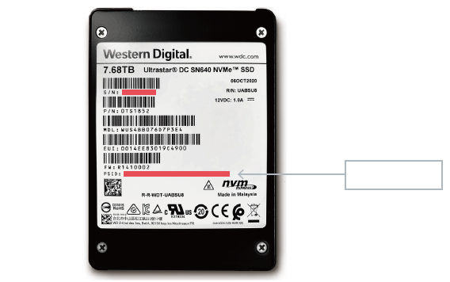

PSID Position

Figure 9. PSID position on the label

The command clearly warns you about erasing your data (Figure 9).



Figure 10. Restoring defaults with PSID

Conclusions

This paper presents an open source sedutil tool that allows a user to configure encryption on an Ultrastar DC SN640 or DC SN840 NVMe SSD TCG Ruby compliant SSD. Basic concepts and commands have been discussed, showing how to take control of the drive, encrypt the data, erase and restore the drive to defaults.

References

1 https://trustedcomputinggroup.org/wp-content/uploads/TCG_Storage_SSC_Ruby_v1_r1_pub.pdf

2 https://trustedcomputinggroup.org/wp-content/uploads/TCG_Storage-Opal_SSC_v2.01_rev1.00.pdf

3 https://[www.flashmemorysummit.com/English/Collaterals/Proceedings/2018/20180807_SECU-102B-1_Tipton.pdf](http://www.flashmemorysummit.com/English/Collaterals/Proceedings/2018/20180807_SECU-102B-1_Tipton.pdf)

4 https://trustedcomputinggroup.org/wp-content/uploads/Storage-Ruby-SSC-v1.0-Specification-FAQ _20182811_Final.pdf

5 https://nvmexpress.org/wp-content/uploads/TCGandNVMe_Joint_White_Paper-TCG_Storage_Opal_and_NVMe_FINAL.pdf

|  |  |
| --- | --- |
| **Western Digital.** |  |
|  |  |
|  |  |
| 5601 Great Oaks Parkway  San Jose, CA 95119, USA  www.westerndigital.com | © 2021 Western Digital Corporation or its affiliates. All rights reserved.  Western Digital, the Western Digital logo, and Ultrastar are registered trademarks or trademarks of Western Digital Corporation or its affiliates in the US and/or other countries. The NVMe word mark and NVMe logo mark are trademarks of NVM Express, Inc. All other marks are the property of their respective owners. All other marks are the property of their respective owners. |