WD Purple™ HDDs Optimized for Performance and Low Power

Today’s smart video environment requires support for applications that go beyond traditional surveillance. Cameras now support a main video feed that consists of multiple video streams at high-definition or 4K resolutions. In addition to the main video stream, cameras also output auxiliary video streams, picture streams, and video metadata information.

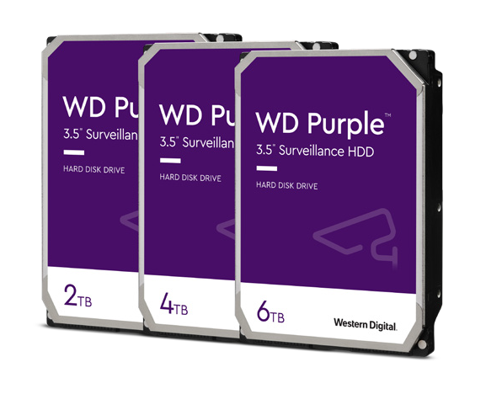

Main video, auxiliary video, picture streams, and video metadata all have different data characteristics including structure, size, and frequency of the transmitted data. HDDs can help optimize the entire smart video solution by supporting these data requirements with performance and low power.

New 2TB, 4TB. and 6TB* WD Purple Smart Video HDDs1 have been optimized for performance and low power. They utilize enhancements to WD AllFrame™ technology to reduce the drive’s RPM and lower overall power consumption. These drives can recognize incoming video stream characteristics and data types, coalesce data together in cache and place data in specific track locations on disk.

# Not All Video Workloads Are the Same

A typical DVR or NVR encounters mixed workloads of both sequential and random data. Multiple video streams from primary and auxiliary video produces a constant sequential data stream, coming at the same rate and same time continuously. The data is well quantified, with a known MB/s written in continuous blocks of files. Metadata and AI analytics data is random in nature and can be cached until it needs to be written to the HDD.

Recorder manufacturers employ different video analytic implementations, which have an impact on data movement and storage. Some implementations require frequent metadata capture, analysis, and storage; others are dependent on the individual analytic data requirements and data sizing needs may vary widely.

# An Intelligent Approach to Smart Video Data

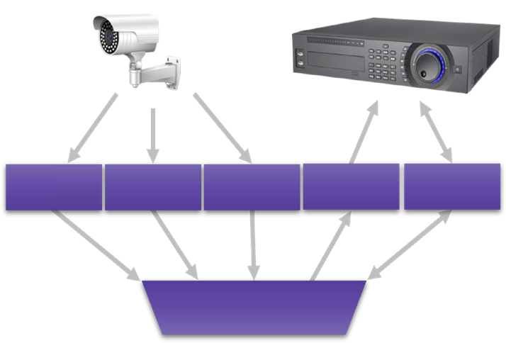New WD Purple HDDs have optimized AllFrame to better detect data types, such as video metadata, video streaming data and host OS file system data. By detecting the host environment and self-configuring into the appropriate operating state, the HDD can set up to be more predictive of incoming workloads.

Data blocks can be coalesced in cache and system performance can be optimized by intelligent placement of different data types. This maximizes data utilization, reduces the need for higher RPMs, and results in lower power. Machine learning capabilities in the firmware can improve self- configuration effectiveness over time, making this approach truly smart.

AI Metadata

Playback Stream

Picture Stream

Aux Video Stream

Main Video Stream

For example, video data as a continuous incoming video stream can be written to the outer part of an HDD disk where the sequential write speed is higher compared to the inner part of the disk. Embedded video analytics metadata is highly structured and consistent. This can be written to the inner part of the disk where raw data speeds are not as important.

AllFrame Technology

# Lower RPM for Surveillance Workloads

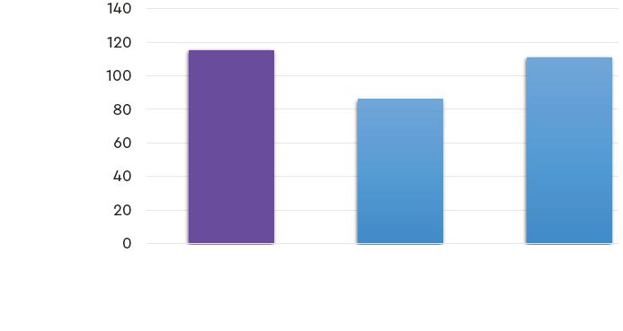AllFrame’s intelligent data placement reduces the need for higher RPM disks. New WD Purple HDDs operating at low RPM speeds may perform equally well compared to standard HDDs at higher RPM. In a simulation with a typical video surveillance workload2, a WD Purple HDD with a power- efficient speed of 5040 RPM exceeded the performance of HDDs at 5400RPM and 7200 RPM3.

MB/s

**Sustainable Data Rate**

# Lower Power Smart Video HDDs

WD Purple Smart Video HDDs operating at slower RPM speeds are generally more power efficient. By using innovation to improve data management and keeping RPM low, these new 2TB/4TB/6TB WD Purple HDDs1 are more power efficient than previous generation higher RPM drives, using up to 25.8%4 fewer watts per drive, in average operating conditions.

7200 RPM

5400 RPM

5040 RPM

WD Purple HDD

2TB/4TB/6TB1

Lower power can help provide both operating cost benefits and performance needed to handle the challenging workloads of new mainstream recorders. Power efficient hard drives will benefit recorder manufacturers and suppliers whose NVRs may have constrained power budgets and face thermal limitations with limited airflow. For end-user customers, more efficient drives can result in lower system operating costs.

up to **28.5%**

fewer watts/ drive

non-optimized HDD

# New Generation of WD Purple HDDs

The latest line of 2TB, 4TB, and 6TB WD Purple Smart Video HDDs1 utilize enhancements in WD AllFrame technology to intelligently manage video data. The drives can recognize incoming video stream characteristics and data types, coalesce data together in cache and place data in specific track locations on disk. Intelligent data placements allow for lower drive RPM that has equivalent performance to drives with higher RPM. Lower RPM leads to power savings which benefits customers through lower system operating costs.

Western Digital’s investment in smart video optimized storage innovation ensures that we continue to deliver trust, reliability, and capability in our WD Purple family of storage devices.

**Learn more about Western Digital smart video solutions**

<https://www.westerndigital.com/solutions/surveillance>

<https://www.westerndigital.com/tools/surveillance-capacity-calculator>

* 1TB = 1 trillion bytes. Actual user capacity may be less depending on operating environment.

1 Applies to the following WD Purple models: WDPURZ22, WDPURZ42, WDPURZ63, WDEJRX22, WDEJRX42, WDEJRX63

2 “Typical” video surveillance workload includes a balance of network cameras at varying resolutions, frame rates, and video codes, along with auxiliary streams, and metadata.

3 Based on Read speed, unless otherwise stated. 1 MB/s = 1 million bytes per second. Based on internal testing; performance may vary depending upon host device, usage conditions, drive capacity, and other factors.

4 Power Efficiency calculations are based on comparison of previous generation versus latest generation WD Purple HDD models.

|  |  |  |
| --- | --- | --- |
| 5601 Great Oaks Parkway  San Jose, CA 95119, USA  [www.westerndigital.com](http://www.westerndigital.com/) |  | ©2022 Western Digital Corporation or its affiliates. All rights reserved.  Western Digital, the Western Digital design, the Western Digital logo, AllFrame, and WD Purple are registered trademarks or trademarks of Western Digital Corporation or its affiliates in the US and/or other countries. All other marks are the property of their respective owners. Product specifications subject to change without notice. Pictures shown may vary from actual products. |