

Internet And Web Programming

CSE3002 (A2 L47+L48)

Professor: Archana T

Project On

**FIFA Player Management System**

 FIFA(International Federation of Association Football)

18BCI0203 - Md Arham Siddiqui

18BCE0682 - Anuj Kapoor

**Review 3**

Abstract***:***

‘FIFA 18 Player management system’ is player management software for monitoring and accessing players based on their FIFA 18 PC or XBOX Game ratings. The project will be developed using HTML, CSS and JavaScript for front-end and PHP, MySQL for back-end, which focuses on basic operation like adding a new player, new statistics, searching players with detailed information and edit as they grow their skills. This project is a web based application designed and developed to help user’s access players and organise teams.

This project also aims at providing best user interface along with searching, insertion, and deletion with procedure capabilities for each player in FIFA.

Hardware and software requirements :

* Windows 7 or higher version OS
* WAMPP web server
* Google chrome v70.0.3538 or greater
* 1.7 or more GHz processor
* 32/64-bit processor
* i3 or greater intel processor chip

Introduction:

The project will have player details, which will describe about player biodata such as age and nationality. It will also consist of player stats which describes about players technical skills. It will also consist of tables containing details such as player earnings, club information and preferred position of playing. It will also provide a strong searching, updating, deleting and inserting operations with a user friendly web based UI. The project will help the users to keep track of the player details in a computerised way without any trouble. The project will contain 7 stored procedures and 3 triggers per table. Stored procedures are used in search engine. Every time the user searches through the database, a procedure is called and the results is collected and displayed for the user in a structured manner. It also has 3 trigger namely “Insert, Delete and Update” triggers assigned separately to each table. Whenever operations such as insert or delete or update will be performed on any table, these triggers will be automatically called, and the logs will be captured into 3 separate tables, individually for each trigger. Hence use of triggers will provide users to trace back all the latest as well as the oldest changes into any table at any point of time.

Website Structure

Home page

* Menus
* Home
* Search
* Update*
* Insert*
* Database
* Report
* Procedures*
* About

*Further in each menu option there will sub menus or operations

At Center

Category based Search option

Categories: (of players)

* Age
* Nationality
* Overall rating
* Player ID
* Player Name
* Player Position
* Team

Web Screenshots:

HomePage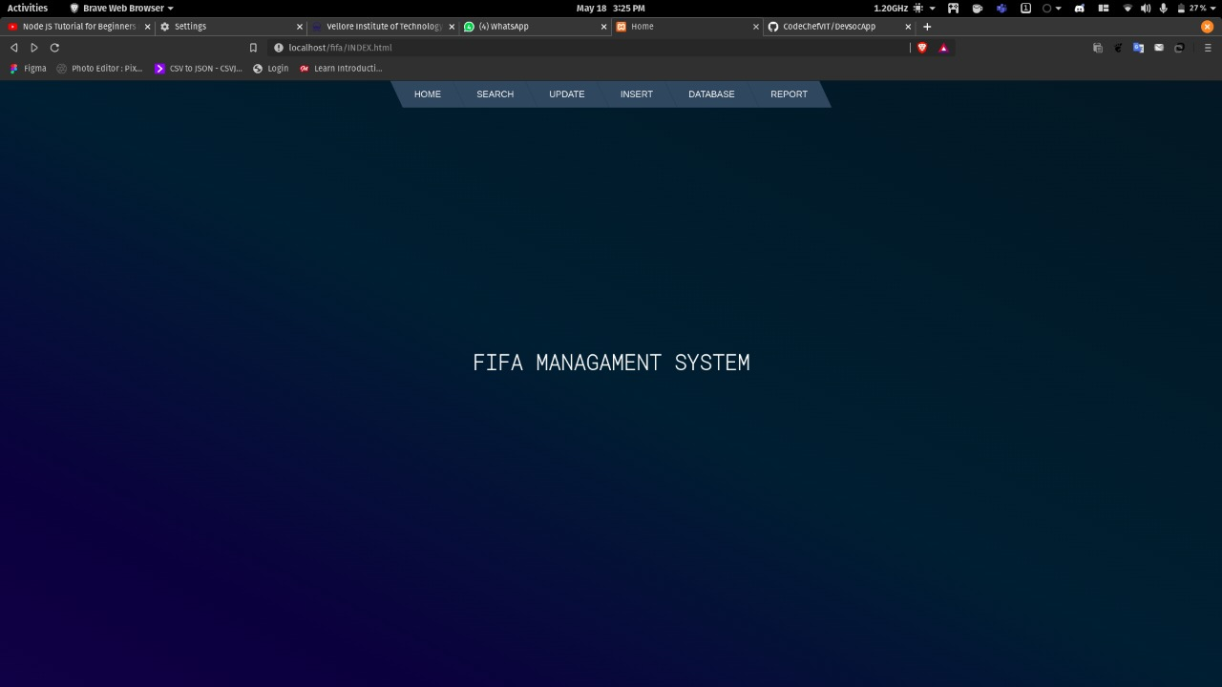

Modify (UpdateData) in Database: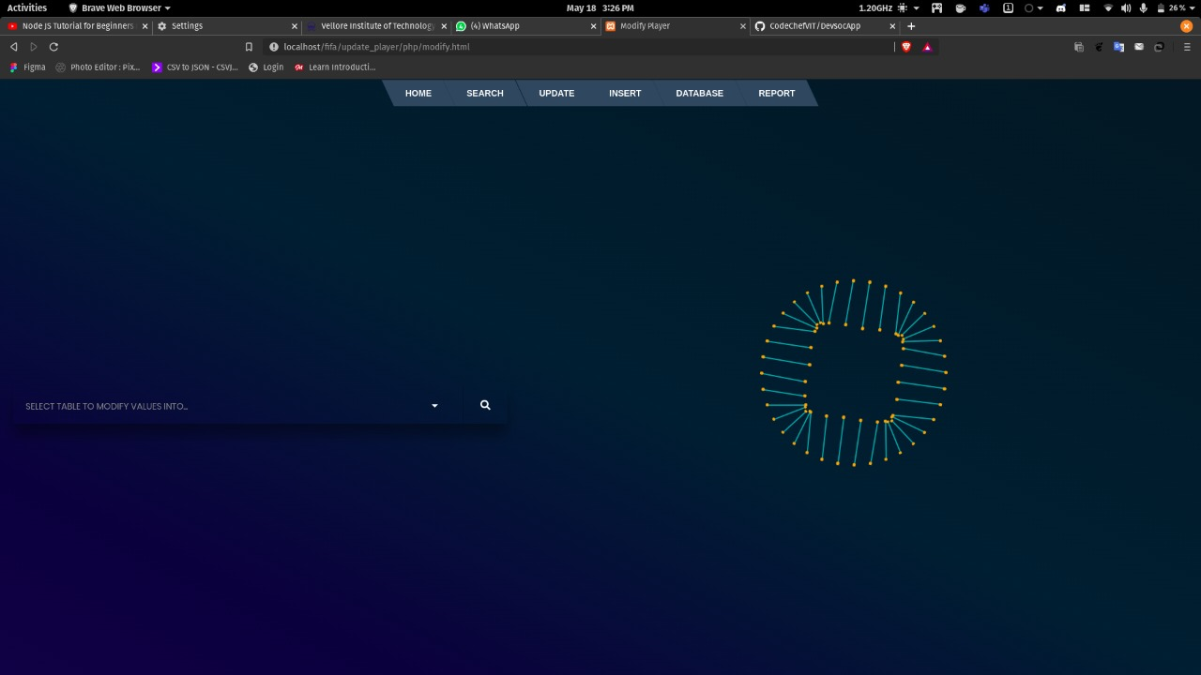

FootballTeamDatabse: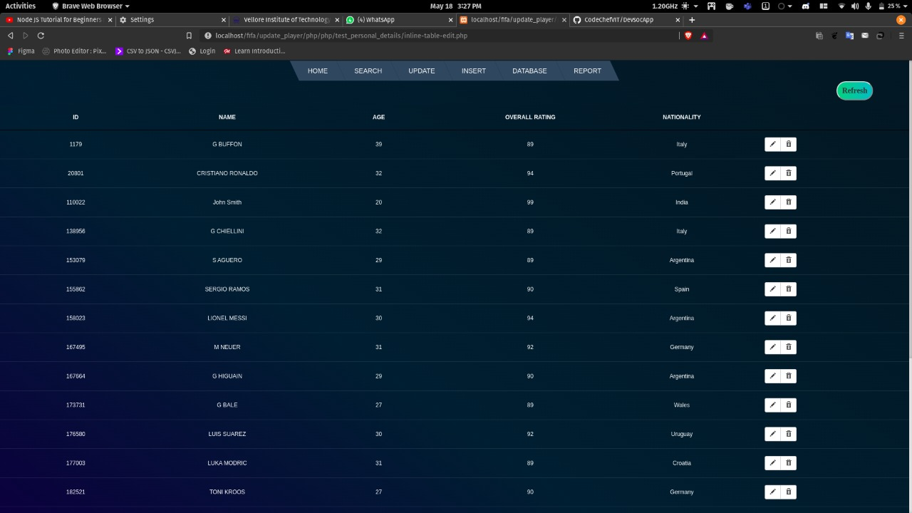

OnClick screen: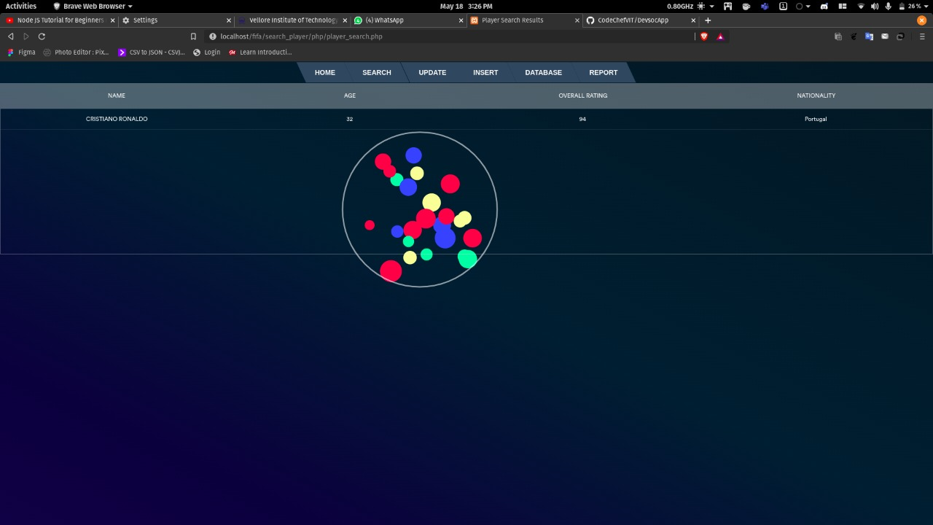

PlayerDatabse:

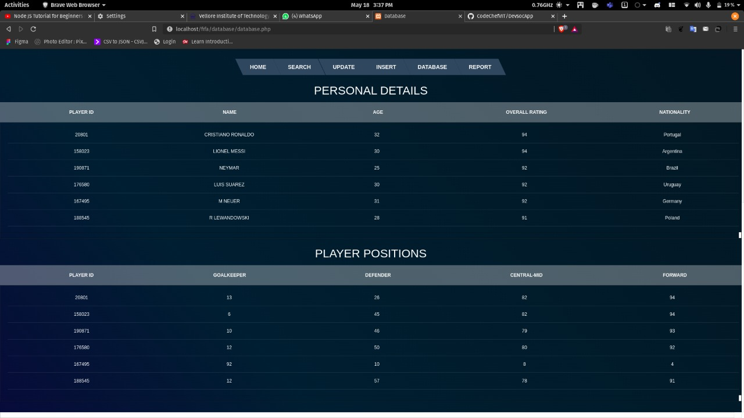

Insert (ToEdit PlayerDetails) :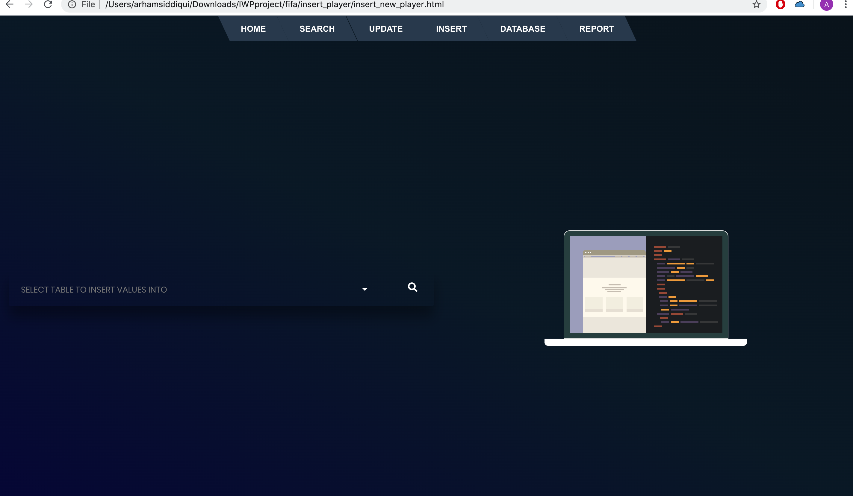

ReportTab: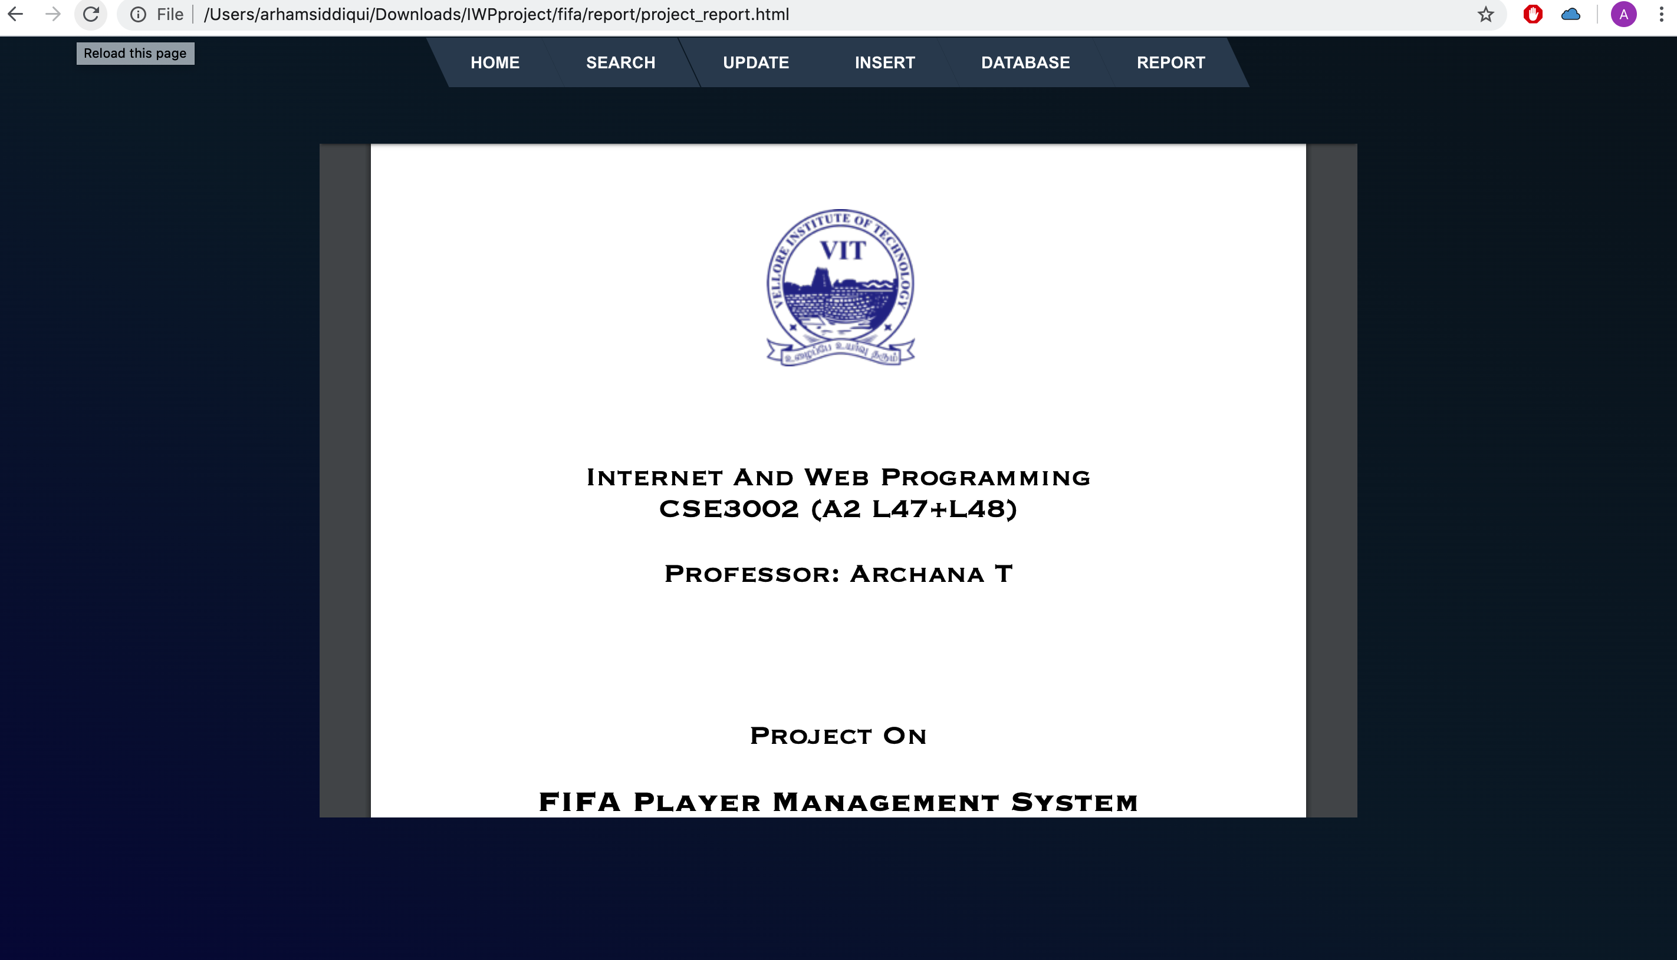

*Code Snippets :*

Js

index.js

var _createClass = function () {

function defineProperties(target, props) {

for (var i = 0; i < props.length; i++) {

var descriptor = props[i];

descriptor.enumerable = descriptor.enumerable || false;

descriptor.configurable = true;

if ("value" in descriptor)

descriptor.writable = true;

Object.defineProperty(target, descriptor.key, descriptor);

}

}

return function (Constructor, protoProps, staticProps) {

if (protoProps)

defineProperties(Constructor.prototype, protoProps);

if (staticProps) defineProperties(Constructor, staticProps);

return Constructor;

};

}();

function _classCallCheck(instance, Constructor) {

if (!(instance instanceof Constructor)) {

throw new TypeError("Cannot call a class as a function");

}

}

// ——————————————————————————————————————————————————

// TextScramble

// ——————————————————————————————————————————————————

var

TextScramble = function () {

function TextScramble(el) {_classCallCheck(this, TextScramble);

this.el = el;

this.chars = '!<>-_\\/[]{}—=+*^?#________';

this.update = this.update.bind(this);

}_createClass(TextScramble, [{ key: 'setText', value: function setText(

newText) {var _this = this;

var oldText = this.el.innerText;

var length = Math.max(oldText.length, newText.length);

var promise = new Promise(function (resolve) {return _this.resolve = resolve;});

this.queue = [];

for (var i = 0; i < length; i++) {

var from = oldText[i] || '';

var to = newText[i] || '';

var start = Math.floor(Math.random() * 40);

var end = start + Math.floor(Math.random() * 40);

this.queue.push({ from: from, to: to, start: start, end: end });

}

cancelAnimationFrame(this.frameRequest);

this.frame = 0;

this.update();

return promise;

} }, { key: 'update', value: function update()

{

var output = '';

var complete = 0;

for (var i = 0, n = this.queue.length; i < n; i++) {var _queue$i =

this.queue[i],from = _queue$i.from,to = _queue$i.to,start = _queue$i.start,end = _queue$i.end,char = _queue$i.char;

if (this.frame >= end) {

complete++;

output += to;

} else if (this.frame >= start) {

if (!char || Math.random() < 0.28) {

char = this.randomChar();

this.queue[i].char = char;

}

output += '<span class="dud">' + char + '</span>';

} else {

output += from;

}

}

this.el.innerHTML = output;

if (complete === this.queue.length) {

this.resolve();

} else {

this.frameRequest = requestAnimationFrame(this.update);

this.frame++;

}

} }, { key: 'randomChar', value: function randomChar()

{

return this.chars[Math.floor(Math.random() * this.chars.length)];

} }]);return TextScramble;}();

// ——————————————————————————————————————————————————

// Example

// ——————————————————————————————————————————————————

var phrases = [

'FIFA MANAGAMENT SYSTEM',

'DEVELOPED WITH LOVE AND PASSION',

'BY Anuj Kapoor And Md Arham Siddiqui'];

var el = document.querySelector('.text');

var fx = new TextScramble(el);

var counter = 0;

var next = function next() {

fx.setText(phrases[counter]).then(function () {

setTimeout(next, 1700);

});

counter = (counter + 1) % phrases.length;

};

next();

*Css:*

Menu.css

.cf:before, .cf:after {

content:" ";

display: table;

}

.cf:after {

clear: both;

}

.cf {

*zoom: 1;

}

.menu {

list-style:none;

margin: 1px auto;

width: 800px;

width: -moz-fit-content;

width: -webkit-fit-content;

width: fit-content;

}

.menu > li {

background: #34495e;

float: left;

position: relative;

-webkit-transform: skewX(25deg);

}

.menu a {

display: block;

color: #fff;

text-transform: uppercase;

text-decoration: none;

font-family: Arial, Helvetica;

font-size: 14px;

}

.menu li:hover {

background: #e74c3c;

}

.menu > li > a {

-webkit-transform: skewX(-25deg);

padding: 1em 2em;

}

/* Dropdown */

.submenu {

position: absolute;

width: 200px;

left: 50%;

margin-left: -100px;

-webkit-transform: skewX(-25deg);

-webkit-transform-origin: left top;

}

.submenu li {

background-color: #34495e;

position: relative;

overflow: hidden;

}

.submenu > li > a {

padding: 1em 2em;

}

.submenu > li::after {

content:'';

position: absolute;

top: -125%;

height: 100%;

width: 100%;

box-shadow: 0 0 50px rgba(0, 0, 0, .9);

}

/* Odd stuff */

.submenu > li:nth-child(odd) {

-webkit-transform: skewX(-25deg) translateX(0);

}

.submenu > li:nth-child(odd) > a {

-webkit-transform: skewX(25deg);

}

.submenu > li:nth-child(odd)::after {

right: -50%;

-webkit-transform: skewX(-25deg) rotate(3deg);

}

/* Even stuff */

.submenu > li:nth-child(even) {

-webkit-transform: skewX(25deg) translateX(0);

}

.submenu > li:nth-child(even) > a {

-webkit-transform: skewX(-25deg);

}

.submenu > li:nth-child(even)::after {

left: -50%;

-webkit-transform: skewX(25deg) rotate(3deg);

}

/* Show dropdown */

.submenu, .submenu li {

opacity: 0;

visibility: hidden;

}

.submenu li {

transition: .2s ease -webkit-transform;

}

.menu > li:hover .submenu, .menu > li:hover .submenu li {

opacity: 1;

visibility: visible;

}

.menu > li:hover .submenu li:nth-child(even) {

-webkit-transform: skewX(25deg) translateX(15px);

}

.menu > li:hover .submenu li:nth-child(odd) {

-webkit-transform: skewX(-25deg) translateX(-15px);

}

insert_new_player.html

<body style="background:linear-gradient(to right top, #050744, #072031, #071823);">

<canvas class="fireworks">

</canvas>

<section>

<ul class="menu cf">

<li><a href="../INDEX.html">Home</a></li>

<li><a href="../search_player/player_search.html">Search</a> </li>

<li><a href="../update_player/update_player.html">Update</a></li>

<li><a href="insert_new_player.html">Insert</a></li>

<li><a href="../database/database.php">Database</a></li>

<li><a href="../report/project_report.html">Report</a></li>

<!-- <li><a href="../procedures/procedures.html">Procedures</a></li>

<li><a href="../about/about.html">About</a></li> -->

</ul>

<div class="s003">

<form action="php/try_insert_into.php" method="post">

<div class="inner-form" style="margin-left: auto;">

<div class="input-field first-wrap" style="width: inherit;">

<div class="input-select">

<select data-trigger="" name="choices-single-defaul">

<option placeholder="">SELECT TABLE TO INSERT VALUES INTO</option>

<option>PERSONAL DETAILS</option>

<option>PLAYER POSITION</option>

<option>PLAYER EARNINGS</option>

<option>PLAYER STATS</option>

<option>PLAYER CLUB</option>

</select>

</div>

</div>

<!-- <div class="input-field second-wrap">

<input id="search" type="text" placeholder="Search..." name="input_search_keyword">

</div> -->

<div class="input-field third-wrap" style="position: inherit;">

<button class="btn-search" type="submit" onclick="php/try_insert_into.php" >

<svg class="svg-inline--fa fa-search fa-w-16" aria-hidden="true" data-prefix="fas" data-icon="search" role="img" xmlns="http://www.w3.org/2000/svg" viewBox="0 0 512 512">

<path fill="currentColor" d="M505 442.7L405.3 343c-4.5-4.5-10.6-7-17-7H372c27.6-35.3 44-79.7 44-128C416 93.1 322.9 0 208 0S0 93.1 0 208s93.1 208 208 208c48.3 0 92.7-16.4 128-44v16.3c0 6.4 2.5 12.5 7 17l99.7 99.7c9.4 9.4 24.6 9.4 33.9 0l28.3-28.3c9.4-9.4 9.4-24.6.1-34zM208 336c-70.7 0-128-57.2-128-128 0-70.7 57.2-128 128-128 70.7 0 128 57.2 128 128 0 70.7-57.2 128-128 128z"></path>

</svg>

</button>

</div>

</div>

</form>

<div class="wrap">

<div class="comp">

<div class="monitor">

<div class="mid">

<div class="site">

<div class="topbar">

<div class="cerrar">

<div class="circl"></div>

<div class="circl"></div>

<div class="circl"></div>

</div>

</div>

<div class="inhead">

<div class="mid">

<div class="item"></div>

</div>

<div class="mid txr">

<div class="item"></div>

<div class="item"></div>

<div class="item"></div>

<div class="item"></div>

</div>

</div>

<div class="inslid">

</div>

<div class="incont">

<div class="item"></div>

<div class="item"></div>

<div class="item"></div>

<div class="item"></div>

<div class="wid">

<div class="itwid">

<div>

<div class="contfoot"></div>

</div>

</div>

<div class="itwid">

<div>

<div class="contfoot"></div>

</div>

</div>

<div class="itwid">

<div>

<div class="contfoot"></div>

</div>

</div>

<div class="clearfix"></div>

</div>

<div class="infoot">

</div>

</div>

</div>

</div>

<div class="mid codigo">

<div class="line">

<div class="item var"></div>

<div class="item cont"></div>

<div class="clearfix"></div>

</div>

<div class="line">

<div class="item min var"></div>

<div class="item min fun"></div>

<div class="clearfix"></div>

</div>

<div class="line">

<div class="item min var"></div>

<div class="clearfix"></div>

</div>

<div class="line">

<div class="item var"></div>

<div class="item atr"></div>

<div class="item cont"></div>

<div class="clearfix"></div>

</div>

<div class="line tab1">

<div class="item min atr"></div>

<div class="item lrg fun"></div>

<div class="item min fun"></div>

<div class="item lrg cont"></div>

<div class="clearfix"></div>

</div>

<div class="line tab1">

<div class="item lrg atr"></div>

<div class="item min fun"></div>

<div class="item min cont"></div>

<div class="clearfix"></div>

</div>

<div class="line tab1">

<div class="item atr"></div>

<div class="item min fun"></div>

<div class="item atr"></div>

<div class="clearfix"></div>

</div>

<div class="line tab1">

<div class="item min atr"></div>

<div class="item min cont"></div>

<div class="item lrg atr"></div>

<div class="item fun"></div>

<div class="clearfix"></div>

</div>

<div class="line tab1">

<div class="item min atr"></div>

<div class="item lrg fun"></div>

<div class="item lrg cont"></div>

<div class="item min fun"></div>

<div class="clearfix"></div>

</div>

<div class="line tab1">

<div class="item min var"></div>

<div class="clearfix"></div>

</div>

<div class="line tab1">

<div class="item min var"></div>

<div class="clearfix"></div>

</div>

<div class="line tab2">

<div class="item min var"></div>

<div class="clearfix"></div>

</div>

<div class="line tab2">

<div class="item min atr"></div>

<div class="item min fun"></div>

<div class="clearfix"></div>

</div>

<div class="line tab3">

<div class="item min atr"></div>

<div class="item min fun"></div>

<div class="item lrg fun"></div>

<div class="item lrg cont"></div>

<div class="clearfix"></div>

</div>

<div class="line tab3">

<div class="item min atr"></div>

<div class="item min fun"></div>

<div class="item lrg atr"></div>

<div class="item lrg cont"></div>

<div class="clearfix"></div>

</div>

<div class="line tab4">

<div class="item min fun"></div>

<div class="item lrg atr"></div>

<div class="clearfix"></div>

</div>

<div class="line tab1">

<div class="item atr"></div>

<div class="item var"></div>

<div class="item cont"></div>

<div class="clearfix"></div>

</div>

<div class="line tab3">

<div class="item min var"></div>

<div class="clearfix"></div>

</div>

<div class="line tab4">

<div class="item min atr"></div>

<div class="item min fun"></div>

<div class="item lrg atr"></div>

<div class="item lrg cont"></div>

<div class="clearfix"></div>

</div>

<div class="line">

<div class="item min var"></div>

<div class="clearfix"></div>

</div>

</div>

</div>

<div class="base">

</div>

</div>

</div>

</div>

<defs>

<radialGradient cx="50%" cy="0%" fx="50%" fy="0%" r="50%" id="radialGradient-1">

<stop stop-color="#329FFF" offset="0%"></stop>

<stop stop-color="#206EFF" offset="100%"></stop>

</radialGradient>

<radialGradient cx="50%" cy="0%" fx="50%" fy="0%" r="50%" id="radialGradient-2">

<stop stop-color="#FF7894" offset="0%"></stop>

<stop stop-color="#FF324A" offset="100%"></stop>

</radialGradient>

<radialGradient cx="50%" cy="0%" fx="50%" fy="0%" r="100%" id="radialGradient-3">

<stop stop-color="#FF7894" offset="0%"></stop>

<stop stop-color="#FF324A" offset="100%"></stop>

</radialGradient>

<radialGradient cx="50%" cy="0%" fx="50%" fy="0%" r="100%" id="radialGradient-4">

<stop stop-color="#359FFC" offset="0%"></stop>

<stop stop-color="#206EFF" offset="100%"></stop>

</radialGradient>

<radialGradient cx="50%" cy="0%" fx="50%" fy="0%" r="50%" id="radialGradient-5">

<stop stop-color="#5FFFD2" offset="0%"></stop>

<stop stop-color="#31FFA6" offset="100%"></stop>

</radialGradient>

</defs>

<g stroke="none" stroke-width="1" fill="none" fill-rule="evenodd">

<rect id="dot-js" x="80" y="352" width="32" height="32" rx="16"></rect>

</g>

</section>

Database (php):

<?php

$servername = "localhost";

$username = "root";

$password = "";

$dbname = "fifa";

$conn = mysqli_connect($servername, $username, $password, $dbname);

// Check connection

**if** ($conn->connect_error) {

**die**("Connection failed: " **.** $conn->connect_error);

}

?>

<h1>PERSONAL DETAILS</h1>

<div **class**="tbl-header">

<table cellpadding="0" cellspacing="0" border="0">

<thead>

<tr>

<th>PLAYER ID</th>

<th>NAME</th>

<th>AGE</th>

<th>OVERALL RATING</th>

<th>NATIONALITY</th>

</tr>

</thead>

</table>

</div>

<div **class**="tbl-content">

<table cellpadding="0" cellspacing="0" border="0">

<!--<tbody>-->

<?php

$sql = "SELECT * FROM personal_details ORDER BY id";

$result = $conn->query($sql);

**if** ($result->num_rows >0 ) {

**while**($row = $result->fetch_assoc()) {

**echo** "<tbody>";

**echo** "<tr>";

**echo** "<td>" **.**$row["player_id"]**.** "</td>";

**echo** "<td>" **.**$row["player_name"]**.** "</td>";

**echo** "<td>" **.**$row["age"]**.** "</td>";

**echo** "<td>" **.**$row["overall_rating"]**.** "</td>";

**echo** "<td>" **.**$row["nationality"]**.** "</td>";

**echo** "</tr>";

**echo** "</tbody>";

}

}else {

**echo** "0 results";

}

?>

<!-- </tbody>-->

</table>

</div><br>

<h1>PLAYER POSITIONS</h1>

<div **class**="tbl-header">

<table cellpadding="0" cellspacing="0" border="0">

<thead>

<tr>

<th>PLAYER ID</th>

<th>GOALKEEPER</th>

<th>DEFENDER</th>

<th>CENTRAL-MID</th>

<th>FORWARD</th>

</tr>

</thead>

</table>

</div>

<div **class**="tbl-content">

<table cellpadding="0" cellspacing="0" border="0">

<!--<tbody>-->

<?php

$sql = "SELECT * FROM position ORDER BY id";

$result = $conn->query($sql);

**if** ($result->num_rows >0 ) {

**while**($row = $result->fetch_assoc()) {

**echo** "<tbody>";

**echo** "<tr>";

**echo** "<td>" **.**$row["player_id"]**.** "</td>";

**echo** "<td>" **.**$row["gk"]**.** "</td>";

**echo** "<td>" **.**$row["df"]**.** "</td>";

**echo** "<td>" **.**$row["cm"]**.** "</td>";

**echo** "<td>" **.**$row["fr"]**.** "</td>";

**echo** "</tr>";

**echo** "</tbody>";

}

}else {

**echo** "0 results";

}

?>

<!-- </tbody>-->

</table>

</div><br>

<h1>PLAYER EARNINGS</h1>

<div **class**="tbl-header">

<table cellpadding="0" cellspacing="0" border="0">

<thead>

<tr>

<th>PLAYER ID</th>

<th>WAGE</th>

<th>VALUE</th>

</tr>

</thead>

</table>

</div>

<div **class**="tbl-content">

<table cellpadding="0" cellspacing="0" border="0">

<!--<tbody>-->

<?php

$sql = "SELECT * FROM salary ORDER BY id";

$result = $conn->query($sql);

**if** ($result->num_rows >0 ) {

**while**($row = $result->fetch_assoc()) {

**echo** "<tbody>";

**echo** "<tr>";

**echo** "<td>" **.**$row["player_id"]**.** "</td>";

**echo** "<td>" **.**$row["wage"]**.** "</td>";

**echo** "<td>" **.**$row["value"]**.** "</td>";

**echo** "</tr>";

**echo** "</tbody>";

}

}else {

**echo** "0 results";

}

?>

<!-- </tbody>-->

</table>

</div><br>

<h1>PLAYER STATS</h1>

<div **class**="tbl-header">

<table cellpadding="0" cellspacing="0" border="0">

<thead>

<tr>

<th>PLAYER ID</th>

<th>ACCELERA TION</th>

<th>BALANCE</th>

<th>BALL CONTROL</th>

<th>CROSSING</th>

<th>CURVE</th>

<th>DRIBBLING</th>

<th>FINISHING</th>

<th>GK KICKING</th>

<th>GK POSITIONING</th>

<th>PENALTIES</th>

<th>SHORT PASS</th>

<th>STAMINA</th>

<th>STRENGTH</th>

</tr>

</thead>

</table>

</div>

<div **class**="tbl-content">

<table cellpadding="0" cellspacing="0" border="0">

<!--<tbody>-->

<?php

$sql = "SELECT * FROM player_stats ORDER BY id";

$result = $conn->query($sql);

**if** ($result->num_rows >0 ) {

**while**($row = $result->fetch_assoc()) {

**echo** "<tbody>";

**echo** "<tr>";

**echo** "<td>" **.**$row["player_id"]**.** "</td>";

**echo** "<td>" **.**$row["acceleration"]**.** "</td>";

**echo** "<td>" **.**$row["balance"]**.** "</td>";

**echo** "<td>" **.**$row["ball_control"]**.** "</td>";

**echo** "<td>" **.**$row["crossing"]**.** "</td>";

**echo** "<td>" **.**$row["curve"]**.** "</td>";

**echo** "<td>" **.**$row["dribbling"]**.** "</td>";

**echo** "<td>" **.**$row["finishing"]**.** "</td>";

**echo** "<td>" **.**$row["gk_kicking"]**.** "</td>";

**echo** "<td>" **.**$row["gk_positioning"]**.** "</td>";

**echo** "<td>" **.**$row["penalties"]**.** "</td>";

**echo** "<td>" **.**$row["short_pass"]**.** "</td>";

**echo** "<td>" **.**$row["stamina"]**.** "</td>";

**echo** "<td>" **.**$row["strength"]**.** "</td>";

**echo** "</tr>";

**echo** "</tbody>";

}

}else {

**echo** "0 results";

}

?>

<!-- </tbody>-->

</table>

</div><br>

<h1>PLAYER CLUB</h1>

<div **class**="tbl-header">

<table cellpadding="0" cellspacing="0" border="0">

<thead>

<tr>

<th>PLAYER ID</th>

<th>CLUB</th>

<th>PREFERRED POSITION</th>

</tr>

</thead>

</table>

</div>

<div **class**="tbl-content">

<table cellpadding="0" cellspacing="0" border="0">

<!--<tbody>-->

<?php

$sql = "SELECT * FROM other_details ORDER BY id";

$result = $conn->query($sql);

**if** ($result->num_rows >0 ) {

**while**($row = $result->fetch_assoc()) {

**echo** "<tbody>";

**echo** "<tr>";

**echo** "<td>" **.**$row["player_id"]**.** "</td>";

**echo** "<td>" **.**$row["club"]**.** "</td>";

**echo** "<td>" **.**$row["preferred_position"]**.** "</td>";

**echo** "</tr>";

**echo** "</tbody>";

}

}else {

**echo** "0 results";

}

$conn-> close();

?>

OnClick ( Burst Effect):

<defs>

<radialGradient cx="50%" cy="0%" fx="50%" fy="0%" r="50%" id="radialGradient-1">

<stop stop-color="#329FFF" offset="0%"></stop>

<stop stop-color="#206EFF" offset="100%"></stop>

</radialGradient>

<radialGradient cx="50%" cy="0%" fx="50%" fy="0%" r="50%" id="radialGradient-2">

<stop stop-color="#FF7894" offset="0%"></stop>

<stop stop-color="#FF324A" offset="100%"></stop>

</radialGradient>

<radialGradient cx="50%" cy="0%" fx="50%" fy="0%" r="100%" id="radialGradient-3">

<stop stop-color="#FF7894" offset="0%"></stop>

<stop stop-color="#FF324A" offset="100%"></stop>

</radialGradient>

<radialGradient cx="50%" cy="0%" fx="50%" fy="0%" r="100%" id="radialGradient-4">

<stop stop-color="#359FFC" offset="0%"></stop>

<stop stop-color="#206EFF" offset="100%"></stop>

</radialGradient>

<radialGradient cx="50%" cy="0%" fx="50%" fy="0%" r="50%" id="radialGradient-5">

<stop stop-color="#5FFFD2" offset="0%"></stop>

<stop stop-color="#31FFA6" offset="100%"></stop>

</radialGradient>

</defs>

<g stroke="none" stroke-width="1" fill="none" fill-rule="evenodd">

<rect id="dot-js" x="80" y="352" width="32" height="32" rx="16"></rect>

</g>

**SearchPlayer ( php ) :**

<?php

$servername = "localhost";

$username = "root";

$password = "";

$dbname = "fifa";

// Create connection

$conn = **new** mysqli($servername, $username, $password, $dbname);

// Check connection

**if** ($conn->connect_error) {

**die**("Connection failed: " **.** $conn->connect_error);

}

$choices = $_POST['choices-single-defaul'];

$input_name = $_POST['input_search_keyword'];

**if** ($choices == 'AGE' && ctype_digit(strval($input_name))) {

$sql = "SELECT player_name,age,nationality,overall_rating FROM personal_details pd WHERE pd.age=\"$input_name\"";

?>

<div **class**="tbl-header">

<table cellpadding="0" cellspacing="0" border="0"><thead>

<tr>

<th>NAME</th>

<th>AGE</th>

<th>OVERALL RATING</th>

<th>NATIONALITY</th>

</tr>

</thead>

</table>

</div>

<div **class**="tbl-content">

<table cellpadding="0" cellspacing="0" border="0">

<tbody>

<?php

$result = $conn->query($sql);

**if** ($result) {

// output data of each row

**while**($row = $result->fetch_assoc()) {

**echo** "<tr>";

**echo**("<td>" **.** $row["player_name"] **.** "</td> <td>" **.** $row["age"] **.** "</td> <td>" **.** $row["overall_rating"] **.** "</td><td>" **.**$row["nationality"]**.** "</td>");

**echo** "</tr>";

}

}

}

**else** **if** ($choices == 'NATIONALITY' && !ctype_digit(strval($input_name))) {

$sql = "SELECT * FROM personal_details WHERE nationality=\"$input_name\"";

?>

</tbody>

</table>

</div>

<div **class**="tbl-header">

<table cellpadding="0" cellspacing="0" border="0"><thead>

<tr>

<th>NAME</th>

<th>AGE</th>

<th>OVERALL RATING</th>

<th>NATIONALITY</th>

</tr>

</thead>

</table>

</div>

<div **class**="tbl-content">

<table cellpadding="0" cellspacing="0" border="0">

<tbody>

<?php

$result = $conn->query($sql);

**if** ($result) {

// output data of each row

**while**($row = $result->fetch_assoc()) {

**echo** "<tr>";

**echo**("<td>" **.** $row["player_name"] **.** "</td> <td>" **.** $row["age"] **.** "</td> <td>" **.** $row["overall_rating"] **.** "</td><td>" **.**$row["nationality"]**.** "</td>");

**echo** "</tr>";

}

}

}

**else** **if** ($choices == 'OVERALL RATING' && ctype_digit(strval($input_name))) {

$sql = "SELECT * FROM personal_details WHERE overall_rating=\"$input_name\"";

?>

</tbody>

</table>

</div>

<div **class**="tbl-header">

<table cellpadding="0" cellspacing="0" border="0"><thead>

<tr>

<th>NAME</th>

<th>AGE</th>

<th>OVERALL RATING</th>

<th>NATIONALITY</th>

</tr>

</thead>

</table>

</div>

<div **class**="tbl-content">

<table cellpadding="0" cellspacing="0" border="0">

<tbody>

<?php

$result = $conn->query($sql);

**if** ($result) {

// output data of each row

**while**($row = $result->fetch_assoc()) {

**echo** "<tr>";

**echo**("<td>" **.** $row["player_name"] **.** "</td> <td>" **.** $row["age"] **.** "</td> <td>" **.** $row["overall_rating"] **.** "</td><td>" **.**$row["nationality"]**.** "</td>");

**echo** "</tr>";

}

}

}

**else** **if** ($choices == 'PLAYER ID' && ctype_digit(strval($input_name))) {

$sql = "SELECT * FROM personal_details WHERE player_id=\"$input_name\"";

?>

</tbody>

</table>

</div>

<div **class**="tbl-header">

<table cellpadding="0" cellspacing="0" border="0"><thead>

<tr>

<th>NAME</th>

<th>AGE</th>

<th>OVERALL RATING</th>

<th>NATIONALITY</th>

</tr>

</thead>

</table>

</div>

<div **class**="tbl-content">

<table cellpadding="0" cellspacing="0" border="0">

<tbody>

<?php

$result = $conn->query($sql);

**if** ($result) {

// output data of each row

**while**($row = $result->fetch_assoc()) {

**echo** "<tr>";

**echo**("<td>" **.** $row["player_name"] **.** "</td> <td>" **.** $row["age"] **.** "</td> <td>" **.** $row["overall_rating"] **.** "</td><td>" **.**$row["nationality"]**.** "</td>");

**echo** "</tr>";

}

}

}

**else** **if** ($choices == 'PLAYER NAME' && !ctype_digit(strval($input_name))) {

$sql = "SELECT * FROM personal_details WHERE player_name LIKE \"$input_name\"";

?>

</tbody>

</table>

</div>

<div **class**="tbl-header">

<table cellpadding="0" cellspacing="0" border="0"><thead>

<tr>

<th>NAME</th>

<th>AGE</th>

<th>OVERALL RATING</th>

<th>NATIONALITY</th>

</tr>

</thead>

</table>

</div>

<div **class**="tbl-content">

<table cellpadding="0" cellspacing="0" border="0">

<tbody>

<?php

$result = $conn->query($sql);

**if** ($result) {

// output data of each row

**while**($row = $result->fetch_assoc()) {

**echo** "<tr>";

**echo**("<td>" **.** $row["player_name"] **.** "</td> <td>" **.** $row["age"] **.** "</td> <td>" **.** $row["overall_rating"] **.** "</td><td>" **.**$row["nationality"]**.** "</td>");

**echo** "</tr>";

}

}

}

**else** **if** ($choices == 'TEAM' && !ctype_digit(strval($input_name))) {

$sql = "SELECT pd.player_name,pd.overall_rating,pd.age,pd.nationality,od.club FROM personal_details pd,other_details od WHERE od.club = \"$input_name\" AND pd.player_id = od.player_id ORDER BY pd.player_id";

?>

</tbody>

</table>

</div>

<div **class**="tbl-header">

<table cellpadding="0" cellspacing="0" border="0"><thead>

<tr>

<th>NAME</th>

<th>AGE</th>

<th>OVERALL RATING</th>

<th>NATIONALITY</th>

<th>TEAM</th>

</tr>

</thead>

</table>

</div>

<div **class**="tbl-content">

<table cellpadding="0" cellspacing="0" border="0">

<tbody>

<?php

$result = $conn->query($sql);

**if** ($result) {

// output data of each row

**while**($row = $result->fetch_assoc()) {

**echo** "<tr>";

**echo**("<td>" **.** $row["player_name"] **.** "</td> <td>" **.** $row["age"] **.** "</td> <td>" **.** $row["overall_rating"] **.** "</td><td>" **.**$row["nationality"]**.** "</td><td>" **.** $row["club"] **.** "</td>");

**echo** "</tr>";

}

}

}

**else** **if** ($choices == 'PLAYING POSITION' && !ctype_digit(strval($input_name))) {

$sql = "SELECT pd.player_name, pd.overall_rating, od.preferred_position, p.gk, p.df, p.cm, p.fr FROM personal_details pd, other_details od, position p WHERE od.preferred_position LIKE \"$input_name\" AND p.player_id = od.player_id AND p.player_id = pd.player_id GROUP BY pd.player_id";

?>

</tbody>

</table>

</div>

<div **class**="tbl-header">

<table cellpadding="0" cellspacing="0" border="0"><thead>

<tr>

<th>NAME</th>

<th>PLAYING POSITION</th>

<th>OVERALL RATING</th>

<th colspan="4">RATING AT OTHER POSITIONS</th>

</tr>

<tr>

<th></th>

<th></th>

<th></th>

<th>GOALKEEPER</th>

<th>DEFENDER</th>

<th>CENTER-MID</th>

<th>FORWARD</th>

</tr>

</thead>

</table>

</div>

<div **class**="tbl-content">

<table cellpadding="0" cellspacing="0" border="0">

<tbody>

<?php

$result = $conn->query($sql);

**if** ($result) {

// output data of each row

**while**($row = $result->fetch_assoc()) {

**echo** "<tr>";

**echo**("<td>" **.** $row["player_name"] **.** "</td> <td>" **.** $row["preferred_position"] **.** "</td> <td>" **.** $row["overall_rating"] **.** "</td><td>" **.**$row["gk"]**.** "</td><td>" **.** $row["df"] **.** "</td><td>" **.** $row["cm"] **.** "</td><td>" **.** $row["fr"] **.** "</td>");

**echo** "</tr>";

}

}

} else {

header("Location:index.html");

}

$conn->close();

?>

**UpdatePlayer:**

**Modify** *( php ):*

<?php

$servername = "localhost";

$username = "root";

$password = "";

$database = "fifa";

// Create connection

$conn = new mysqli($servername, $username, $password,$database);

// Check connection

if ($conn->connect_error) {

die("Connection failed: " . $conn->connect_error);

}

$choices = $_POST["choices-single-defaul"];

if($choices=='PERSONAL DETAILS'){

header("Location:test_personal_details/inline-table-edit.php");

}

else if($choices=='PLAYER EARNINGS'){

header("Location:test_player_salary/inline-table-edit.php");

}

else if($choices=='PLAYER POSITION'){

header("Location:test_player_position/inline-table-edit.php");

}

else if($choices=='PLAYER CLUB'){

header("Location:test_player_club/inline-table-edit.php");

}

else if($choices=='PLAYER STATS'){

header("Location:test_player_stats/inline-table-edit.php");

}

else {

header("Location:index.html");

// echo "oopss";

} ?>

**DeletePlayer** *( php )* **:**

<?php

$servername = "localhost";

$username = "root";

$password = "";

// Create connection

$conn = **new** mysqli($servername, $username, $password);

// Check connection

**if** ($conn->connect_error) {

**die**("Connection failed: " **.** $conn->connect_error);

}

$choices = $_POST["choices-single-defaul"];

?>

<?php

**if**($choices=='BY AGE'){

**echo** "<form action=\"php_submit_delete/delete_byage.php\" method=\"post\">";

**echo** "<input id=\"input-1s\" type=\"text\" placeholder=\"PLAYER AGE\" required autofocus name=\"page\"/>";

**echo** "<label for=\"input-1\">";

**echo** "<span class=\"label-text\">PLAYER AGE</span>";

**echo** "<span class=\"nav-dot\"></span>";

**echo** "</label>";

**echo** "<button type=\"submit\" onclick=\"php_submit_delete/delete_byage.php\" class=\"signup-button\">DELETE</button>";

**echo** "<p class=\"tip\">Press Tab</p>";

// echo "<div class=\"signup-button\">INSERT</div>";

**echo** "</form>";

}

**else** **if**($choices=='BY NAME'){

**echo** "<form action=\"php_submit_delete/delete_byname.php\" method=\"post\">";

**echo** "<input id=\"input-1s\" type=\"text\" placeholder=\"PLAYER NAME\" required autofocus name=\"pname\"/>";

**echo** "<label for=\"input-1\">";

**echo** "<span class=\"label-text\">PLAYER NAME</span>";

**echo** "<span class=\"nav-dot\"></span>";

**echo** "</label>";

**echo** "<button type=\"submit\" onclick=\"php_submit_delete/delete_byname.php\" class=\"signup-button\">DELETE</button>";

**echo** "<p class=\"tip\">Press Tab</p>";

// echo "<div class=\"signup-button\">INSERT</div>";

**echo** "</form>";

}

**else** **if**($choices=='BY PLAYER ID'){

**echo** "<form action=\"php_submit_delete/delete_byplayerid.php\" method=\"post\">";

**echo** "<input id=\"input-1s\" type=\"text\" placeholder=\"PLAYER ID\" required autofocus name=\"pid\"/>";

**echo** "<label for=\"input-1\">";

**echo** "<span class=\"label-text\">PLAYER ID</span>";

**echo** "<span class=\"nav-dot\"></span>";

**echo** "</label>";

**echo** "<button type=\"submit\" onclick=\"php_submit_delete/delete_playerid.php\" class=\"signup-button\">DELETE</button>";

**echo** "<p class=\"tip\">Press Tab</p>";

// echo "<div class=\"signup-button\">INSERT</div>";

**echo** "</form>";

}

**else** **if**($choices=='BY OVERALL RATING'){

**echo** "<form action=\"php_submit_delete/delete_byoverallrating.php\" method=\"post\">";

**echo** "<input id=\"input-1s\" type=\"text\" placeholder=\"OVERALL RATING\" required autofocus name=\"poverall_rating\"/>";

**echo** "<label for=\"input-1\">";

**echo** "<span class=\"label-text\">PLAYER OVERALL RATING</span>";

**echo** "<span class=\"nav-dot\"></span>";

**echo** "</label>";

**echo** "<button type=\"submit\" onclick=\"php_submit_delete/delete_byoverallrating.php\" class=\"signup-button\">DELETE</button>";

**echo** "<p class=\"tip\">Press Tab</p>";

// echo "<div class=\"signup-button\">INSERT</div>";

**echo** "</form>";

}

**else** **if**($choices=='BY NATIONALITY'){

**echo** "<form action=\"php_submit_delete/delete_bynationality.php\" method=\"post\">";

**echo** "<input id=\"input-1s\" type=\"text\" placeholder=\"PLAYER NATIONALITY\" required autofocus name=\"pnationality\" />";

**echo** "<label for=\"input-1\">";

**echo** "<span class=\"label-text\">PLAYER NATIONALITY</span>";

**echo** "<span class=\"nav-dot\"></span>";

**echo** "</label>";

**echo** "<button type=\"submit\" onclick=\"php_submit_delete/delete_bynationality.php\" class=\"signup-button\">DELETE</button>";

**echo** "<p class=\"tip\">Press Tab</p>";

// echo "<div class=\"signup-button\">INSERT</div>";

**echo** "</form>";

}

else {

header("Location:index.html");

}

?>