Department of Computer and Software Engineering–ITU
CE203L: Computer Organization and Architecture Lab

Course Instructor: Mr. Aftab Alam | Dated:
Lab Engineer: Muhammad Usama Riaz | Semester: 4th
Session: 2024-2028 | Batch: BSCE24

Lab 10. Integrating the Single Cycle RISC-V Datapath

Name | Roll No | Obtained Marks/35

Checked on:

Signature:

Objective
The goal of this handout is to design and implement different components required to make the MIPS data path.

Equipment and Component

Component Description | Value | Quantity
Computer/Xilinx Vivado | On Campus | 1

Conduct of Lab
- Students are required to perform this experiment individually.
- In case the lab experiment is not understood, the students are advised to seek help from the course instructor, lab engineers, assigned teaching assistants (TA) and lab attendants.

Theory and Background
We reminded ourselves that the Datapath and control are the two components that come together to be collectively known as the processor.
Datapath consists of the functional units of the processor elements that hold data i.e., Program counter, register file, instruction memory, etc. and elements that operate on data i.e., ALU, adders, etc. and buses for transferring data between elements.
Control unit commands the Datapath regarding when and how to route and operate on data.

Lab Tasks

Task:
Integrate the RISC-V Datapath components made in the previous lab. Details shown in the diagram below:
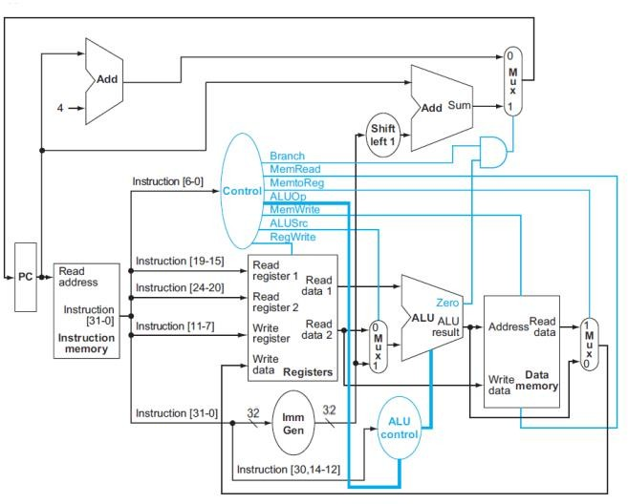
Single Cycle RISC-V Processor

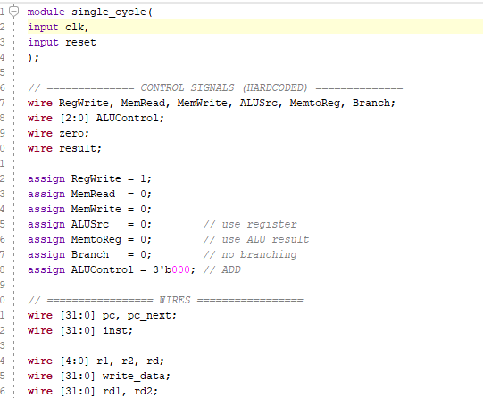
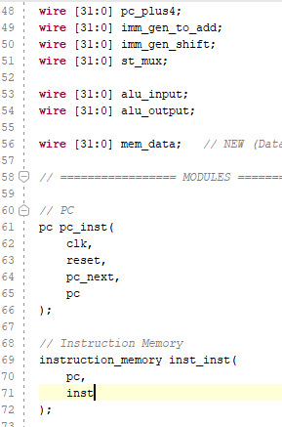

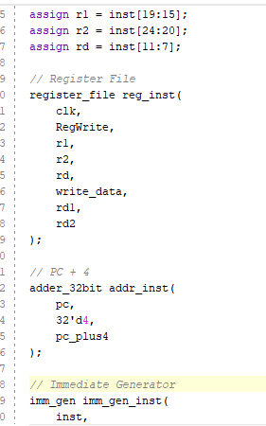
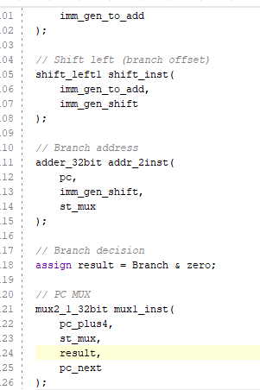
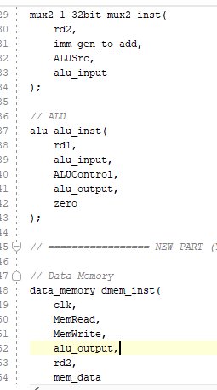
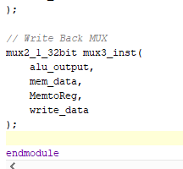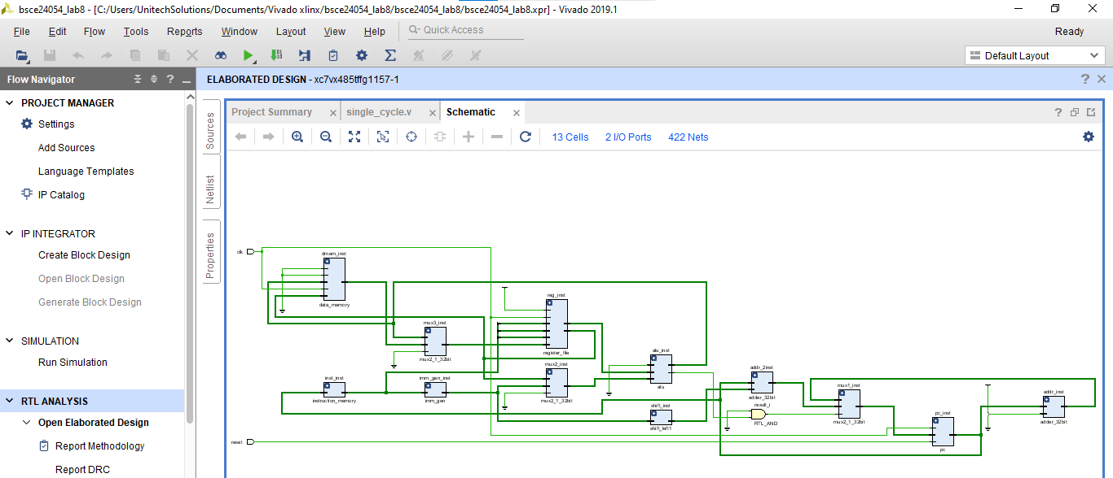
Assessment Rubric for Lab

Performance metric | CLO | Able to complete the task over 80% (4-5) | Able to complete the task 50-80% (2-3) | Able to complete the task below 50% (0-1) | Marks
1. Realization of experiment | 1 | Executes without errors excellent user prompts, good use of symbols, spacing in output.  Through testing has been completed. | Executes without errors, user prompts are understandable, minimum use of symbols or spacing in output.  Some testing has been completed. | Does not execute due to syntax errors, runtime errors, user prompts are misleading or non- existent. No testing  has been completed.
2. Conducting experiment | 1 | Able to make changes and answered all questions. | Partially able to make changes and few incorrect answers. | Unable to make changes and answer all questions.
3. Computeruse | 2 | Document submission timely. | Document submission late. | Document submission not done.
4. Teamwork | 3 | Actively engages and cooperates with other group member(s) in effective manner. | Cooperates with other group member(s) in a reasonable manner but conduct can be improved. | Distracts or discourages other group members from  conducting the experiment
5. Laboratorysafety and disciplinary rules | 3 | Code comments are added and does help the reader to understand the  code. | Code comments are added and does not help the reader to understand  the code. | Code comments are not added.
6. Data collection | 3 | Excellent use of white space, creatively organized work, excellent use of variables and constants, correct  identifiers for constants, No line-wrap. | Includes name, and assignment, white space makes the program fairly easy to read. Title, organized work, good use of variables. | Poor use of white space (indentation, blank lines) making code hard to read, disorganized and messy.
7. Data analysis | 4 | Solution is efficient, easy to understand, and maintain. | A logical solution that is easy to follow but it is not the most efficient. | A difficult and inefficient solution.
Total (out of 35):

