CE203L: Computer Organization and Architecture Lab
Department of Computer and Software Engineering–ITU

Course Instructor: Mr. Aftab Alam | Dated:
Lab Engineer: Muhammad Usama Riaz | Semester: 4th
Session: 2024-2028 | Batch: BSCE24

Lab 11. Control Unit Design of RISC-V Processor

Name | Roll No | Obtained Marks/35

Checked on:

Signature:

Objective
The goal of this handout is to design and implement control unit for the 32-bit RISC-V processor

Equipment and Component

Component Description | Value | Quantity
Computer/Xilinx Vivado | On Campus | 1

Conduct of Lab
- Students are required to perform this experiment individually.
- In case the lab experiment is not understood, the students are advised to seek help from the course instructor, lab engineers, assigned teaching assistants (TA) and lab attendants.

Theory and Background
We reminded ourselves that the Datapath and control are the two components that come together to be collectively known as the processor.
The control unit is responsible for setting all the control signals so that each instruction is executed properly. Control unit commands the Datapath regarding when and how to route and operate on data. Signals that need to be generated include:
- Operation to be performed by ALU.
- Whether register file needs to be written.
- Signals for multiple intermediate multiplexors.
- Whether data memory needs to be written.
For the most part, we can generate these signals using only the opcode and funct fields of an instruction.
We are using a few instructions from RISC-V architecture. These are:

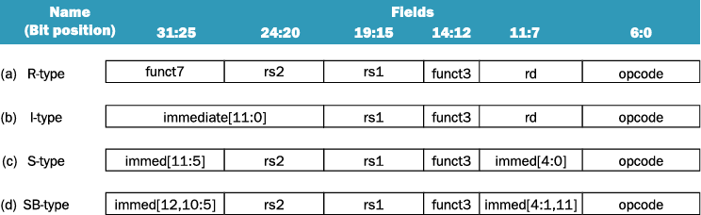

- Op Code Values for Different Instruction Types

Instruction Type | Opcode Value
R-Type | 0110011
I-Type | 0000011
S-Type | 0100011
SB-Type | 1100011

Following is a list of Control signals value for different instruction types.
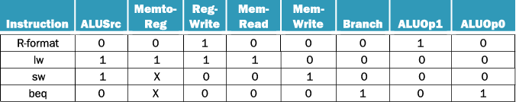

RISC-V ALU defines the following four combinations.
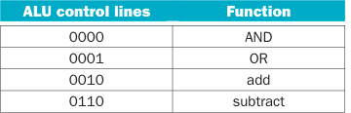

Following signals will be generated by ALU Control unit for the operation of different types of instruction.

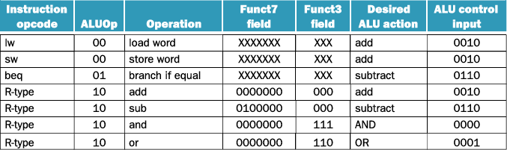

Lab Tasks

Task:
Design and impplement the control unit for 32-bit RISC-V processor and also create the top module to integrate it with datapath.

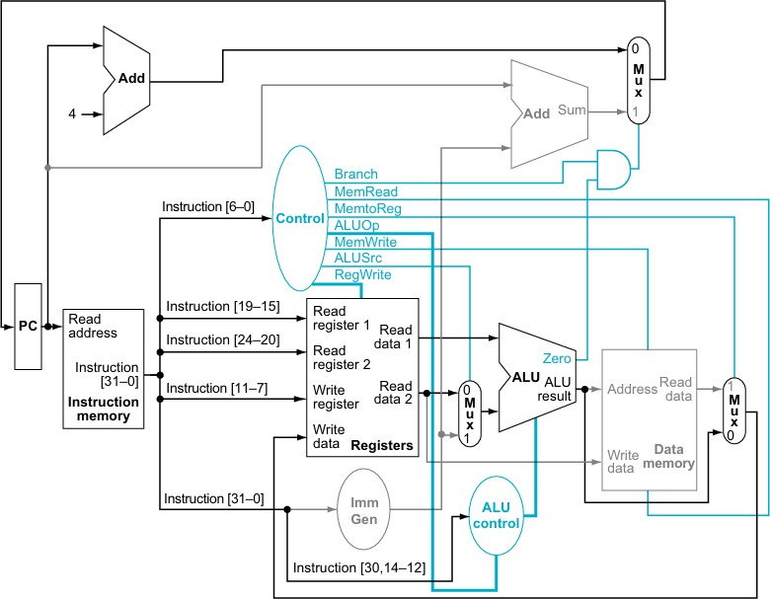

RISC-V Single Cycle Processor

Schematic
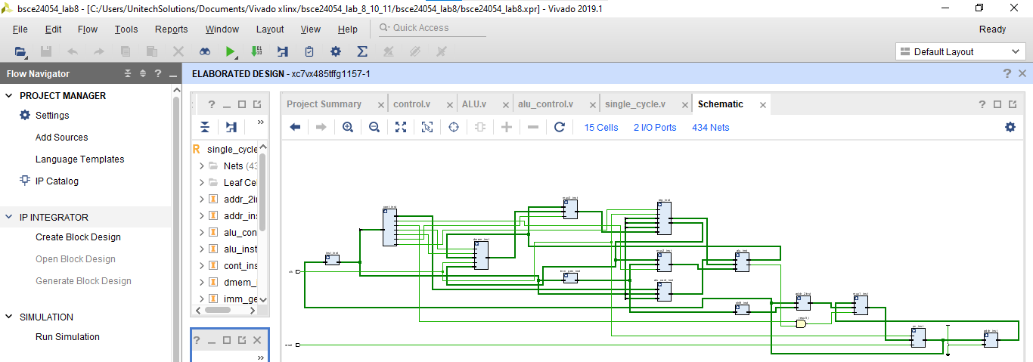

Code for control unit
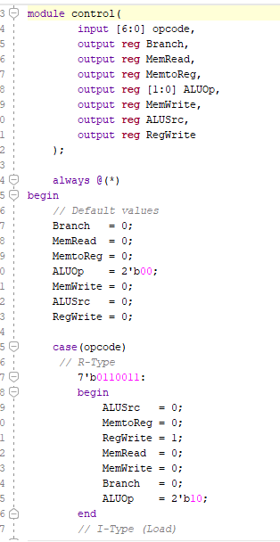 | 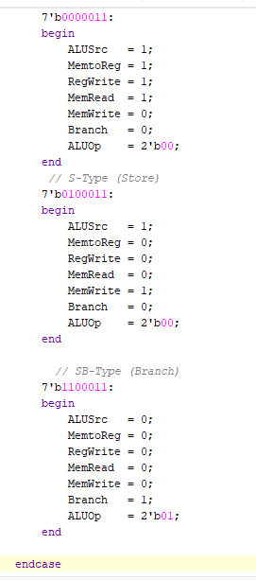

Code for ALU control
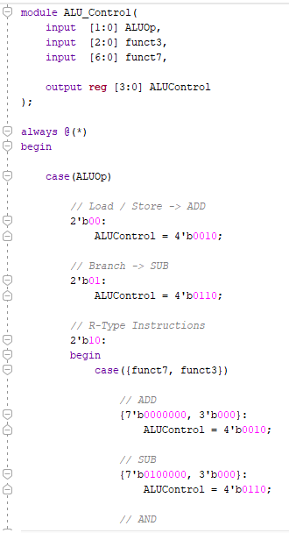 | 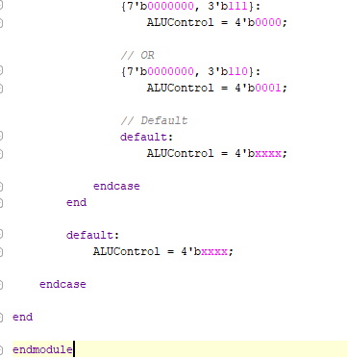

Top module
h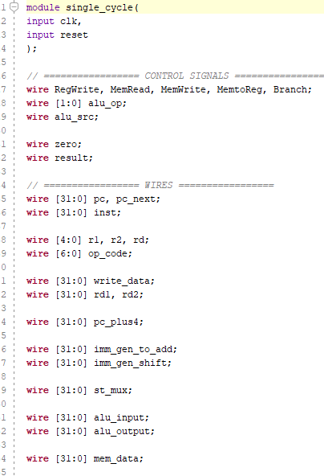 | 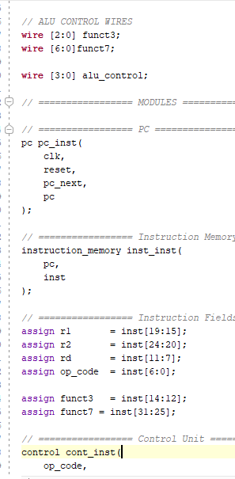

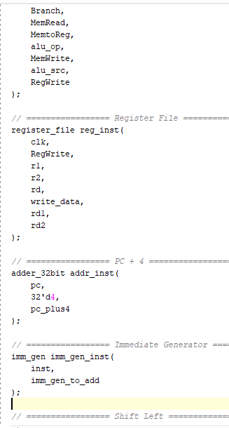 | 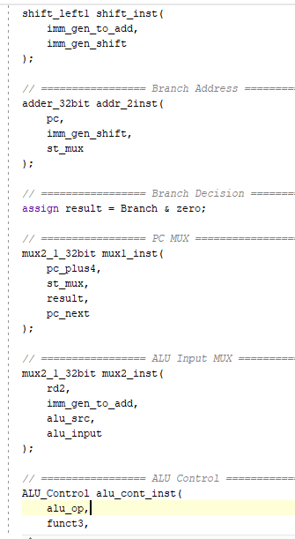

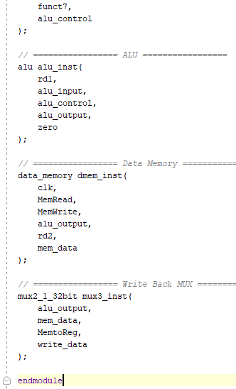

Assessment Rubric for Lab

Performance metric | CLO | Able to complete the task over 80% (4-5) | Able to complete the task 50-80% (2-3) | Able to complete the task below 50% (0-1) | Marks
1. Realization of experiment | 1 | Implements the Verilog code correctly, executes without errors, well- structured module definitions, proper signal  naming, and complete testbench. | Implements the Verilog code with minor errors, partial testbench coverage, and minimal use of meaningful signal names. | Code does not execute due to syntax errors, missing modules, or incorrect logic. No testbench included.
2. Conducting experiment | 1 | Able to modify Verilog code as required, answers all conceptual and implementation questions  correctly. | Partially able to modify code, some incorrect or incomplete answers. | Unable to modify the code, incorrect or no answers to the questions.
3. Computer use | 2 | Submits lab reports and code on time with appropriate documentation and organization. | Submits lab reports and code with minor delays, lacks proper documentation. | Lab report or code submission is missing or significantly late.
4. Teamwork | 3 | Actively engages in discussions, collaborates effectively, and contributes significantly to group work. | Collaborates but with minimal engagement, contribution could be improved. | Distracts or discourages team members, minimal or no contribution.
5. Laboratorysafety and disciplinary rules | 3 | Verilog code is well- commented, explaining each module and functionality  clearly. | Verilog code has comments, but they are not informative or insufficient. | No comments in the code, making it difficult to understand.
6. Data collection | 3 | Waveforms and simulation results are well-organized, properly labeled, and demonstrate correct functionality. | Waveforms and simulation results are partially organized but lack clarity or some required tests. | Poorly captured waveforms, incorrect or missing simulation results.
7. Data analysis | 4 | Efficient and optimized Verilog design, easy to understand and scalable. | Functional design but lacks optimization or clarity in certain areas. | Inefficient or difficult-to- maintain design, hard to interpret logic.
Total (out of 35):

