CE203L: Computer Organization and Architecture Lab
Department of Computer and Software Engineering–ITU

Course Instructor: Mr. Aftab Alam | Dated:
Lab Engineer: Muhammad Usama Riaz | Semester: 4th
Session: 2024-2028 | Batch: BSCE24

Lab 12. Implementing Top Module and Test Bench for RISC-V Processor

Name | Roll No | Obtained Marks/35

Checked on:
Signature:

Objective
The goal of this handout is to design and implement the top module for MIPS processor and verify its functionality.

Equipment and Component

Component Description | Value | Quantity
Computer/Xilinx Vivado | On Campus | 1

Conduct of Lab
- Students are required to perform this experiment individually.
- In case the lab experiment is not understood, the students are advised to seek help from the course instructor, lab engineers, assigned teaching assistants (TA) and lab attendants.

Theory and Background
So far we have only viewed the signals from top module. To view the signals from its child modules, we will have to call them in the top modules test bench.
We use following Steps to add the signals in the Test Bench
-First create the wire of the test signal which you want to add in the test bench.
-After the instantiation, use the following syntax to assign the value of a child module.
assign Signal=<Instance name of TOP module> . < instance name of child module> . < Name of the signal to call>
If the signal is within another module which is within the child i.e., child of child module then use the same syntax and add another instance name at appropriate place.
Here is an example, to see B in test Bench we use

Test Bench
TOP uut(xxx,xxx,xxx) module TOP
M1 mod1(xxx,xxx,xxx) M2 mod2(.A(x),.B(x));
module M2(A,B) Input A; output B; assign B=A;

assign data=uut.mod1.mod2.B;
Remember that we use instance names, not modules names when adding a signal in test bench Create a wire of the new signal before top module instantiation, in the test bench
Assign that wire the value right after the instantiation line and before the initial block, according to the specified syntax.
We will need following signals in our test bench. To see the different stages of instruction PC_Out
Instr RF_Data1 RF_Data2 ALU_Out

Write the instruction in the instruction memory at appropriate location using initial block. begin

IM[0]<=32'b0000000_00100_00011_000_00010_0110011;// add x2,x3,x4 IM[1]<=32'b0100000_00001_00010_000_00101_0110011;// sub x5,x2,x1 IM[2]<=32'b0001010_00001_00101_010_01010_0100011;// sw x5,10(x1)
end
Lab Tasks

Task:
As you have implemented the RISC-V datapath and control unit in previous labs, now implement the top module and test bench for your RISC-V processor.
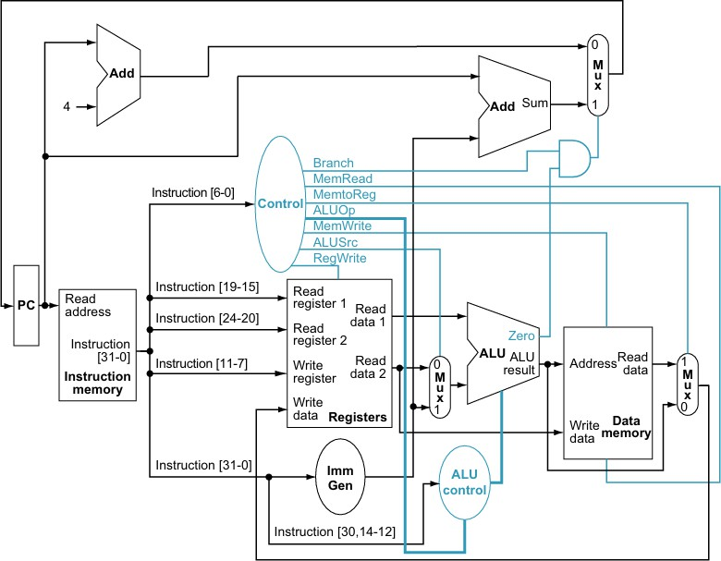
RISC-V Single Cycle Processor

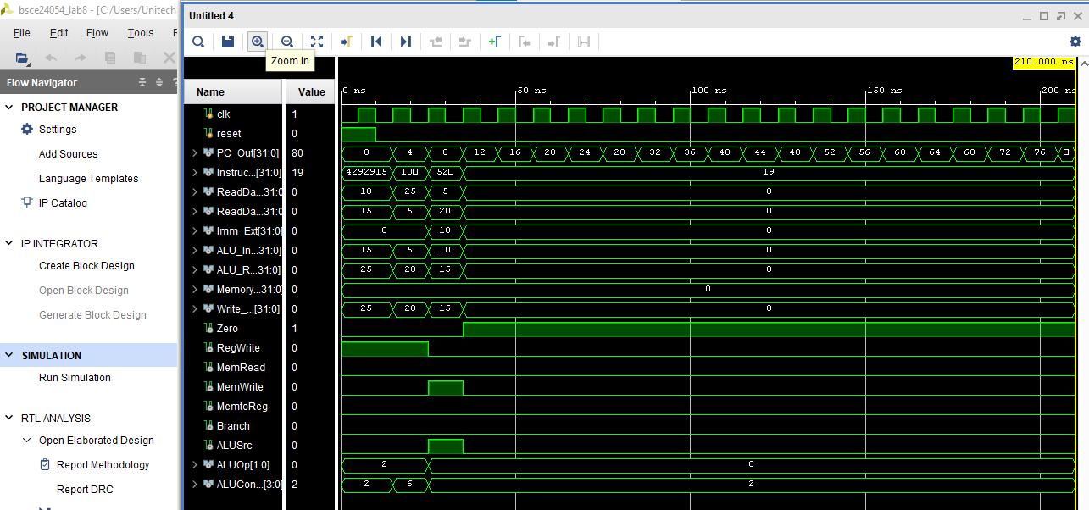

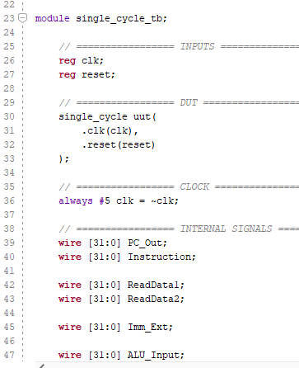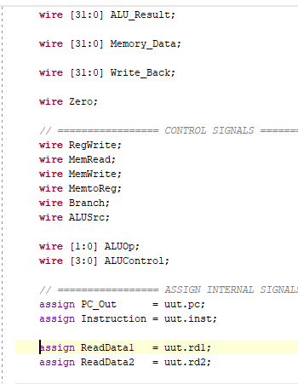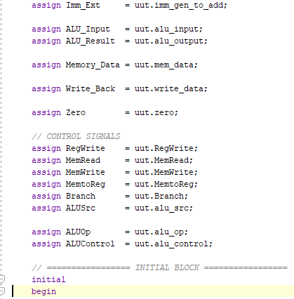
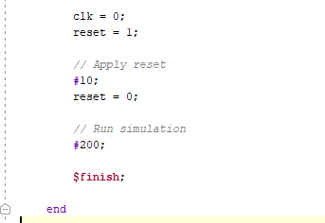
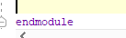
Assessment Rubric for Lab

Performance metric | CLO | Able to complete the task over 80% (4-5) | Able to complete the task 50-80% (2-3) | Able to complete the task below 50% (0-1) | Marks
1. Realization of experiment | 1 | Implements the Verilog code correctly, executes without errors, well- structured module definitions, proper signal  naming, and complete testbench. | Implements the Verilog code with minor errors, partial testbench coverage, and minimal use of meaningful signal names. | Code does not execute due to syntax errors, missing modules, or incorrect logic. No testbench included.
2. Conducting experiment | 1 | Able to modify Verilog code as required, answers all conceptual and implementation questions  correctly. | Partially able to modify code, some incorrect or incomplete answers. | Unable to modify the code, incorrect or no answers to the questions.
3. Computer use | 2 | Submits lab reports and code on time with appropriate documentation and organization. | Submits lab reports and code with minor delays, lacks proper documentation. | Lab report or code submission is missing or significantly late.
4. Teamwork | 3 | Actively engages in discussions, collaborates effectively, and contributes significantly to group work. | Collaborates but with minimal engagement, contribution could be improved. | Distracts or discourages team members, minimal or no contribution.
5. Laboratorysafety and disciplinary rules | 3 | Verilog code is well- commented, explaining each module and functionality  clearly. | Verilog code has comments, but they are not informative or insufficient. | No comments in the code, making it difficult to understand.
6. Data collection | 3 | Waveforms and simulation results are well-organized, properly labeled, and demonstrate correct functionality. | Waveforms and simulation results are partially organized but lack clarity or some required tests. | Poorly captured waveforms, incorrect or missing simulation results.
7. Data analysis | 4 | Efficient and optimized Verilog design, easy to understand and scalable. | Functional design but lacks optimization or clarity in certain areas. | Inefficient or difficult-to- maintain design, hard to interpret logic.
Total (out of 35):

