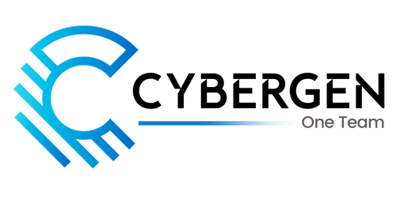

Ahmad Saeed

[LinkedIn](https://www.linkedin.com/in/rana-ahmad-data-scientist/)| +923049515704 | [AhmadSaeed.com](https://ranaahmad9151.github.io/Ahmad-Saeed/) | Ranaahmad9151@gmail.com | [GitHub](https://github.com/Ranaahmad9151)

**Technical Skills**

**Languages and Databases**: Python, SQL, HTML, CSS, JavaScript, Node JS, React, AWS, Azure, GitHub, Unity, C#, Firebase

**Visualization Tools**: Power BI, Tableau and Looker

**Other Skills**: Data Science, Data Analysis, Data Modeling & Engineering, Gen-AI, Computer Vision, DevOps, Advanced Excel

**Experience**

**Tesseract Technologies**   **Jan 2024 – Present**



*Data Scientist & AI/ML EngineerLahore, Pakistan*

•**AI-Powered Document Processing:** Developed **Claustro.io**, an AI-driven platform leveraging **GPT-3.5-Turbo** to

generate summaries, **MCQs, short and long questions** from user-provided PDFs. Implemented seamless **PDF/DOCX**

**exports**, enhancing accessibility. Successfully **delivered to a Spanish client**, optimizing document analysis and

educational content creation**.**

**ITSOLERA**   **Aug 2022 – Jan 2024**

*Data Scientist & AI/ML Engineer Islamabad, Pakistan*

•**Predictive Analytics & Data Automation:** Designed and implemented ML/DL models, increasing **forecasting**

**accuracy by 20%** and improving operational efficiency by **15%**. Optimized **ETL pipelines**, reducing data processing

time by **30%** while ensuring **high data integrity and reliability**.

•**Financial Data Insights & BI Solutions:** Developed interactive **Power BI dashboards** for real-time **financial analysis**,

enabling data-driven decision-making across departments. Integrated **advanced analytics** to uncover trends,

**enhance reporting**, and **drive strategic business** insights.

**Personal Projects**

**1.***Chatbot with Web scraping and LLM integration*

• Developed a chatbot with web scraping using **Requests and BeautifulSoup**. Proficient in **Transformers, Ngrok,**

**Pandas, Flask, and NLP tasks** (text generation, translation, sentiment analysis, NER) using Hugging Face and

Blenderbot. **Integrated and fine-tuned NLP models** for high accuracy and deployment.

**2.***Stock Market Price Prediction Model*

• Analyzed stock data using **Pandas, NumPy, Matplotlib, Pytorch, and scikit-learn**. Implemented K-Nearest Neighbors

(KNN) for predicting **time-series** stock prices, validated using **accuracy and RMSE metrics** against actual values.

**3.***Movie Recommender System*

• **Pandas, NumPy, Tensorflow, Keras, and scikit learn** for data processing and similarity calculations. Develop custom

recommender function utilizing **CountVectorizer** and **cosine similarity** to suggest **top 5 movies based on user input**.

**4.***License Plate Recognition (LPR)*

•Developed a **deep learning AI-Powered based LPR** using **Python, YOLOv8,** and **EasyOCR**. Applied **object detection**

and **optical character recognition** (**OCR)** techniques to achieve **high-precisionreal-time LPR**. Optimized model

performance for **accuracy and scalability** in **real-world applications**.

**Courses & Certifications**

**IBM** *| Python for data science*  
 **IBM** *| Machine learning with python*   
 **IBM** *| Deep learning with fundamentals*   
 **IBM** *| SQL & Relational Database*   
 **Coursera** *| Essential Google Cloud Infrastructure - Foundation*

**Sep 2023 - Dec 2023 Jan 2024 - May 2024 May 2024 - Oct 2024 Aug 2020 – Nov 2020 Jan 2024 – April 2024**

**Coursera** *| Google Cloud Fundamental – Core Infrastructure Certificate*  **May 2024 – Aug 2024**

**Education**

**Superior University**   **Sep 2018 – July 2022**



*Bachelor of Science in Information and Technology*

*Lahore, Pakistan*