**Aim :** To run a VM Server from the Google Cloud.

**Steps :**

**1.** Go to Google Management Console and select Compute Engine -> VM instances from the Dashboard and click on Createbutton to create new instance.

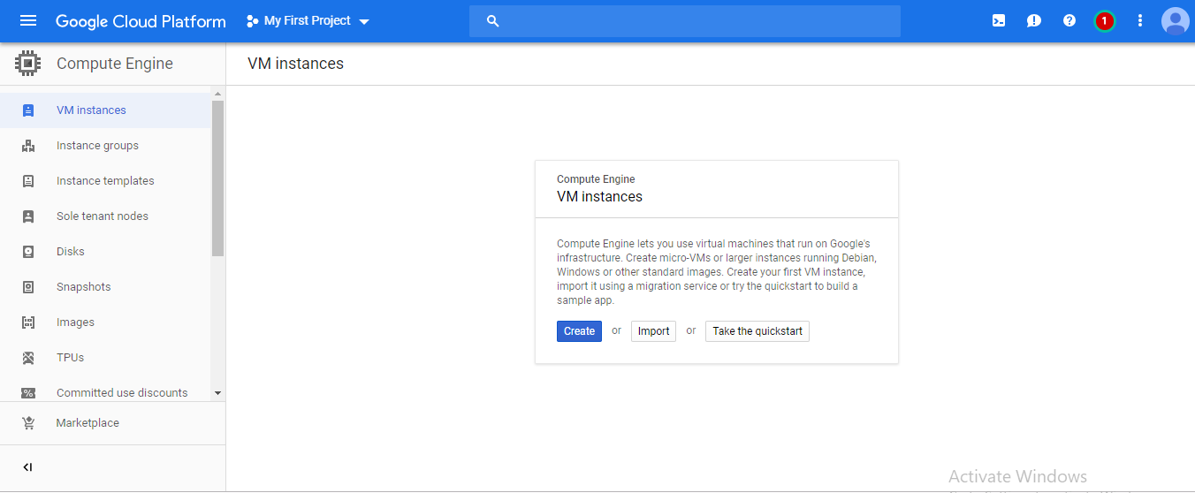

**2.** Give name to your instance, select the region and the type of OS you want.

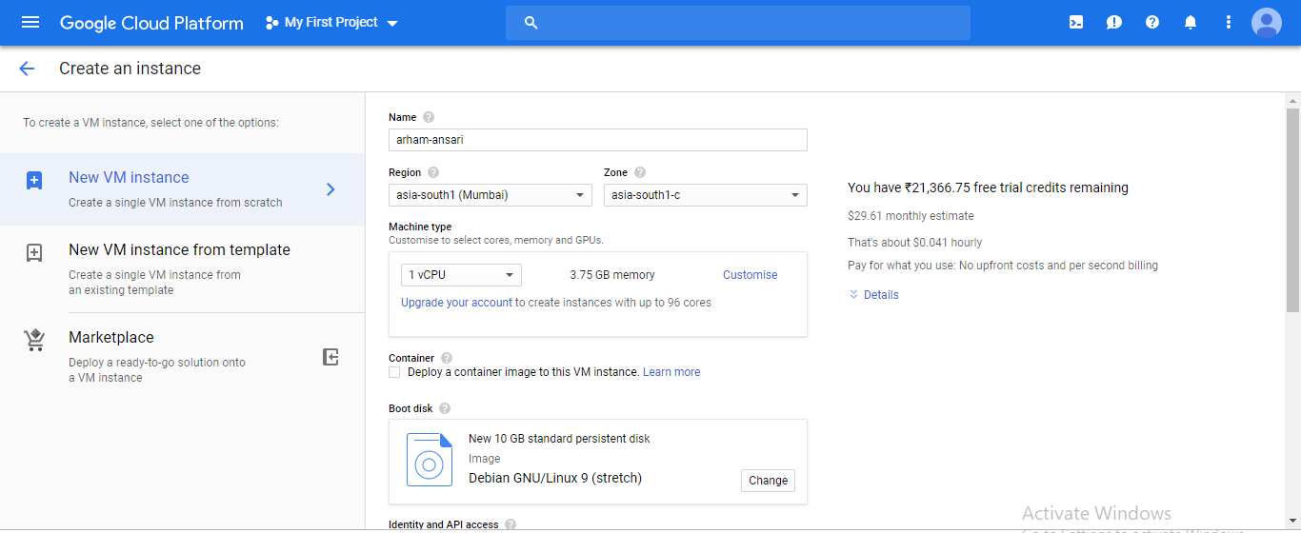

**3.** The instance will be created and started successfully.

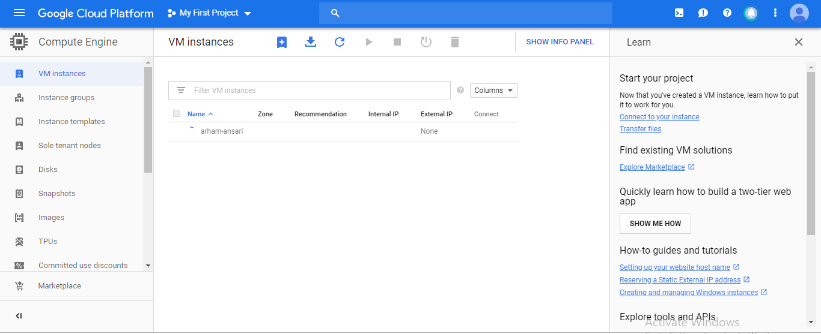

**4.** Now download the Remote Desktop File (RDP) and get the windows password and copy it.

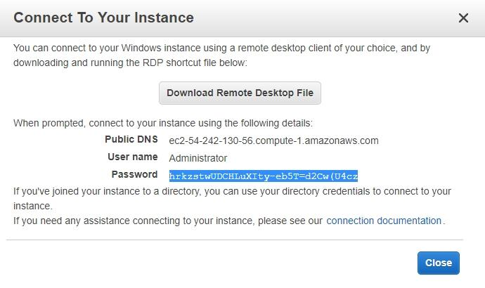

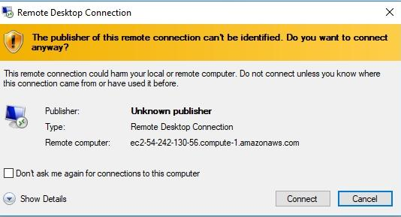**5.** Open or Run the RDP file you will get a dialog box shown below. Click on Connect.

**6.** After clicking Connect it will ask for your password. Paste the Copied password and Click Ok.

You will get a dialog box shown below. Click on Yes.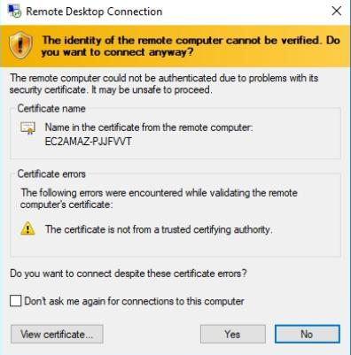

**7.** After clicking Yes, the VM will start running from the Google Cloud. It is **Windows 2008 R2**

**Datacenter**.

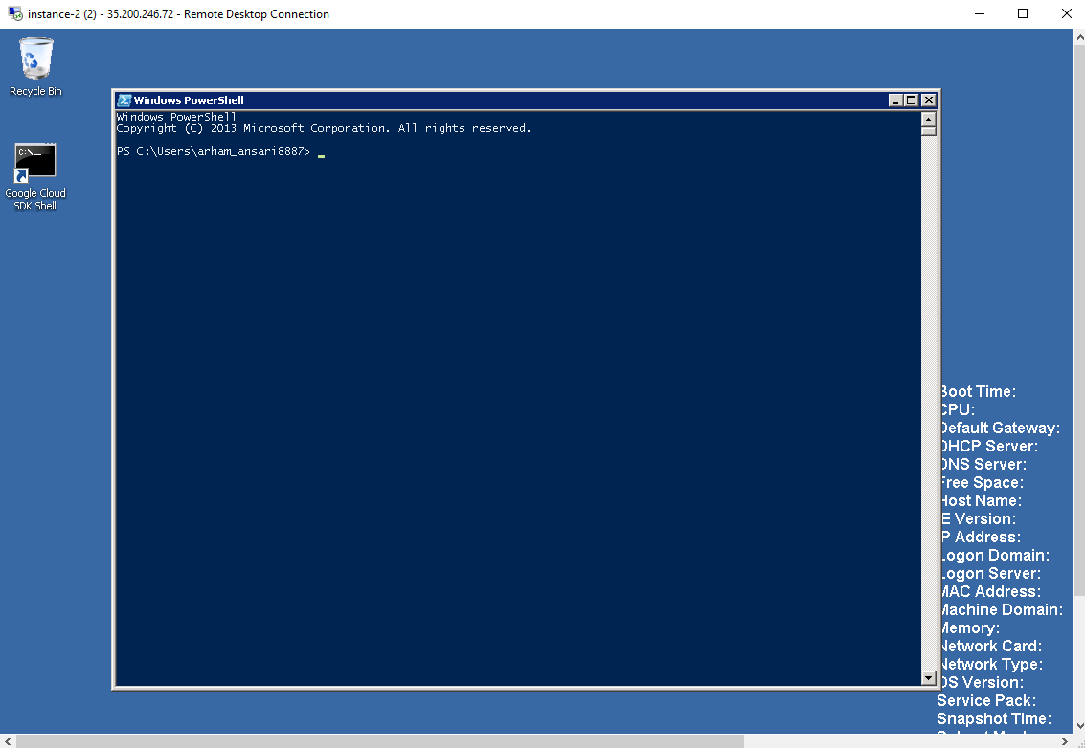

**8.** After Completion of the task, Stop or Terminate the running VM.