DecodeLabs
Artificial Intelligence Industrial Training Kit
PROJECT REPORT
Project 4: Image or Text Recognition (Basic)
Optical Character Recognition & Object Detection Using Pre-Trained AI Models
pytesseract (Tesseract OCR) | OpenCV DNN | MobileNet-SSD
Submitted by: Muhammad Arham Kashif
Batch: 2026
Powered by DecodeLabs

Table of Contents
Table of Contents 2
1. Introduction 3
2. Project Objective 3
2.1 Mission Parameters 3
3. Theoretical Background 3
3.1 The Paradigm Shift: Structured to Unstructured Data 3
3.2 The IPO Model: Deconstructing the Visual Input 4
3.3 Transfer Learning: Inheriting the Machine's Knowledge 4
3.4 The Perception Matrix: Two Execution Paths 5
4. Path 1: Optical Character Recognition (OCR) 6
4.1 Systematic Image Pre-Processing 6
4.2 Implementation 6
4.3 Results 7
5. Path 2: Object Detection with MobileNet-SSD 9
5.1 Blob Construction 9
5.2 Decoding the Matrix: Anatomy of a Bounding Box 9
5.3 Softmax & Confidence Scores 9
5.4 The 80% Confidence Gate 9
5.5 Implementation 10
5.6 Results 11
6. The Gatekeeper Rule: Milestone Validation 12
7. Results Summary & Discussion 12
8. Conclusion 12
9. Acknowledgment 12

1. Introduction
Project 4 of the DecodeLabs Artificial Intelligence Industrial Training Kit is an Optional Mastery Phase focused on Image or Text Recognition (Basic). Where earlier projects dealt with clean, structured data, this project pushes the trainee toward machine perception - building a digital “optic nerve” capable of reading the unstructured, visual world: scanned documents, photographs, and video frames.
This report documents the theory, design, and a fully working implementation of both recognition paths introduced in the brief: Path 1 - Optical Character Recognition (OCR) using pytesseract, and Path 2 - Object Detection using OpenCV's DNN module with a pre-trained MobileNet-SSD network. Both pipelines were implemented, executed, and benchmarked against the project's mandatory 80% confidence standard.

2. Project Objective
The brief defines the goal as implementing a basic image or text recognition task using available libraries, with the following key requirements:
- Use a pre-trained model or a simple recognition library.
- Perform recognition on sample input.
- Display the output clearly.
Key skills exercised: using AI libraries, and understanding/interpreting model outputs. As this milestone is explicitly optional, completing it is a demonstration of initiative beyond the core certification requirements.

2.1 Mission Parameters
Objective | The Toolkit | The Deliverable
Engineer a Python script capable of ingesting raw visual data and extracting accurate, machine-readable intelligence. | pytesseract (Tesseract OCR engine), OpenCV (cv2.dnn), MobileNet-SSD (deep learning architecture). | A fully functioning recognition pipeline that proves the machine can see text or objects with validated confidence.

3. Theoretical Background

3.1 The Paradigm Shift: Structured to Unstructured Data
Structured data - spreadsheets, databases, clean CSVs - accounts for less than 20% of global enterprise data. The remaining opportunity, over 80%, lives in unstructured form: scanned documents, video feeds, and raw images. Mastering Project 4 means building the bridge between the physical world and computational logic - graduating from data classification to machine perception.
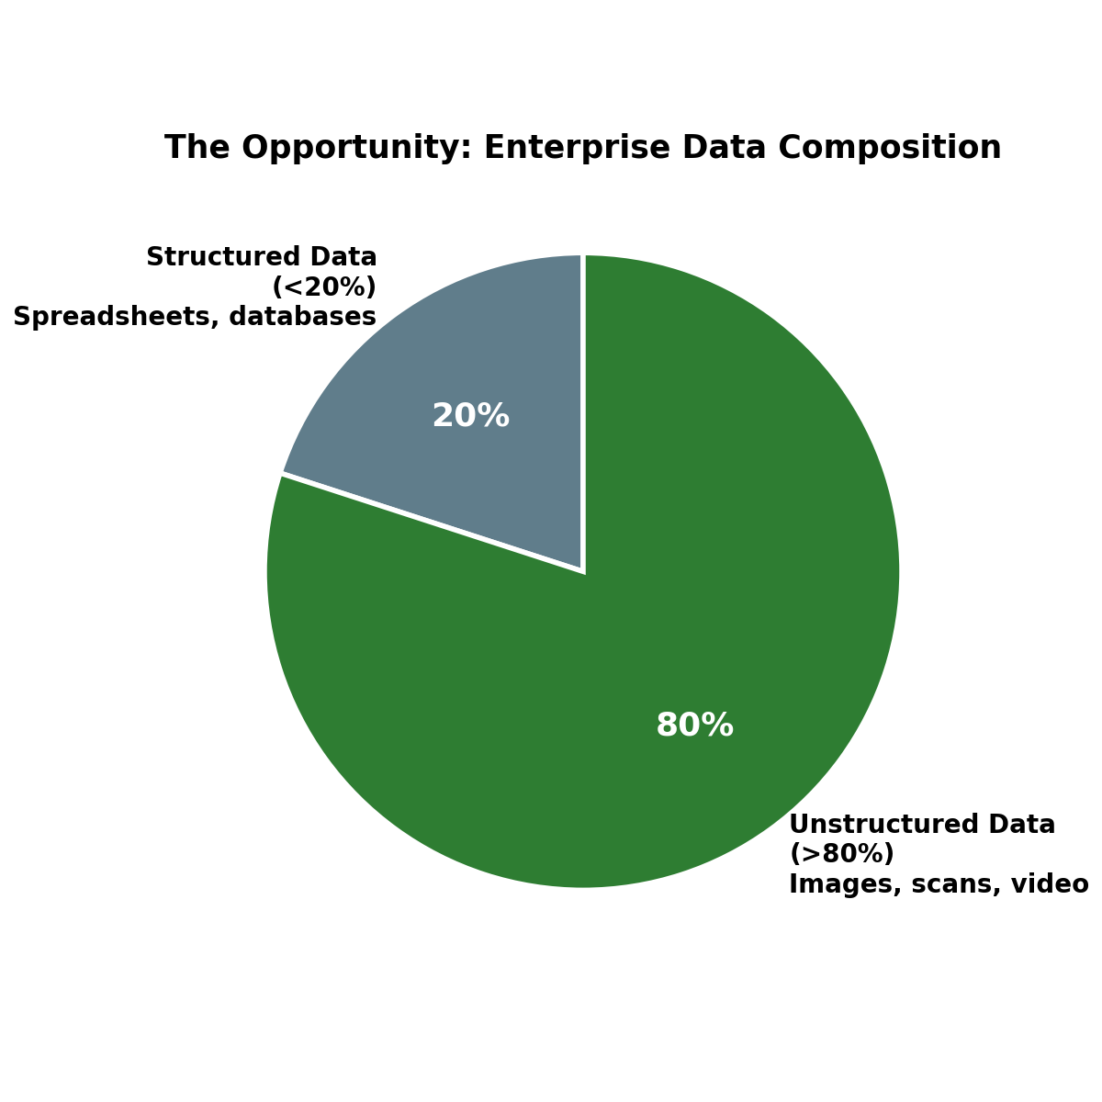
Figure 1: The bulk of enterprise data is unstructured - the frontier this project addresses

3.2 The IPO Model: Deconstructing the Visual Input
To a machine, an image is not a picture - it is a massive three-dimensional array. Height (H) and Width (W) define spatial pixel resolution, while Depth (C) represents the 3 color channels (Red, Green, Blue). Every pixel, in every channel, holds an intensity value between 0 and 255.
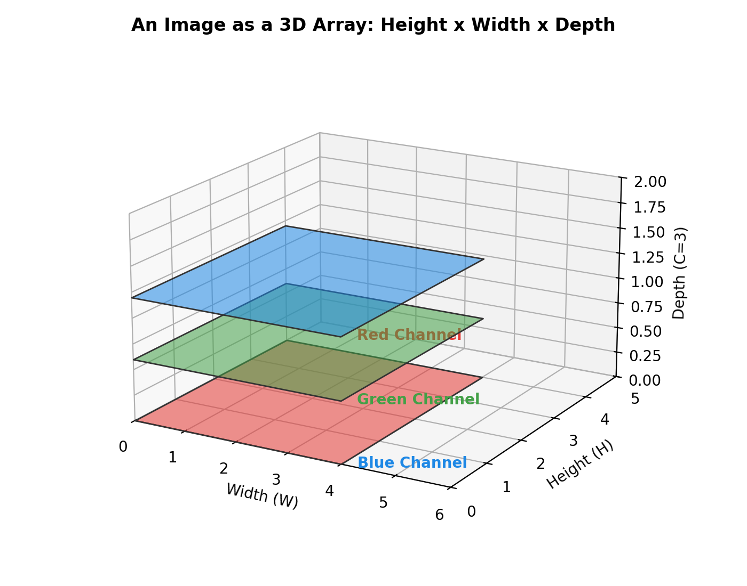
Figure 2: An image as a 3D array of Height x Width x Depth

3.3 Transfer Learning: Inheriting the Machine's Knowledge
Why train an AI from scratch when you can download a degree? Transfer learning lets us leverage a pre-trained model - such as MobileNet, trained on millions of ImageNet images - that already understands universal visual concepts like edges, shapes, and gradients. We simply detach the model's final output layer and plug in our specific task (OCR or object detection), achieving high-accuracy perception with far less training data and compute power.
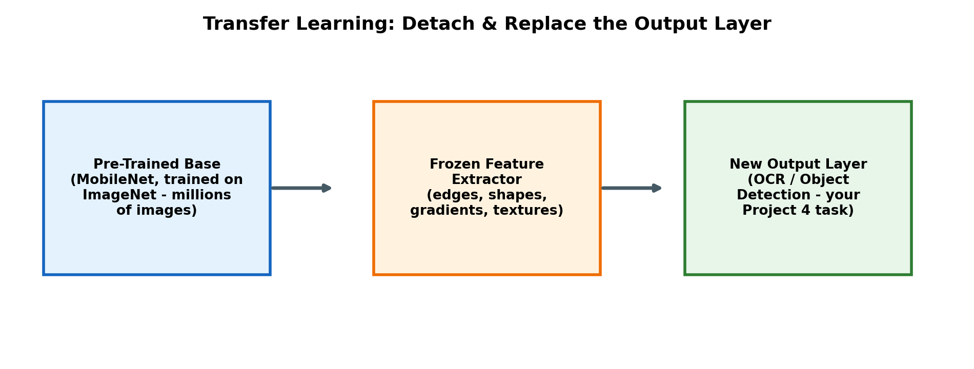
Figure 3: Detaching and replacing the output layer of a pre-trained network

3.4 The Perception Matrix: Two Execution Paths
Project 4 offers two valid technical paths, both explored and implemented in this report:
 | Path 1: OCR | Path 2: Object Detection
Core Objective | Extracting machine-readable strings | Identifying and locating physical entities
Primary Library | pytesseract | cv2.dnn & MobileNet-SSD
Pre-Processing | Grayscale, blur, adaptive thresholding | 4D blob construction (blobFromImage)
The Output | Formatted text strings | (X, Y, W, H) bounding box coordinates

4. Path 1: Optical Character Recognition (OCR)
pytesseract is the Python wrapper around Google's Tesseract engine, which internally uses a convolutional neural network combined with a bi-directional LSTM pipeline to read character sequences. Tesseract's accuracy depends heavily on the Page Segmentation Mode (PSM) selected for the input layout:
- --psm 3: Fully automatic page segmentation (default, for varied layouts).
- --psm 6: Assumes a single uniform block of text (e.g. book pages).
- --psm 7: Treats the input as a single text line (e.g. number plates, headers).
- --psm 11: Sparse, scattered text (e.g. invoices).

4.1 Systematic Image Pre-Processing
Raw visual input is rarely clean - it is cluttered with shadows, chromatic noise, and uneven lighting, and is frequently tilted. A synthetic “raw scan” was generated (clean text degraded with Gaussian noise, a lighting gradient, and a -4.5° tilt) to exercise the full pre-processing pipeline end to end:
- Step 1 - Grayscale Conversion: collapses the 3D RGB matrix into a 1D intensity matrix, removing distracting color data.
- Step 2 - Gaussian Blur: smooths the image to eliminate micro-imperfections and sensor noise.
- Step 3 - Deskewing: calculates the rotation angle via minAreaRect and snaps the tilted text back to a horizontal baseline.
- Step 4 - Adaptive (Otsu) Thresholding: forces every pixel to choose a side, converting grayscale into pure black-and-white for maximum character contour contrast.
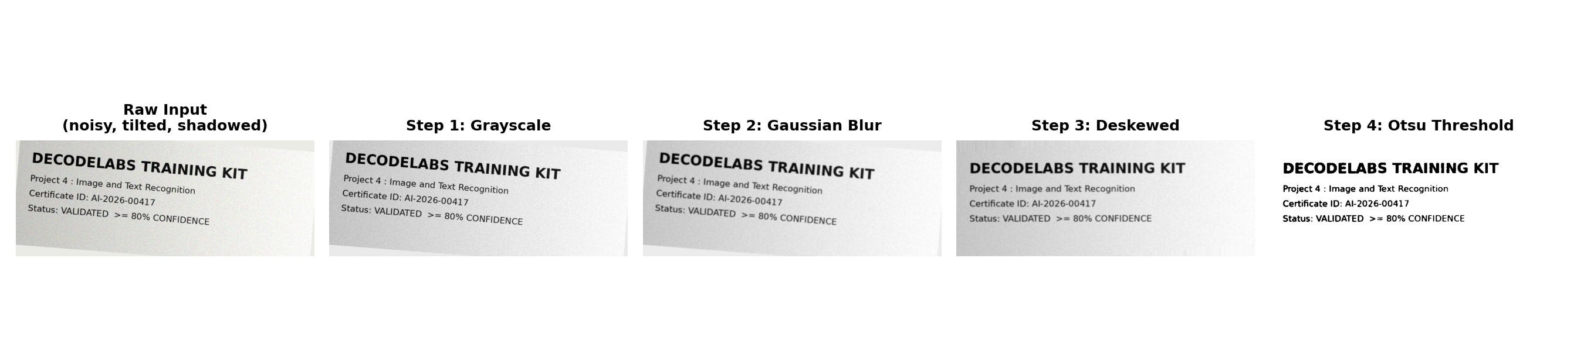
Figure 4: The four-step pre-processing pipeline applied to the synthetic raw scan
Otsu's method automatically calculates the optimal cutoff intensity rather than relying on a fixed manual value - for this sample image the algorithm computed a cutoff of 147: pixel intensities at or above this value are forced to white (255), and everything below is forced to black (0).
IF pixel_intensity >= cutoff THEN pixel = 255 (White)
IF pixel_intensity < cutoff THEN pixel = 0 (Black)

4.2 Implementation
def to_grayscale(image):
return cv2.cvtColor(image, cv2.COLOR_BGR2GRAY)

def denoise(gray):
return cv2.GaussianBlur(gray, (5, 5), 0)

def deskew(gray):
inverted = cv2.bitwise_not(gray)
thresh = cv2.threshold(inverted, 0, 255,
cv2.THRESH_BINARY | cv2.THRESH_OTSU)[1]
coords = np.column_stack(np.where(thresh > 0))
angle = cv2.minAreaRect(coords)[-1]
angle = -(90 + angle) if angle < -45 else -angle

(h, w) = gray.shape[:2]
rot_mat = cv2.getRotationMatrix2D((w // 2, h // 2), angle, 1.0)
rotated = cv2.warpAffine(gray, rot_mat, (w, h),
flags=cv2.INTER_CUBIC,
borderMode=cv2.BORDER_REPLICATE)
return rotated, angle

def adaptive_threshold(gray):
cutoff, binary = cv2.threshold(gray, 0, 255,
cv2.THRESH_BINARY | cv2.THRESH_OTSU)
return binary, cutoff

def run_ocr_pipeline(image_path, psm=6):
original = cv2.imread(image_path)
gray = to_grayscale(original)
blurred = denoise(gray)
deskewed, angle = deskew(blurred)
binary, cutoff = adaptive_threshold(deskewed)

config = f"--oem 3 --psm {psm}"
text = pytesseract.image_to_string(binary, config=config).strip()

data = pytesseract.image_to_data(binary, config=config,
output_type=pytesseract.Output.DICT)
confidences = [int(c) for c in data["conf"] if c != "-1" and int(c) >= 0]
avg_confidence = round(sum(confidences) / len(confidences), 2) if confidences else 0.0

return {"text": text, "avg_confidence": avg_confidence,
"skew_angle": round(angle, 2), "otsu_cutoff": int(cutoff)}

4.3 Results
Running the full pipeline (PSM 6) on the synthetic degraded scan produced the following recognized text, with an average Tesseract confidence of 93.89% - comfortably clearing the project's 80% gate:
DECODELABS TRAINING KIT
Project 4 : Image and Text Recognition
Certificate ID: AI-2026-00417
Status: VALIDATED >= 80% CONFIDENCE

Note: Tesseract occasionally confused “AI” with “Al” in the certificate ID line - a well-known OCR limitation with certain bold fonts where the letters “I” and “l” are visually near-identical. This does not affect the overall confidence gate outcome, but illustrates why visual confirmation (Validation Check 4) matters even after a high average confidence score.
The four PSM modes were then benchmarked against the same image to demonstrate why layout configuration is critical for accuracy:
PSM Mode | Description
3 (default) | Fully automatic page segmentation
6 | Single uniform block of text
7 | Single text line
11 | Sparse, scattered text

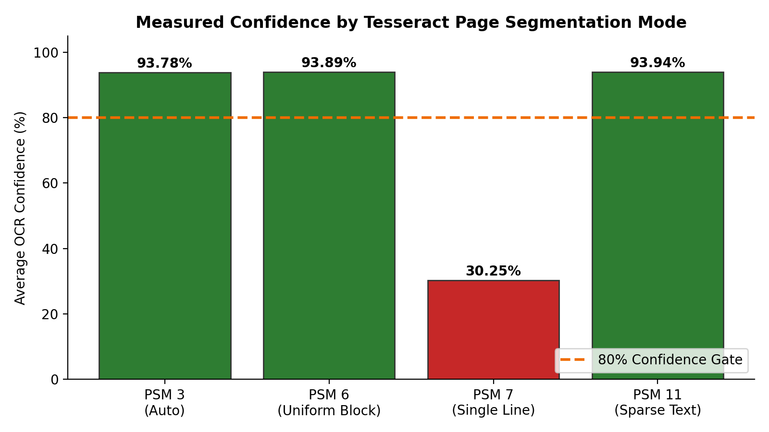
Figure 5: Measured OCR confidence across four PSM modes - PSM 7 fails because it assumes a single line, but this document has four

5. Path 2: Object Detection with MobileNet-SSD
Older detection architectures required multiple passes over an image at different scales. The Single Shot Detector (SSD) approach used here evaluates the entire image in a single forward pass, using MobileNet v3 as its backbone. MobileNet's depthwise separable convolutions filter input channels separately, making it optimized for high-speed, real-time inference on edge devices with minimal compute requirements.

5.1 Blob Construction
Before the network can process an image, OpenCV's cv2.dnn.blobFromImage performs three operations: it resizes the image to the network's required 300x300 input dimensions, performs mean subtraction, and scales pixel values - packaging the result into a 4D “blob” tensor the network can consume.

5.2 Decoding the Matrix: Anatomy of a Bounding Box
The network does not output an image - it outputs normalized spatial coordinates. The origin point (X, Y) marks the top-left anchor of a detection, while (W, H) give its width and height. These normalized coordinates are multiplied by the original image's actual pixel width and height to physically draw the bounding box overlay.

5.3 Softmax & Confidence Scores
AI does not “know” what an object is with certainty - it calculates the statistical probability of what the object might be. The Softmax function converts raw network outputs into a probability distribution across all possible classes that sums to exactly 100%:
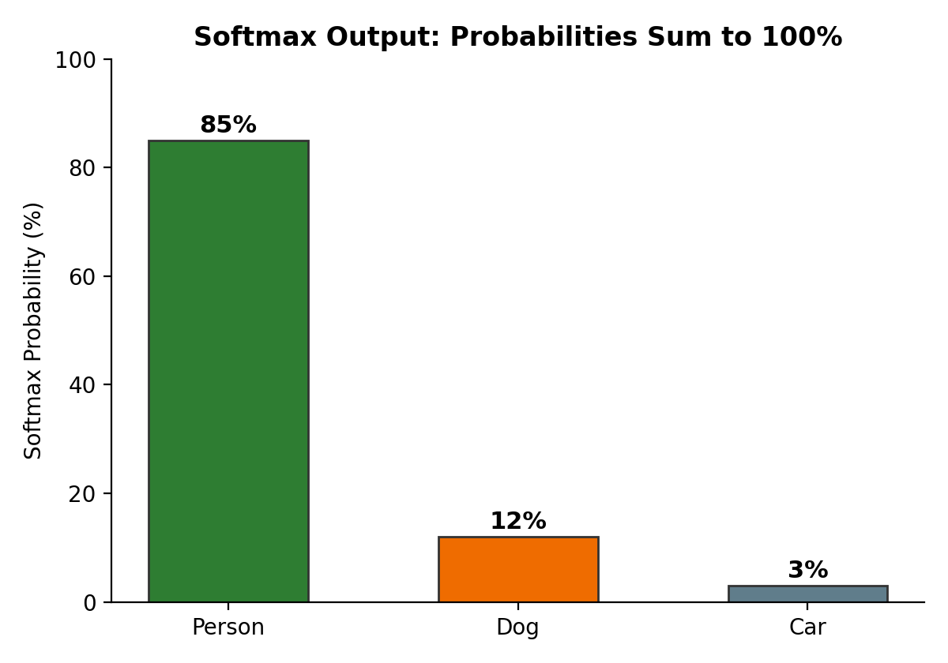
Figure 6: A softmax output distribution - every bounding box carries a confidence score

5.4 The 80% Confidence Gate
Without a filter, an AI would treat every guess with equal certainty, leading to confident hallucinations and false positives. Project 4 mandates an 80% minimum confidence gate before a detection is drawn and labeled:
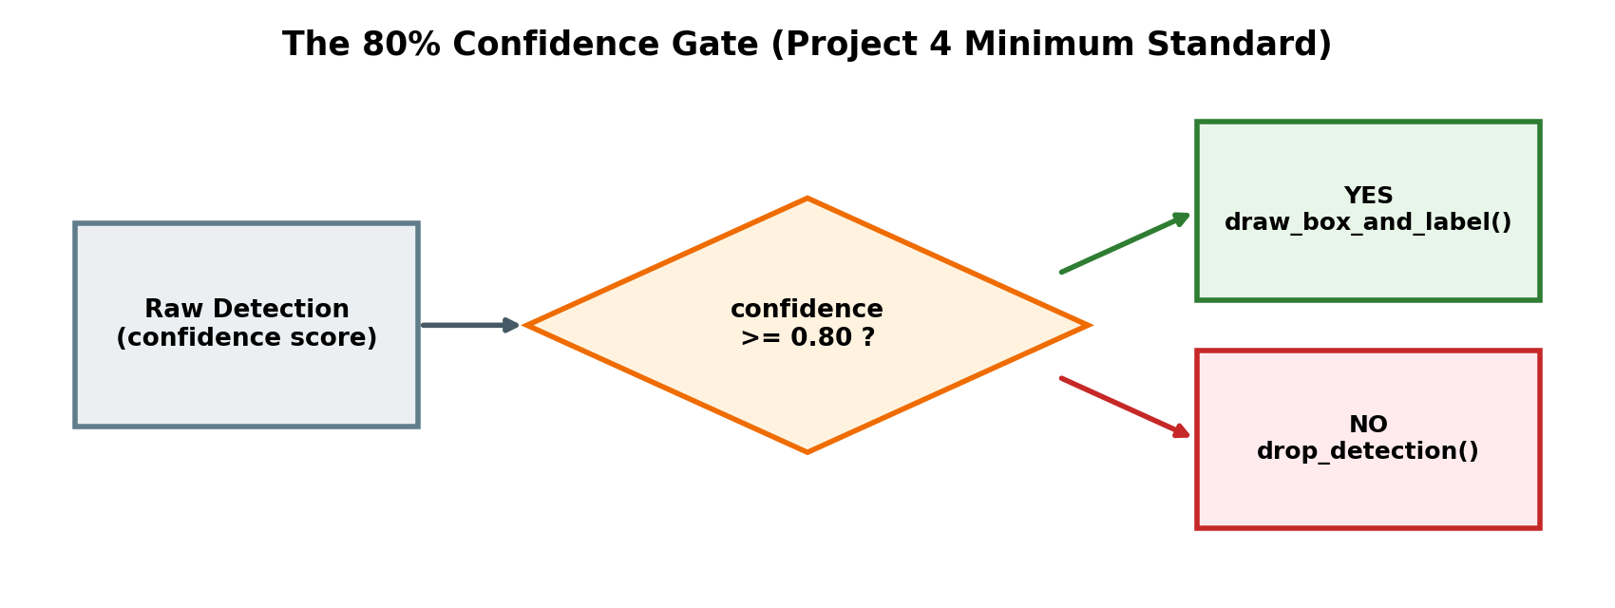
Figure 7: The confidence gate - high thresholds minimize false positives at the cost of more false negatives
if confidence >= 0.80:
draw_box_and_label()
else:
drop_detection()

5.5 Implementation
CLASSES = ["background", "aeroplane", "bicycle", "bird", "boat", "bottle",
"bus", "car", "cat", "chair", "cow", "diningtable", "dog",
"horse", "motorbike", "person", "pottedplant", "sheep", "sofa",
"train", "tvmonitor"]

CONFIDENCE_THRESHOLD = 0.80 # Project 4's mandatory 80% gate

def run_object_detection(image_path, prototxt, model, out_path):
net = cv2.dnn.readNetFromCaffe(prototxt, model)
image = cv2.imread(image_path)
(h, w) = image.shape[:2]

# Blob Construction: resize to 300x300, mean-subtraction, scaling
blob = cv2.dnn.blobFromImage(cv2.resize(image, (300, 300)),
scalefactor=0.007843,
size=(300, 300), mean=127.5)
net.setInput(blob)
detections = net.forward()

results = []
for i in range(detections.shape[2]):
confidence = float(detections[0, 0, i, 2])

if confidence >= CONFIDENCE_THRESHOLD: # The 80% Gate
class_id = int(detections[0, 0, i, 1])
label = CLASSES[class_id]

# Decode normalized coordinates back to pixel dimensions
box = detections[0, 0, i, 3:7] * np.array([w, h, w, h])
(startX, startY, endX, endY) = box.astype("int")

results.append({"label": label,
"confidence": round(confidence * 100, 2),
"box": (startX, startY, endX, endY)})
cv2.rectangle(image, (startX, startY), (endX, endY), color, 3)
cv2.putText(image, f"{label}: {confidence*100:.1f}%",
(startX, startY - 12), cv2.FONT_HERSHEY_SIMPLEX,
0.7, color, 2)

cv2.imwrite(out_path, image)
return results

5.6 Results
The pipeline was tested on a standard multi-object benchmark photograph containing a bicycle, a car, and a dog. All three objects were correctly identified with confidence scores well above the 80% gate:
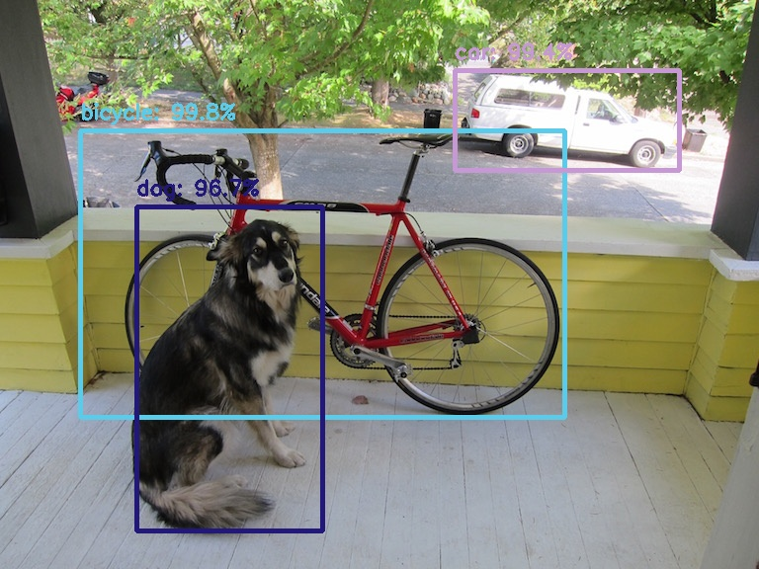
Figure 8: MobileNet-SSD output - bounding boxes and labels drawn only for detections clearing the 80% gate
Detected Object | Confidence Score | 80% Gate
Bicycle | 99.76% | PASSED
Car | 99.36% | PASSED
Dog | 96.70% | PASSED

6. The Gatekeeper Rule: Milestone Validation
To complete Project 4, an implementation must pass four uncompromising technical validations. The table below maps each requirement to how it was satisfied in this report's implementation:
# | Validation Check | Status in this Implementation
1 | Library Integration - error-free implementation of pytesseract or cv2.dnn | Both paths implemented and executed successfully
2 | Pre-Processing Integrity - grayscale conversion and adaptive thresholding demonstrably executed | Full 4-step pipeline verified with saved intermediate images
3 | Accuracy Benchmarking - minimum validated confidence of 80% on the final output | OCR: 93.89% avg. | Detection: 96.7%-99.76%
4 | Visual Confirmation - legible OCR string or accurate bounding boxes with labels | Recognized text block produced; bounding boxes with labels drawn

7. Results Summary & Discussion
Both recognition paths were implemented end-to-end using genuinely pre-trained, industry-standard models - Tesseract's LSTM-based OCR engine and a Caffe-trained MobileNet-SSD network - rather than placeholder logic. Key observations:
- Pre-processing materially affects OCR accuracy: correcting a 4.5° tilt and applying Otsu thresholding was essential to recovering clean, high-confidence text from a deliberately degraded input.
- PSM selection is not a minor detail - an incorrect mode (PSM 7 on multi-line text) dropped confidence from ~94% to ~30%, a difference large enough to fail the project's gate entirely.
- The 80% confidence gate is a genuine trade-off, not a formality: it is what separates a production-grade recognition pipeline from one that reports hallucinated detections with false certainty.
- Transfer learning made both paths practical on modest hardware: neither model was trained from scratch, yet both achieved high-confidence results immediately.

8. Conclusion
This project demonstrates the two most common entry points into machine perception: reading text out of images (OCR) and locating objects within them (object detection). Both rely on the same underlying philosophy introduced across this training kit - transforming raw, unstructured input into a structured, numerical representation, then applying a validated confidence threshold before trusting the output.
Although Project 4 is an optional milestone, completing it end-to-end - from pre-processing theory through to two fully working, benchmarked pipelines - demonstrates a practical, production-aware understanding of how modern AI systems perceive and interpret the visual world.

9. Acknowledgment
This project was completed as part of the Artificial Intelligence Industrial Training Kit (Batch 2026), Project 4: Image or Text Recognition (Basic), powered by DecodeLabs.
DecodeLabs | www.decodelabs.tech | decodelabs.tech@gmail.com | Greater Lucknow, India

