DecodeLabs
Artificial Intelligence Industrial Training Kit
PROJECT REPORT
Project 3: AI Recommendation Logic
Tech Stack Recommender
Content-Based Filtering using TF-IDF Vectorization and Cosine Similarity
Submitted by: Muhammad Arham Kashif
Batch: 2026
Powered by DecodeLabs

Table of Contents
Table of Contents 2
1. Introduction 3
2. Project Objective 3
2.1 Qualification Criteria 3
3. Theoretical Background 3
3.2 The Input-Process-Output (IPO) Architecture 4
3.3 Vector Mapping: Bridging the Language Barrier 4
3.4 From Binary Vectors to TF-IDF Weighting 4
3.5 Cosine Similarity: Measuring Orientation, Not Magnitude 5
4. System Design: The 4-Step Ranking Pipeline 7
5. Implementation: Tech Stack Recommender 7
5.1 Dataset: raw_skills.csv 7
5.2 Ingestion — Loading the Catalog 7
5.3 Feature Extraction — TF-IDF Vectorization 8
5.4 Scoring — Cosine Similarity 8
5.5 Full Recommendation Pipeline 8
6. Results & Testing 10
6.1 Test Case 1 — Cloud / Automation Profile 10
6.2 Test Case 2 — Web Development Profile 10
6.3 Test Case 3 — Out-of-Vocabulary Input (Cold Start) 11
7. Challenges: The Cold Start Problem 11
8. Conclusion 11
9. Acknowledgment 12

1. Introduction
Recommendation engines are the digital matchmakers behind platforms such as Netflix and Amazon, connecting users to relevant content before their needs are explicitly stated. Project 3 of the DecodeLabs Artificial Intelligence Industrial Training Kit moves the trainee from passive data classification toward active prediction: building a system that can look at a small, explicit set of user preferences and mathematically infer what that user is likely to want next.
This report documents the design, theory, implementation, and testing of a Content-Based Filtering recommendation engine, applied practically as a Tech Stack Recommender that maps a user's raw technical skills to the most suitable career/job roles.

2. Project Objective
The goal defined by the project brief is to create a simple recommendation system based on user preferences, satisfying the following key requirements:
- Take user input in the form of choices or interests (a minimum of three inputs).
- Match those preferences against a catalog of items using logic or similarity scoring.
- Display the most relevant recommended items to the user (a truncated Top-N list).
Key skills exercised: logic building, pattern matching, and recommendation-system concepts.

2.1 Qualification Criteria
- Requirement: Complete Project 3 to unlock subsequent project milestones.
- Standard: All submitted projects must be verified for quality.
- Mandatory: Project 3 is treated as the definitive milestone for mastering this domain.

3. Theoretical Background
Recommendation systems generally diverge into two methodologies, illustrated below.
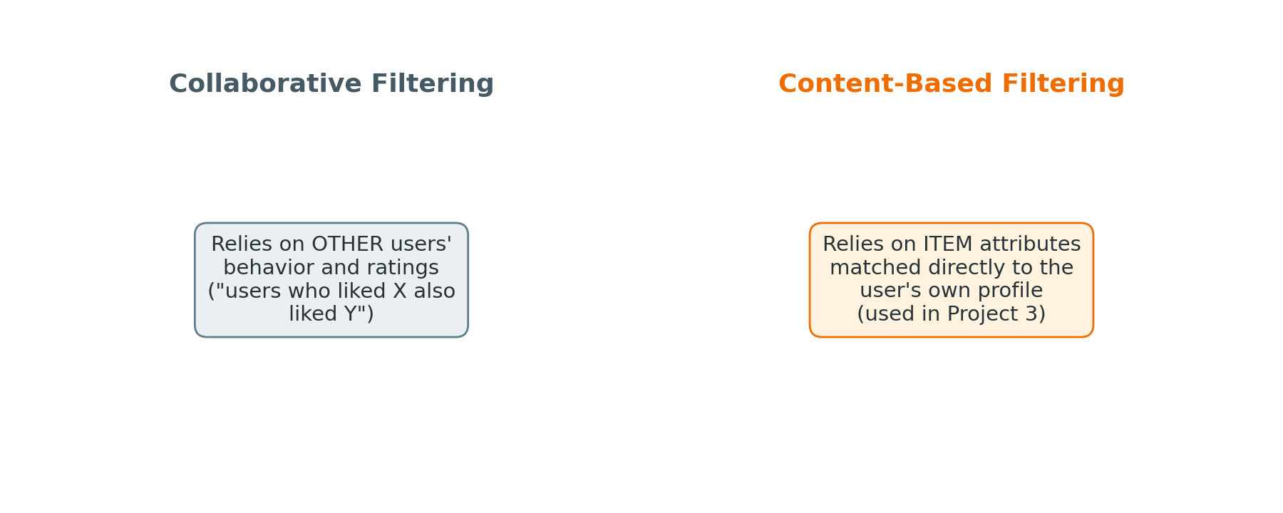
Figure 1: Collaborative Filtering vs. Content-Based Filtering
Collaborative Filtering is driven by community behavior — it identifies patterns among similar users ("users who bought this also bought that") and therefore depends heavily on large historical interaction datasets. Content-Based Filtering, in contrast, is driven purely by item attributes: it maps a single user's stated preferences directly to the intrinsic properties of the items themselves, independent of any other user's behavior.
Project 3 focuses exclusively on Content-Based Filtering. This choice allows an effective engine to be built immediately, without waiting to accumulate massive historical usage logs — an important practical advantage for any new product or platform.

3.2 The Input-Process-Output (IPO) Architecture
Every recommendation engine requires a systematic flow that transforms raw user interaction into a refined list of suggestions. This project follows the standard IPO model:
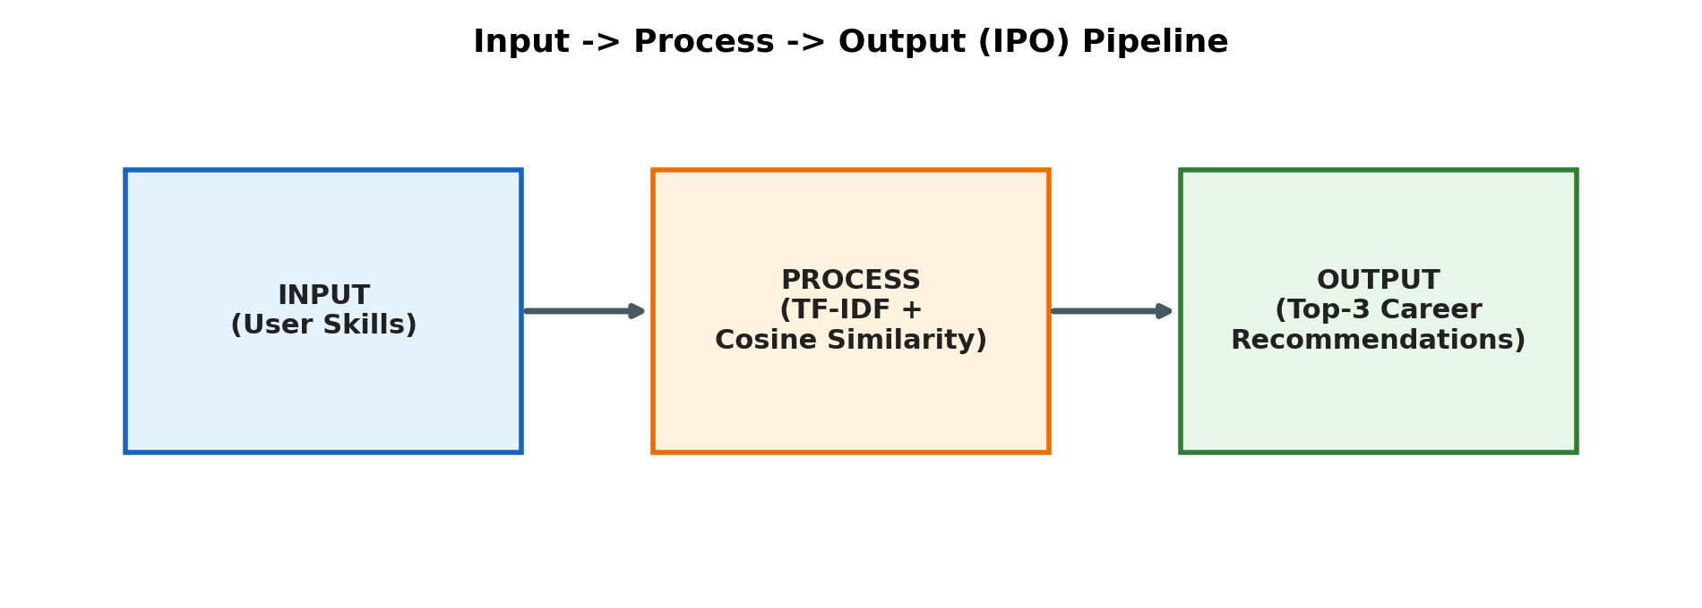
Figure 2: The Input → Process → Output pipeline used in this project
- Input (User State): capturing explicit choices, i.e. the skill tags entered by the user.
- Process (Similarity Logic): applying a mathematical distance/similarity metric to compare the user's structured profile against every available item.
- Output (Top-N List): generating a short, tailored list of the highest-scoring matches to prevent information overload.

3.3 Vector Mapping: Bridging the Language Barrier
Machines cannot reason over qualitative labels such as “Python” or “Cloud Computing” directly — they operate on numbers. To build the similarity engine, both item data and user profiles must be transformed into numerical arrays (vectors) that share a common vocabulary space. It is essential that item features and user features map onto the exact same vocabulary; a naming mismatch (for example “Web Design” vs. “Frontend Development”) would silently break the similarity math.

3.4 From Binary Vectors to TF-IDF Weighting
The simplest similarity approach counts overlapping tags using binary vectors (1 for presence, 0 for absence), measured for example with Jaccard Similarity. However, binary vectors treat generic, high-frequency terms exactly the same as rare, highly descriptive ones. Term Frequency – Inverse Document Frequency (TF-IDF) solves this by weighting each feature according to two factors:
- Term Frequency (TF): terms that appear more frequently within a specific item's description are assumed to be more representative of that item.
- Inverse Document Frequency (IDF): terms that appear across too many items in the whole catalog are penalized, since they carry little discriminating power.
The formulas used are:
TF(t, d) = (Count of term t in document d) / (Total terms in document d)
IDF(t) = log( Total Documents / Documents containing term t )
Weight(t) = TF(t, d) × IDF(t)
The logarithm inside the IDF formula acts as a dampening effect, ensuring the penalty for very common terms scales logarithmically rather than linearly, which keeps the resulting weights comparable across the vocabulary.

3.5 Cosine Similarity: Measuring Orientation, Not Magnitude
A naive approach to comparing two vectors is Euclidean distance — the straight-line distance between two points. This metric, however, is highly sensitive to vector magnitude: two items that share identical tags but differ greatly in overall description length would appear artificially “far apart.”
Cosine Similarity solves this by measuring the angle between two vectors rather than their length, making it invariant to magnitude and focused purely on the orientation (direction) of the preferences:
cos(θ) = (A . B) / (||A|| × ||B||)
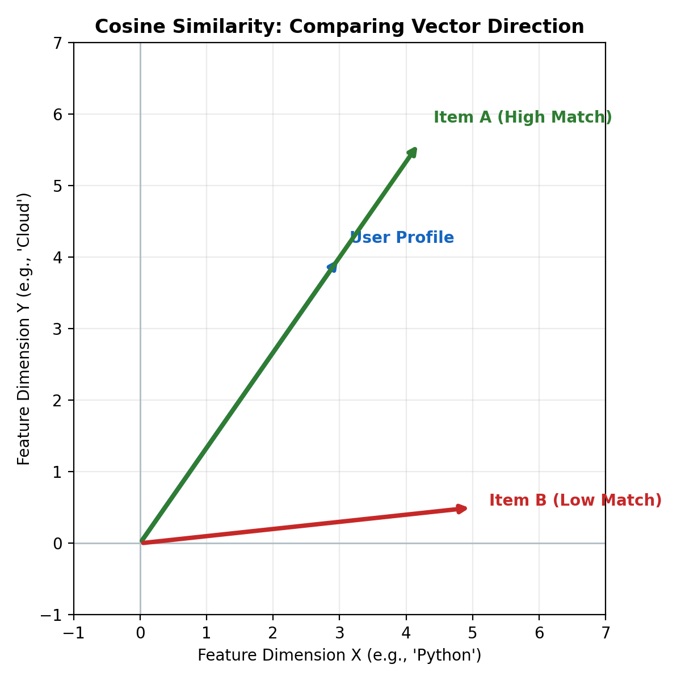
Figure 3: Item A shares a closer direction with the User Profile than Item B, even though raw magnitudes differ
- Score = 1 → vectors are perfectly aligned (identical orientation).
- Score = 0 → vectors are orthogonal (no shared characteristics).
- Score = -1 → vectors point in opposite directions (not possible here, since TF-IDF weights are non-negative, so scores stay within 0–1).

4. System Design: The 4-Step Ranking Pipeline
With the mathematical tools defined, the recommendation script is implemented as a strict four-step assembly line, ensuring the system is responsive, accurate, and protects the user from choice overload.
- Step 1 — Ingestion: capture the user's raw skill inputs (minimum of three, per the project brief).
- Step 2 — Scoring: loop through every item in the dataset, calculate its Cosine Similarity score against the newly ingested user profile, and store the result.
- Step 3 — Sorting: organize the scored dataset in descending order of similarity, pushing the most relevant items to the top.
- Step 4 — Filtering: truncate the sorted list to the Top-N (here, Top 3) to present only the highest-value matches.

5. Implementation: Tech Stack Recommender
The chosen capstone application is a Tech Stack Recommender. It maps a user's raw skills and stated career interests to a curated catalog of job roles, treating each role as an “item” in the recommendation engine — turning qualitative career guidance into an objective, ranked, mathematical output.

5.1 Dataset: raw_skills.csv
Ten job roles were catalogued, each described by a set of representative skill tags forming the shared vocabulary space:
Job Role (Item) | Skill Tags (Feature Set)
Data Scientist | Python, SQL, Machine Learning, Statistics, Data Analysis, Pandas, NumPy, Deep Learning
DevOps Engineer | AWS, Docker, Kubernetes, CI/CD, Linux, Automation, Git, Cloud Computing
Backend Developer | Java, Python, SQL, APIs, Git, Data Structures, Node.js, Databases
Cloud Architect | AWS, Cloud Computing, Automation, Kubernetes, Networking, Security, Docker, Terraform
Frontend Developer | HTML, CSS, JavaScript, React, UI Design, Git, Web Design, Responsive Design
ML Engineer | Python, Machine Learning, Deep Learning, TensorFlow, PyTorch, Data Structures, Statistics, Cloud Computing
Database Administrator | SQL, Databases, Data Structures, Linux, Security, Backup, Automation, Git
Full Stack Developer | JavaScript, React, Node.js, SQL, Python, Git, APIs, HTML
Cybersecurity Analyst | Security, Networking, Linux, Automation, Python, Risk Analysis, Cloud Computing, Encryption
QA Engineer | Automation, Testing, Python, Git, Selenium, CI/CD, Java, Bug Tracking

5.2 Ingestion — Loading the Catalog
def load_dataset(path):
roles = []
with open(path, newline="") as f:
reader = csv.DictReader(f)
for row in reader:
skills = [s.strip() for s in row["skills"].split(";")]
roles.append({"role": row["role"], "skills": skills})
return roles

5.3 Feature Extraction — TF-IDF Vectorization
def compute_idf(roles, vocab):
n_docs = len(roles)
idf = {}
for term in vocab:
df = sum(1 for r in roles if term in r["skills"])
idf[term] = math.log(n_docs / df) if df else 0.0
return idf

def tf(doc_terms, vocab):
counts = Counter(doc_terms)
total = len(doc_terms)
return {term: counts.get(term, 0) / total for term in vocab}

def tfidf_vector(doc_terms, vocab, idf):
tf_scores = tf(doc_terms, vocab)
return [tf_scores[term] * idf[term] for term in vocab]

5.4 Scoring — Cosine Similarity
def cosine_similarity(vec_a, vec_b):
dot = sum(a * b for a, b in zip(vec_a, vec_b))
mag_a = math.sqrt(sum(a * a for a in vec_a))
mag_b = math.sqrt(sum(b * b for b in vec_b))
if mag_a == 0 or mag_b == 0:
return 0.0
return dot / (mag_a * mag_b)

5.5 Full Recommendation Pipeline
def recommend(user_skills, dataset_path="raw_skills.csv", top_n=3):
roles = load_dataset(dataset_path)
vocab = build_vocabulary(roles)
idf = compute_idf(roles, vocab)

# Ingestion: build the user's weighted profile vector
user_vector = tfidf_vector(user_skills, vocab, idf)

# Scoring: compare user vector against every role vector
scored = []
for r in roles:
role_vector = tfidf_vector(r["skills"], vocab, idf)
score = cosine_similarity(user_vector, role_vector)
scored.append((r["role"], round(score, 4)))

# Sorting: rank by descending similarity
scored.sort(key=lambda x: x[1], reverse=True)

# Filtering: truncate to Top-N
return scored[:top_n], scored

6. Results & Testing

6.1 Test Case 1 — Cloud / Automation Profile
Input skills: ["Python", "Cloud Computing", "Automation"]
Rank | Job Role | Cosine Similarity Score
1 | Cybersecurity Analyst | 0.2991
2 | DevOps Engineer | 0.2869
3 | Cloud Architect | 0.2445
4 | ML Engineer | 0.1913
5 | QA Engineer | 0.1255
6 | Database Administrator | 0.1028
7 | Backend Developer | 0.0572
8 | Full Stack Developer | 0.0549
9 | Data Scientist | 0.0417
10 | Frontend Developer | 0
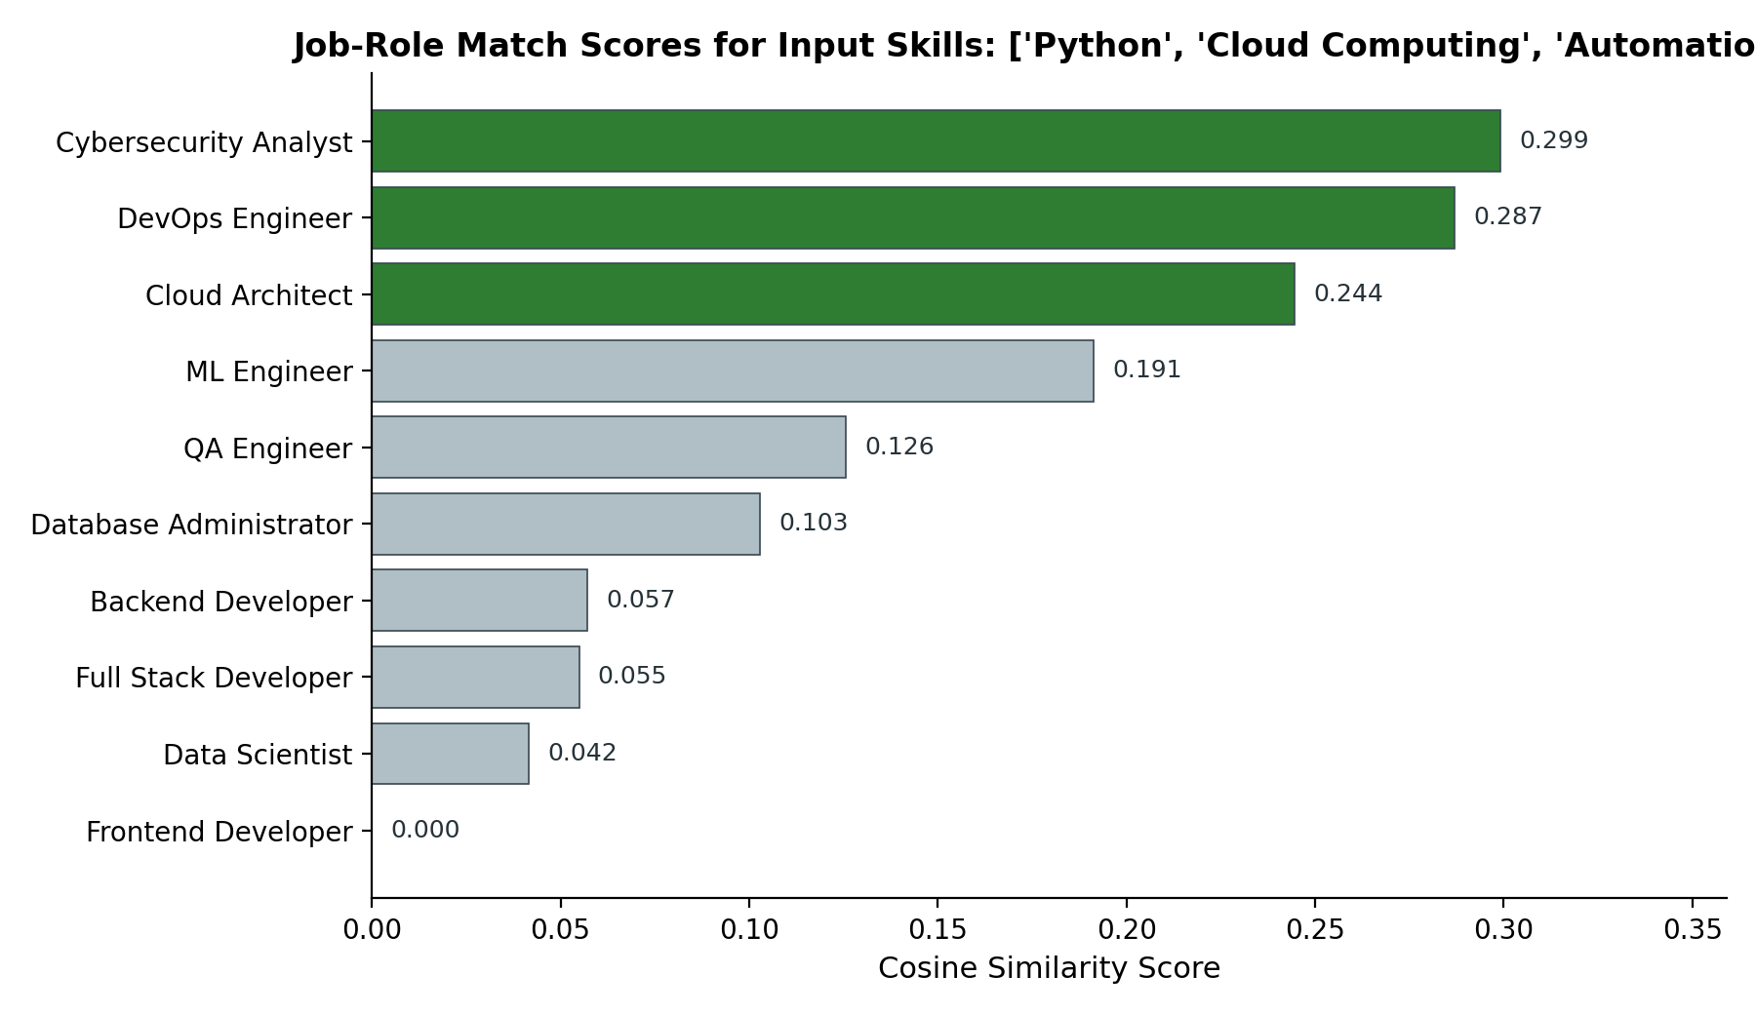
Figure 4: Ranked similarity scores across all ten job roles — the top 3 matches are highlighted in green
The engine correctly surfaces Cybersecurity Analyst, DevOps Engineer, and Cloud Architect as the top three matches, since these roles share the highest combined TF-IDF weighted overlap with “Python,” “Cloud Computing,” and “Automation.” Frontend Developer scores exactly 0.0, as it shares no vocabulary at all with the user's input, correctly demonstrating cosine similarity's zero-orthogonal case.

6.2 Test Case 2 — Web Development Profile
Input skills: ["JavaScript", "React", "SQL"]
Rank | Job Role | Cosine Similarity Score
1 | Full Stack Developer | 0.6485
2 | Frontend Developer | 0.3905
3 | Backend Developer | 0.0943
Full Stack Developer dominates with a score of 0.65, since its tag set overlaps most strongly and specifically with the input. Frontend Developer follows at 0.39 due to partial overlap (JavaScript, React), while Backend Developer trails at 0.09, correctly reflecting a weaker match.

6.3 Test Case 3 — Out-of-Vocabulary Input (Cold Start)
Input skills: ["Photoshop", "Illustrator", "Figma"]
Rank | Job Role | Cosine Similarity Score
1 | Data Scientist | 0
2 | DevOps Engineer | 0
3 | Backend Developer | 0
Every score returns 0.0. This is an expected and instructive failure mode, discussed further in Section 7.

7. Challenges: The Cold Start Problem
Even the best-designed pipeline fails without adequate initial data. The Cold Start problem occurs when the system encounters an entity for which it cannot execute meaningful similarity math.
- User Cold Start: a brand-new user (or, as in Test Case 3, a user whose vocabulary does not intersect the catalog at all) produces a profile vector of all zeros for the known dimensions, so multiplying it against any item vector yields zero.
- Item Cold Start: a newly added item with no tags or interaction history is effectively invisible to the logic skeleton.
Content-Based Filtering is inherently robust against Item Cold Starts, since new items can be recommended immediately based on their own metadata, without needing prior interaction history. For User Cold Starts, three strategic bypasses were identified:
- Onboarding Surveys: force the ingestion step by asking new users to select initial topics of interest, bootstrapping a baseline vector.
- Trending Fallbacks: default to globally popular or trending items until enough personalized data is collected.
- Metadata Inference: use demographic or cross-domain behavioral signals (location, device type) to infer initial feature weightings.

8. Conclusion
This project demonstrates that mastering the IPO model, vector mapping, and TF-IDF / cosine similarity mathematics is what transitions a system from merely classifying data to actively predicting what a user wants. Whether applied to streaming movies, retail products, or — as built here — technical career paths, the fundamental principles of feature extraction and cosine similarity remain the bedrock of modern content-based recommendation engines.
The resulting Tech Stack Recommender successfully ingests a minimum of three user-provided skills, scores them against a ten-role job catalog using TF-IDF weighted cosine similarity, and returns a clean, ranked Top-3 output — fully satisfying the requirements set out in the Project 3 brief, while also surfacing and documenting a well-known limitation of the approach (the Cold Start problem) along with practical mitigation strategies.

9. Acknowledgment
This project was completed as part of the Artificial Intelligence Industrial Training Kit (Batch 2026), Project 3: AI Recommendation Logic, powered by DecodeLabs.
DecodeLabs | www.decodelabs.tech | decodelabs.tech@gmail.com | Greater Lucknow, India

