MUHAMMAD ARHAM KASHIF
Artificial Intelligence Engineer Intern — DecodeLabs
PROJECT 2 REPORT
Data Classification Using AI
Supervised Learning · Iris Dataset · K-Nearest Neighbors

Industrial Training Kit | Batch 2026
Powered by DecodeLabs

1. Introduction
This report documents the completion of Project 2 of the DecodeLabs Artificial Intelligence Industrial Training Kit (Batch 2026): Data Classification Using AI. Building on the rule-based logic explored in Project 1, this project moves into Supervised Learning — training a model on labeled historical data so it can classify new, unseen data on its own.
The exercise mirrors a real predictive-modeling workflow: a dataset is loaded and explored, split into training and testing portions, fed through a classification algorithm, and the resulting predictions are validated using proper evaluation metrics rather than accuracy alone.

Project Goal
Build a basic classification model using a small, well-understood dataset.

Key Requirements
- Load and understand a dataset
- Split the data into training and testing sets
- Apply a simple classification algorithm

Key Skills Demonstrated
- Data handling and exploratory analysis
- Supervised learning fundamentals
- Model training, tuning, and validation

2. Conceptual Foundation

From Heuristics to Supervised Learning
Traditional programs rely on a heuristic 'if/then' rulebook that must anticipate every case in advance. Supervised learning replaces that rulebook with historical, labeled examples: the algorithm is shown data where the correct answer is already known, and it derives its own decision boundary between classes — rather than being handed one.

The IPO Framework
The entire pipeline for this project follows a simple Input -> Process -> Output structure:
- Input: the Iris domain dataset, prepared through feature scaling
- Process: a train-test split followed by the K-Nearest Neighbors (KNN) algorithm
- Output: a confusion matrix and F1 score used to judge how well the model performs

Why Scaling Matters
Because KNN classifies a point based on distance to its neighbors, features measured on different scales (e.g. centimeters vs. arbitrary counts) can distort those distances. StandardScaler re-centers every feature to a mean of 0 and a variance of 1, so no single feature dominates the distance calculation purely because of its numeric range.

3. The Dataset: Iris Benchmark
The classic Iris dataset was used as the raw material for this project. It is a small, balanced, and well-labeled benchmark that is ideal for learning classification fundamentals before moving to more complex, high-dimensional data.
Metric | Value
Total Samples | 150 (perfectly balanced)
Classes | 3 — Setosa, Versicolor, Virginica
Features (Dimensions) | 4 — sepal length, sepal width, petal length, petal width
Measurement Unit | Centimeters (cm)

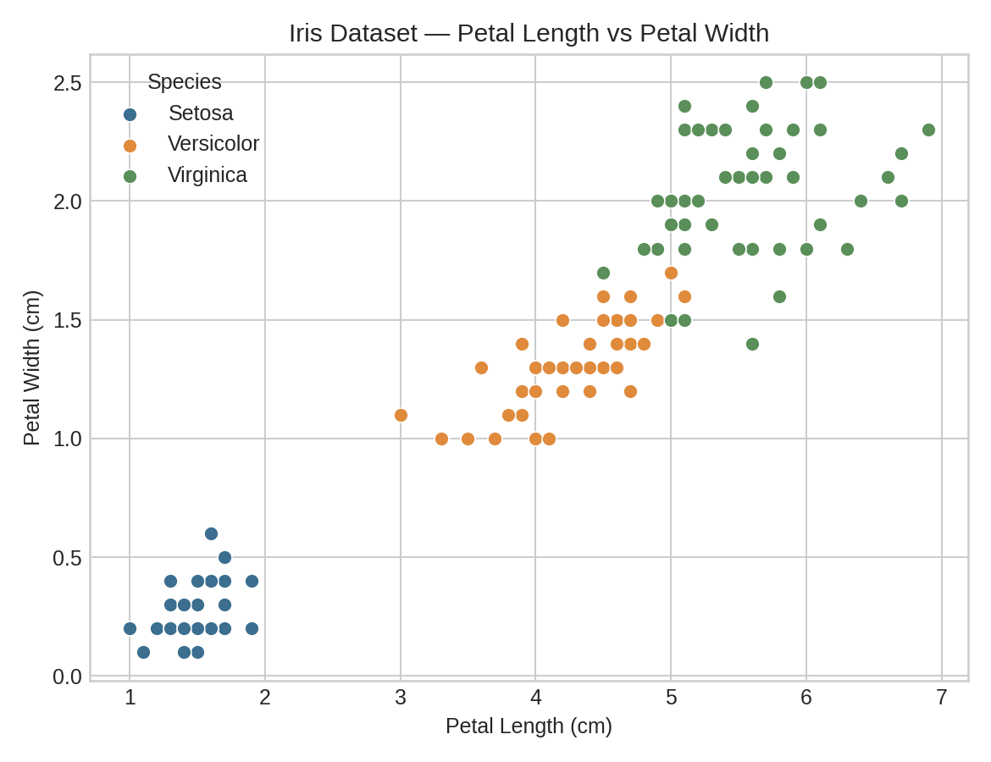
Figure 1 — Petal length vs. petal width, colored by species. Even in two dimensions, the three Iris species form visually separable clusters, which is exactly the structure a classifier learns to exploit.

4. Methodology and Implementation
The model was built with scikit-learn following the standard Instantiate -> Fit -> Predict workflow. Each stage below pairs the working code with a short explanation.

Step 1 — Load and Understand the Dataset
The Iris dataset was loaded and inspected to confirm its shape and class balance before any modeling began.
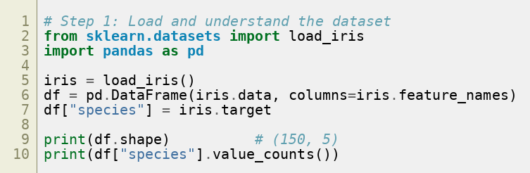

Step 2 — Train/Test Split and Feature Scaling
Data was shuffled and split 80/20 into training and testing sets, stratified by class so each species is proportionally represented in both sets. StandardScaler was then fit on the training data only, and applied to both sets to prevent data leakage.
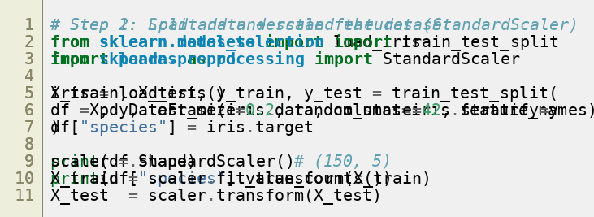

Step 3 — Choosing K and Training the Classifier
K controls how many neighboring points 'vote' on a new point's class. A very small K (e.g. K=1) overfits to noise, while a very large K underfits and washes out real structure. The error-rate curve below was generated by testing K from 1 to 30 — the curve flattens into a low-error zone in the K=3 to K=9 range, confirming K=5 (used in the reference workflow) is a reasonable, stable choice.
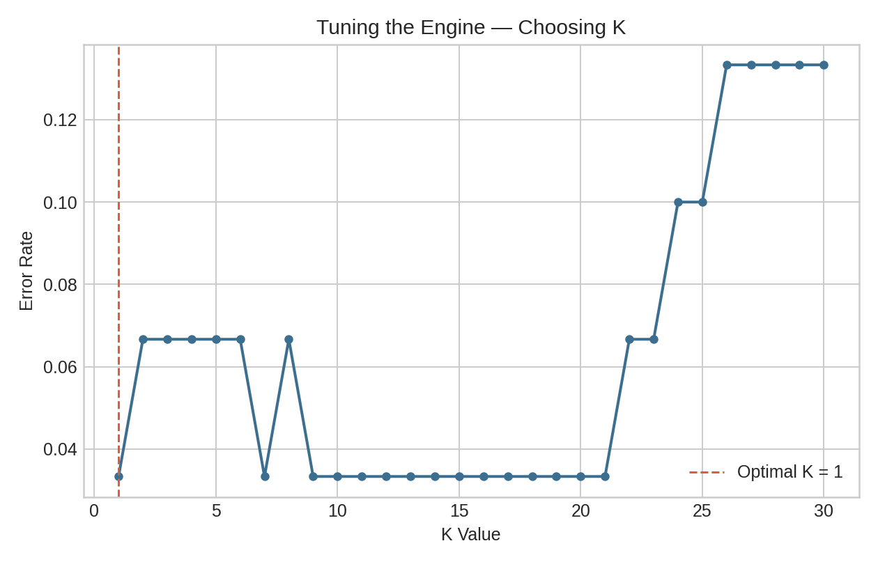
Figure 2 — Test error rate across K values. Very low K overfits; very high K underfits. K=5 sits comfortably inside the stable low-error region.
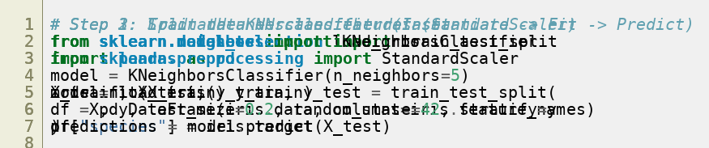

Step 4 — Evaluating the Model
Accuracy alone can be misleading, especially on imbalanced data, so the model was also evaluated with a confusion matrix and the F1 score (the harmonic mean of precision and recall).
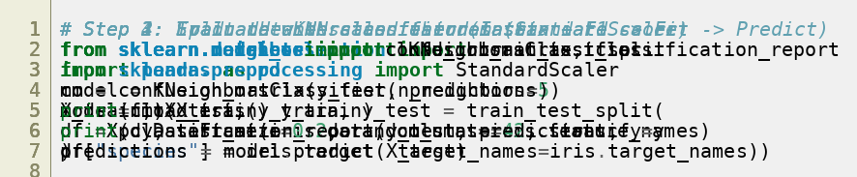

5. Results and Evaluation
The final KNN model (K=5) was trained on 120 samples and evaluated on the 30 held-out test samples. Results are summarized below.
Metric | Value
Neighbors (K) | 5
Training Samples | 120
Testing Samples | 30
Accuracy | 93.3%
Macro Precision | 94.4%
Macro Recall | 93.3%
Macro F1 Score | 93.3%

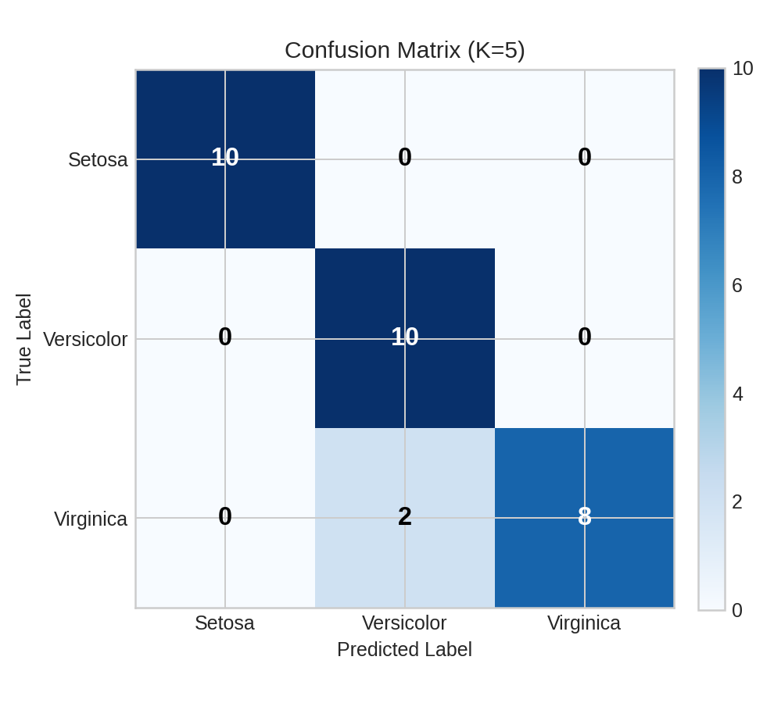
Figure 3 — Confusion matrix on the test set. Setosa was classified perfectly; the model's only errors were a small overlap between Versicolor and Virginica, the two species whose petal measurements naturally border one another.
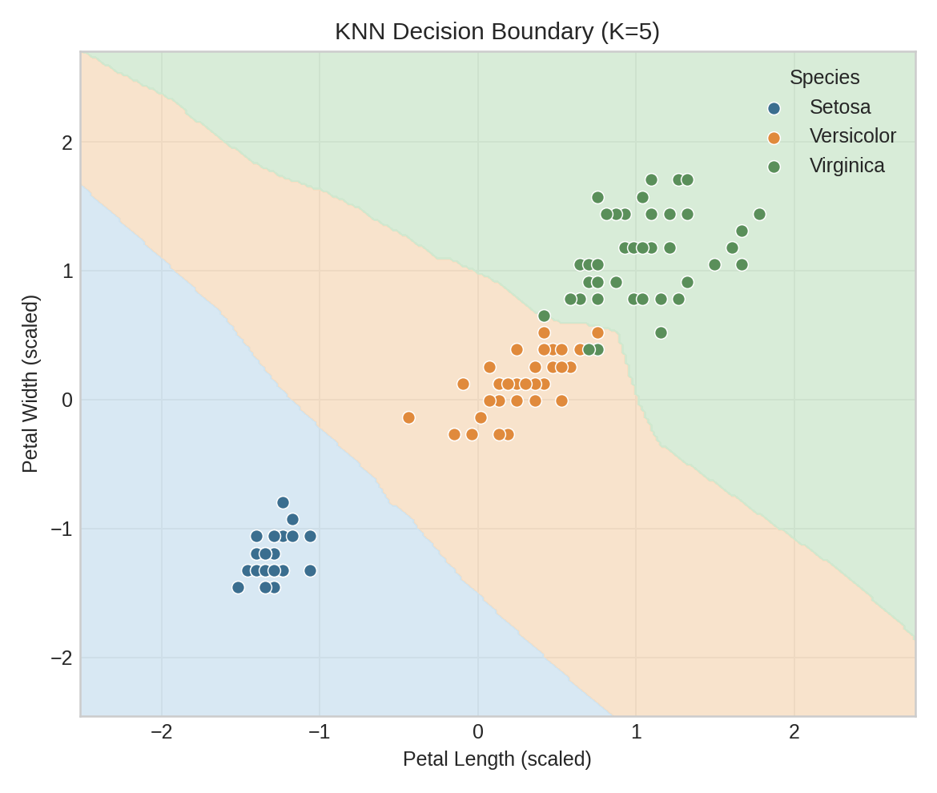
Figure 4 — KNN decision boundary learned from petal length and petal width (scaled). The colored regions show how the model would classify any new point in that feature space; dots are the actual training samples.

Interpreting the Results
- Setosa is linearly separable from the other two species and was classified with perfect precision and recall.
- Versicolor and Virginica overlap slightly in petal dimensions, which accounts for the few misclassifications visible in the confusion matrix.
- A 93.3% accuracy with balanced precision and recall indicates the model generalizes well and is not simply memorizing the training data.

6. Conclusion
Project 2 demonstrates the complete supervised learning pipeline: loading and understanding a dataset, preparing it through scaling and a proper train/test split, training a K-Nearest Neighbors classifier, and validating it with metrics that go beyond raw accuracy. The resulting model classifies Iris species with 93.3% accuracy and balanced performance across all three classes.
More importantly, this project establishes the foundational workflow — Input, Process, Output — that scales up directly into the more advanced models covered in later projects, including neural networks and computer vision.

Next Steps
- Experiment with alternative algorithms (e.g. Logistic Regression, Decision Trees) on the same dataset for comparison.
- Test the trained model against new, unseen flower measurements outside the original dataset.
- Carry the same Input -> Process -> Output framework forward into Project 3's deep learning and computer vision tasks.

Prepared by Muhammad Arham Kashif | DecodeLabs Industrial Training Kit — Batch 2026

