Project: Typical 3 BHK Residential Flat
1. General
This document describes the 3 BHK flat shown in the floor plan below. All dimensions are clear internal sizes.
Floor to ceiling height shall be 3.0 m throughout the flat.
External walls are 150 mm thick brick masonry. Internal partition walls are 125 mm thick.
2. Doors and windows
All internal doors are 900 x 2100 mm; the main entrance door is 1000 x 2100 mm.
Window sill height is 750 mm above finished floor; windows are 1500 x 1350 mm.
Toilet ventilators are 600 x 450 mm with sill at 1650 mm.
RCC slab thickness 150 mm. Skirting height 100 mm in all dry rooms.
3. Floor plan
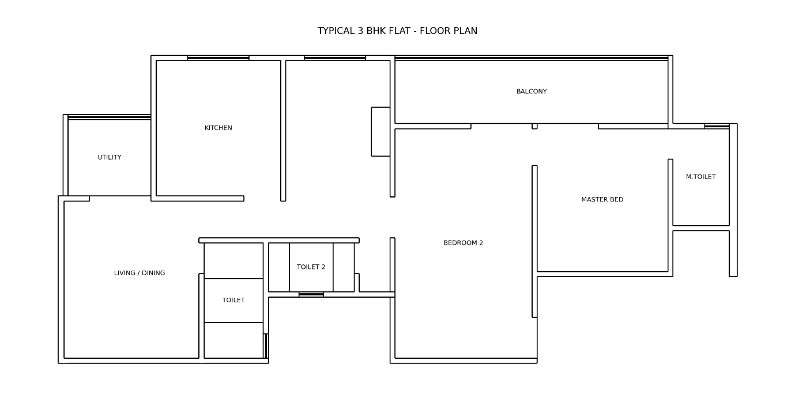
4. Room schedule
Room | Size | Remarks
Living / Dining | 25.7 sq m | L-shaped
Master Bedroom | 10'6" x 11'6" | attached toilet
Bedroom 2 | 11'0" x 18'6"
Kitchen | 3.05 x 3.33 m | with utility
Balcony | 1.55 x 6.68 m | glass railing
Utility | 1.88 x 2.04 m
Master Toilet | 4'6" x 7'9"
Common Toilet | 1.45 x 2.83 m
Toilet 2 | 1.20 x 2.10 m

