

HUMAN RESOURCE DEVELOPMENT CENTER


(Customizing workshops on Understanding & Re-defining Organizations)

(To help us frame your organization’s Learning & Development curve, please answer the following)

Need Profile form

- In which areas would you like your organization to grow further (Please tick)

i Customer Service ii Market Share (Expanding Customer Base)

iii Retaining Talented Staff iv Enhancing Brand Equity

v Work Efficiency vi Any Other

- What kind of updation in knowledge, skills and attitude do you visualize in various categories of staff

Staff Category | Updation Required | Remarks if any

- Which of the following training types would you be interested in for professional development of staff? – (please tick }
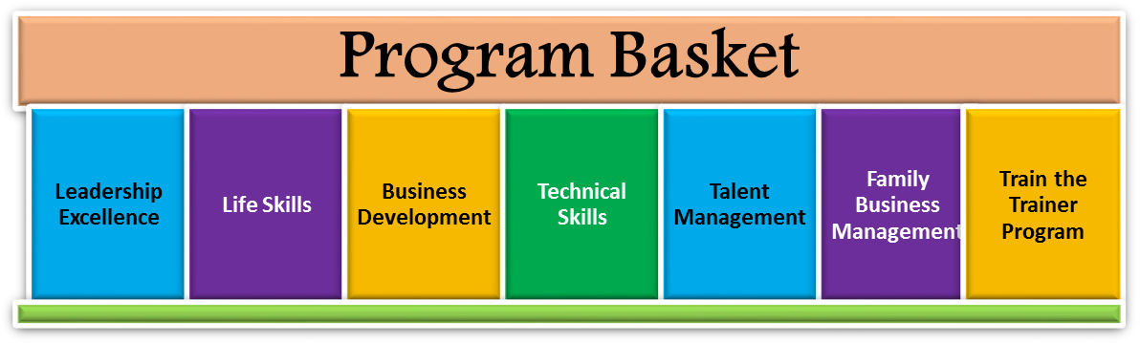

- What percentage of your salary budget is spent on Training & Capacity Building?

Up to 4% 5 to 9 % 9% and above

- What is the current frequency of trainings undertaken (Current Training Calendar Followed)?

_______________________________________________________________________________________

- Name the topics of the trainings undertaken along with the Training Organization
_______________________________________________________________________________________
_______________________________________________________________________________________
_______________________________________________________________________________________

- What are your three major expectations from the training?
a) ____________________________________________________________________________________
b) ____________________________________________________________________________________
c) ____________________________________________________________________________________

---------------------------------------------------------------------------------------------------------------------------------------

Name of Dealing Official_______________________________________ Designation __________________

Name of Organization: _____________________________________________________________________

Address: ________________________________________________________________________________

City:____________________________ Pin code:_________________State:__________________________

Nature of Business (Please specify) ___________________________________________________________

Mobile: ________________________Landline Phone:____________________________________________

E-mail:_________________________________Website:__________________________________________

No. of Staff Employed: Cadre Wise No. Front Line Team________ Supervisors_____________

Mid-Level Managers__________ Top Management__________ Others (support staff etc) ____________

Do you have branches? If so where?

__________________________________________________________________________________________

__________________________________________________________________________________________

