Course Name: | Web Development Laboratory (316U01L306) | Semester: | III
Date of Performance: | __18_ / _08__ / 2026______ | DIV/ Batch No: | D1
Student Name: | Neeti Singh | Roll No: | 16010125248

Experiment No: 2
Title: Design web Portal using CSS3.

Aim of the Experiment: To apply CSS3 style sheets to an existing HTML5-based Web Portal for the given Use Case study in order to enhance layout, responsiveness, visual aesthetics, and user interaction using modern CSS3 features.

Objectives for the Experiment:
- Implement different CSS3 styling techniques
- Design responsive layouts using Flexbox and media queries
- Enhance user interaction using animations
- Maintain separation of content and presentation

COs to be achieved:
CO1: Use CSS to prepare the layout of web pages.

Books/ Journals/ Websites references:
- Students should write ……..

Theory:
Students should write about CSS3 (citation needed for content taken (IEEE or APA7 style))

Problem statement: Demonstrate the implementation of CSS3 features to enhance the layout, responsiveness, and aesthetics of the selected HTML-based web portal for the selected Use Case in experiment 1.
Note: All tasks are compulsory to use.

Task 1: Style the Homepage Header (Inline CSS)
Requirements:
- Use inline CSS to:
  - Set background color for header
  - Change text color of store name
  - Center align slogan
  - Add padding and border
- Apply inline style to:
  - <h1>, <p>, <header>
Concepts tested:
Inline CSS, color, background, padding, text-align, border.

Task 2: Internal CSS for Navigation Menu
Navigation menu should look professional and consistent across the page.
Requirements:
- Use internal CSS (<style> in <head>)
- Style navigation menu:
  - Remove bullet points
  - Display menu items horizontally
  - Add hover effect
  - Change link colors
- Use:
  - :hover, text-decoration, display: inline-block
Concepts tested:
Internal CSS, selectors, pseudo-class, styling links.

Task 3: External CSS for Whole Website Theme

For a consistent look across all pages.
Requirements:
- Create file: style.css
- Link it using <link>
- Apply:
  - Body font-family
  - Background color
  - Common heading color
  - Common footer style
Concepts tested:
External CSS, reusable styles, site-wide theming.
Deliverables : style.css linked with book.html
Task 4: Style Book Categories Sidebar
The categories section should look like a card.
Requirements:
- Use external or internal CSS
- Apply:
  - Border
  - Box shadow
  - Padding
  - Rounded corners
- Style list items with:
  - Spacing
  - Hover color change
Concepts tested:
Box model, border-radius, box-shadow, list styling.

Task 5: Book Card Layout Using CSS Box Model
To make Each item appear as a product card.
Requirements:
- Style a <div> as a book card:
  - Width, margin, padding, border
  - Center align content
- Use:
  - display: inline-block
  - Add background color and shadow
Concepts tested:
Box model, margin, padding, display property.
Deliverable : link this .css file with book.html
Task 6: Image Gallery Styling with CSS
To make Featured appropriate items/ attributes, whichever applicable in the Use Case look like a grid.
Requirements:
- Use CSS to:
  - Set same size for all images
  - Add border and hover zoom effect
  - Add spacing between images
- Use:
  - transition, transform: scale()
Concepts tested:
Image styling, hover effects, transitions.
Deliverable nav.css , link to nav bar of expt1
Task 7: Table Styling for Price List
Requirements:
- Use CSS to:
  - Collapse borders
  - Add header background color
  - Zebra-striping rows
  - Center align text
- Use:
  - border-collapse, nth-child(even)
Concepts tested:
Table styling, pseudo-classes.
Deliverable table.css , link to the corresponding file.
Task 8: Style Registration Form
Requirements:
- Style:
  - Input boxes width, padding
  - Submit button color and hover effect
  - Fieldset and legend
- Use:
  - :focus, :hover
  - border-radius
Concepts tested:
Form UI styling, pseudo-classes, layout.
Deliverable : form.css
Task 9: Page Layout Using CSS (Header, Sidebar, Content, Footer)
To Create a proper website layout.
Requirements:
- Use CSS to:
  - Set sidebar to left
  - Content to right
  - Footer at bottom
- Use:
  - float or flex
  - Set widths and spacing
Concepts tested:
Layout design, positioning, float/flex.
Deliverable : layout.css

Task 10: CSS Effects & Highlighting.
To attract attention for Special events/data/section, etc..
Requirements:
- Create an “Offer” box:
  - Blinking or glowing effect
  - Different background color
  - Bigger font
- Use:
  - @keyframes animation OR hover effect
  - text-shadow, box-shadow
Concepts tested:
CSS animations, effects, visual emphasis.

Code:
Task1:
<html>
<head>
<title>Heatwave Intelligence System</title>
</head>
<body style="background-color:white;">

<header style="background-color:#ffe6e6; padding:20px; border:3px solid #b30000;">
<h2 style="color:blue;">HIS</h2>
<h1 id="system"
class="heading"
title="Welcome to the Heatwave Intelligence System. This portal provides real-time temperature monitoring, heatwave forecasts, early warning alerts, and safety advisories for citizens and disaster management authorities."
style="color:red; text-align:center;">
Heatwave Intelligence System
</h1>

<h3 style="text-align:center;">Climate Intelligence Portal</h3>
</header>
<hr>

<p id="season" class="text" style="font-size:18px;">
Monitoring Season : Summer 2026 </p>
<p style="color:green;">
Status : Active Monitoring </p>
<p> This portal provides heatwave monitoring, temperature updates,weather forecasts and early warning alerts for different regions. </p>
<hr>
<p> Department : India Meteorological Department </p>
</body>
</html>

Task3:External File
body
{
font-family: Arial;
background-color: #fdf6f0;
margin: 0;
padding: 0;
}

h2
{
color: #b30000;
}

footer
{
background-color: #333;
color: white;
text-align: center;
padding: 10px 0;
}

Task4:
<html>
<head>
<title>Data Sources and Stakeholders</title>
<link rel="stylesheet" href="style.css">
<style>
ul{
border: 2px solid #b30000;
border-radius: 10px;
box-shadow: 2px 2px 10px rgba(0,0,0,0.2);
padding: 15px 30px;
width: 300px;
background-color: #fff;
}
ul li {
padding: 6px 0;
}
ul li:hover {
color: #b30000;
cursor: pointer;
}
ul ul {
border: none;
box-shadow: none;
width: auto;
padding-left: 20px;
background-color: transparent;
}
</style>
</head>
<body>
<h1 align="center">Data Sources and Stakeholders</h1>
<hr>
<h2>Forecast Workflow</h2>
<ol>
<li>Collect Weather Data</li>
<li>Analyze Temperature</li>
<li>Prepare Forecast</li>
<li>Issue Heatwave Alert</li>
<li>Publish Advisory</li>
</ol>
<hr>
<h2>Data Sources</h2>
<ul>
<li>AWS Sensors</li>
<li>IMD Database</li>
<li>Satellite Feeds</li>
</ul>
<hr>
<h2>Stakeholders</h2>
<ul>
<li>Meteorologists
<ul>
<li>Prepare Forecast</li>
<li>Monitor Weather</li>
</ul>
</li>
<li>Disaster Management Officers
<ul>
<li>Issue Alerts</li>
<li>Coordinate Response</li>
</ul>
</li>
<li>Citizens
<ul>
<li>View Forecast</li>
<li>Follow Safety Advisory</li>
</ul>
</li>
</ul>
<hr>
<h2>Abbreviations</h2>
<dl>
<dt>AWS</dt>
<dd>Automatic Weather Station</dd>
<dt>IMD</dt>
<dd>India Meteorological Department</dd>
<dt>HW</dt>
<dd>Heat Wave</dd>
<dt>SHW</dt>
<dd>Severe Heat Wave</dd>
</dl>
</body>
</html>

Task5:
<html>
<head>
<title> About Heatwave Intelligence System</title>
<link rel="stylesheet" href="style.css">
<style>
.card{
width: 250px;
margin: 15px;
padding: 20px;
border: 2px solid #b30000;
border-radius: 10px;
box-shadow: 3px 3px 12px rgba(0,0,0,0.3);
display: inline-block;
vertical-align: top;
text-align: center;
}
.card-wrapper{
text-align: center;}
</style>
</head>
<body>
<h1 align="center">About Heatwave Intelligence System</h1>
<hr>
<div class="card-wrapper">
<div class="card" style="background-color:lightyellow">
<h2>Objective</h2>
<p>
The <b>Heatwave Intelligence System</b> provides
heatwave monitoring, weather forecasts and
<b>early warning alerts</b> to protect people during
extreme heat conditions.
</p>
</div>
<div class="card" style="background-color:lightblue">
<h2>Data Sources</h2>
<p>
Weather information is collected from
<b>AWS Sensors</b>,
IMD Database,
satellite observations and weather models.
</p>
</div>
<div class="card" style="background-color:lightgreen">
<h2>Stakeholders</h2>
<p>
The portal helps
Citizens,
Meteorologists,
Disaster Management Officers,
Hospitals and Government Authorities.
</p>
</div>
</div>
<hr>
<h2>Message from Chief Meteorologist</h2>
<blockquote>
<b>Early warning saves lives. Monitor temperature regularly and follow official heatwave advisories issued by IMD.</b>
</blockquote>
</body>
</html>

Task6 and Task2:
<html>
<head>
<title>Navigation and Hotspot Page</title>
<link rel="stylesheet" href="style.css">
<style>
ul {
list-style-type: none;
margin: 0;
padding:0;
background-color: #b30000;
}
ul li{
display: inline-block;
}
ul li a{
display: inline-block;
padding: 12px 18px;
color: white;
font-family: Arial;
}
ul li a:hover {
background-color: #ff4d4d;
color: #fff;
}
img{
width: 400px;
height: 250px;
object-fit: cover;
border: 1px solid #b30000;
margin: 3px;
transition: transform 0.4s ease;}
img:hover {
transform: scale(1.1);
box-shadow: 0 0 15px rgba(0,0,0,0.4);
}
</style>
</head>
<body>

<h2 style ="color:red;text-align:center">Navigation Menu</h2>
<hr>

<ul>
<li><a href="home.html">Home</a></li>
<li><a href="alert.html">Alert Description</a></li>
<li><a href="about.html">About System</a></li>
<li><a href="sources.html">Data Sources and Stakeholders</a></li>
<li><a href="https://mausam.imd.gov.in">Indian Meteorological Department (IMD) Website</a></li>
<li><a href="mailto:heatwave.coordinator@example.gov.in">Email the Heatwave Advisory Coordinator</a></li>
<li><a href="tel:1078">Disaster Management Helpline: 1078</a></li>
</ul>

<hr>
<h2 style ="color:red;text-align:center">Hotspot Map</h2>
<hr>
<p align="center">Click on the image to know more about the heatwave conditions</p>

<center>
<a href="north.html">
<img src="north.jpg" alt="North Zone" width="400">
</a>
<br>
<a href="central.html">
<img src="central.jpg" alt="Central Zone" width="400">
</a>
</center>

</body>
</html>

North.html:
<html>
<head>
<title>North Zone</title>
<link rel="stylesheet" href="style.css">
</head>

<body>
<h2 style="text-align:center">North Zone</h2>
<p>Heatwave Alert : Severe</p>
<a href="navigation_hotspot.html">Back to Map</a>
</body>
</html>

Central.html:
<html>
<head>
<title>Central Zone</title>
<link rel="stylesheet" href="style.css">
</head>

<body>
<h2 style="text-align:center">Central Zone</h2>
<p>Heatwave Alert : Moderate</p>
<a href="navigation_hotspot.html">Back to Map</a>
</body>
</html>

Task7:
<html>
<head>
<meta charset="UTF-8">

<title>Forecast Summary</title>
<link rel="stylesheet" href="style.css">
<style>
table{
border-collapse: collapse;
width: 80%;
margin: 20px auto;
text-align: center;}

caption{
font-weight:bold;
font-size: 18px;
margin-bottom:10px;
}

thead th{
background-color: #b30000;
color:white;
}

tbody tr:noth-child(even){
background-color: #ffe6e6;}

tfoot td{
font-weight:bolc;
background-color: #f2f2f2;}
</style>
</head>
<body>

<h1>Forecast Summary Page</h1>

<table border="1" cellpadding="8" cellspacing="0">
<caption>
Region-wise Temperature & Forecast Results
</caption>

<thead>
<tr>
<th rowspan="2">Region</th>
<th rowspan="2">Station</th>
<th colspan="2">Forecast</th>
</tr>
<tr>
<th>Max Temperature (°C)</th>
<th>Severity Level</th>
</tr>
</thead>

<tbody>
<tr>
<td>North</td>
<td>Delhi</td>
<td>44</td>
<td>Severe</td>
</tr>
<tr>
<td>West</td>
<td>Mumbai</td>
<td>36</td>
<td>Moderate</td>
</tr>
<tr>
<td>South</td>
<td>Chennai</td>
<td>41</td>
<td>High</td>
</tr>
<tr>
<td>East</td>
<td>Kolkata</td>
<td>39</td>
<td>High</td>
</tr>
<tr>
<td>Central</td>
<td>Nagpur</td>
<td>43</td>
<td>Severe</td>
</tr>
</tbody>

<tfoot>
<tr>
<td colspan="4">
Total Regions Covered: 5
</td>
</tr>
</tfoot>
</table>

</body>
</html>

Task8:
<html>
<head>
<title>Heatwave Advisory Subscription Form</title>
<link rel="stylesheet" href="style.css">
<style>
fieldset{
width: 350px;
margin:20px auto;
border: 2px solid #b30000;
border-radius: 10px;
padding: 20px;}

legend{
font-weight: bold;
color: #b30000;
padding: 0 10px;}

label{
display: block;
margin-top = 10px;}

input[type="text"],
input[type="email"],
input[type="tel"],
select{
width: 100%;
padding: 8px;
margin-top: 5px;
border: 1px solid #ccc;
border-radius: 6px;
box-sizing: border-box;
}

input[type="text"]:focus,
input[type="email"]:focus,
input[type="tel"]:focus,
select:focus{
border-color:#b30000;
outline: none;
background-color: #fff5f5;
}

input[type="submit"],
input[type="reset"]{
padding: 10px, 20px;
margin-top: 15px;
margin-right: 10px;
border: none;
border-radius: 6px;
cursor: pointer;
font-size: 15px;
}

input[type="submit"]{
background-color: #b30000;
color: white;}

input[type="submit"]:hover{
background-color: #ff4d4d;}

input[type="reset"]{
background-color: #ccc;
color: #333;}

input[type="reset"]:hover{
background-color: #aaa;}
</style>
</head>
<body>

<h2 align="center">Heatwave Advisory Subscription Form</h2>

<form>

<label>Citizen Name:</label><br>
<input type="text" name="name" required><br><br>

<label>Email Address:</label><br>
<input type="email" name="email" required><br><br>

<label>Mobile Number:</label><br>
<input type="tel" name="mobile" required><br><br>

<label>Select Region:</label><br>
<select name="region" required>
<option value="">--Select Region--</option>
<option>North India</option>
<option>South India</option>
<option>East India</option>
<option>West India</option>
<option>Central India</option>

</select><br><br>

<label>Preferred Alert Language:</label><br>
<input type="radio" name="language" value="English"> English<br>
<input type="radio" name="language" value="Hindi"> Hindi<br>
<input type="radio" name="language" value="Marathi"> Marathi<br><br>

<label>Alert Types to Receive:</label><br>
<input type="checkbox" name="alert" value="Heatwave Warning"> Heatwave Warning<br>
<input type="checkbox" name="alert" value="Temperature Updates"> Temperature Updates<br>
<input type="checkbox" name="alert" value="Health Advisory"> Health Advisory<br>
<input type="checkbox" name="alert" value="Emergency Alerts"> Emergency Alerts<br><br>

<input type="submit" value="Submit">
<input type="reset" value="Reset">

</form>

</body>
</html>

Task9:
<html>
<head>
<title>Media Awareness Page</title>
<link rel="stylesheet" href="style.css">
<style>
body {
margin: 0;
}
header {
background-color: #b30000;
color: white;
padding: 20px;
text-align: center;
}
.layout {
display: flex;
min-height: 70vh;
}
aside {
width: 220px;
padding: 20px;
background-color: #fdf6f0;
box-sizing: border-box;
}
aside ul {
list-style-type: none;
padding: 0;
}
aside ul li {
padding: 8px 0;
}
aside ul li a {
text-decoration: none;
color: #b30000;
font-weight: bold;
}
aside ul li a:hover {
text-decoration: underline;
}
main {
flex: 1;
padding: 20px;
box-sizing: border-box;
}
footer {
background-color: #333;
color: white;
text-align: center;
padding: 10px 0;
}
</style>
</head>
<body>

<header>
<h1>Media and Awareness</h1>
</header>

<div class="layout">

<aside>
<h3>Quick Links</h3>
<ul>
<li><a href="#video-section">Awareness Video</a></li>
<li><a href="#audio-section">Audio Advisory</a></li>
<li><a href="#map-section">Weather Map</a></li>
</ul>
</aside>

<main>
<h2 id="video-section" style="color:red;">Awareness Video</h2>
<video width="400" controls>
<source src="heatwave.mp4" type="video/mp4">
</video>
<hr>

<h2 id="audio-section" style="color:red;">Audio Advisory</h2>
<audio controls>
<source src="wind.mp3" type="audio/mpeg">
</audio>
<hr>

<h2 id="map-section" style="color:red;">Weather Map</h2>
<iframe src="https://www.google.com/maps/embed?pb=!1m18!1m12!1m3!1d241317.75590743867!2d72.71354284471423!3d19.081758704983443!2m3!1f0!2f0!3f0!3m2!1i1024!2i768!4f13.1!3m3!1m2!1s0x3be7c6306644edc1%3A0x5da4ed8f8d648c69!2sMumbai%2C%20Maharashtra!5e0!3m2!1sen!2sin!4v1785236975984!5m2!1sen!2sin" width="600" height="450" style="border:0;" allowfullscreen="" loading="lazy" referrerpolicy="strict-origin-when-cross-origin"></iframe>

<noscript>
Your browser has JavaScript disabled. Please enable it to view full content
</noscript>
</main>

</div>

<footer>
<p>India Meteorological Department ; Heatwave Intelligence System</p>
</footer>

</body>
</html>

Task10:
<html>
<head>
<title>Heatwave Alert Details</title>
<style>
.offer-box{
background-color: #ffe6e6;
border: 2px solid #b30000;
padding: 15px;
text-align: center;
border-radius: 8px;
animation: glow 1.5s infinite alternate;}

.offer-box marks{
font-size: 22px;
color:red;
background-color: transparent;}

@keyframes glow{
from{box-shadow: 0 0 5px #b30000;}
to{box-shadow: 0 0 25px #ff4d4d;}}
</style>
</head>

<body style="background-color: white">
<h1 style = "color:red;text-align:center;">
Heatwave Alert Bulletin
</h1>
<hr>
<h3>Current Alert</h3>
<div class = "offer-box">
<p>
<strong>
<mark>Severe Heatwave Alert - Mumbai Region</mark>
</strong>
</p>
</div>
<p>
Maximum Temperature Expected : 47<sup>o</sup>C
</p>
<p style = "color:blue">
Alert Status: Active
</p>
<hr>
<small>
Forecast subject to revison. Please check official weather updates
</small>
</body>
</html>

Output / Screenshot:
Output Task 1:
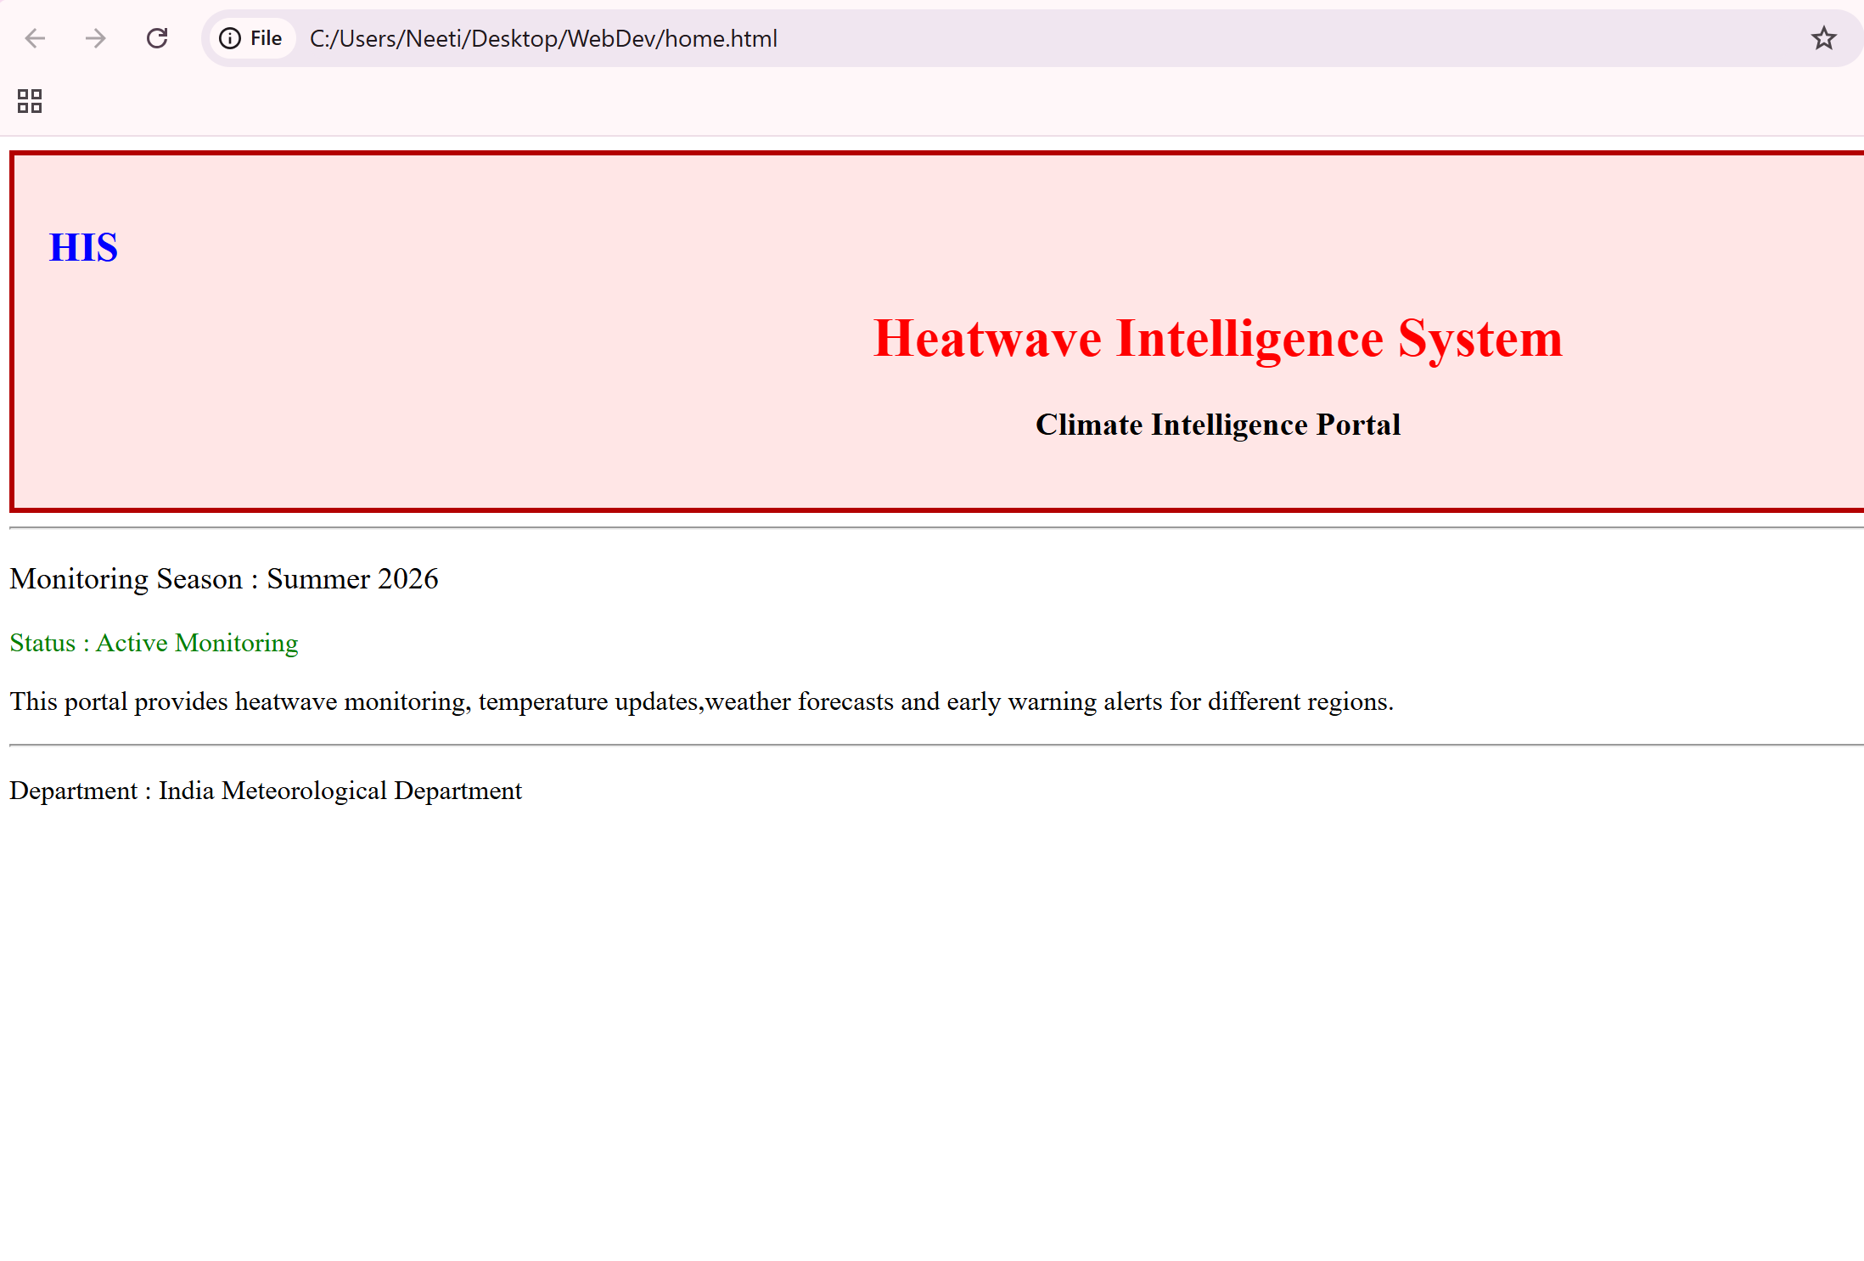
Output Task 4:
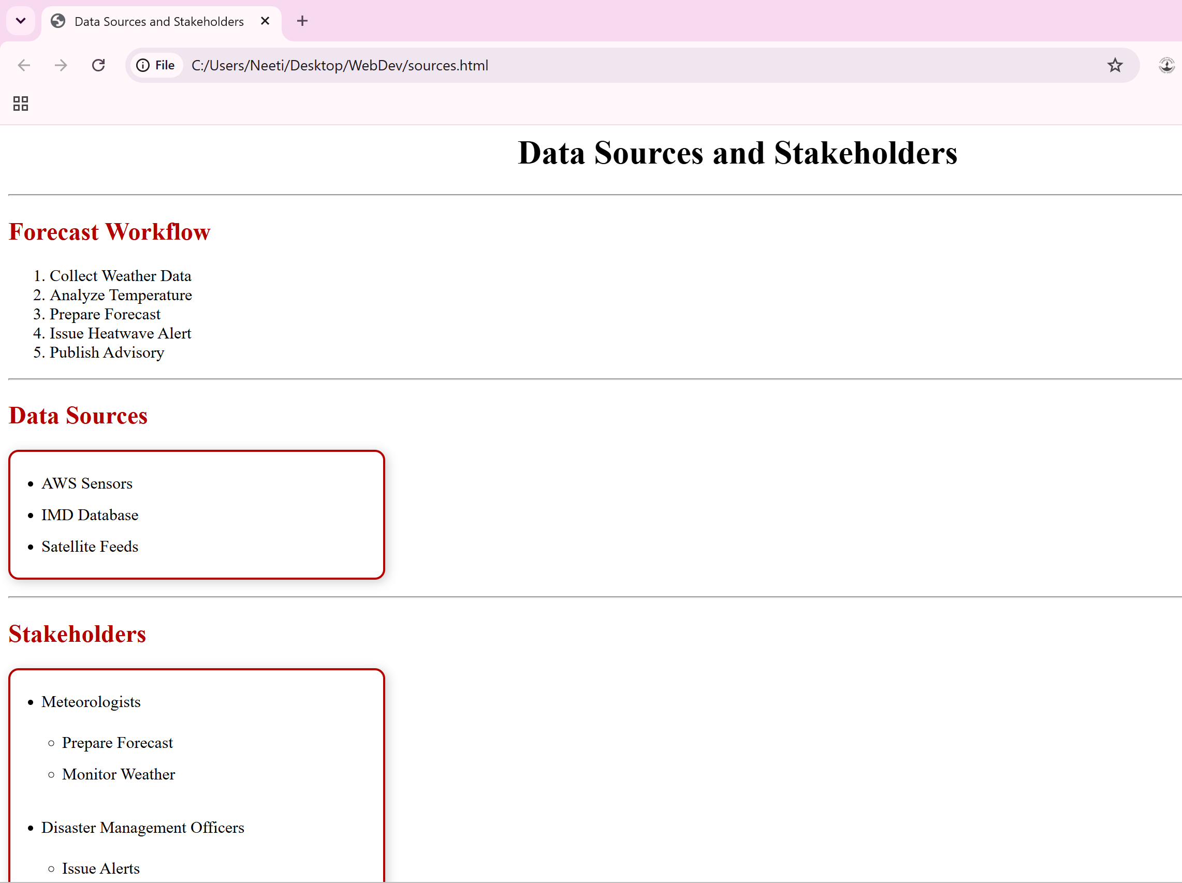
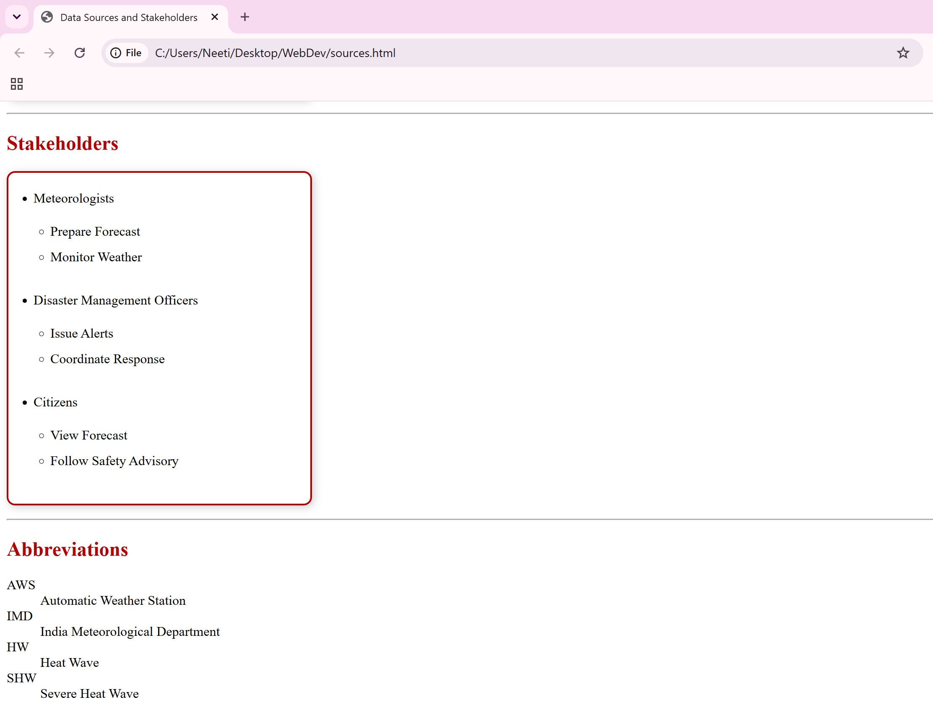

Output Task 5:
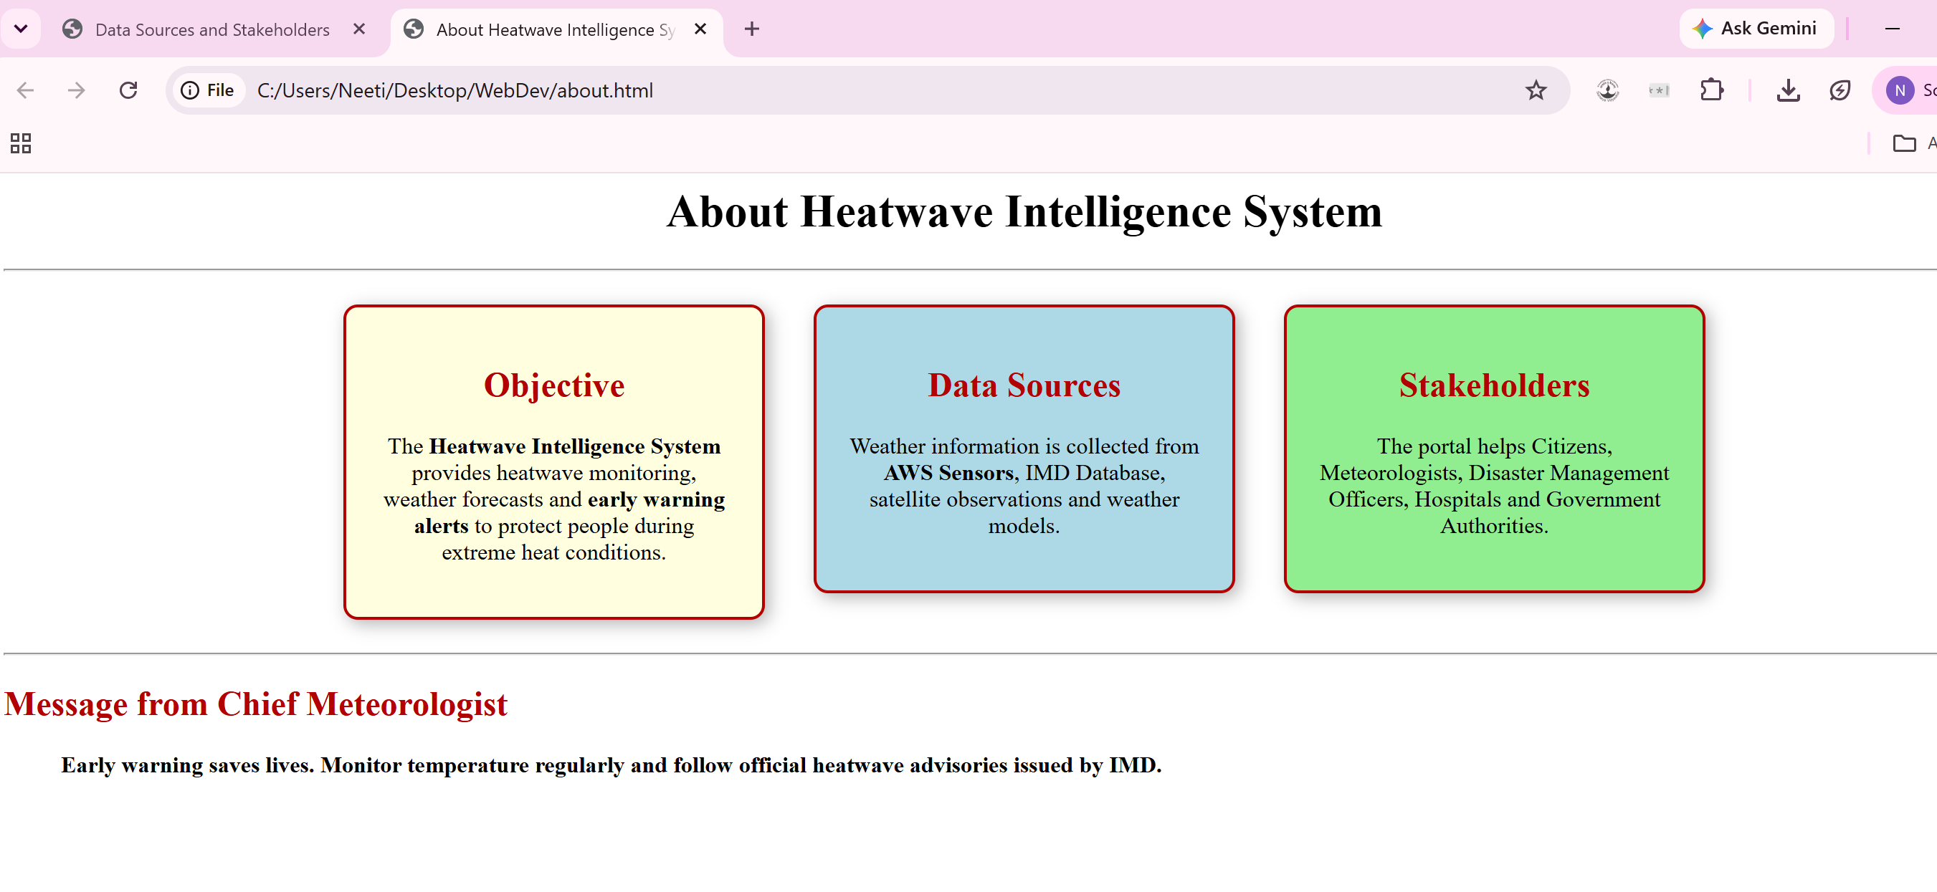

Output Task 6 and Task 2:
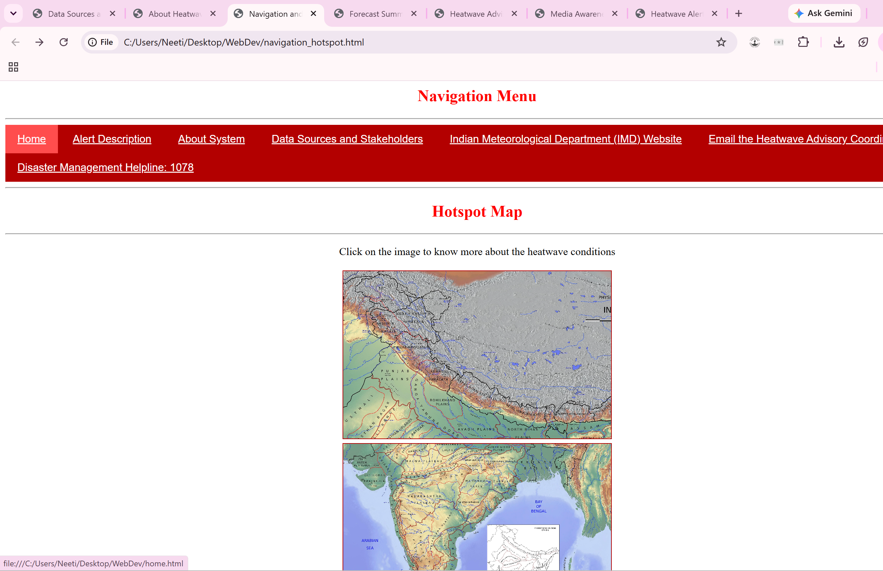

Output Task 7:
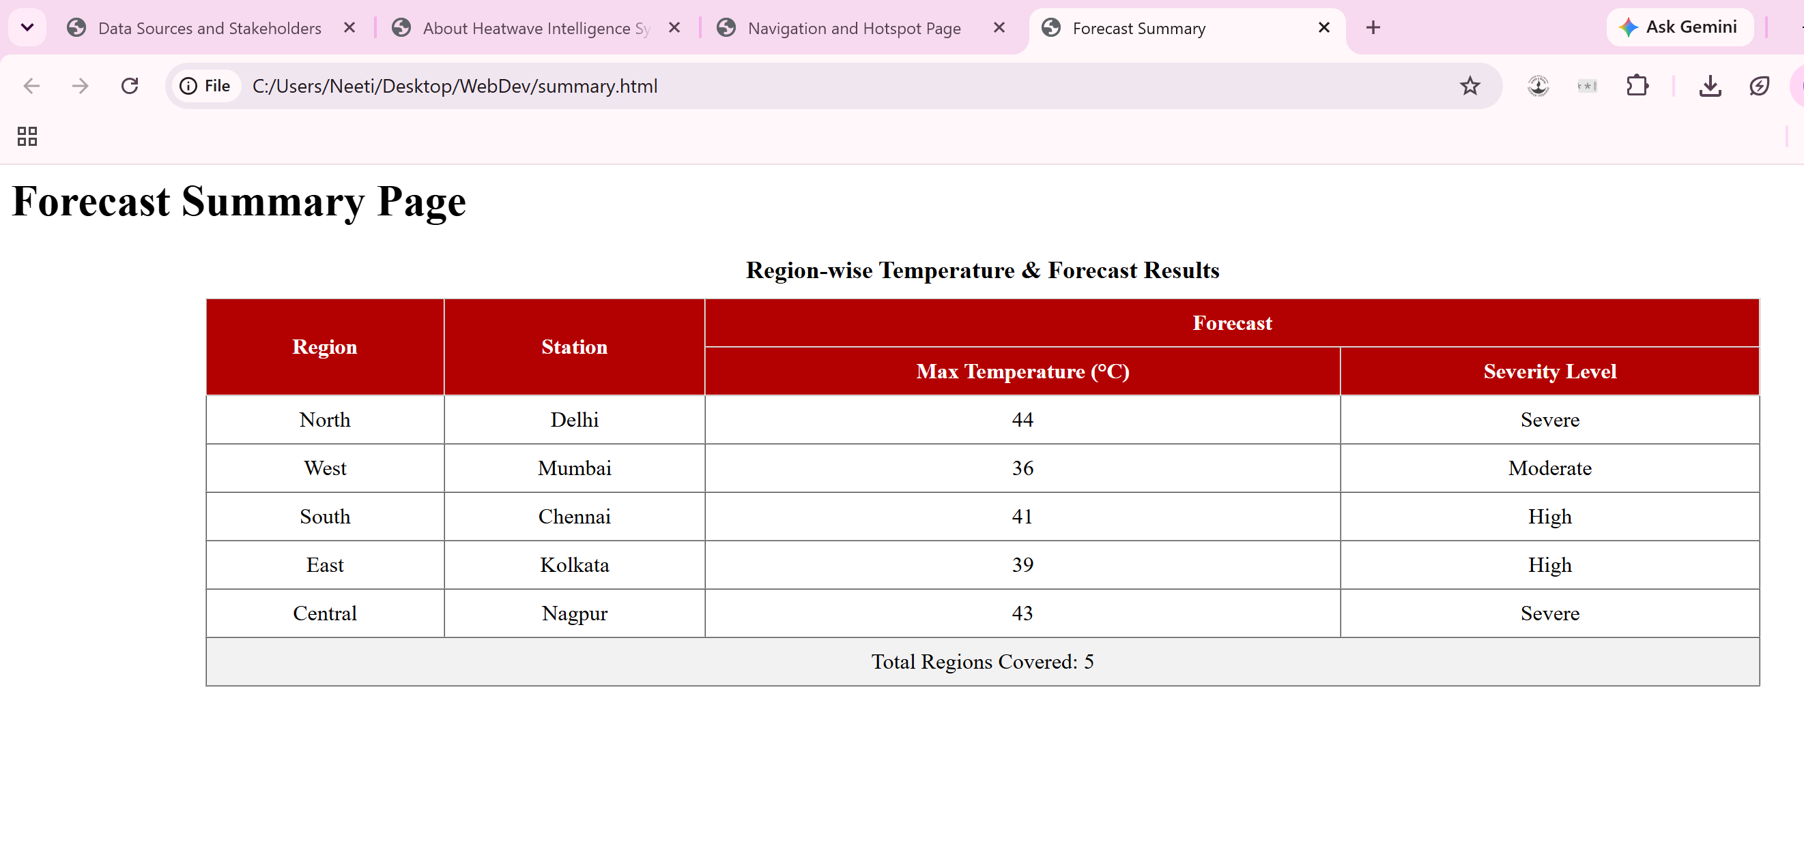
Output Task 8:
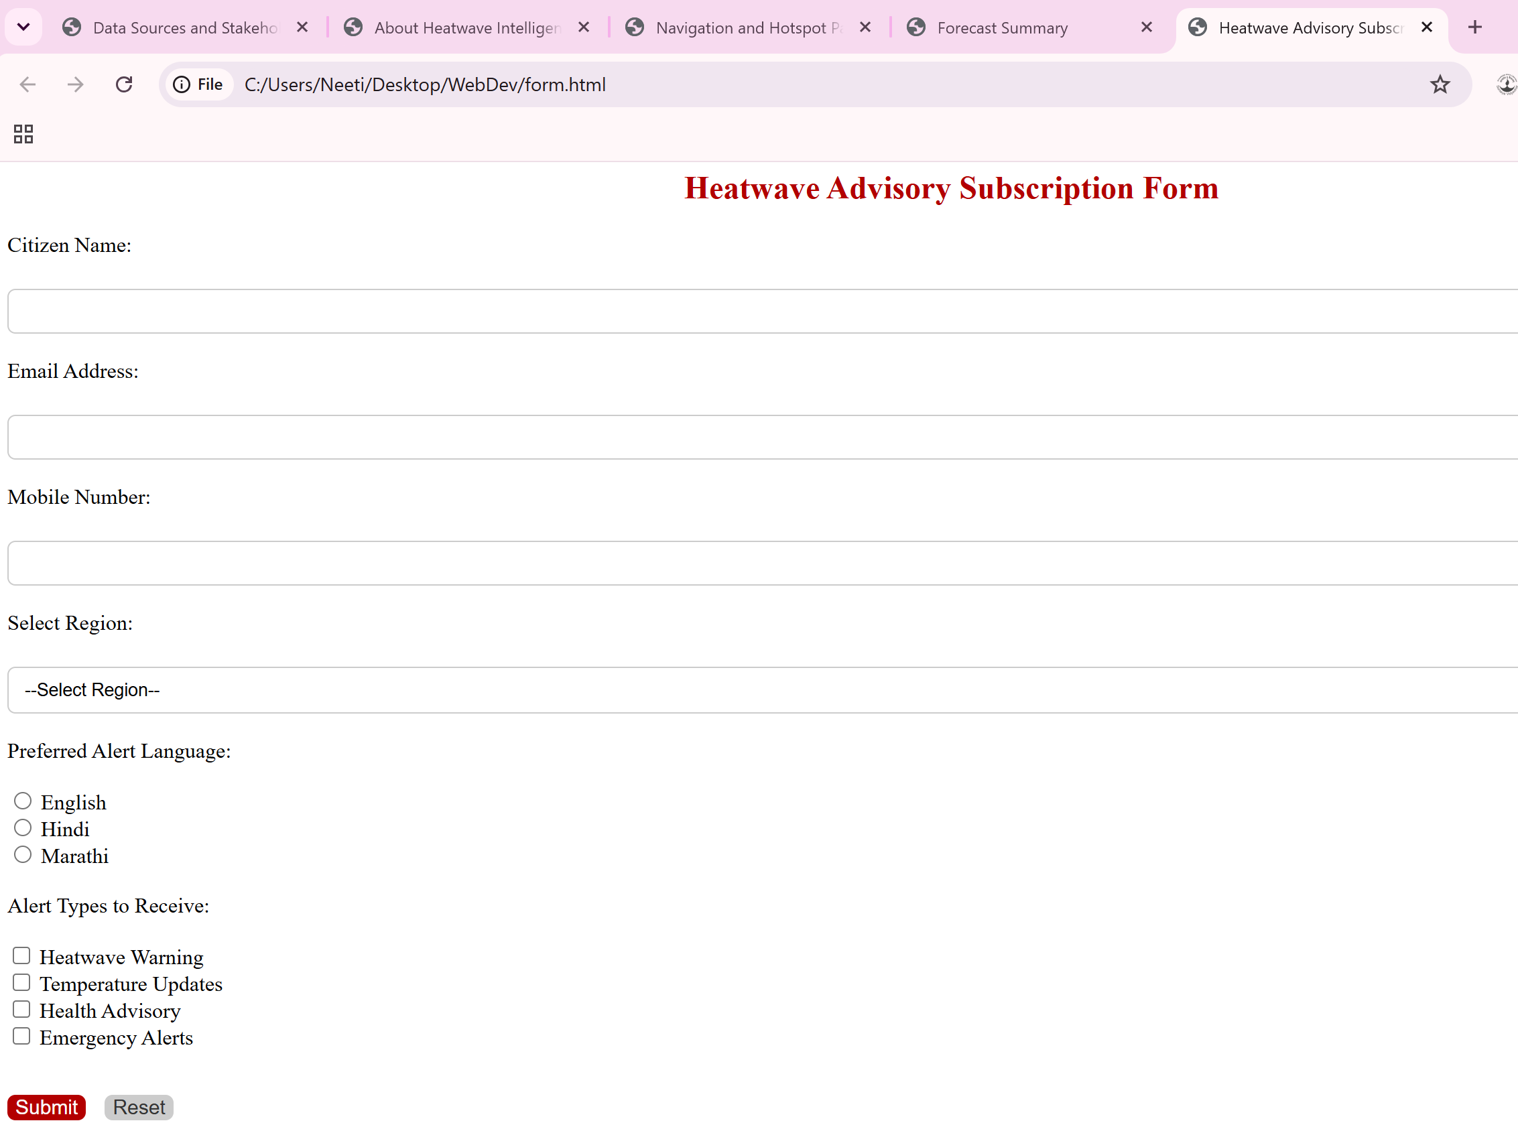
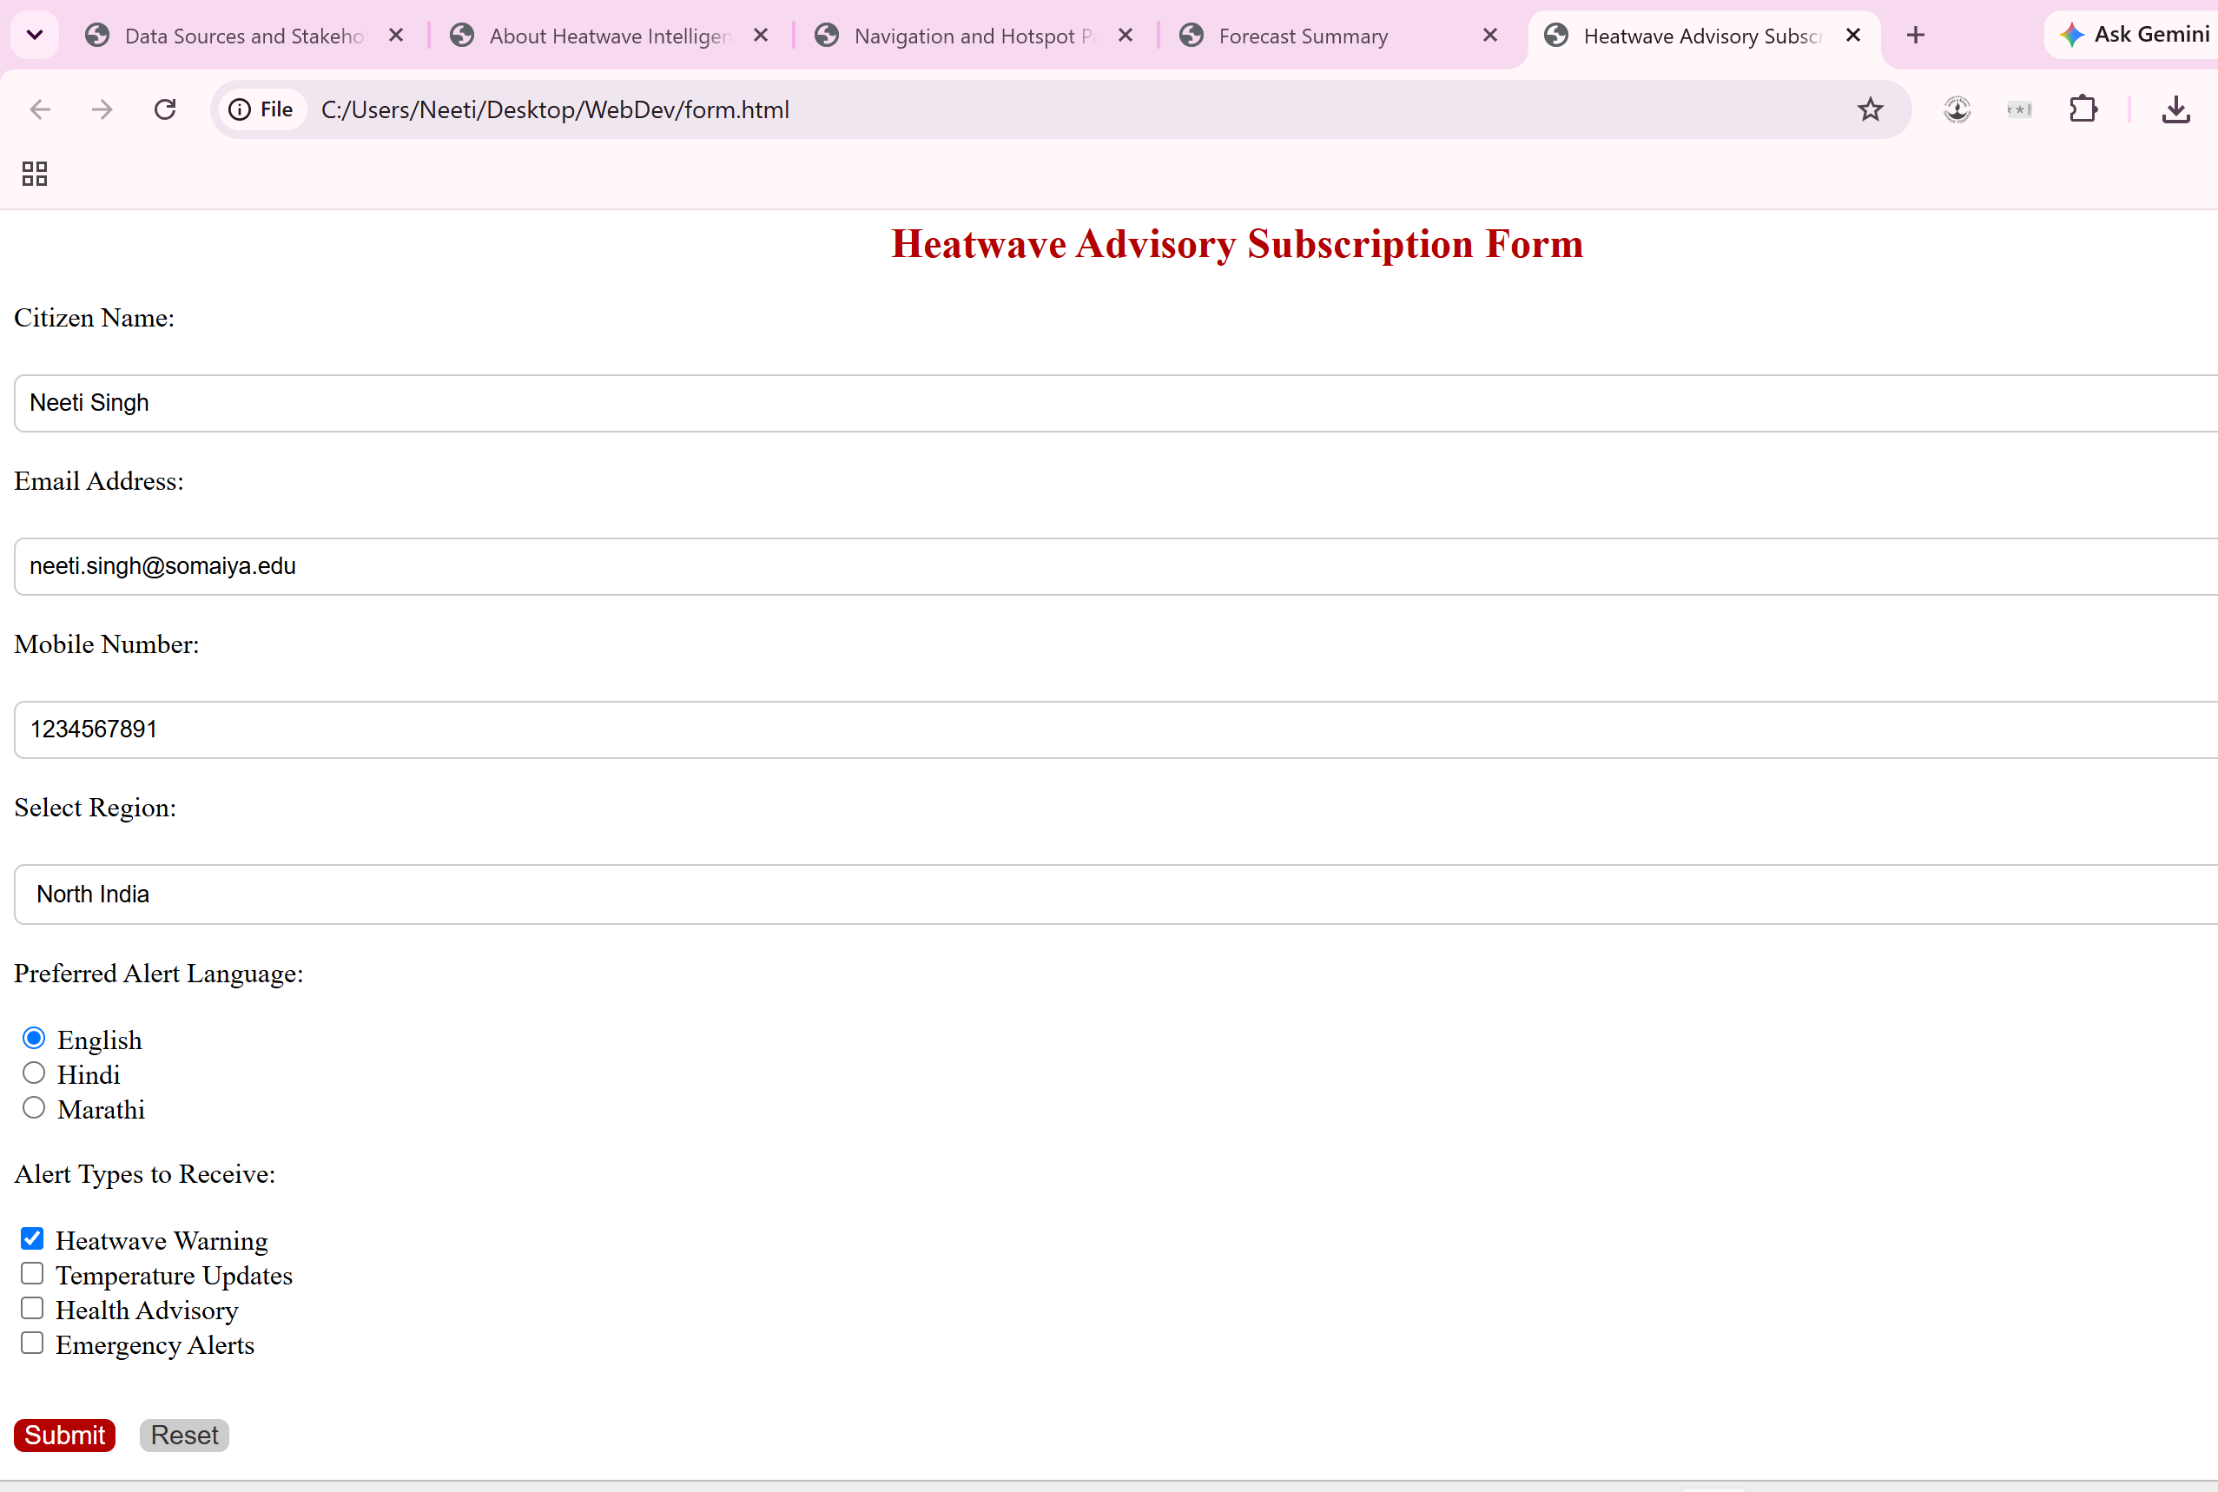
Output Task 9:
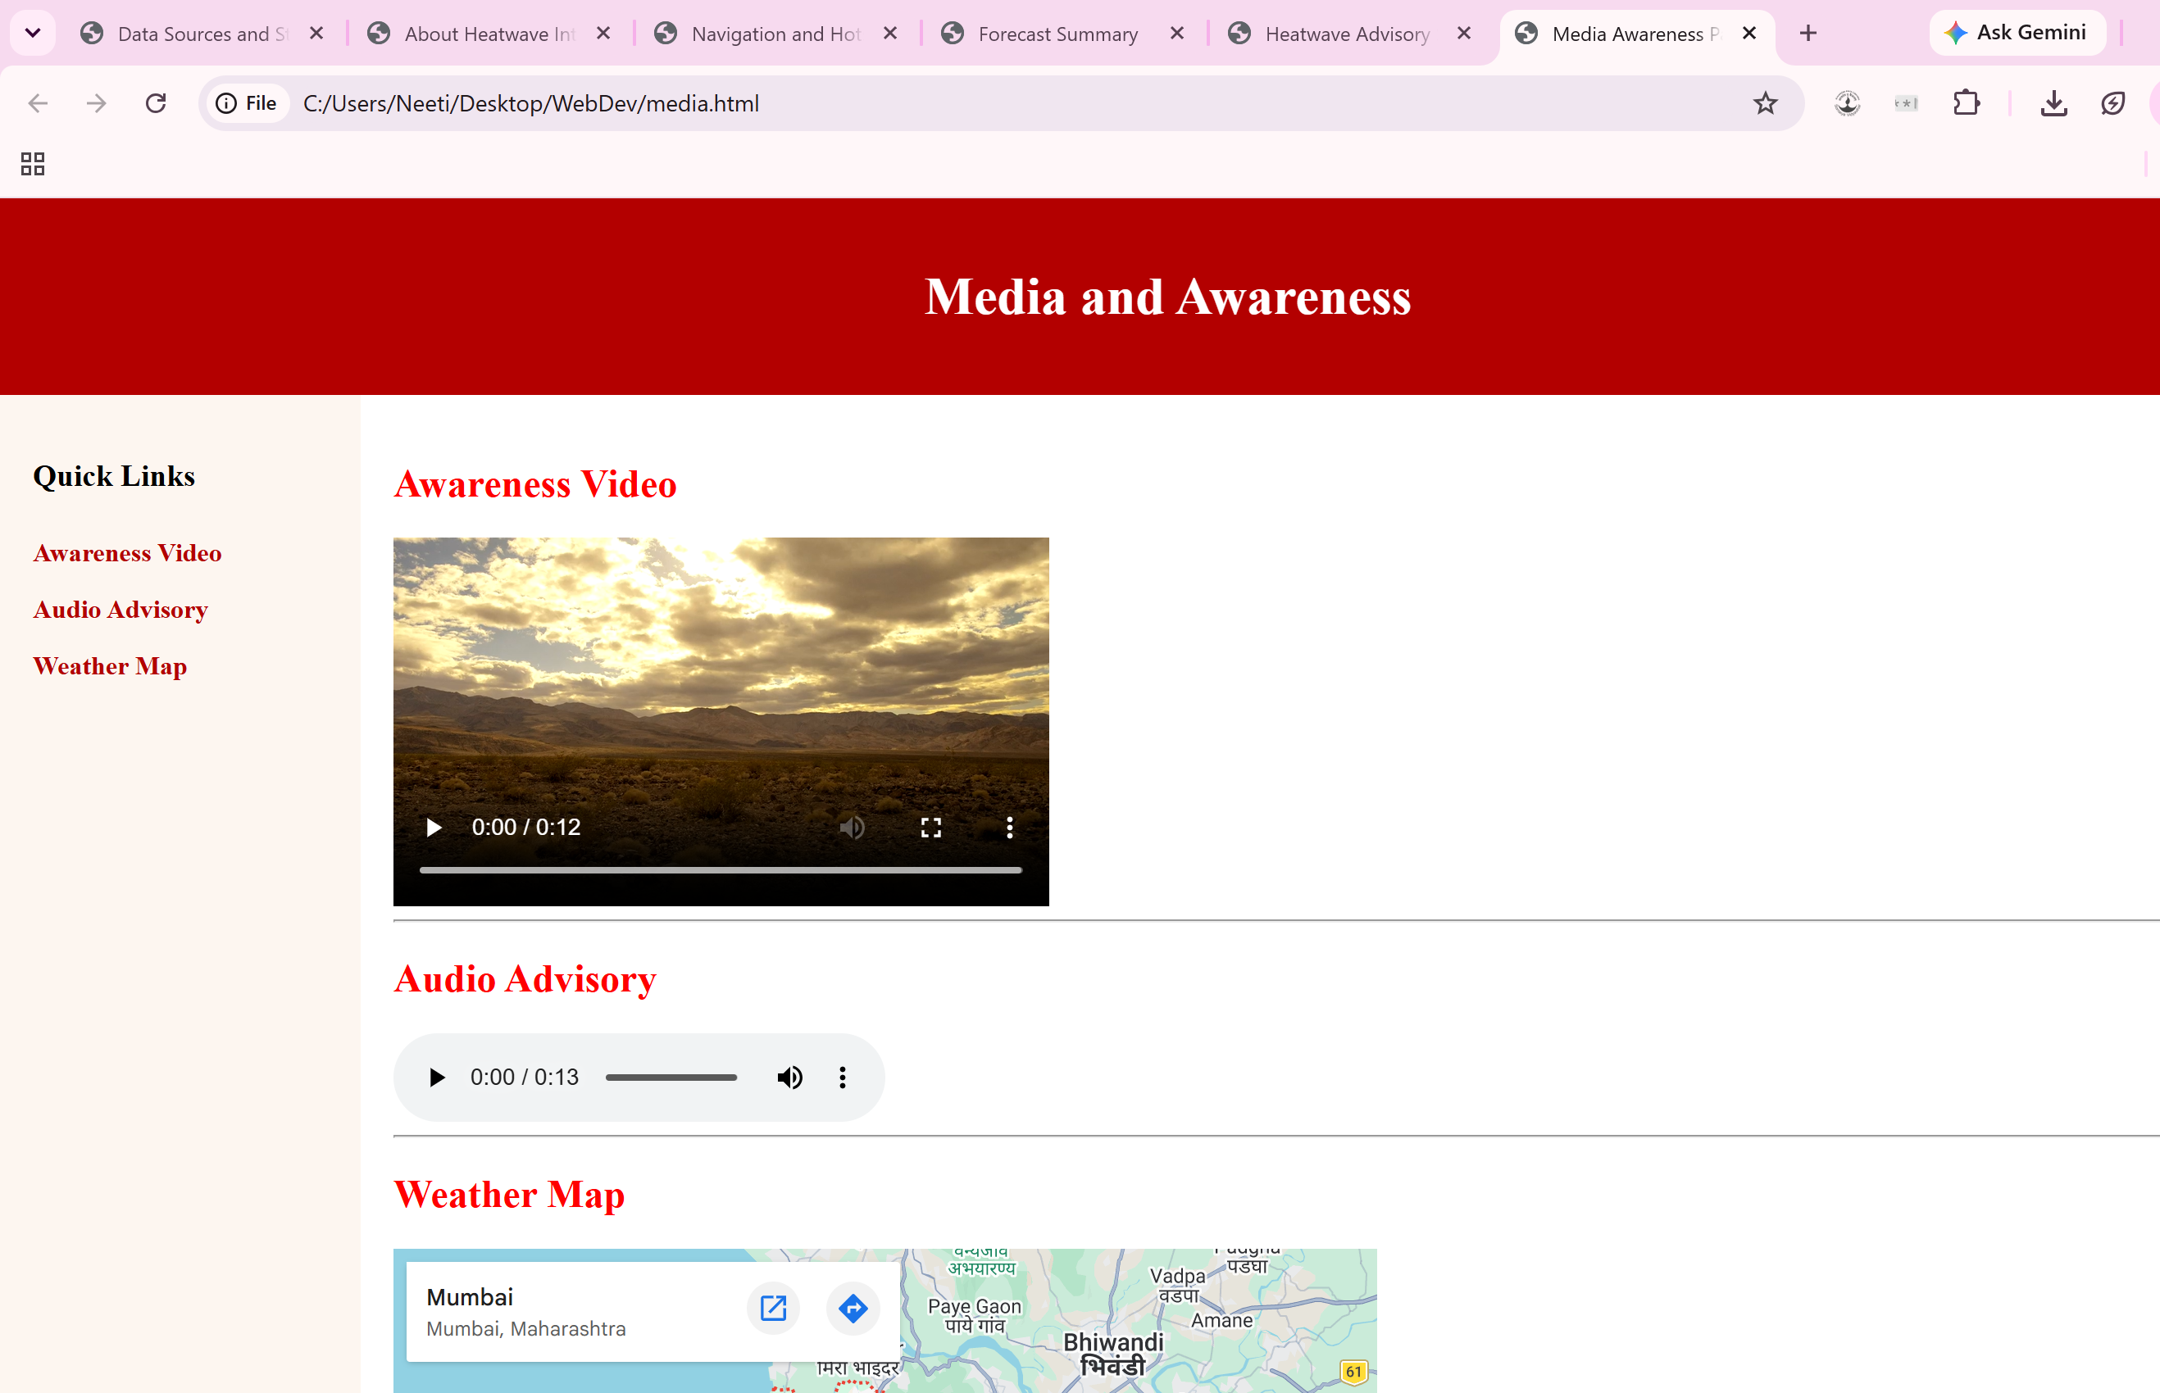
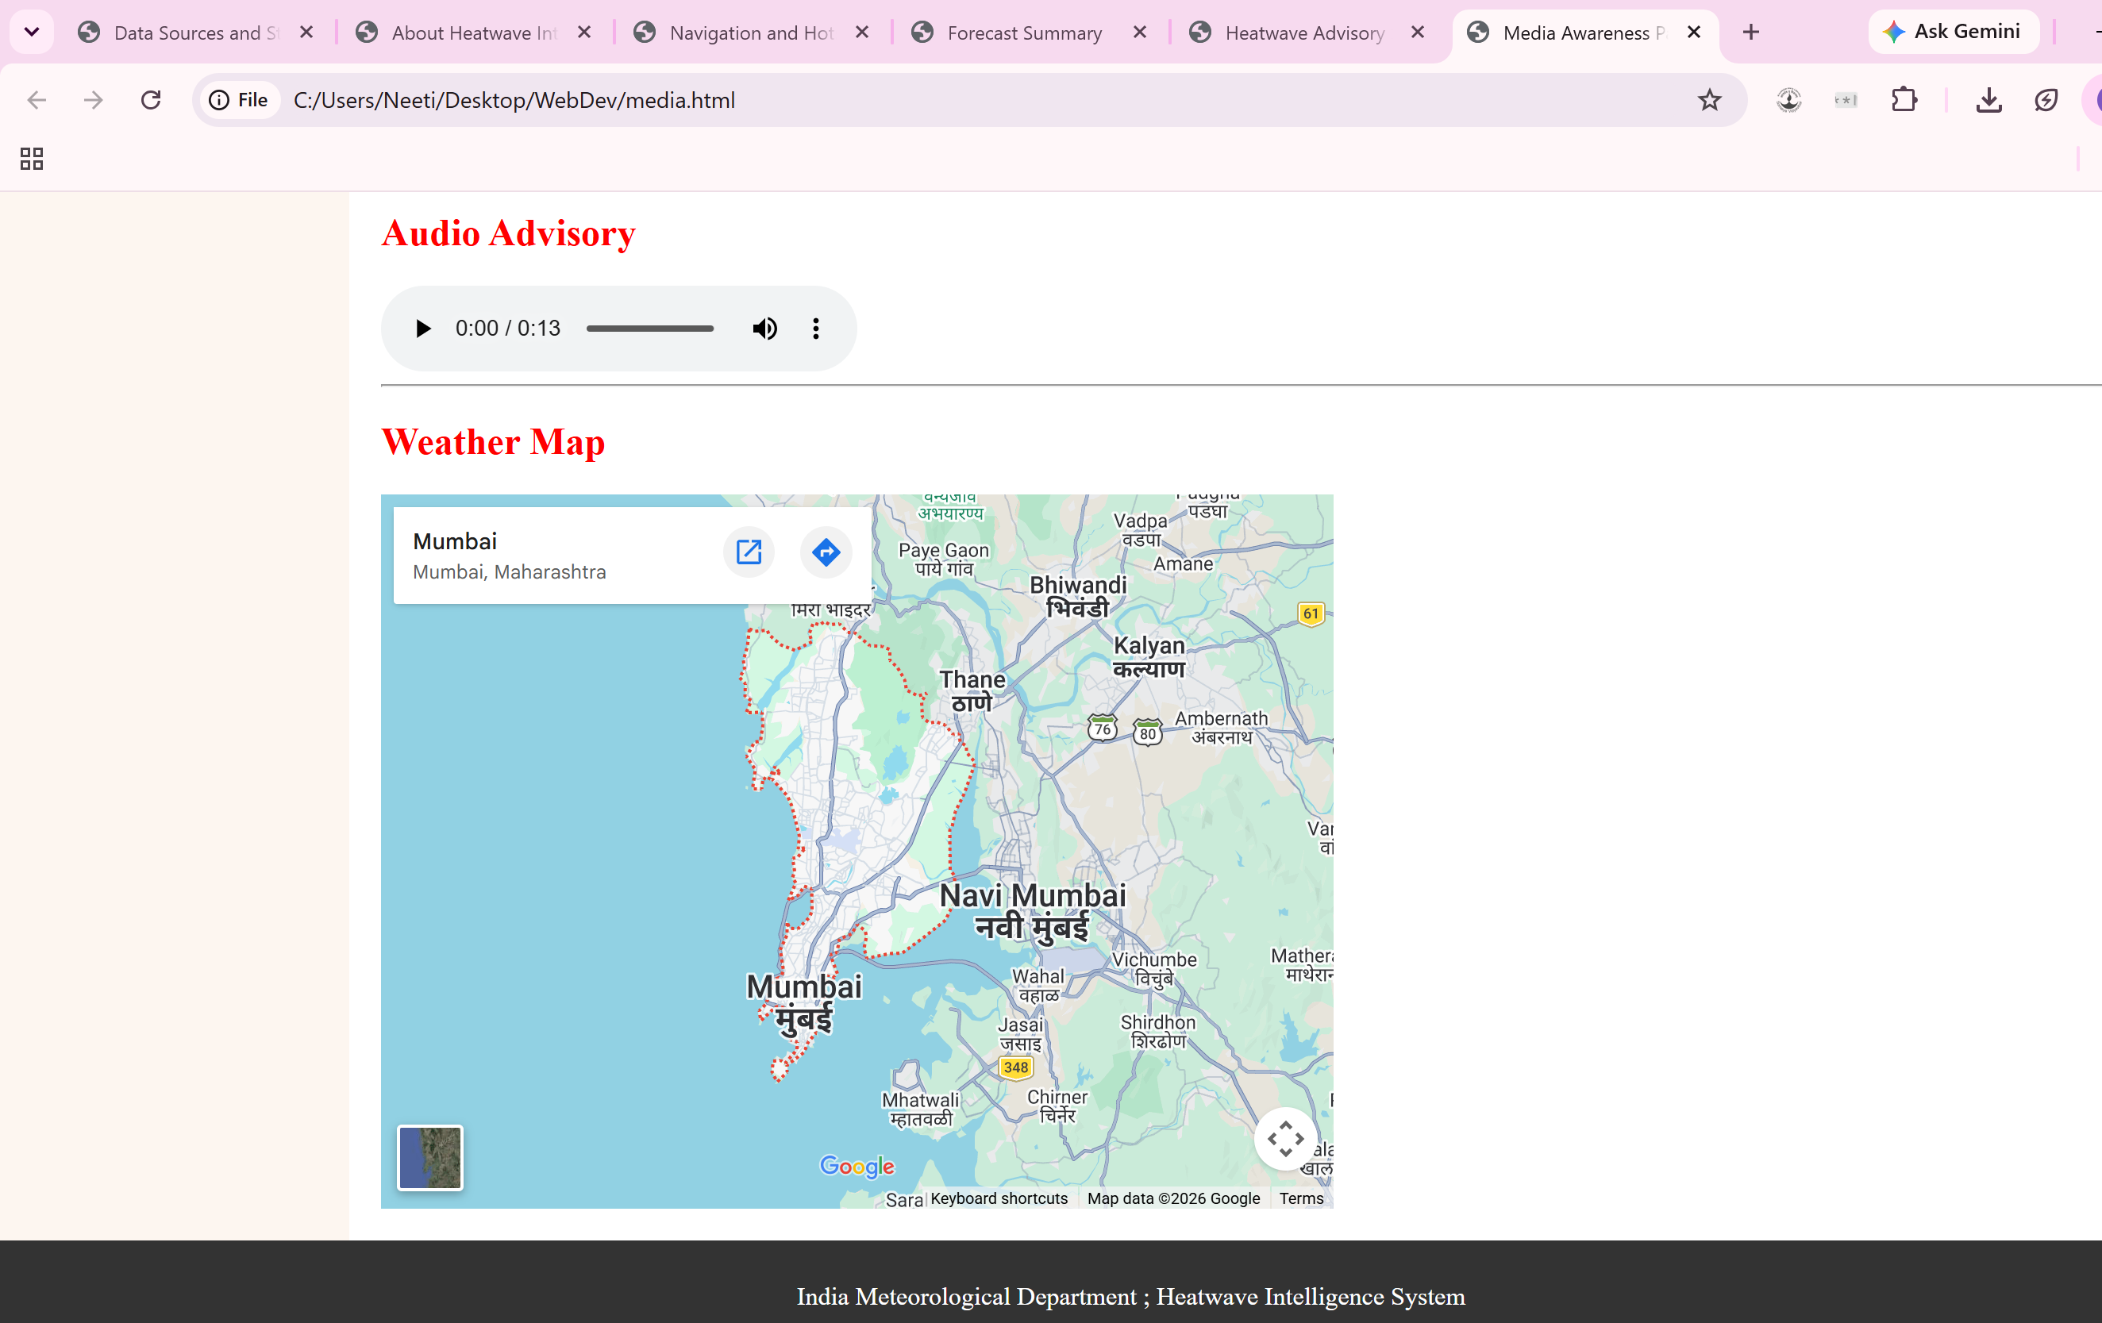
Output Task 10:
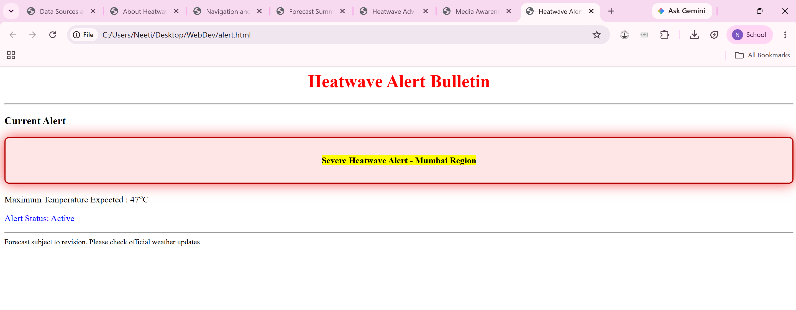

Post Lab Subjective/Objective type Questions:
- Use Bootstrap for CSS.
Using Bootstrap for CSS is different from using regular CSS because Bootstrap provides prebuilt classes and components for styling web pages. It reduces the amount of custom CSS code that needs to be written and speeds up development. Bootstrap also includes built-in responsive features, making it easier to create websites that work on different screen sizes.

Conclusion and Discussion:
Through this experiment I have learnt how to use css in html. We can use it to enhance how our website looks, making it look more attractive and interactive.

