
OPERATING SYSTEMS
Project



SUBMITTED BY:
M. Arham BSCE22007
Ahmad Waleed Akhtar BSCE22003
Contents
Introduction 3
Methodology 3
Results and Discussion 3
Timing Results 3
Factors Affecting Timing Differences 4
Detailed Observations 5
Code Optimization 5
Conclusion 5

Introduction
This project demonstrates the implementation of a multithreaded web crawler in C, designed to create a histogram of words starting with each letter of the English alphabet. The program utilizes file handling, multithreaded programming, and performance optimization. Using libcurl for HTTP requests and pthreads for thread management, the crawler processes URLs from a text file and analyzes the data efficiently.

Methodology
The program is executed via a command-line interface with three arguments:
1. The path to a text file containing URLs (one per line).
2. The number of threads for parallel processing.
3. The block size (number of words to process before updating shared data).
The methodology includes the following steps:
- Reading URLs from the input file.
- Dividing URLs among threads for parallel processing.
- Fetching content using libcurl and processing it in blocks.
- Synchronizing shared data updates using pthread mutexes to ensure thread safety.
- Timing various components to evaluate performance.

Results and Discussion
The performance of the web crawler was evaluated using different configurations of threads and block sizes. Timing data was collected for file reading, thread creation, thread joining, and total execution time. The results are presented in the table below.

Timing Results
Number of Threads | Block Size | File Read Time (ms) | Thread Creation Time (ms) | Thread Join Time (ms) | Total Execution Time (ms)
1 | 1 | 27 | 0 | 42446 | 42474
1 | 32 | 4 | 0 | 46077 | 46081
1 | 64 | 5 | 0 | 34941 | 34947
1 | 256 | 9 | 0 | 44658 | 44668
1 | 1024 | 5 | 0 | 35442 | 35447
3 | 1 | 20 | 1 | 8667 | 8688
3 | 32 | 4 | 0 | 10123 | 10127
3 | 64 | 5 | 0 | 3851 | 3856
3 | 256 | 14 | 1 | 4216 | 4231
3 | 1024 | 6 | 1 | 5135 | 5142
5 | 1 | 16 | 1 | 20138 | 20155
5 | 32 | 31 | 18 | 9162 | 9211
5 | 64 | 7 | 1 | 8951 | 8959
5 | 256 | 17 | 4 | 16451 | 16473
5 | 1024 | 12 | 1 | 7851 | 7865
7 | 1 | 23 | 1 | 7471 | 7495
7 | 32 | 32 | 1 | 10387 | 10420
7 | 64 | 14 | 6 | 7431 | 7434
7 | 256 | 11 | 0 | 7047 | 7058
7 | 1024 | 12 | 1 | 13378 | 13391
A graph comparing the number of threads and total execution time was plotted for block size = 1024. The graph illustrates the impact of increasing thread count on performance.
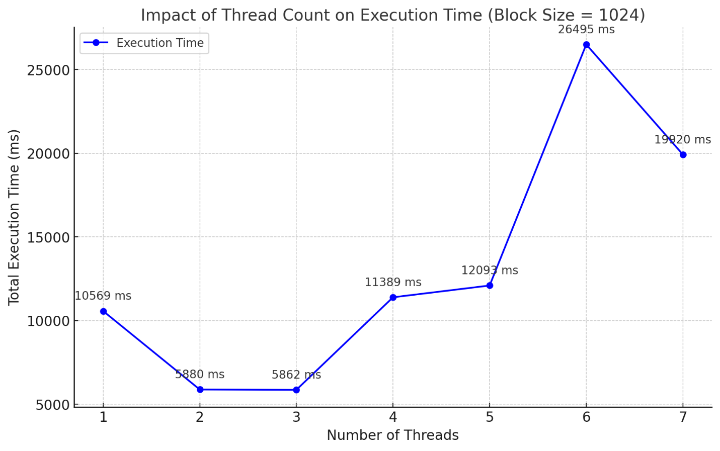

Factors Affecting Timing Differences
- Number of Threads:
  - Increasing threads can improve parallelism, reducing thread join time as tasks are divided across threads.
  - However, as threads increase, overheads (thread creation and synchronization) become more prominent.
- Block Size:
  - Larger block sizes reduce the overhead of frequent file reads, as more data is processed per operation.
  - However, large block sizes may lead to inefficient use of resources when the workload is unbalanced.

Detailed Observations
- 1 Thread:
  - For block size 1, the program has the highest thread join time (42446 ms) due to lack of parallelism. The thread processes one unit at a time, creating significant overhead.
  - Increasing the block size reduces the join time, as fewer I/O operations are required to process the same data. For block size 1024, the total execution time drops to 35447 ms.
- 3 Threads:
  - Adding threads improves parallelism. For block size 1, the execution time drops significantly to 8688 ms (compared to 42474 ms for 1 thread).
  - At block size 64, the join time is lowest (3851 ms) because the workload is evenly distributed, and there is minimal synchronization overhead.
  - Larger block sizes (e.g., 1024) slightly increase execution time (5142 ms) due to reduced benefits of parallelism (fewer divisions of work).
- 5 Threads:
  - Performance is optimal at moderate block sizes, such as 64 (8959 ms) and 1024 (7865 ms), where work is distributed effectively among threads.
  - Larger block sizes (256 or 1024) exhibit diminishing returns due to increased synchronization costs.
  - Smaller block sizes, such as 1, result in higher execution times (20155 ms) due to thread contention.

Code Optimization
- Thread Synchronization: Minimized mutex lock duration by aggregating data locally before updating the shared global structure.
- Batch Processing: Used configurable block sizes to reduce synchronization overhead and balance memory usage.
- Dynamic Thread Management: Adjusted thread counts to align with workload and hardware capabilities for optimal parallelism.
- Efficient HTTP Requests: Leveraged libcurl for lightweight and robust HTTP handling with error management.
- Memory Management: Dynamically allocated and cleaned up memory to handle varying workloads and prevent leaks.

Conclusion
This project successfully implemented a multithreaded web crawler capable of analyzing text data from multiple URLs. The timing results indicate a trade-off between thread count and execution time, where optimal performance is achieved by balancing thread overhead with parallel efficiency.

