Login Screen

Please make the login screen look like this in the Center of the page.

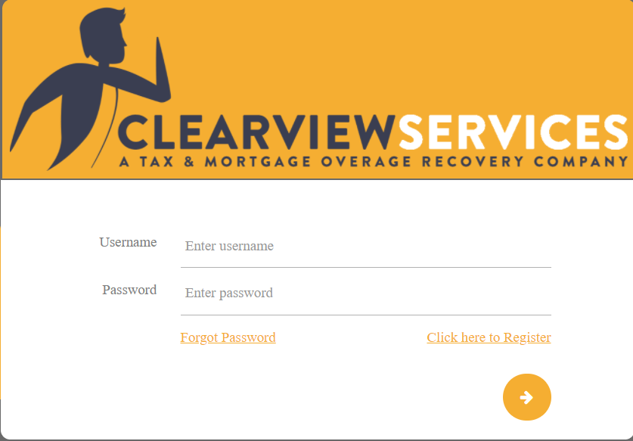

Can you make it look like this? I like this better.



Task



Rename field form Esculate STask = Escalate Task

Option Yes/No

Rename field from Esculate_Task = Escalate Task To

List Users in the company list

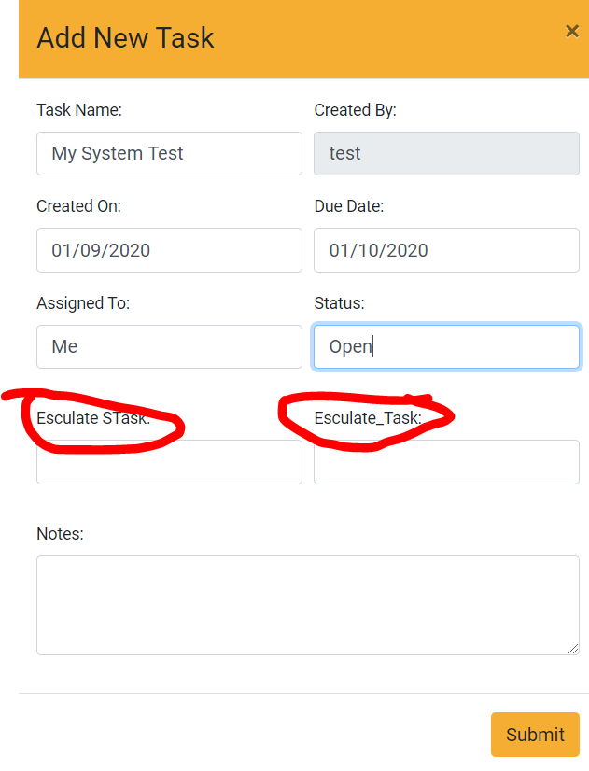

Owner

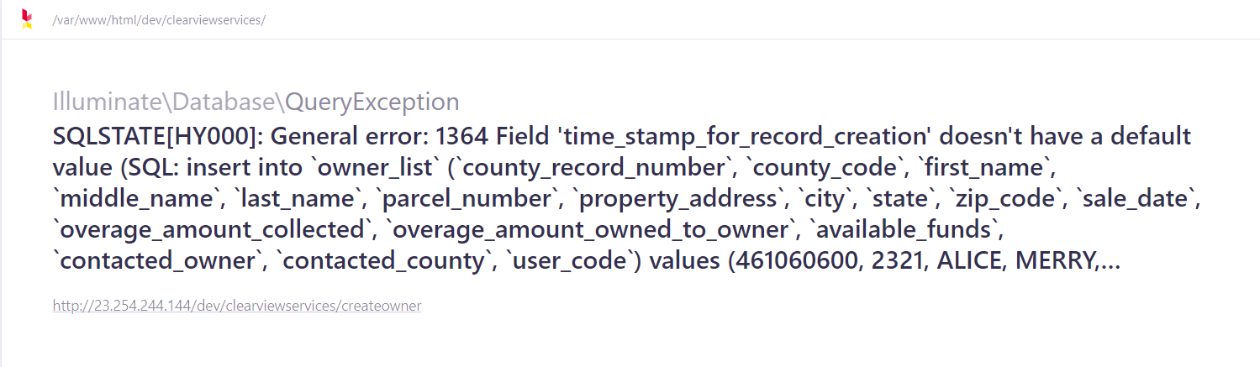

Make line clickable to opne properties like the County Record No

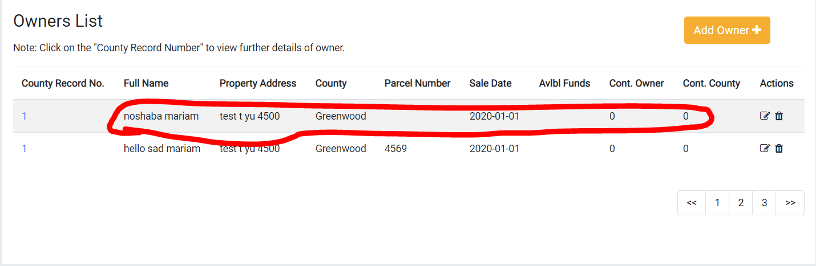

Owner’s Contact

Skip Tracing Source = list

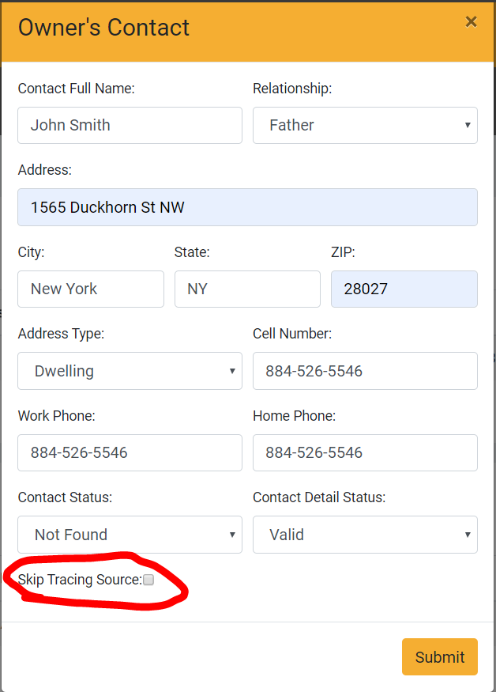

Make the field to type the information and not a checkbox

Error when you submit

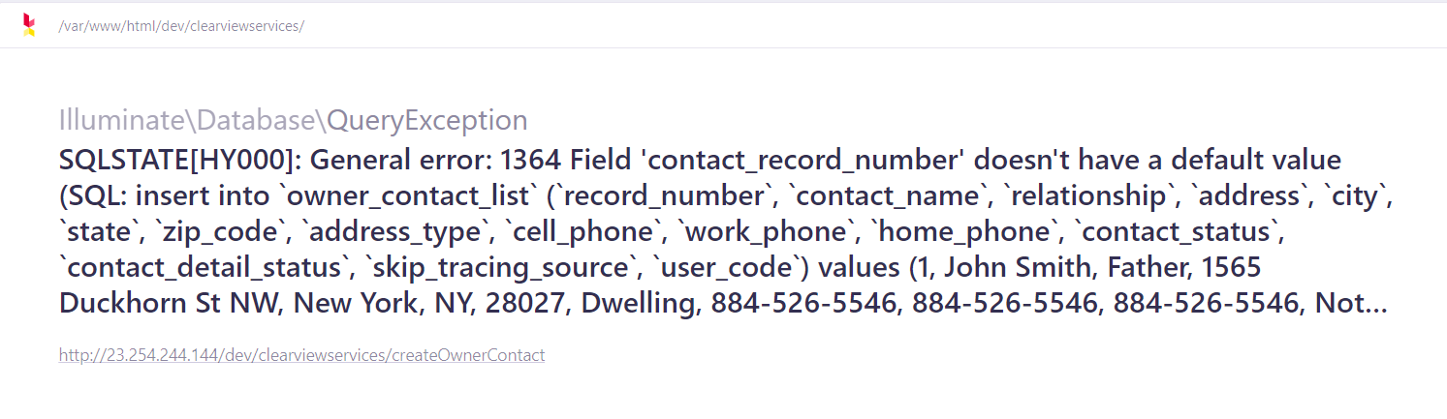

Document List

Error on submit

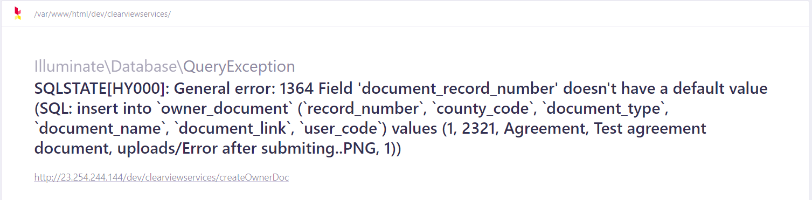

Overage Request Tracking

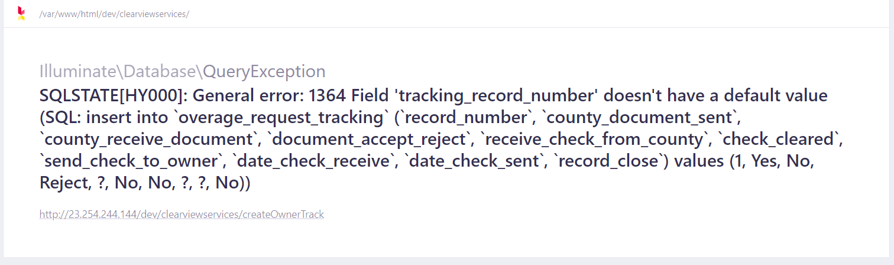

Make field Check Recieved From County: = Yes/No

