import pandas as pd

df = pd.read_csv("dataset4.csv")

print("Original DataFrame:")

print(df)

#Filter employees from Pune

pune_employees = df[df['City'] == 'Pune']

print("Employees from Pune:")

print(pune_employees)

#Calculate the average salary

average_salary = df['Salary'].mean()

print("Average Salary:", average_salary)

#Count employees by gender

gender_counts = df['Gender'].value_counts()

print("Employee Gender Counts:")

print(gender_counts)

#Sort employees by salary in descending order

sorted_df = df.sort_values('Salary', ascending=False)

print("Employees Sorted by Salary:")

print(sorted_df)

#Group employees by designation and calculate the average salary for each group

designation_salary = df.groupby('Designation')['Salary'].mean()

print("Average Salary by Designation:")

print(designation_salary)

#Add a new column 'Age' with default value 0

df['Age'] = 0

print("DataFrame with 'Age' Column:")

print(df)

#Select only the 'Name' and 'Salary' columns

selected_columns = df[['Name', 'Salary']]

print("Selected Columns:")

print(selected_columns)

#Filter employees with a salary greater than 100,000

high_salary_employees = df[df['Salary'] > 100000]

print("Employees with High Salary:")

print(high_salary_employees)

# Calculate the total salary for each city

city_salary_total = df.groupby('City')['Salary'].sum()

print("Total Salary by City:")

print(city_salary_total)

# Calculate the age based on the current year and assuming all employees are born in 1980

current_year = 2023

df['Age'] = current_year - 1980

print("DataFrame with Age Column:")

print(df)

Dataset:

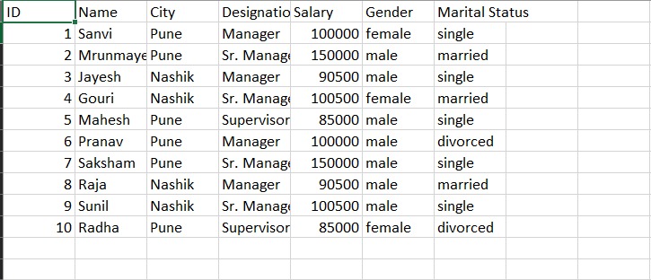

OUTPUT:

[Running] python -u "e:\_school\sem 2\EDS\assign_4.py"

Original DataFrame:

   ID       Name    City  Designation  Salary  Gender Marital Status

0   1      Sanvi    Pune      Manager  100000  female         single

1   2  Mrunmayee    Pune  Sr. Manager  150000    male        married

2   3     Jayesh  Nashik      Manager   90500    male         single

3   4      Gouri  Nashik  Sr. Manager  100500  female        married

4   5     Mahesh    Pune   Supervisor   85000    male         single

5   6     Pranav    Pune      Manager  100000    male       divorced

6   7    Saksham    Pune  Sr. Manager  150000    male         single

7   8       Raja  Nashik      Manager   90500    male        married

8   9      Sunil  Nashik  Sr. Manager  100500    male         single

9  10      Radha    Pune   Supervisor   85000  female       divorced

Employees from Pune:

   ID       Name  City  Designation  Salary  Gender Marital Status

0   1      Sanvi  Pune      Manager  100000  female         single

1   2  Mrunmayee  Pune  Sr. Manager  150000    male        married

4   5     Mahesh  Pune   Supervisor   85000    male         single

5   6     Pranav  Pune      Manager  100000    male       divorced

6   7    Saksham  Pune  Sr. Manager  150000    male         single

9  10      Radha  Pune   Supervisor   85000  female       divorced

Average Salary: 105200.0

Employee Gender Counts:

Gender

male      7

female    3

Name: count, dtype: int64

Employees Sorted by Salary:

   ID       Name    City  Designation  Salary  Gender Marital Status

1   2  Mrunmayee    Pune  Sr. Manager  150000    male        married

6   7    Saksham    Pune  Sr. Manager  150000    male         single

3   4      Gouri  Nashik  Sr. Manager  100500  female        married

8   9      Sunil  Nashik  Sr. Manager  100500    male         single

0   1      Sanvi    Pune      Manager  100000  female         single

5   6     Pranav    Pune      Manager  100000    male       divorced

2   3     Jayesh  Nashik      Manager   90500    male         single

7   8       Raja  Nashik      Manager   90500    male        married

4   5     Mahesh    Pune   Supervisor   85000    male         single

9  10      Radha    Pune   Supervisor   85000  female       divorced

Average Salary by Designation:

Designation

Manager         95250.0

Sr. Manager    125250.0

Supervisor      85000.0

Name: Salary, dtype: float64

DataFrame with 'Age' Column:

   ID       Name    City  Designation  Salary  Gender Marital Status  Age

0   1      Sanvi    Pune      Manager  100000  female         single    0

1   2  Mrunmayee    Pune  Sr. Manager  150000    male        married    0

2   3     Jayesh  Nashik      Manager   90500    male         single    0

3   4      Gouri  Nashik  Sr. Manager  100500  female        married    0

4   5     Mahesh    Pune   Supervisor   85000    male         single    0

5   6     Pranav    Pune      Manager  100000    male       divorced    0

6   7    Saksham    Pune  Sr. Manager  150000    male         single    0

7   8       Raja  Nashik      Manager   90500    male        married    0

8   9      Sunil  Nashik  Sr. Manager  100500    male         single    0

9  10      Radha    Pune   Supervisor   85000  female       divorced    0

Selected Columns:

        Name  Salary

0      Sanvi  100000

1  Mrunmayee  150000

2     Jayesh   90500

3      Gouri  100500

4     Mahesh   85000

5     Pranav  100000

6    Saksham  150000

7       Raja   90500

8      Sunil  100500

9      Radha   85000

Employees with High Salary:

   ID       Name    City  Designation  Salary  Gender Marital Status  Age

1   2  Mrunmayee    Pune  Sr. Manager  150000    male        married    0

3   4      Gouri  Nashik  Sr. Manager  100500  female        married    0

6   7    Saksham    Pune  Sr. Manager  150000    male         single    0

8   9      Sunil  Nashik  Sr. Manager  100500    male         single    0

Total Salary by City:

City

Nashik    382000

Pune      670000

Name: Salary, dtype: int64

DataFrame with Age Column:

   ID       Name    City  Designation  Salary  Gender Marital Status  Age

0   1      Sanvi    Pune      Manager  100000  female         single   43

1   2  Mrunmayee    Pune  Sr. Manager  150000    male        married   43

2   3     Jayesh  Nashik      Manager   90500    male         single   43

3   4      Gouri  Nashik  Sr. Manager  100500  female        married   43

4   5     Mahesh    Pune   Supervisor   85000    male         single   43

5   6     Pranav    Pune      Manager  100000    male       divorced   43

6   7    Saksham    Pune  Sr. Manager  150000    male         single   43

7   8       Raja  Nashik      Manager   90500    male        married   43

8   9      Sunil  Nashik  Sr. Manager  100500    male         single   43

9  10      Radha    Pune   Supervisor   85000  female       divorced   43

[Done] exited with code=0 in 0.613 seconds