

Lab Project Report

# MCT-333l CONTROL SYSTEMS -1

**SUBMIT TO:**

**SIR IMRAN**

**NAMES REG NUMBERS**

MUHAMMAD AMIR 2020-MC-267

ARHAM ALI 2019-MC-253

FAIZAN ALI 2020/2019-MC-297

MUHAMMAD HASSAN 2020-MC-321

NAFEEL SAJID 2020-MC-295

KANWAR ABDULLAH 2020-MC-277

## Department of Mechanical, Mechatronics & Manufacturing Engineering B.Sc. Mechatronics & Control Engineering Program

**University of Engineering & Technology Lahore (Faisalabad Campus)**

**Design and Implementation of Ball and Beam System using PID Controller**

**INTRODUCTION:**

The control of unstable systems is very important for many control problems. Since such systems prove dangerous to test in vertical position control of aerospace and air planes, we can only study them in laboratories by modeling the system. The ball and beam system is also called ‘balancing a ball on a beam’. It is generally linked to real control problems such as horizontally stabilizing an airplane during landing and in turbulent airflow. The aim of the system is to control the position of the ball to a desired reference point, and reject disturbances such as a push from a finger. The control signal can be derived by feeding back the position information of the ball. The control voltage signal goes to the Direct Current (DC) servomotor, and then the torque generated from the motor drives the beam to rotate to the desired angle. Thus, the ball can be located at the desired position.

**SYSTEM MATHEMATICAL MODELING:**

The system consist of two separated systems, the first one is the DC servo motor which is an electromechanical system that receives electrical signal from controller and gives output as a rotational displacement (angle). The second is ball and beam model which is a mechanical system that receives rotational displacement (angle) from motor and converts it into a linear displacement.

**A.DC Servo Motor Model**

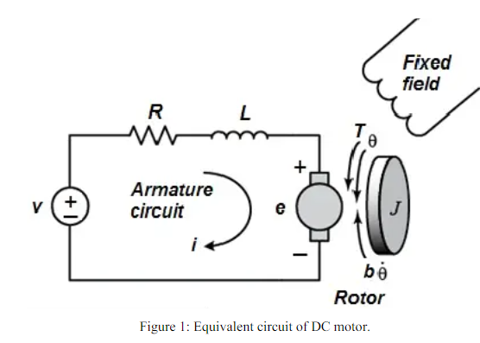A common actuator in control systems is the DC motor. It directly provides rotary motion and, coupled with wheels or drums and cables, can provide translational motion. The electric equivalent

circuit of the armature and the free-body diagram of the rotor are shown in Fig. 1.

Figure 1: Equivalent circuit of DC motor.

So the transfer function becomes as shown in Equation (1):



(s): Motor position

V(s): Supply voltage

Kg: Gears ratio

K: Motor torque constant and the back emf constant

J: Moment of inertia of the rotor

b: Motor viscous friction constant

La: Motor electric inductance

Ra: Motor electric resistance, and (V) is the voltage source

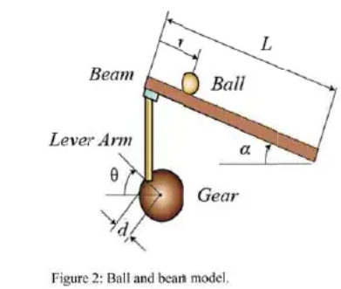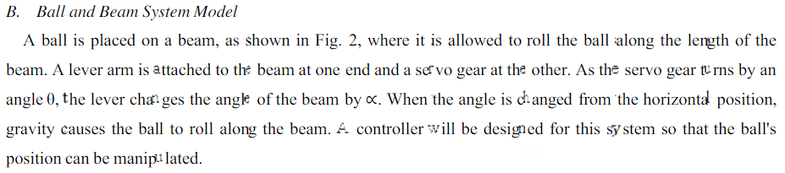

So the transfer function will be:

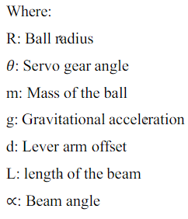

**MECHANICAL PARTS OF BALL AND BEEM SYSTEM**

Selection of appropriate material for a mechanical part is an essential element of all engineering projects. Themain mechanical parts of the system are the base support, beam and ball as shown in Fig. 3.Following materials are used in to build the system:

Base support made of wood has length of (2.55) and width of (10 INCH).

TWO Aluminum hollow beams which has length of (2FT), and width of (2 INCH ).

Servo motor horn is (4 inch)

Lever horn is 6 inch

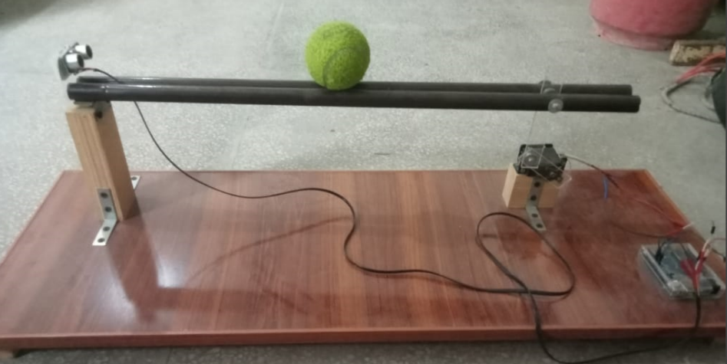

Ball beam system

**System Electrical Part**

The Electrical circuit consists of:

Arduino Uno

DC servo motor (DSS-M15)

Ultrasonic sensor

Ultrasonic sensor connected to pin 7 (digital pin) because it sends its output signal in a digital form to the Arduino which divide the input signal into 58 to determine the ball distance in centimeters, this value represent the input of the PID to be compared with the set point. The servo motor connected to pin 9 which it can be used as a Pulse Width Modulation (PWM), it receives its input (angle) from PID controller. The electric circuit connections are shown in Fig.

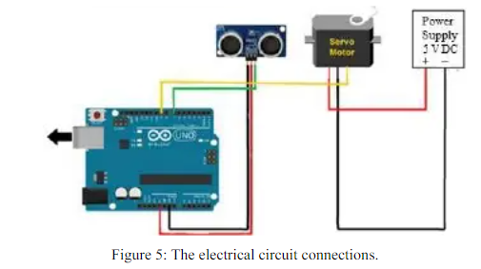

**PID CONTROLLER DESIGN**

It is difficult to design a controller with Ziegler-Nicolas for major reason; it was found that the overall system is a fifth order system which mean difficult to design controller for a higher order systems. To make the control design easy the whole system is separated into two feedback loops; inner loop and outer loop as shown in Fig.6.The purpose of the inner loop is to control the motor gear angle position so that gear angle (θ) tracks there ferences signal (ref θ). The outer loop uses the inner feedback loop to control the ball position.

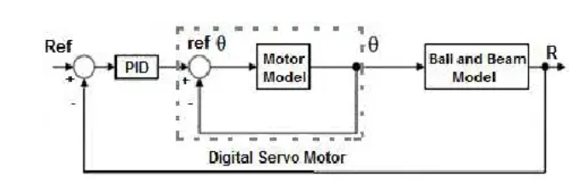

PID control of overall system

In general the gains of Kp, Ki, and Kd will need to be adjusted by the user in order to best serve the system. While there is no a static set of rules for which the values should be used for any system, following the general procedures should help in tuning a circuit to match one’s system and environment. In general a PID circuit will typically overshoot the set point value slightly and then quickly damp out to reach the set point value. Manual tuning of the gain settings is the simplest method for setting the PID controls. However, this procedure is done actively (the PID controller turned on and properly attached to the system) and requires some amount of experience to fully integrate. To tune PID controller manually, first the integral and derivative gains are set to zero . Increase the proportional gain until observing oscillation in the output. After the proportional gain is set, the derivative gain can then be increased.

Derivative gain will reduce overshoot and damp the system quickly to the set point value or near it. If the derivative gain increased too much, large overshoot will be seen. Once the derivative gain is set, increase the integral gain until any offset is corrected for on a time scale appropriate for the system. If the gain increased too much, significant overshoot of the set point value and instability in the circuit will be observed. The best performance depends on designer specifications. All the parameters had get from manual tuning method shown in Table 1.

**EXPERIMENTAL RESULTS**

This section demonstrates the results of a real time plotting using MATLAB of ball and beam system using design of PID controller with manual tuning method. With desired value of distance between ultrasonic sensor and rolling ball set to be 15 cm, noted that this value can be changed by modifying it in the controller algorithm considering it as the set point (reference) of the control system.

**CODE:**

**#include <Servo.h>**

**// Ultrasonic sensor pins**

**const int trigPin = 6;**

**const int echoPin = 7;**

**// Servo motor pins**

**const int servoPin = 9;**

**// Constants for PID control**

**const double Kp = 6; // Proportional constant**

**const double Ki = 0.0; // Integral constant**

**const double Kd = 1.5; // Derivative constant**

**// Variables for PID control**

**double setpoint = 50/2; // Desired position in centimeters**

**//double setpoint = 30; // Desired position in centimeters**

**double input = 0.0; // Current position in centimeters**

**double output = 0.0; // Servo motor angle**

**double error = 0.0; // Position error**

**double previousError = 0.0;**

**double integral = 0.0;**

**double derivative = 0.0;**

**Servo servo;**

**void setup() {**

**// Initialize the servo motor**

**Serial.begin(9600);**

**servo.attach(servoPin);**

**// Initialize the ultrasonic sensor**

**pinMode(trigPin, OUTPUT);**

**pinMode(echoPin, INPUT);**

**// Set the initial position of the servo motor**

**servo.write(130); // Zero degree position**

**}**

**void loop() {**

**// Read the current position from the ultrasonic sensor**

**double duration, distance;**

**digitalWrite(trigPin, LOW);**

**delayMicroseconds(2);**

**digitalWrite(trigPin, HIGH);**

**delayMicroseconds(10);**

**digitalWrite(trigPin, LOW);**

**duration = pulseIn(echoPin, HIGH);**

**distance = duration * 0.034 / 2.0; // Calculate distance in centimeters**

**Serial.println(distance);**

**delay(100);**

**CONCLUSION:**

A mathematical model of the ball and beam system was developed using physical and electrical laws .A simplified mathematical model was derived through system parameters. The controller parameters values (Kp, Ki and Kd) were obtained by using manual tuning method from practical model so as to perform best system response. From experimental results, it is found that the best controller parameters which gave the best response of the system are: Kp=4, Ki=1 and Kd=2. The accuracy of the system is tested by adjusting the position of the ball at three different points and it found that the accuracy doesn’t affected by changing the set point

**REFERENCES:**

**[1]**E. P. Dadios, R. Baylon, R. D. Guzman, A. Florentino, R. M. Lee ve Z. Zulueta, Vision Guided Ball-Beam Balancing System UsingFuzzy Logic, 26th Annual Conference of the IEEE Industrial Electronics Society, Cilt 3, pp. 1973-1978, 2000.

[2] J. Whelan ve J. W. Ringwood, A Demonstration Rig for Control Systems Based on the Ball and Beam with Vision Feedback, Proc.3

rd

 IFAC Symposium on Control Education, Tokyo, 1994.

[3] S. Sridharan ve G. Sridharan, Ball and Beam on Roller: A New Control Laboratory Device, Proceedings of the 2002 IEEE InternationalSymposium on Industrial Electronics, Cilt 4, 2002, pp. 1318-1321.

[4] Sıtkı KOCAOĞLU, Hilmi KUŞÇU: “Design and Control of PID-Controlled Ball and Beam System”

*Unitech. Int. Science Conference,Gabrovo, 2013, PP: 41-46*