|  |  |
| --- | --- |
| **Name** | **Arham Ali** |
| **Registration** | **2019-MC-253** |
| **Date** | **11-08-2020** |
| **Marks** |  |

**Creating A Gcode and Engraving it on Repetier.**

**Task:**

* Installing Inkscape and Repetier.
* Making a GCODE file and exporting it using INKSCAPE.
* Simulating its output on REPETIER

**Download and Installation Procedure of the Softwares :**

* First of all write Inkscape in your web browser.

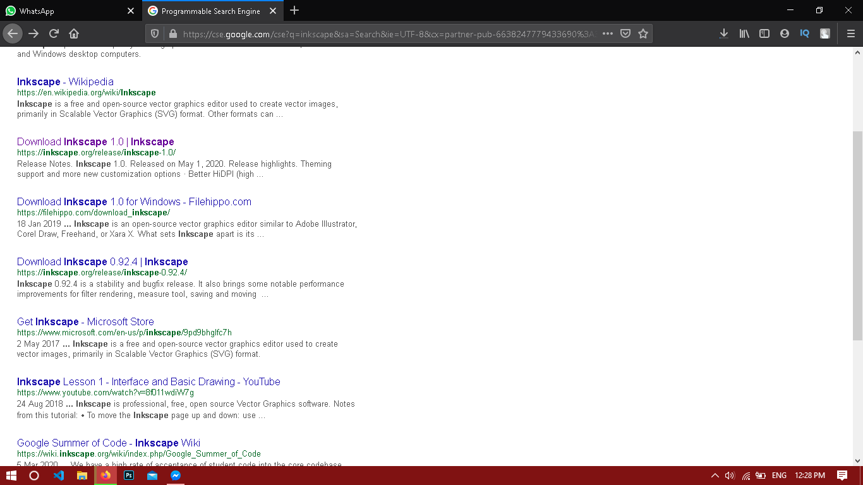

Fig 9.1(Illustrating the link to INKSCAPE official site)

* After that you will be redirected to the official site of the inkscape. There you will see the following screen.

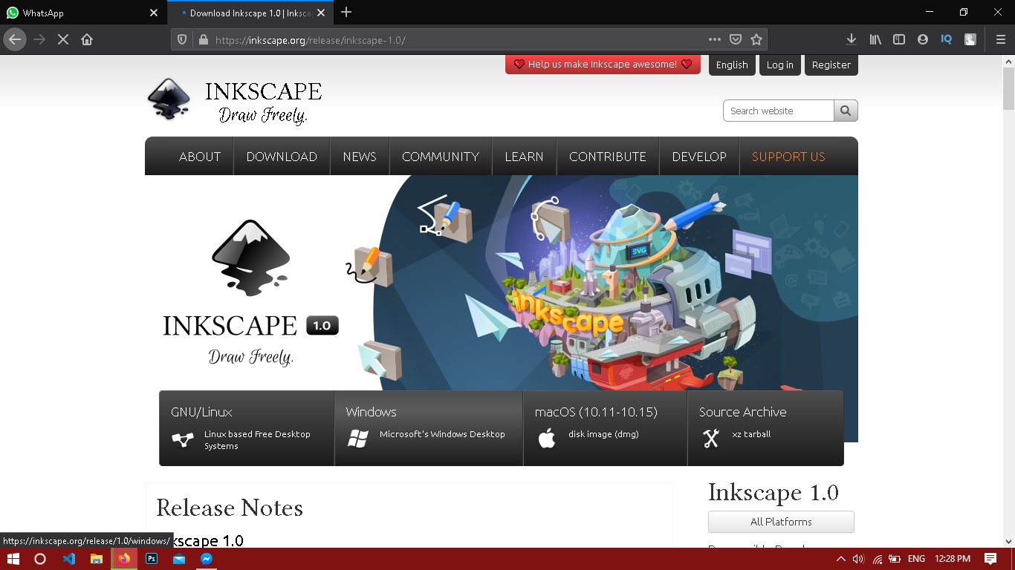

* There you will have to specify what type of operating system you want it to run after selecting the specified OS you will be asked to tell what kind of architecture your windows of MAC has you will select the specific one as shown below:

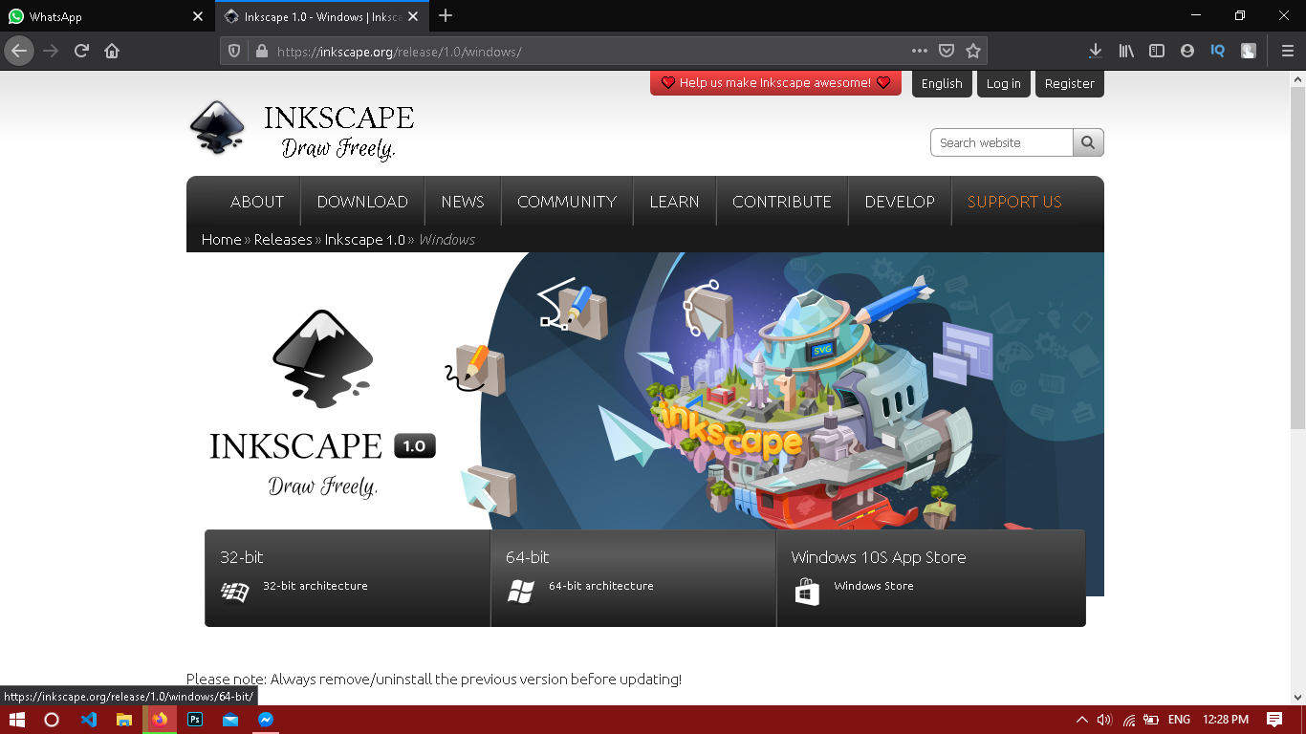

* After selecting your specific architecture of the windows you will be asked what kind of file do you want to download there will be 3 types of files
* EXE(executable windows file)
* MSI(Configurable windows file)
* 7z (Compressed windows file)
* After selecting your desired file download it using one of the mirror links as shown below:

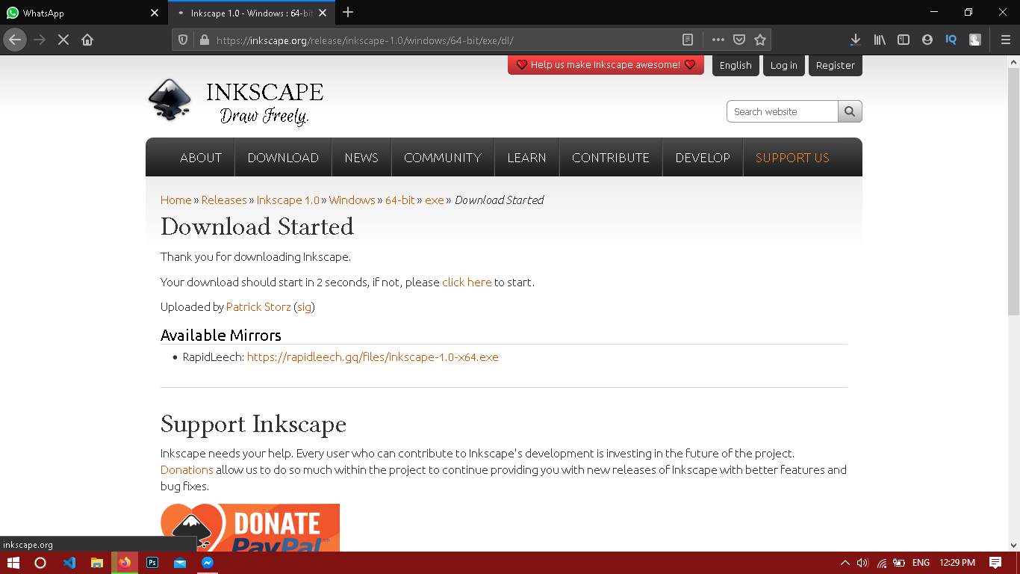

Fig 9.2 (Illustrating the mirror link to the download file in exe )

* After download has been finished you will be asked to specify the download location it will for you to decide which location suites you best but as default the location is in C/users/programx86.

After the installation is complete you will see the following screens:

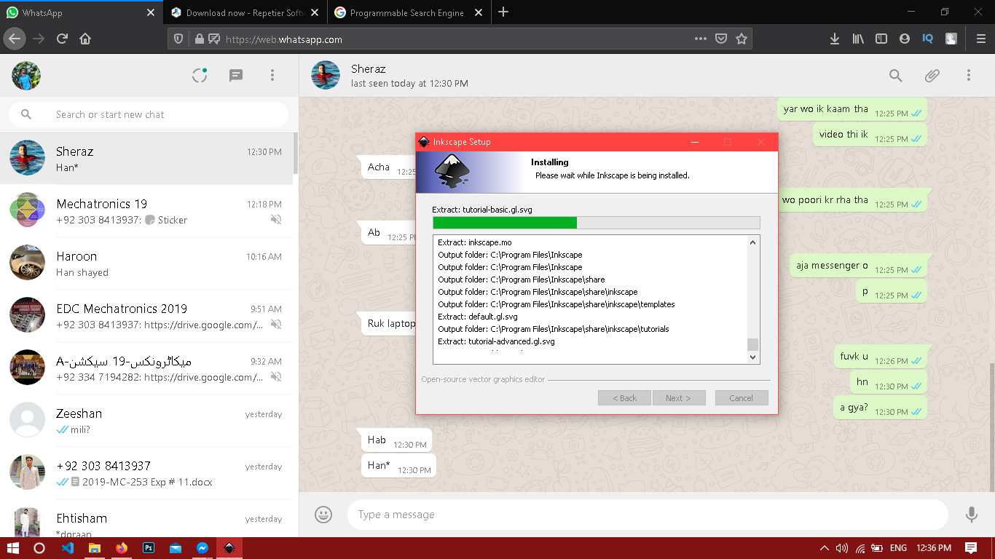

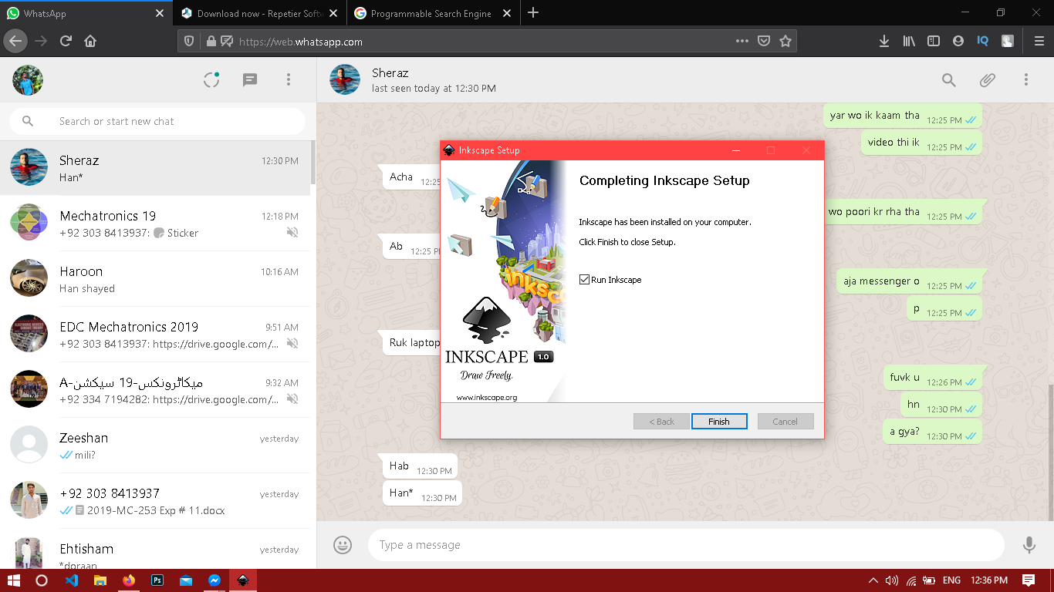

Fig 9.3(Illustrating installed software message)

* Now you can either run the software or let it be for later use.
* Now write Repetier in your specific web browser you will see a lot of sites and you should click the one with the name on it as it is the official site for it after clicking the specific link you will be redirected to the following screen.

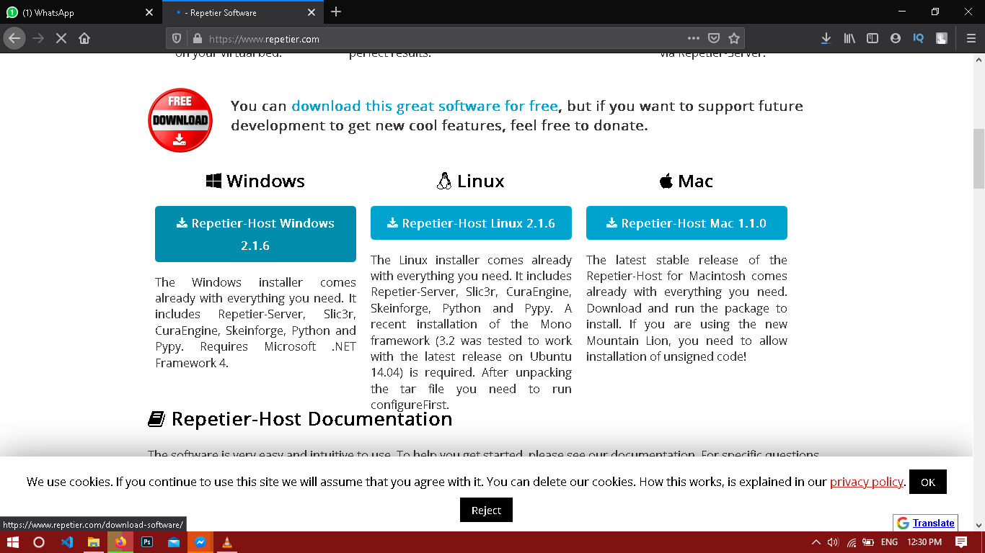

* Select your specific OS as the last time and If you are using windows click on repetier host windows 2.1.6 you will be prompted to following window:

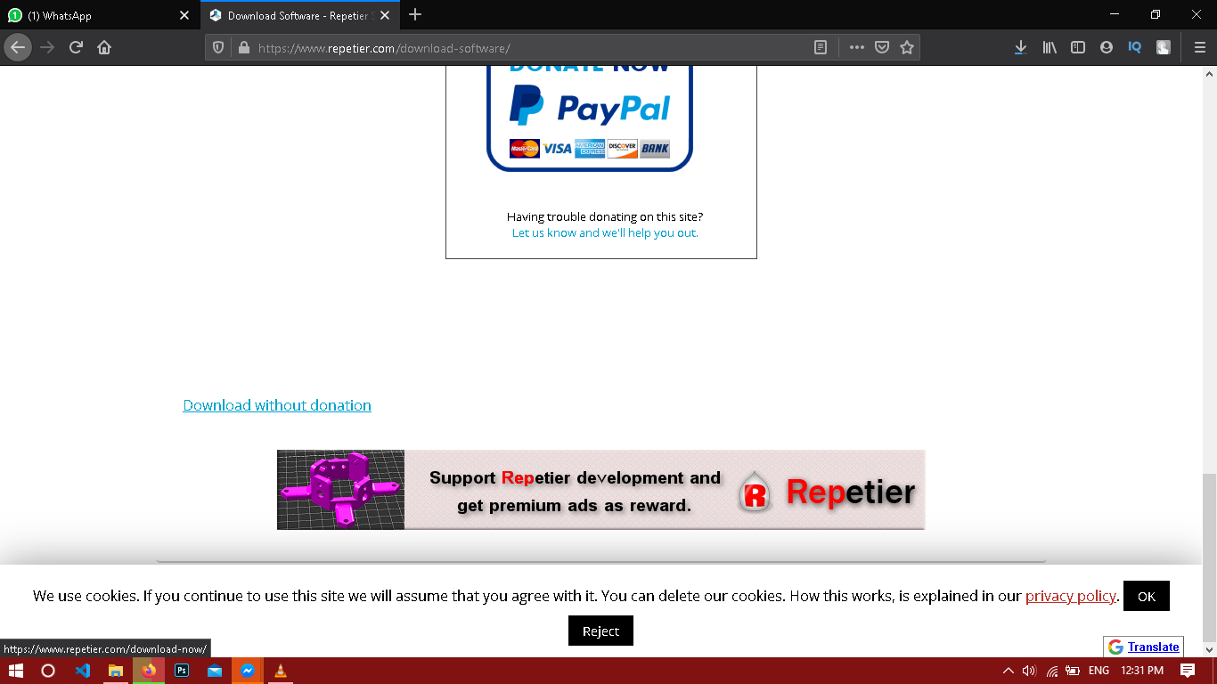

* Click on the text **DOWNLOAD WITHOUT DONATION . Your download will begin shortly.**
* 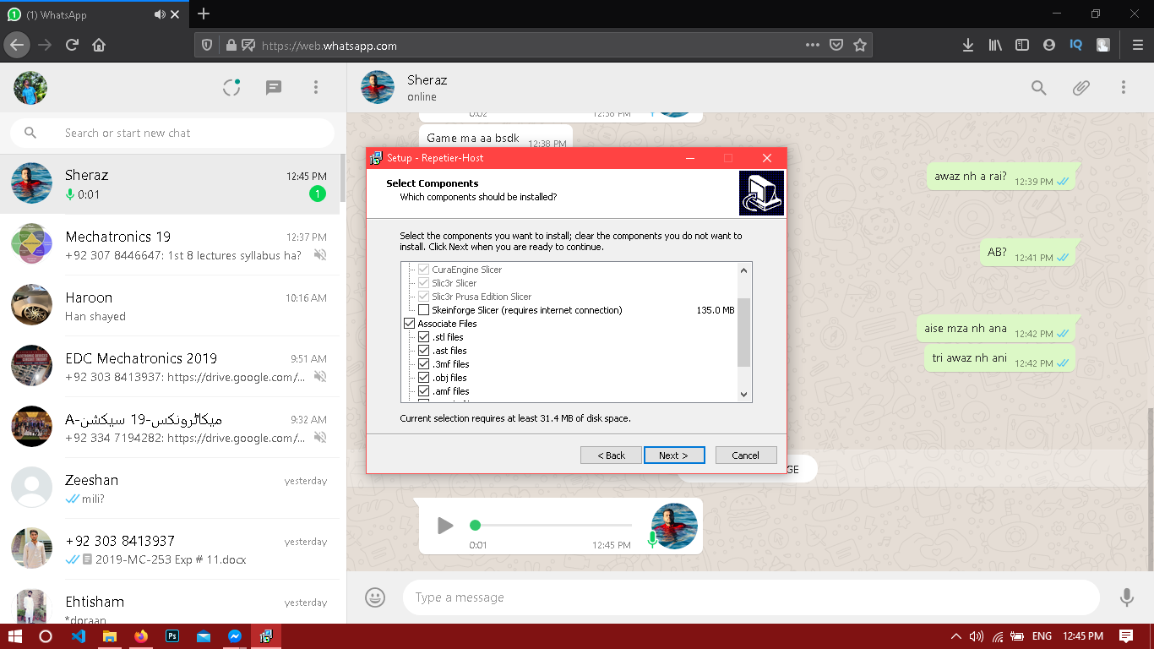After the download is finished open the host file it will show some message like this:
* Select the following files as they are needed for us and uncheck the slicer as it is not for our use.
* After downloading you will be prompted to tell a new directory in which your repitier software should be installed. Select the desired directory and your installation will be completed**.**

**Procedure for the Task:**

* First open the INKSCAPE you will see the following window:
* 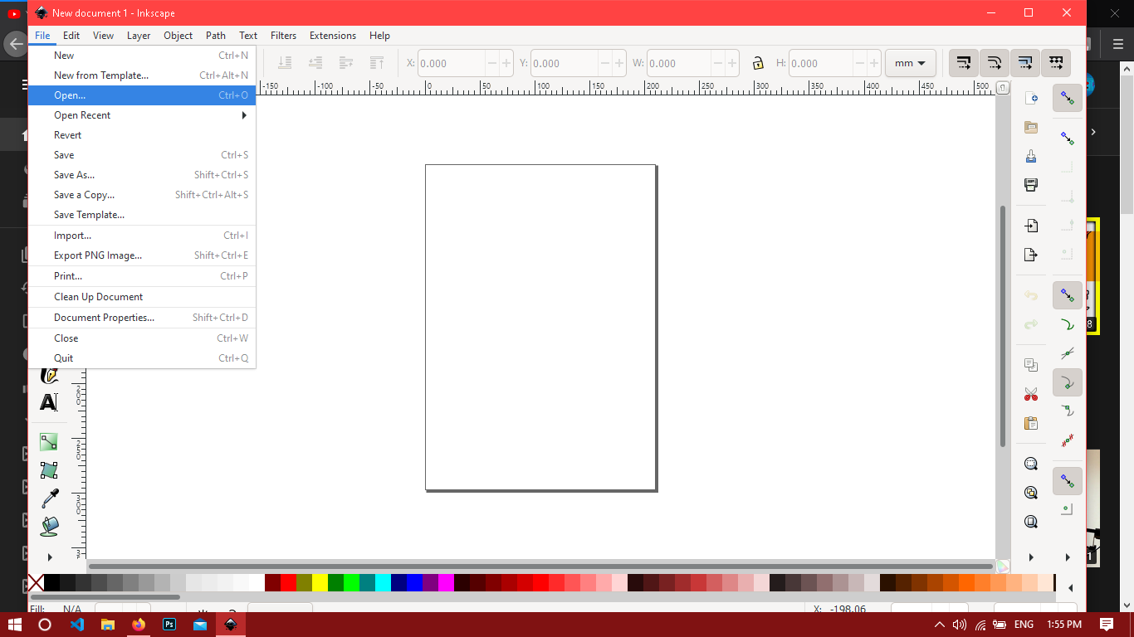You will see the open option by using this option open up a Graphical file like in PNG or JPEG format what so ever you are pleased with.
* 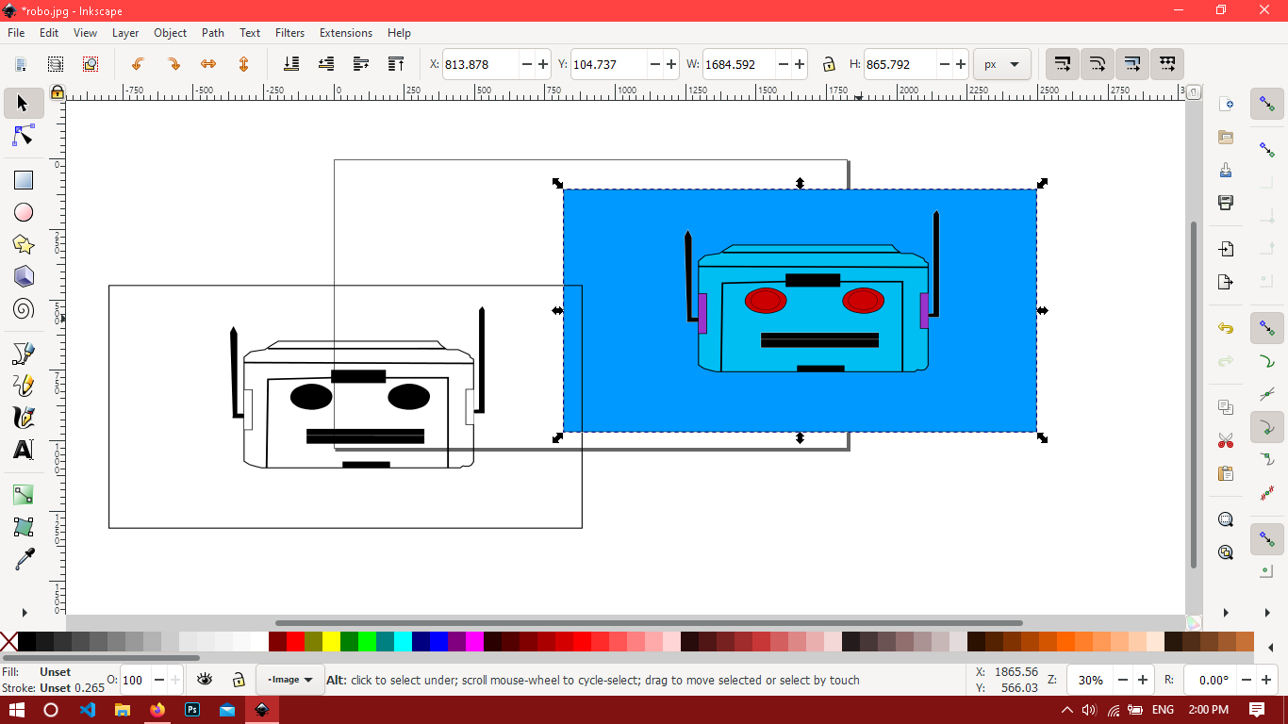For me I created a design in Adobe Illustrator and I imported the JPEG format file here which is as below:
* After selecting the file you will see the following screen if want the best results out of the software then select the following things:

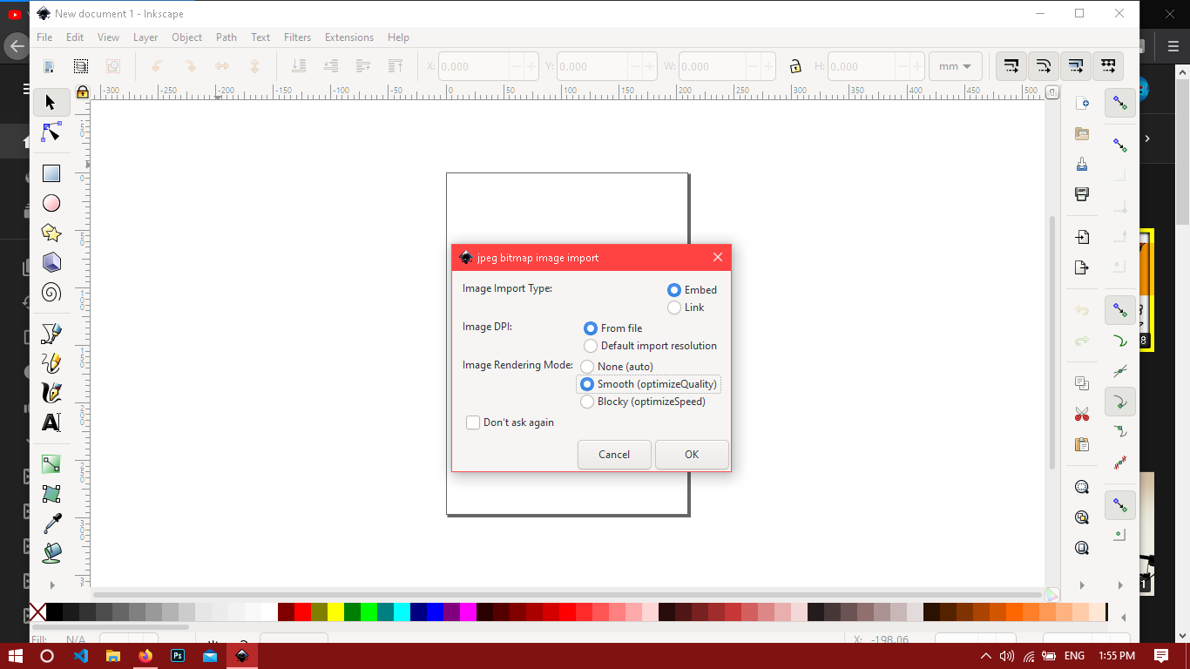

* Then go to files/document settings and just change the document size to be 100x100 in mm not pixels as it is as default and very small unit.
* After that go to Path tab or just press ctrl and E as shortcut to trace the bit map the following screen will be shown to you:

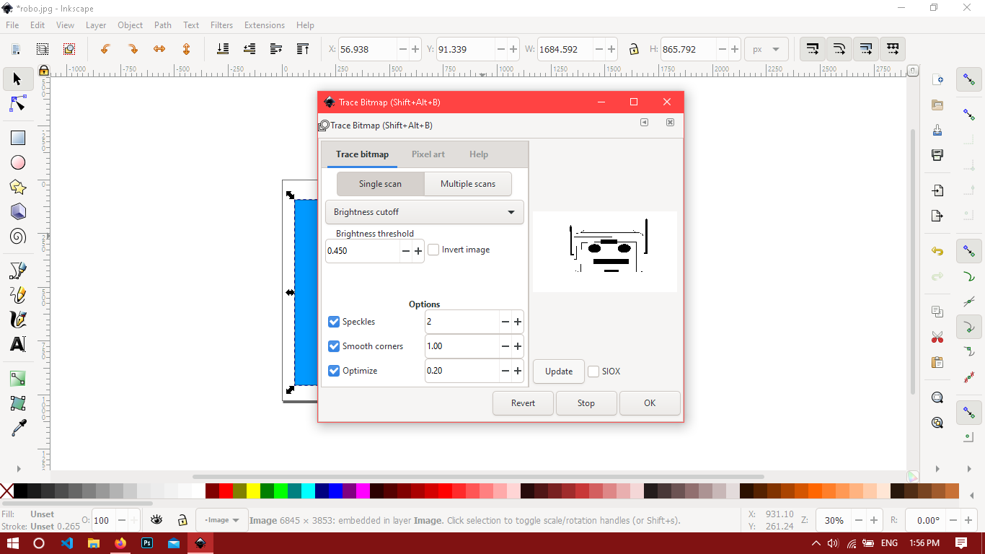

* Select the following settings and you are good to go. If you want to see the live tracing just click on update it will show you the traced picture in the right corner.
* You will see two images now one traced and one is the orignal picture as you wished to traced delete the orignal one.
* 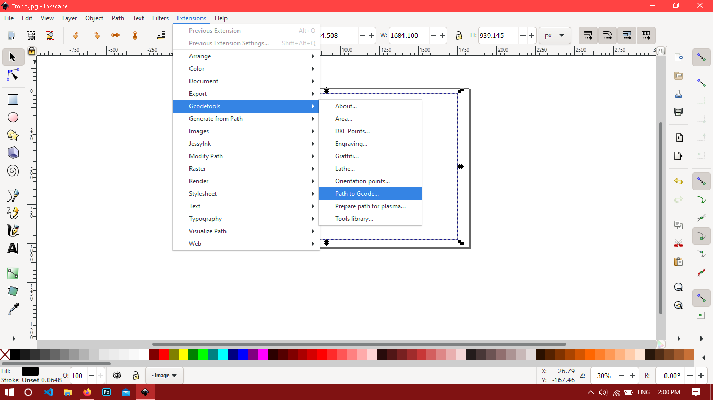After that go to extension/gcode tools/path to gcode.
* 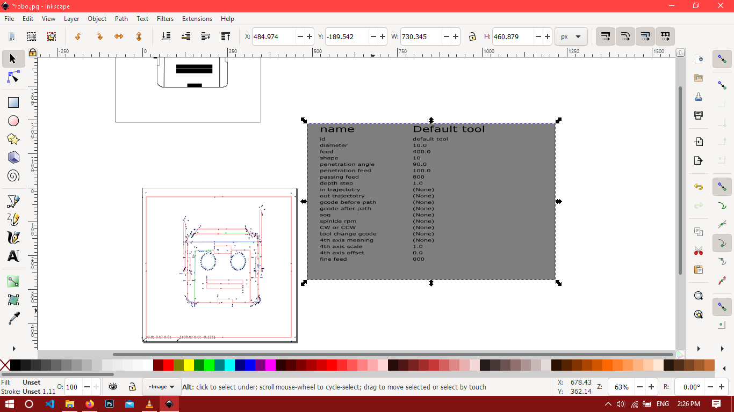After that you will be asked to set some things go to preference tab and set your custom location and rename the file with an extension of .gcode if it is something else or else your picture will not be exported.You will see the following screen:
* Your work on INKSCAPE is finished as of now.
* Now open the Repetier software you will see following screen:

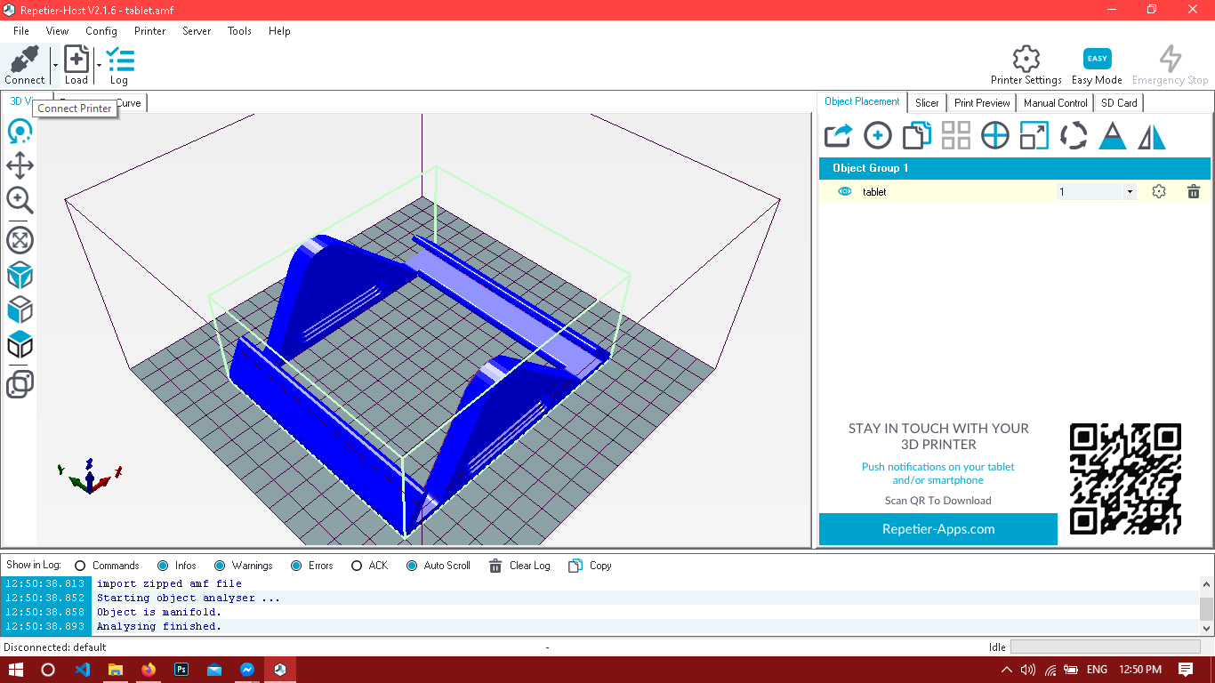

* 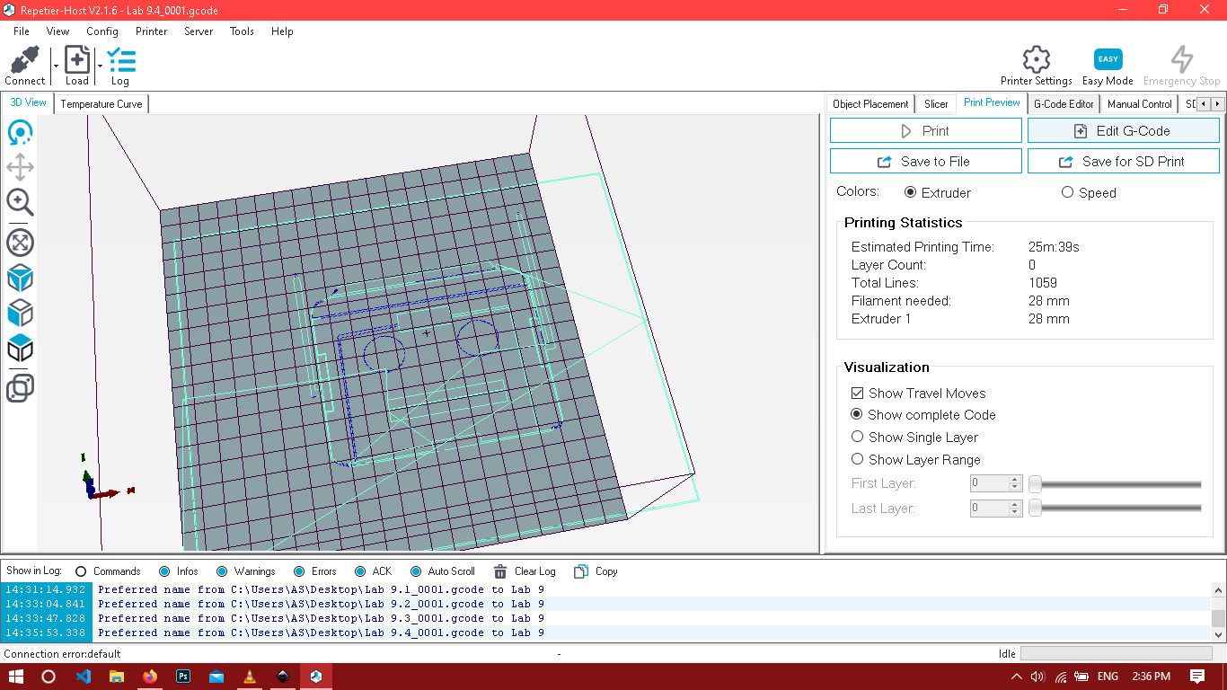Go to the file and select open and open the .gcode file which you exported from the INKSCAPE software a screen like following will be opened.
* If you have a LASER printer you can print your design by using the print option or using the shortcut key ctrl + P.

**RESULT AND DISCUSSION:**

After following the steps explained in the video we made GCODE file of a picture and used it in a LASER ENGRAVER printing software known as REPETIER**.**