|  |  |
| --- | --- |
| **Name** | **Arham Ali** |
| **Registration** | **2019-MC-253** |
| **Date** | **11-08-2020** |
| **Marks** |  |

**CREATING A GCODE AND EXECUTING IT ON SWAN SOFT SIMULATOR.**

**INTRODUCTION:**

**TASK:**

* **To create and export a gcode file using INKSCAPE.**
* **EXECUTING THE GCOE IN SWAN SOFT SIMULATOR**

**INKSCAPE:**

**Inkscape** is a free and open-source vector graphics editor used to create vector images, primarily in Scalable Vector Graphics (SVG) format. Other formats can be imported and exported Inkscape can render primitive vector shapes (e.g. rectangles, ellipses, polygons, arcs, spirals, stars and 3D boxes) and text. These objects may be filled with solid colors, patterns, radial or linear color gradients and their borders may be stroked, both with adjustable transparency. Embedding and optional tracing of raster graphics is also supported, enabling the editor to create vector graphics from photos and other raster sources. Created shapes can be further manipulated with transformations, such as moving, rotating, scaling and skewing.

Inkscape workflow is based around vector objects. Tools allow manipulating primitive vector shapes: simple ones like rectangles, ellipses and arcs, as well as more complex objects like 3D boxes with adjustable perspectives, stars, polygons and spirals.

* **Object manipulation**

### Operations on paths

* Edit Path by Node tool: allows for the editing of single or multiple paths and or their associated node(s).
* Tweak tool (sculpting/painting): provides whole object(s) or node editing regions (parts) of an object. It can push, repel/attract, randomize positioning, shrink/enlarge, rotate, copy/delete selected whole objects.
* Path-Offsets; Outset, Inset, Linked or Dynamic: can create a Linked or Dynamic (unlinked) Inset and or an Outset of an existing path which can then be fine tuned using the given Shape or Node tool.
* Path-Conversion; Object to Path: conversions of Objects; Shapes (square, circle, etc.) or Text into paths.
* Path-Conversion; Stroke to Path: conversions of the Stroke of a shape to a path.
* Path-Simplify: a given path's node count will reduce while preserving the shape.

**REPETIER:**

The Repetier-Host is a simple to use host software, which is be compatible with most firmwares around. You can add and position your STL files on the simulated printbed and slice them all together. For slicing you can use the built-in Slic3r slicer or use the well-known Skeinforge. Just call "Slice & Load" and the job gets delegated to the current slicer, showing its output in the log window.

In the G-Code editor you can change or analyze your code. To help you a short description of the current code is shown below the editor.

The host runs on Windows XP or higher, Linux, and Mac OS X.

**FEATURES:**

* Easy to use GUI.
* Easy to use Windows, Linux or Mac OS X installation.
* Communicates in classic ASCII mode or using binary Repetier-Protocol.
* Includes the fast Slic3r slicer.
* Alternatively integrates Skeinforge as second slicer.
* STL composer - place, rotate and scale your STL files on your printbed and store or slice it.
* STL files are automatically converted to G-Code.
* Visual preview of G-Code. You can even change the code and see the difference.
* Syntax highlighting and code explanation.
* Visualizes the G-Code sent to the printer.
* Shows estimated print time.
* Supports SD cards.
* Simple control panel for tests.
* Jobs can be changed in internal editor before being sent to the printer.
* Supports multiple 3D printers

**Procedure:**

* First of all I took the picture whose GCODE I wanted to execute . I drew the picture to be worked on in ADOBE ILLUSTRATOR .

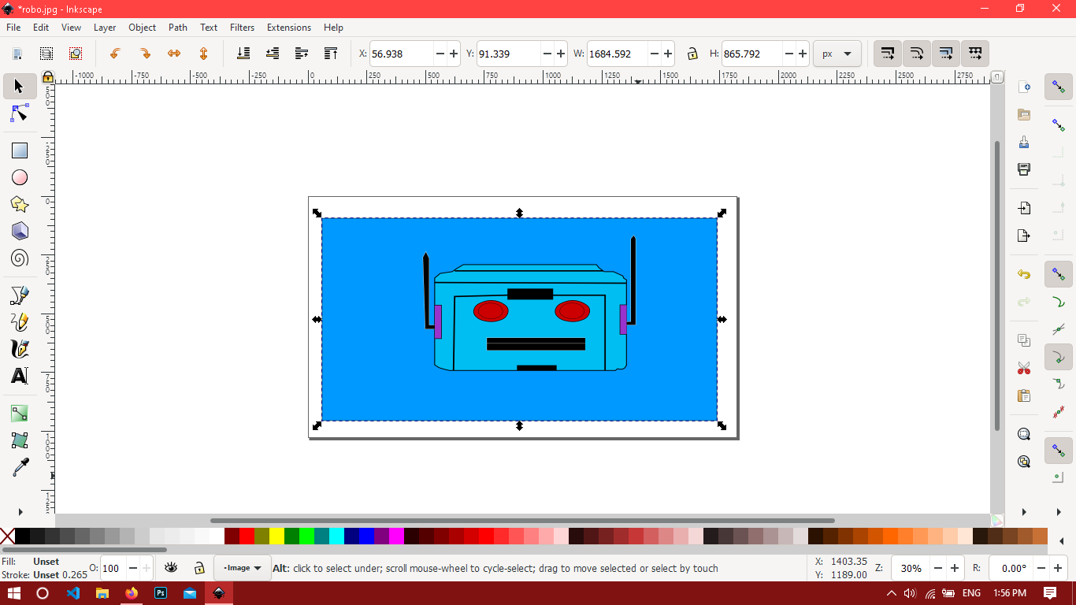

* Then I opened the picture using INKSCAPE just like I did in LAB 9
* After opening the picture I again created its trace.
* The original picture is deleted and the traced is let it be.
* Now I went to extension/tools and selected the option as specified in the video.
* The following screen is shown after that.

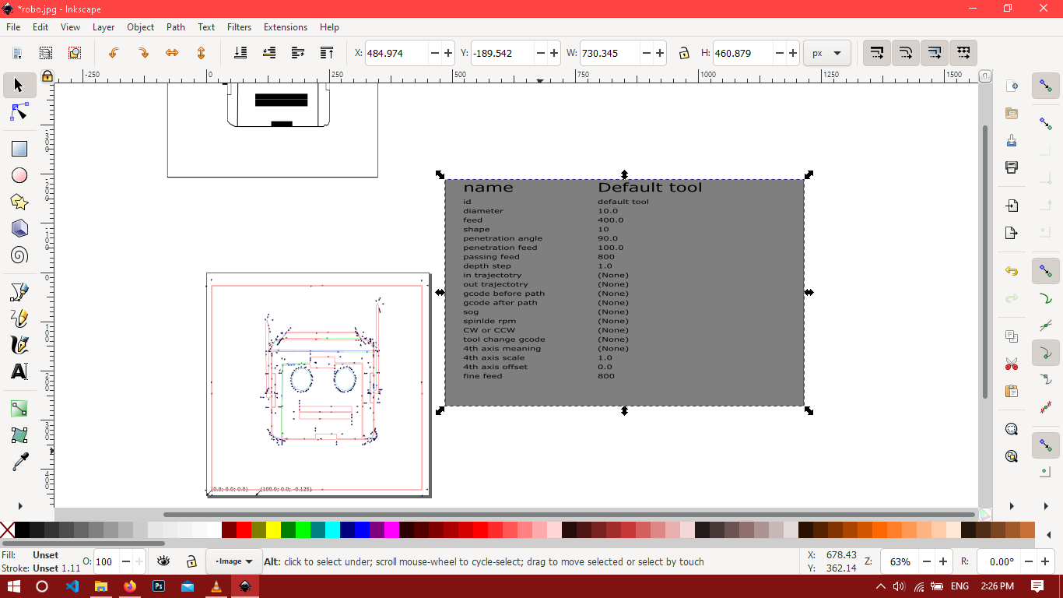

**Fig 10.1(ILLUSTRATING DESIGN IN INKSCAPE.)**

* Then I went to extension/gcode tools/ orientation points and set the selected settings.

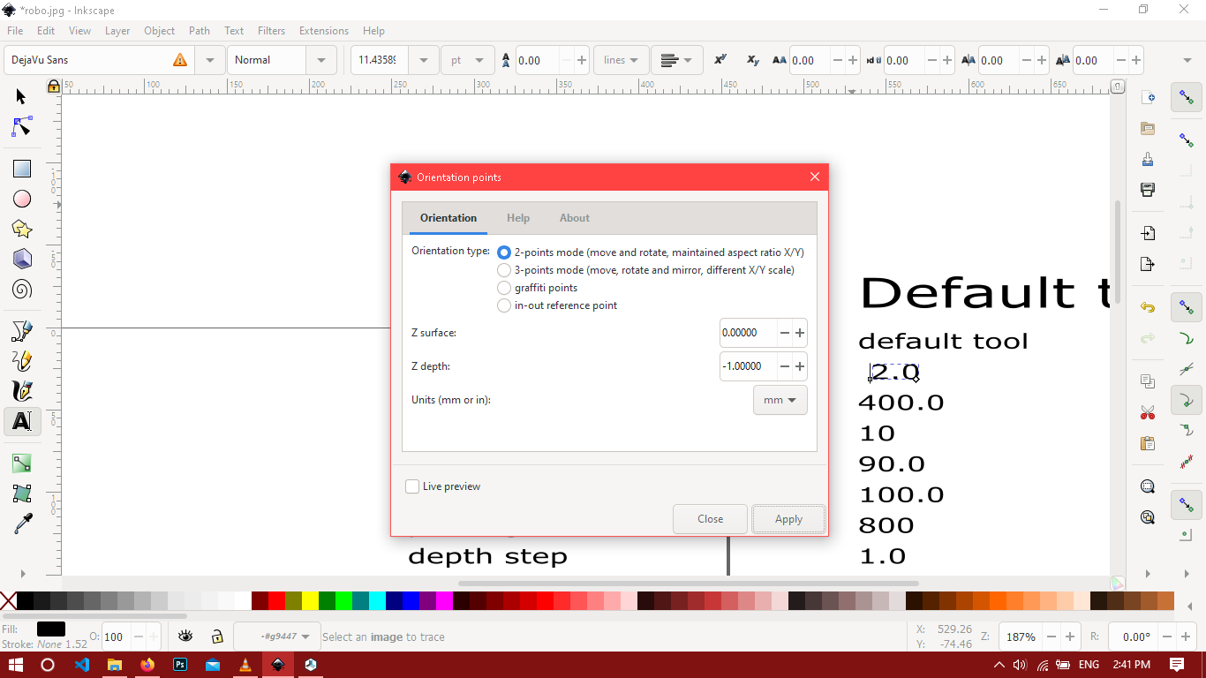

**Fig10.2(Illustrating the step to perform on INKSCAPE.)**

* Set the orientation point mode to 2 point mode as it is used to move point and rotate and that is our purpose.

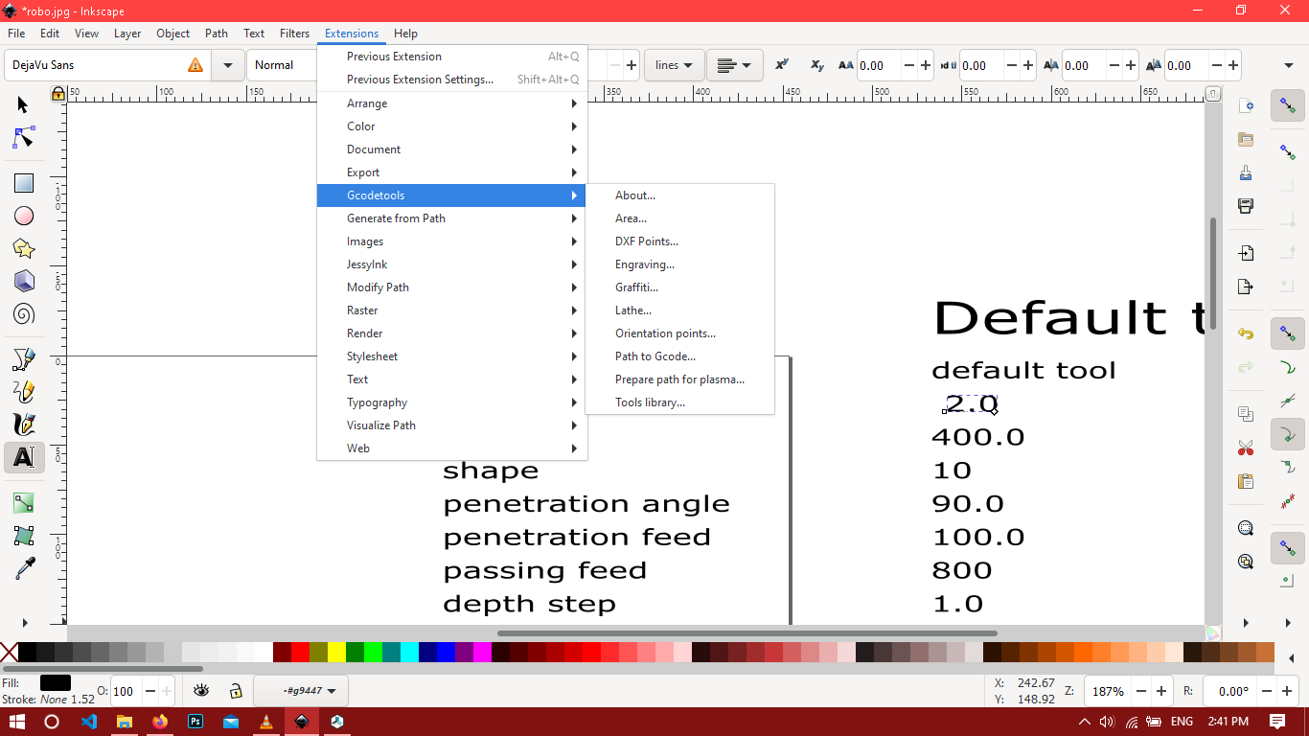

* Now select the following coordinates.

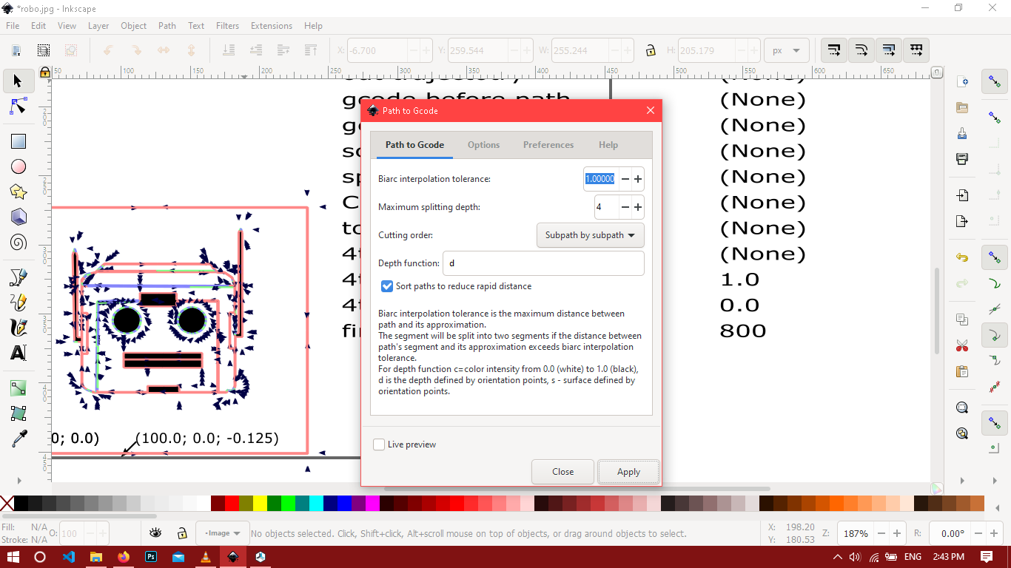

* Go the the same option as went to the last time and select path to gcode option and select the extension to be .gcode which is .ngc as default



**Fig 10.3(Illustrating the Last step in INKSCAPE)**

* Now open Swan soft CNC simulator and select the following machine.

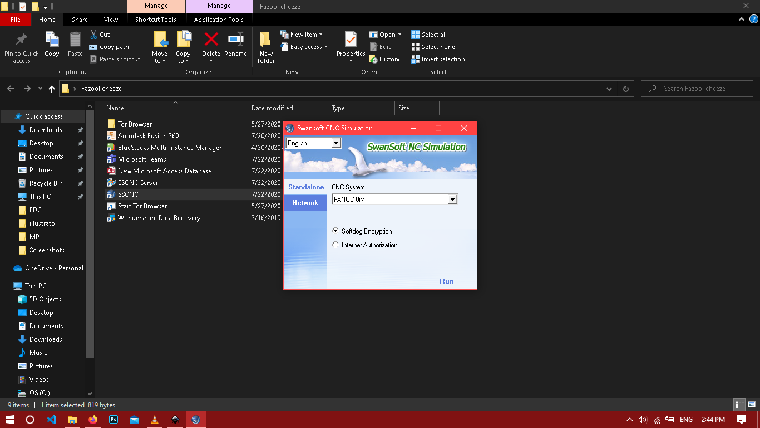

**Fig 10.4( Illustrating the machine to be selected)**

* Now after opening the swansoft software just clear the offset settings
* Empty the nc code if there is one already .
* Now go to the workpiece management and apply the following settings.

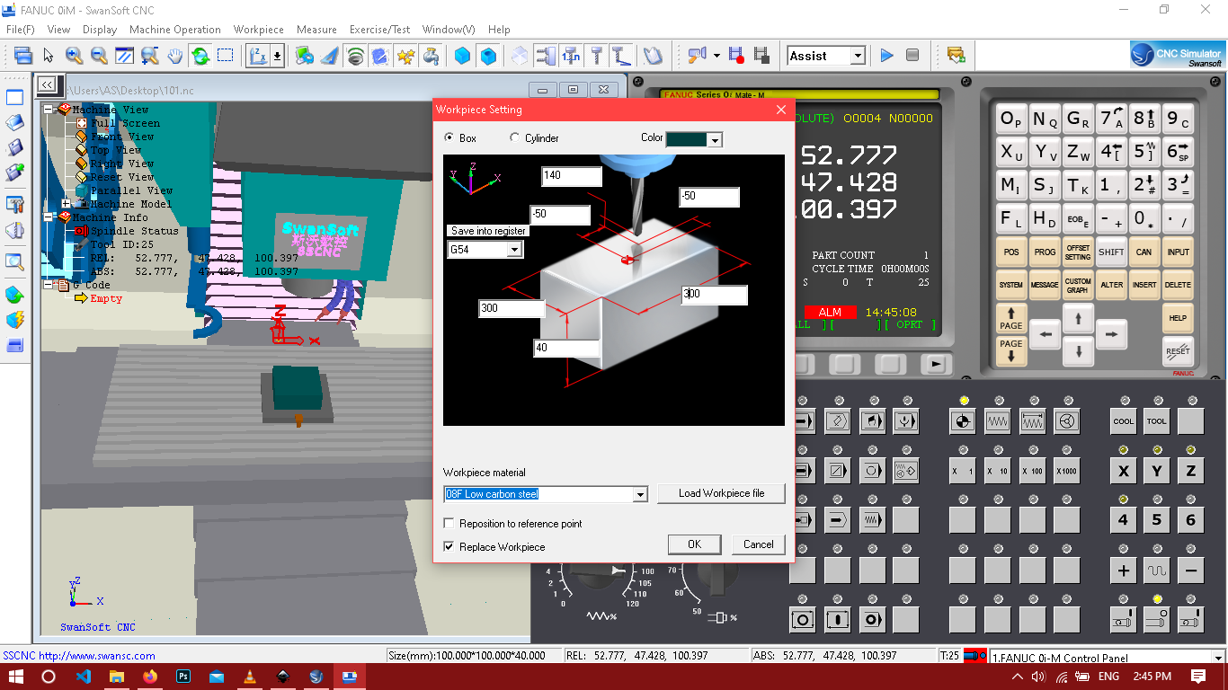

**Fig10.5( Illustrating workpiece setup)**

* Now go to the tool management select flat milling tool and go to edit to select some parameters.

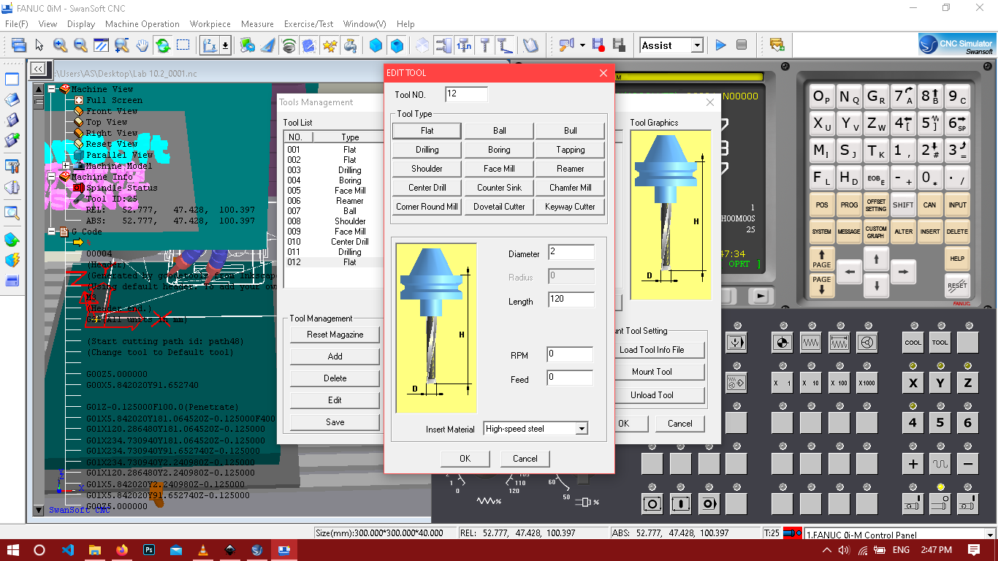

**Fig 10.6 ( Illustrating the tool parameters)**

* Now press ok and select the tool and made it to be placed in tool 1 turret.

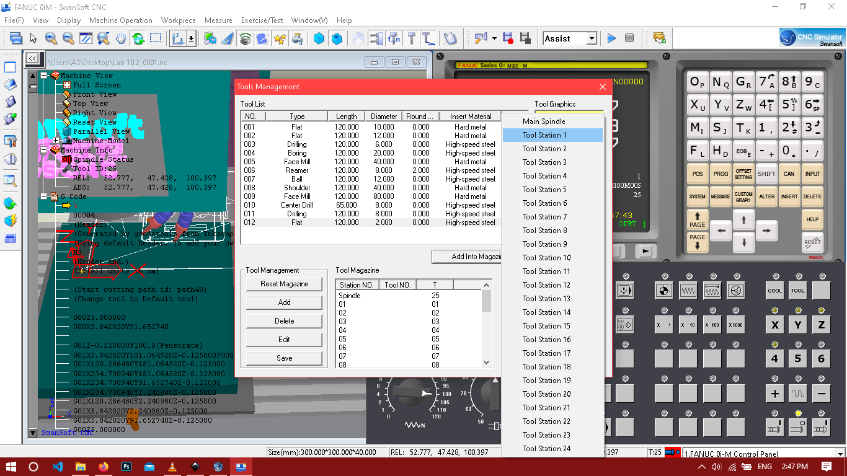

**Fig 10.6( Illustrating where to put tool.)**

* Now do a home search on x y and z axis.
* Turn on the mode in which the machine performs operations
* Your required GCODE will be executed and will look like this.

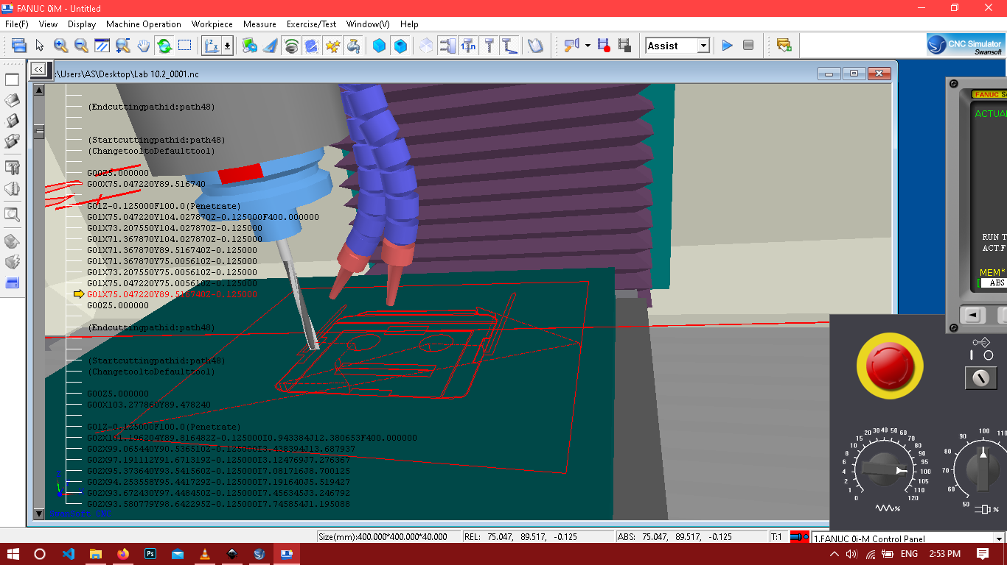

**Fig 10.7( Illustrating the milled GCODE on Swansoft Simulator.)**

**Result and Discussion:**

**After performing certain steps on INKSCAPE and CNC swansoft simulator we have engraved our desired GCODE on a workpiece.**