2019MC253

Abstract:

To implement binomial distribution in MATLAB.

Code:

Function:

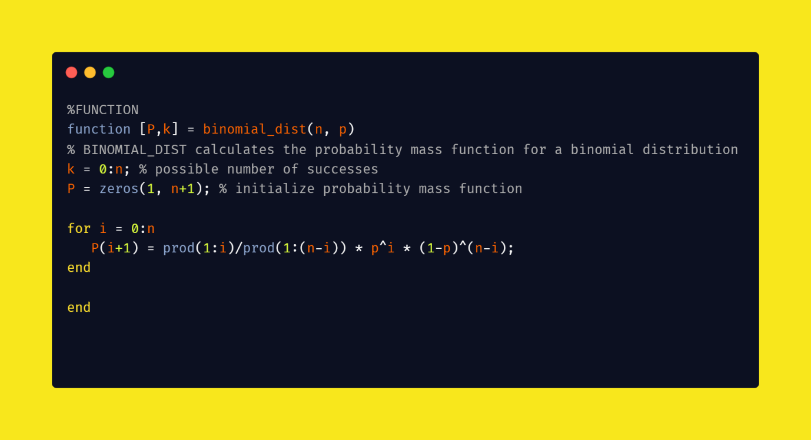

Figure .1(Illustrating the function created)

Script:

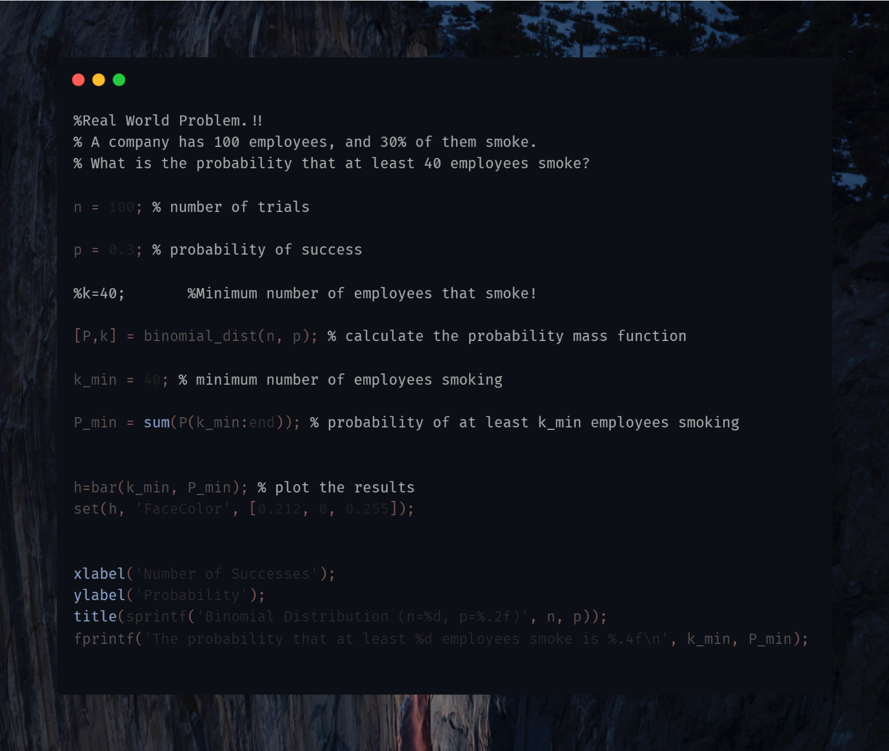

Figure (Illustrating the script file used)

Output:



Graph:

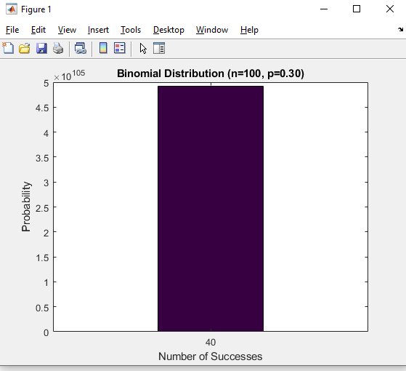

**Code in Raw format:**

Function Code:

function [P,k] = binomial_dist(n, p)

% BINOMIAL_DIST calculates the probability mass function for a binomial distribution

% with parameters n and p.

% Inputs:

% - n: the number of trials

% - p: the probability of success in each trial

%

% Outputs:

% - P: the probability mass function for the binomial distribution

% - k: the number of successes (0 to n) in each trial

k = 0:n; % possible number of successes

P = zeros(1, n+1); % initialize probability mass function

for i = 0:n

P(i+1) = prod(1:i)/prod(1:(n-i)) * p^i * (1-p)^(n-i);

end

end

--------------------🡪>>>>>>>>>>>>>>>Script File Code<<<<<<<<<<<<🡨-------------------

%Real World Problem.!!

% A company has 100 employees, and 30% of them smoke.

% What is the probability that at least 40 employees smoke?

n = 100; % number of trials

p = 0.3; % probability of success

%k=40; %Minimum number of employees that smoke!

[P,k] = binomial_dist(n, p); % calculate the probability mass function

k_min = 40; % minimum number of employees smoking

P_min = sum(P(k_min:end)); % probability of at least k_min employees smoking

h=bar(k_min, P_min); % plot the results

set(h, 'FaceColor', [0.212, 0, 0.255]);

xlabel('Number of Successes');

ylabel('Probability');

title(sprintf('Binomial Distribution (n=%d, p=%.2f)', n, p));

fprintf('The probability that at least %d employees smoke is %.4f\n', k_min, P_min);