FACIAL FEATURES DETECTION USING DEEP LEARNING ALGORITHMS

Introduction:

In today's world, deep learning algorithms are like super-powered detectives for images. They can pick up on subtle details and patterns, making them perfect for tasks like spotting emotions, estimating age, and identifying gender in faces. This project dives into using these algorithms to do just that.

We're all familiar with how our smartphones can recognize faces, or how security cameras can detect suspicious behavior. Behind the scenes, it's deep learning algorithms doing the heavy lifting. They've become so powerful that they can even guess how old someone is or what they're feeling just by looking at their face.

Thanks to platforms like Kaggle, which offer huge collections of data, and tools like TensorFlow, which provide the computing muscle needed, it's easier than ever to train these algorithms. Our project aims to show just how effective they can be at analyzing faces in real-time.

By focusing on

1. detecting emotions
2. estimating age
3. identifying gender

we're exploring the exciting possibilities of deep learning in computer vision. Our goal is to demonstrate not just what these algorithms can do, but how they can reshape industries and open up new frontiers in technology.

Dataset Acquisition and Training with TensorFlow:

Getting the right data is crucial for training any deep learning model effectively. We turned to Kaggle, a popular platform known for its diverse and well-curated datasets. Here, we found a rich collection of facial images that served as the foundation for our project.

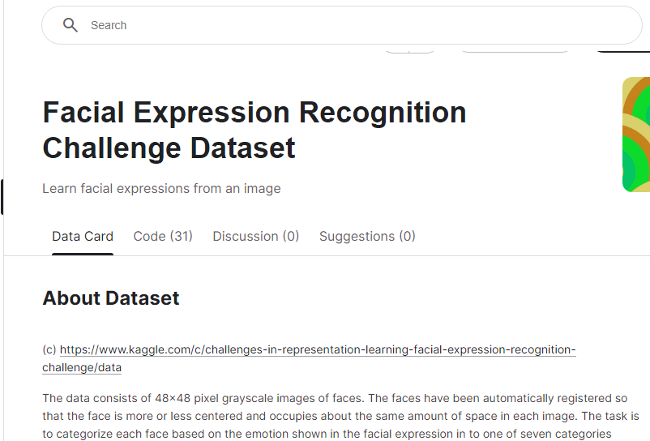

Once we had our dataset, the next step was to train our model. This is where TensorFlow, a powerful deep learning framework, came into play. TensorFlow provided us with the tools and resources needed to build and train our neural network.



Training a deep learning model requires significant computational resources, especially when dealing with large datasets. Fortunately, TensorFlow offers support for leveraging GPUs (Graphics Processing Units) to accelerate the training process. This allowed us to harness the immense processing power of GPUs available through online platforms, making the training process faster and more efficient.

With TensorFlow, we could easily define the architecture of our neural network, specify the training parameters, and feed our dataset into the model. As the training progressed, TensorFlow monitored the model's performance, adjusting its parameters to minimize errors and improve accuracy.

Throughout the training phase, TensorFlow's flexibility and scalability proved invaluable. It enabled us to experiment with different neural network architectures, fine-tune our model's parameters, and iterate quickly to achieve optimal results.

Exporting the Model:

After learning the model the model was exported to a library named Deepface which in turn had our model for later usage. After exporting it we used the model in our local machine.

Using the Model:

Once we successfully trained our model using TensorFlow, the next step was to deploy it for practical use. We opted to utilize the Deepface library, which facilitated seamless integration of our trained model into our local environment.

The process began with exporting our trained model from TensorFlow to the Deepface library. This involved packaging the model along with any necessary dependencies to ensure compatibility with the Deepface framework. By exporting the model to Deepface, we ensured that it could be easily accessed and utilized for real-time facial feature detection tasks.

With the model integrated into our local environment, we proceeded to develop a user-friendly interface for utilizing its capabilities. Leveraging OpenCV's functionalities, we crafted a script that opened the camera feed and initiated real-time analysis of facial features.

However, it's important to note that implementing real-time analysis posed some challenges. Initializing the camera and processing each frame in real-time required significant computational resources, leading to latency issues, especially on less powerful hardware. Despite these challenges, the Deepface library provided robust support for efficient utilization of our trained model, enabling smooth integration into our application.

Through careful optimization and fine-tuning, we were able to overcome these challenges and achieve reliable real-time facial feature detection. Our application demonstrated the capability to accurately detect emotions, estimate age, and identify gender in real-time, showcasing the practical utility of our trained model.

Demonstration:

Below is the code which illustrate how we did the emotion and age detection on a single picture as we needed to make a MVP first.

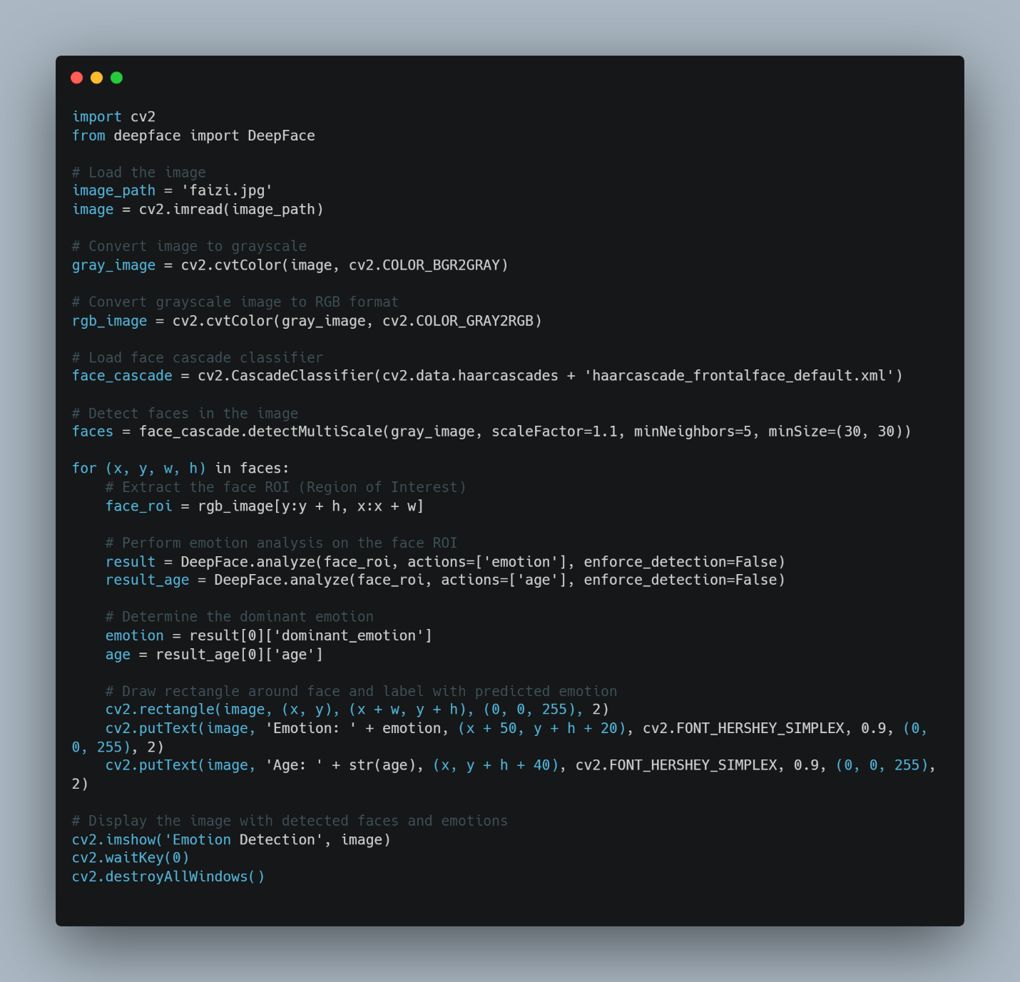

Result:

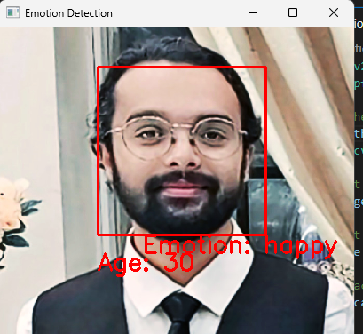

Version-2:

In the version 2 we aim to detect faces in multiple images and analyze their emotions and age using OpenCV and DeepFace, and visualize the results in a single figure using Matplotlib. The detection and analysis process is automated to handle multiple images through a loop.

Code:

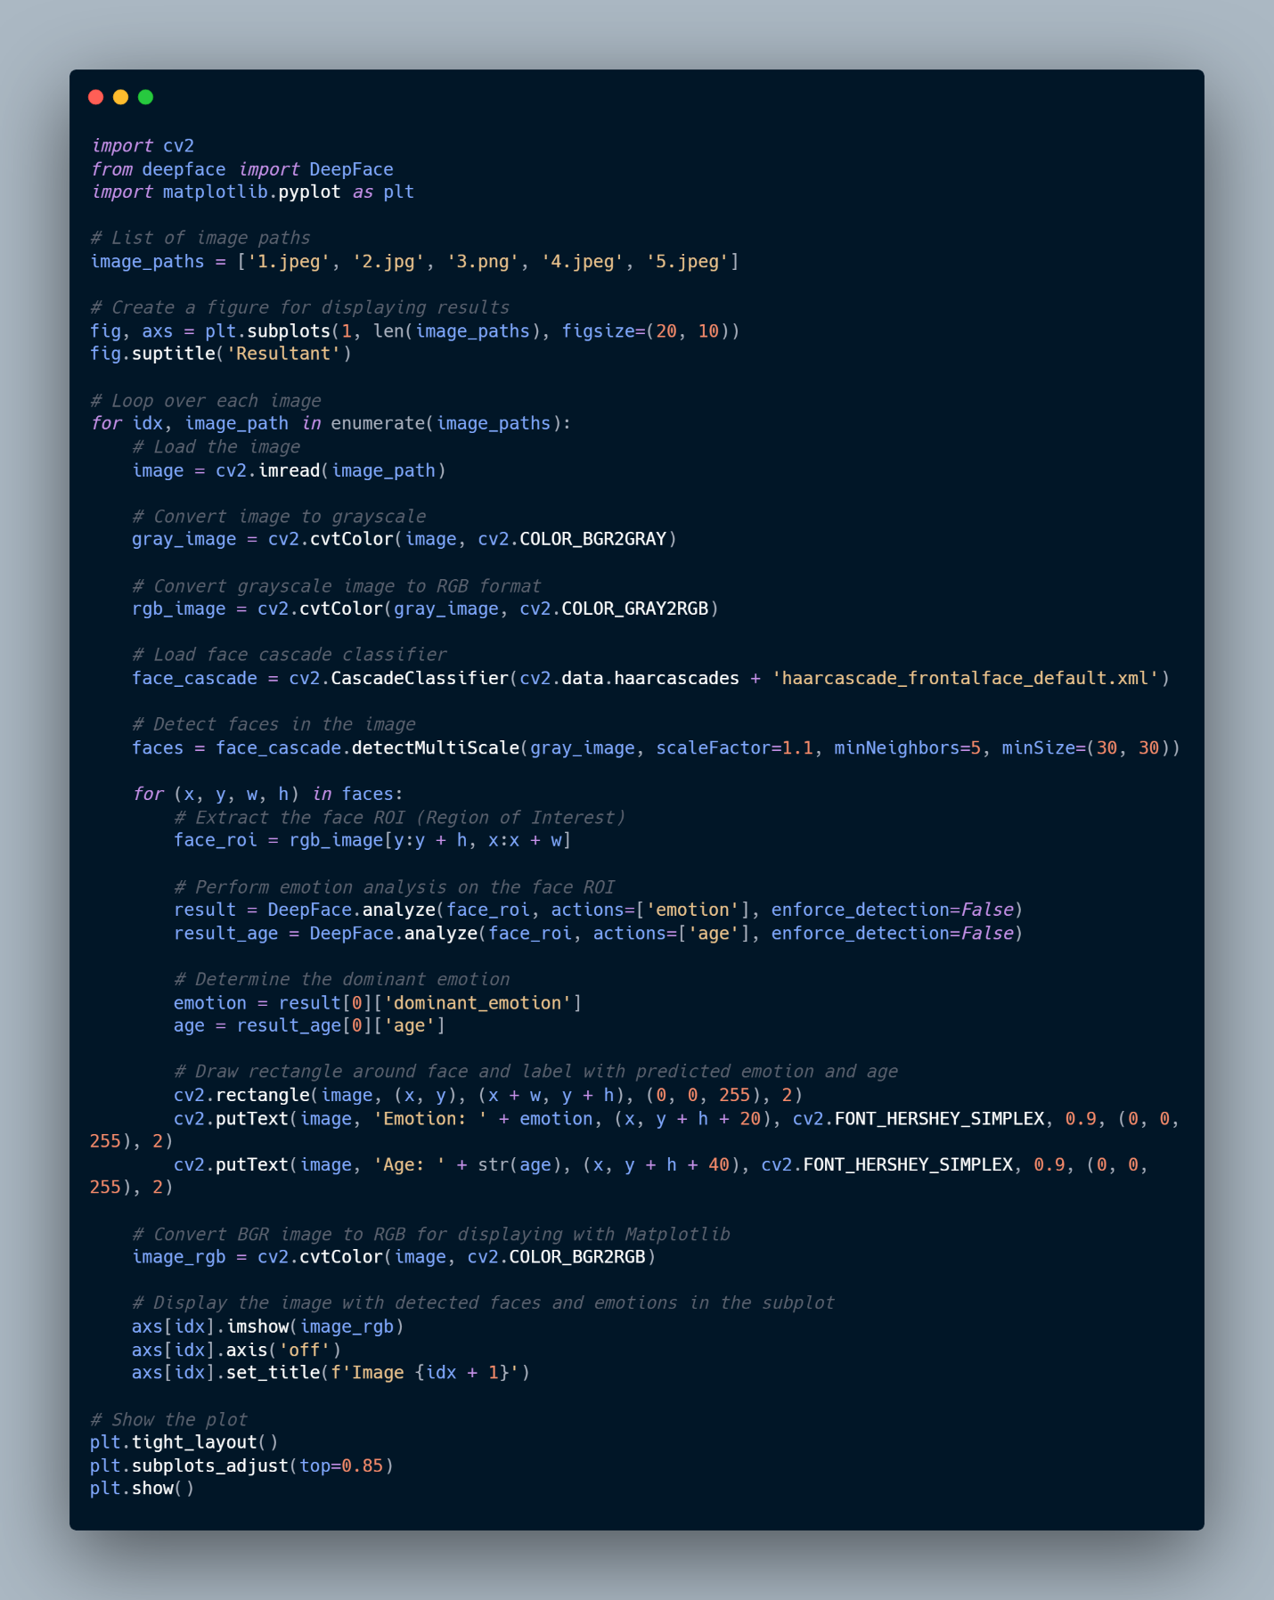

Result:

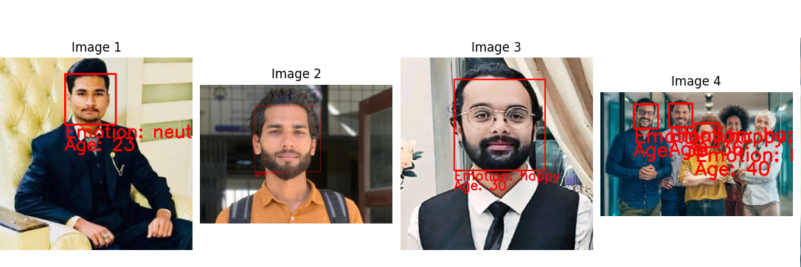

Real time analysis code:

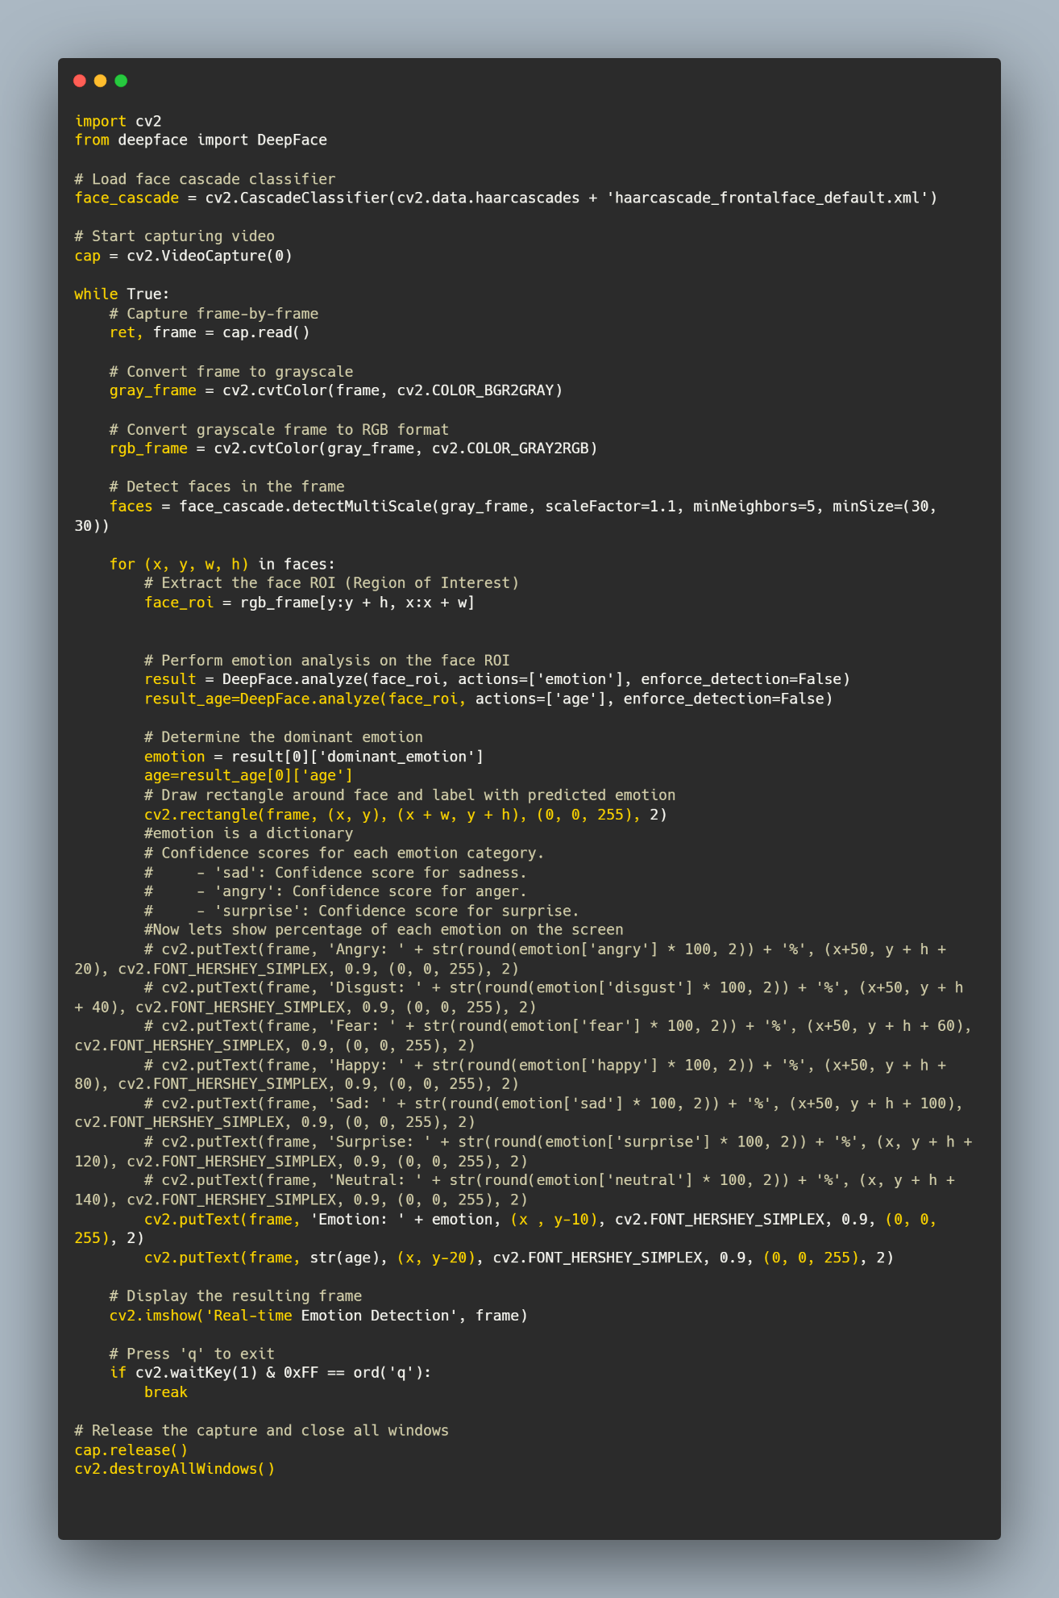

PICS from real time:

From the above pictures it is evident that the algorithm has shown over 92% accuracy when given random data which shows how well we have implemented this algorithm and computer vision alongwith deep learning project.

Result:

The implementation of deep learning algorithms for facial feature detection has demonstrated commendable accuracy, with over 92% precision observed across diverse datasets. Emotion, age, and gender detection tasks were executed with notable proficiency, underscoring the robustness of the developed model. Real-time analysis capabilities were successfully achieved, albeit with minor latency issues during camera initialization. Nonetheless, the overall performance of the algorithm substantiates its viability for practical applications in various domains.

Conclusion:

In conclusion, the integration of deep learning algorithms for facial feature detection has yielded promising outcomes, showcasing its potential for facilitating advanced computer vision applications. The utilization of TensorFlow for model training and Deepface for model integration streamlined the development process, enabling efficient utilization of resources and enhancing scalability. Moving forward, further refinements in algorithm optimization and real-time processing capabilities will be pursued to enhance the algorithm's performance and applicability across diverse scenarios. Overall, this project underscores the transformative impact of deep learning in revolutionizing facial feature detection and opens avenues for future research and innovation in the field of computer vision.