(1) Generate a graph of the following equation. (4 pts)

y = x4 – 6 \* x2

x = linspace(-3, 3, 20);

y = x.^2;

plot(x,y)

Example output of : y = x2



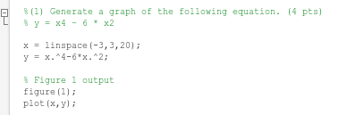

(2) Generate a surface plot of the following equation. (6 pts)

Z = sin(sqrt(X \* X + Y \* Y)) / (sqrt(X \* X + Y \* Y))

xg = linspace(-5,5,20);

[X,Y] = meshgrid(xg, xg);

Z = 2 - X.^2 - Y.^2;

surf(X,Y,Z)

