Implement MATLAB code that calculates the following formula. Use your student ID as eight 1 digit data to be used for your calculation. (μ : average)

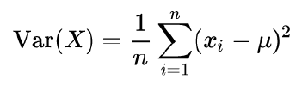

Compare the result from your code with the result produced by MATLAB function “var(X)”, where X contains the data.

Taking the sample of my student ID to be sid = [2 0 5 3 6 9 6 4], my manual code returned a result of 6.7344.

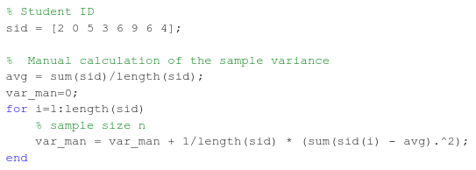

The MATLAB code var(sid) returned the result 7.6964.



Hypothesize the reason why they are different.

The difference could be that the formula provided is the sample variance and does not include a Bessel’s correction (N-1) to extrapolate to a population. The MATLAB code var(sid) assumes a weight of zero, which normalizes the sample size with N-1.

Modify your code (not MATLAB “var(X)”) and show the correctness of your hypothesis.

This can be corrected in my manual code by subtracting 1 from the sample size (N-1). My manual code will then show the same result as the MATLAB code var(sid).

