Plot Vout = a – b, versus R2 in the range from 1 kΩ to 100 kΩ in the following diagram.

Use R1 = R3 = R4 = R5 = 20 kΩ and Vin = 10 V.

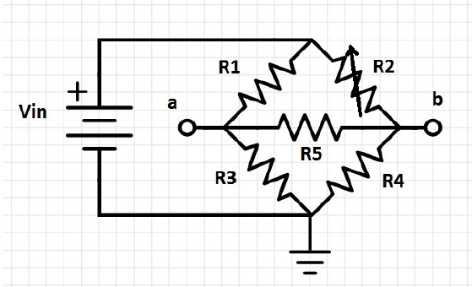

$\begin{aligned}Given: \\ R_{1}=R_{3}=R_{4}=R_{5}=20kΩ \\ V_{i}=10 \\ V_{o}=a−b \\ a=V_{i}⋅\frac{R_{2}}{R_{1}+R_{2}} \\ b=V_{i}⋅\frac{R_{5}}{R_{3}+R_{5}} \\ V_{o}=V_{i}⋅\left(\frac{R_{2}}{R_{1}+R_{2}}−\frac{R_{1}}{R_{1}+R_{1}}\right)=V_{i}⋅\left(\frac{R_{2}}{R_{1}+R_{2}}−\frac{1}{2}\right)\end{aligned}$

$\begin{aligned}0=−10+40I_{1}−20I_{2}−20I_{3} \\ \\ \left(1\right)→40I_{1}−20I_{2}−20I_{3}=10 \\ \\ 0=20\left(I_{2}−I_{1}\right)+R_{2}I_{2}+20\left(I_{2}−I_{3}\right) \\ \\ \left(2\right)→20I_{1}+\left(40+R_{2}\right)I_{2}−20I_{3}=0 \\ \\ 0=20\left(I_{3}−I_{1}\right)+20I_{3}+20\left(I_{3}−I_{2}\right) \\ \\ \left(3\right)→−20I_{1}−20I_{2}+60I_{3}=0\end{aligned}$

Matrix Form:

$\left[\begin{matrix}40 & −20 & −20 \\ −20 & \left(40+R_{2}\right) & −20 \\ −20 & −20 & 60\end{matrix}\right]\left[\begin{matrix}I_{1} \\ I_{2} \\ I_{3}\end{matrix}\right]=\left[\begin{matrix}10 \\ 0 \\ 0\end{matrix}\right]$

$\begin{aligned}ForR_{2}=1:V_{o}=10⋅\left(\frac{1}{1+20}−\frac{1}{2}\right)=−4.5 \\ ForR_{2}=10:V_{o}=10⋅\left(\frac{10}{20+10}−\frac{1}{2}\right)=−1.667 \\ ForR_{2}=20:V_{o}=10⋅\left(\frac{20}{20+20}−\frac{1}{2}\right)=0 \\ ForR_{2}=30:V_{o}=10⋅\left(\frac{30}{20+30}−\frac{1}{2}\right)=1 \\ ForR_{2}=40:V_{o}=10⋅\left(\frac{40}{20+40}−\frac{1}{2}\right)=1.667 \\ ForR_{2}=50:V_{o}=10⋅\left(\frac{50}{20+50}−\frac{1}{2}\right)=2.143 \\ ForR_{2}=60:V_{o}=10⋅\left(\frac{60}{20+60}−\frac{1}{2}\right)=2.5 \\ ForR_{2}=70:V_{o}=10⋅\left(\frac{70}{20+70}−\frac{1}{2}\right)=2.778 \\ ForR_{2}=80:V_{o}=10⋅\left(\frac{80}{20+80}−\frac{1}{2}\right)=3 \\ ForR_{2}=90:V_{o}=10⋅\left(\frac{90}{20+90}−\frac{1}{2}\right)=3.182 \\ ForR_{2}=100:V_{o}=10⋅\left(\frac{100}{20+100}−\frac{1}{2}\right)=3.333\end{aligned}$

|  |  |  |  |  |  |  |  |  |  |  |  |
| --- | --- | --- | --- | --- | --- | --- | --- | --- | --- | --- | --- |
| R2 | 1 | 10 | 20 | 30 | 40 | 50 | 60 | 70 | 80 | 90 | 100 |
| Vout | -4.5 | -1.667 | 0 | 1 | 1.667 | 2.143 | 2.5 | 2.778 | 3 | 3.182 | 3.333 |

