Please submit:

**Hand calculation of your numerical integration using trapezoid rule. Verify**

**your answer with the result from 3.a (3 pts)**

Given the trapezoid rule:

$I≈\sum_{i=1}^{n}{\frac{x_{i}−x_{i−1}}{2}}\left(y_{i}+y_{i−1}\right)$

and our data:

$\begin{aligned}x=\left[1,2,3,4,5,6,7,8\right] \\ y=\left[4,6,9,6,3,5,0,2\right]\end{aligned}$

Our *Δx* values are all 1, so wecan simplify the equation such that:

$I≈\frac{1}{2}\sum_{i=1}^{n}{\left(y_{i}+y_{i−1}\right)}$

which gives us:

$\begin{aligned}I≈\frac{1}{2}\left[\left(4+6\right)+\left(6+9\right)+\left(9+6\right)+\left(6+3\right)+\left(3+5\right)+\left(5+0\right)+\left(0+2\right)\right] \\ I≈\frac{1}{2}\left[64\right]=32\end{aligned}$

**MATLAB code and the screenshot. (3 pts)**

1. **Integration using 8 data points only, without interpolation.**
2. **Integration using nearest-neighbor interpolation.**
3. **Integration using piecewise-linear interpolation.**
4. **Integration using spline interpolation.**

**Explain what causes the calculated integration using the spline interpolation to  
be much different from results from other methods. If all integration values are  
very similar to each other using your student ID, try the example data points  
(****20038533) (1 pt)**

Spline interpolation differs from other numerical integration methods because it approximates data using piecewise polynomials. This can introduce deviations in the integral compared to the trapezoidal rule which relies 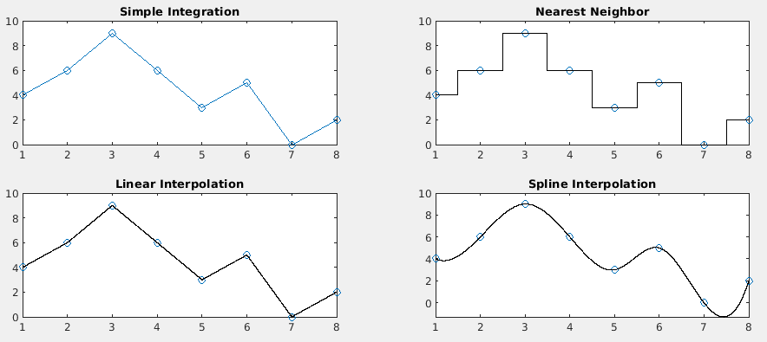on directly approximating the integral of the given data sets.