NLP Mini Project 1 — Phase 1 Report
Wikipedia Article-Type Classifier using Classical NLP (DBpedia-14, Option 6)
Group members: ____________________ | Course: Natural Language Processing | November 2026

1. Problem statement
Wikipedia contains millions of articles, and applications such as search filters, knowledge-base construction, recommendation and automatic tagging of new pages need to know what type of entity an article describes. This project builds a classical NLP application (Units 1–4) that reads the abstract of a Wikipedia article and predicts one of six types: Company, Artist, Athlete, Building, Film or WrittenWork. Along the way it analyses the corpus with N-grams and builds an N-gram language model for next-word prediction.
Pipeline: Corpus → train/test separation → preprocessing → corpus statistics → N-gram analysis → next-word prediction → Bag of Words → classifier → test metrics → demo.

2. Corpus and train/test separation
DBpedia-14 (Zhang et al., 2015) contains Wikipedia abstracts labelled with 14 non-overlapping DBpedia ontology classes: 560,000 training and 70,000 test examples (40,000 / 5,000 per class). Each record has a title, the abstract text (content) and a label. We loaded it from Hugging Face (fancyzhx/dbpedia_14).
Decision | Choice
Classes | 6 of 14: Company, Artist, Athlete, Building, Film, WrittenWork — organisations, people, places and creative works, including confusable pairs
Text field | Content only. The title is just a name and usually reappears at the start of the content
Training set | 3,000 random articles per class from the official training split (18,000), random_state=42
Test set | All official test articles of the 6 classes (30,000; 5,000 per class) — official split, unchanged
Leakage control | Split saved to data/train.csv and data/test.csv before any modelling; 0 texts shared between them; vocabulary, model selection and LM tuning use training data only

3. Text preprocessing
One reusable function, preprocess() in src/preprocessing.py, is applied identically to training data, test data and demo input:
- Normalization: lowercase, strip accents (María → maria), remove URLs, digits, punctuation and non-Latin characters;
- Tokenization: NLTK word_tokenize;
- Stop words: NLTK English stop-word list; tokens shorter than 2 characters dropped;
- Lemmatization: WordNet lemmatizer. We compared it with the Porter stemmer: stemming produces non-words (company → compani, historic → histor), while lemmatization keeps readable words for N-gram tables and feature inspection, with similar vocabulary reduction.
Example. “Bevin Brothers Manufacturing company (also called Bevin Brothers) is a family-owned bell foundry located in East Hampton Connecticut.” → [bevin, brother, manufacturing, company, also, called, bevin, brother, family, owned, bell, foundry, located, east, hampton, connecticut]
For the language model a lighter version keeps stop words and word forms and splits text into sentences, because function words (was, by, the) are exactly what a next-word predictor has to learn.

4. Corpus statistics (training split)
Statistic | Value
Documents (train / test) | 18,000 / 30,000
Raw tokens / raw vocabulary (lowercase) | 856,936 / 60,711
Tokens / vocabulary after preprocessing | 529,455 / 56,723
Average tokens per document (raw → preprocessed) | 47.6 → 29.4
Words occurring only once (hapax) | ≈53% of the vocabulary (mostly proper nouns)
Class balance | Perfectly balanced: 3,000 train and 5,000 test per class

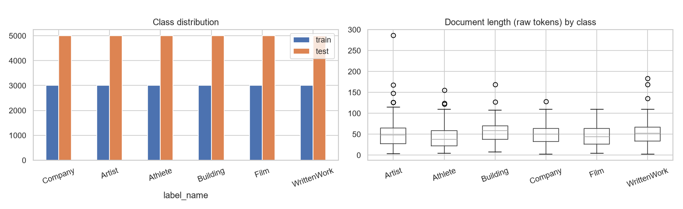
Figure 1. Class distribution and document length by class.
Documents are short abstracts; Building and WrittenWork abstracts are slightly longer, Athlete abstracts shorter. The most frequent words (film, born, company, directed, published, historic, book, novel) are already topical, which suggests Bag of Words will work well. Because about half the vocabulary appears only once, words seen in a single document are removed in the classifier (min_df = 2).

5. N-gram analysis
We extracted the most frequent unigrams, bigrams and trigrams overall and per class, and “distinctive” bigrams (frequent in one class, rare in the others).
Class | Characteristic bigrams | Characteristic trigrams
Company | company founded, company based, record label, company headquartered | independent record label, wholly owned subsidiary, london stock exchange
Artist | singer songwriter, best known, stage name, italian painter | known stage name, american singer songwriter, comic book artist
Athlete | football league, major league, summer olympics, footballer played | major league baseball, professional ice hockey, national football league
Building | national register, historic place, historic home, parish church | national register historic place, grade ii listed, historic home located
Film | film directed, drama film, comedy film, film starring | drama film directed, international film festival, cannes film festival
WrittenWork | first published, science fiction, peer reviewed, short story | science fiction novel, peer reviewed academic journal, non fiction book

- Bigrams and trigrams capture fixed Wikipedia phrasing that is far more class-specific than single words (“directed by”, “national register of historic places”, “peer-reviewed journal”).
- Some bigrams are shared by almost every class — united state(s), new york, also known, th century (from “19th century” after digit removal). They describe places and dates, not the entity type.
- “born + month” is shared only by the two person classes (Artist and Athlete); separating them depends on words like painter/singer versus footballer/league.

6. N-gram language model and next-word prediction
Bigram and trigram models were trained on 43,800 training sentences with <s>/</s> markers (vocabulary 60,681). Two smoothing methods were compared on 4,837 unseen test sentences: add-k (k = 0.01) and linear interpolation of trigram, bigram and unigram estimates. Interpolation weights were chosen on a 10% validation slice of the training articles: bigram (0.6, 0.4), trigram (0.2, 0.5, 0.3).
Model | Perplexity, add-k | Perplexity, interpolation
Bigram | 708.1 | 287.7
Trigram | 3934.5 | 254.0

With add-k the trigram is much worse than the bigram: most trigram contexts are rare, and adding k to all ~60,000 possible next words moves too much probability to unseen words. With interpolation the trigram is the best model, because it uses the extra context when available and falls back to bigram/unigram evidence otherwise. This is the sparsity trade-off from Unit 3: a larger n gives more context but more unseen N-grams.
Prompt | Top next words (probability) | Greedy continuation
the film was directed | by (0.94), and, written | the film was directed by john ford
he is a professional | baseball (0.14), footballer (0.12), american | he is a professional baseball player
the company was founded | in (0.70), by (0.19), as | the company was founded in by the american writer …
the novel was written | by (0.62), and (0.13), in | the novel was written by the american writer of the same name
the building is located | in (0.45), at (0.23), on (0.18) | the building is located in the united states
she is an american | professional, football, singer | she is an american professional baseball player
the airline is based | on (0.72), in (0.22), upon | the airline is based on the national register of …

The predictions reflect typical Wikipedia phrasing and often reveal the entity type. Greedy generation becomes generic after a few words (“based on the national register …”), because the model only sees two previous words; and since digits were removed, “founded in 1990” became “founded in”.

7. Bag of Words and classification
Texts were converted to Bag of Words vectors with CountVectorizer(min_df = 2) fitted on training texts only: 18,000 × 21,490 sparse matrix (0.1% non-zero). Two classifiers were compared with 5-fold stratified cross-validation on the training set; the test set was not used for the choice.
Classifier | CV accuracy | CV macro-F1
Multinomial Naive Bayes | 0.9454 | 0.9454
Logistic Regression | 0.9634 | 0.9635

Logistic Regression was selected and retrained on all 18,000 training articles. Its most influential words per class agree with the N-gram analysis: directed, film, documentary, starring (Film); novel, newspaper, published, book (WrittenWork); footballer, player, professional, played (Athlete); museum, built, church, castle (Building); company, manufacturer, publisher, founded (Company); painter, singer, writer, musician (Artist).

8. Final results on unseen test data
Evaluated once on the 30,000 official test articles: accuracy 0.9648, macro precision 0.9648, macro recall 0.9648, macro F1 0.9648. 1,057 articles (3.5%) were misclassified.
Class | Precision | Recall | F1 | Test articles
Company | 0.9502 | 0.9542 | 0.9522 | 5000
Artist | 0.9557 | 0.9368 | 0.9462 | 5000
Athlete | 0.9908 | 0.9886 | 0.9897 | 5000
Building | 0.9743 | 0.9766 | 0.9754 | 5000
Film | 0.9790 | 0.9774 | 0.9782 | 5000
WrittenWork | 0.9390 | 0.9550 | 0.9470 | 5000

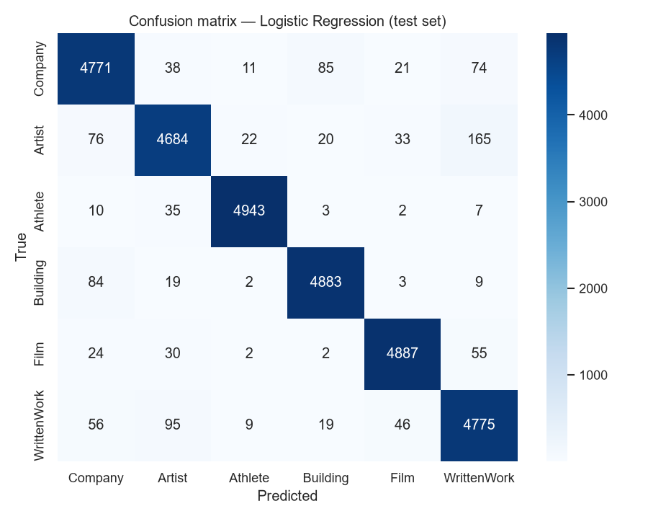
Figure 2. Confusion matrix on the test set (rows: true class, columns: predicted).
The notebook also lists 15 individual test predictions (title, text, true label, prediction, confidence); per-article predictions for the whole test set are saved in results/test_predictions.csv.

9. Error analysis
- Most frequent confusions. Artist → WrittenWork (165) and WrittenWork → Artist (95): writers, cartoonists and memoir authors are described with book, published, novel; novel abstracts often describe their author.
- Company ↔ Building (85 / 84): restaurant chains, hotels, shops and factories are both businesses and places.
- Athlete (F1 0.990) and Film (0.978) are easiest: their vocabulary is used by almost no other class.
Typical failures show topic words pointing to the wrong type:
Article | True | Predicted
Jonathan Rosenbaum — “an American film critic …” | Artist | Film
Svarog Films — “a Russian independent film company …” | Company | Film
The Man Who Watched the Trains Go By — novel; “a film adaptation was released in 1952” | WrittenWork | Film
Josephine Koo — actress described through the films she starred in | Artist | Film
India-West — newspaper “in the United States … California” | WrittenWork | Building

Bag of Words counts which words appear but cannot distinguish what an article is about from what it mentions, and it ignores word order. Wrong predictions have much lower confidence on average (0.72) than correct ones (0.97), so the predicted probability is a useful signal for flagging uncertain cases.

10. Demo
predict_article_type(text) applies the same preprocessing and returns the predicted type with probabilities. On six new descriptions written for the demo (not from the corpus) all six were classified correctly with 97–99% confidence, e.g. “Silent Orbit is a 2019 science fiction thriller directed by James Reed …” → Film (99.0%). An input() cell allows live testing during the presentation.

11. Conclusion and next steps
A complete classical pipeline — preprocessing, corpus statistics, N-gram analysis, an interpolated trigram language model and a Bag-of-Words Logistic Regression classifier — classifies Wikipedia article types with 96.5% accuracy on 30,000 unseen articles. The N-gram analysis explains why: each type has stable, distinctive phrasing. The remaining errors come from overlapping vocabulary between related types and from the inability of Bag of Words to use word order and meaning.
Project 2 will reuse the frozen split, preprocessing function and saved model as a baseline and add embeddings, neural and Transformer (BERT) classifiers, which may resolve “mentions vs. is about” errors, and possibly semantic retrieval over the article collection.

References
- Zhang, X., Zhao, J., LeCun, Y. (2015). Character-level Convolutional Networks for Text Classification. NeurIPS. (DBpedia-14; Hugging Face: fancyzhx/dbpedia_14)
- Jurafsky, D., Martin, J. H. Speech and Language Processing, 3rd ed. draft — N-gram language models; Naive Bayes and Logistic Regression.
- Course material: NLP Units 1–4 and Practical Companion Manual.
- Libraries: NLTK, scikit-learn, pandas, matplotlib, seaborn, Hugging Face datasets.

