

*Water Resources Research*

Supporting Information for

**Biogeochemical Hotspots: Role of Small Water Bodies in Landscape Nutrient Processing**

F. Y. Cheng1, N. B. Basu1,2

1 Department of Civil and Environmental Engineering, University of Waterloo, Waterloo, Ontario, Canada,

2 Department of Earth and Environmental Sciences, University of Waterloo, Waterloo, Ontario, Canada

**Contents of this file**

Figure S1

Figure S2

Figure S3

**Additional Supporting Information (Files uploaded separately)**

Dataset - Table S1 (2016WR020102-Supp-ds01.xlsx)

**Introduction**

Figure S1 shows the nutrient removal rate constants using the continuously stirred tank reactor (CSTR) assumption rather than a plug-flow assumption. The governing equation is described in Table 1 of the article.

Additional analyses related to the wetted area-volume ratio as a function of size are described with Figures S2 and S3.

A well-mixed reactor (CSTR) assumption yields significant inverse relationships between the removal rate constant and the hydraulic residence time similar to the plug-flow assumption.

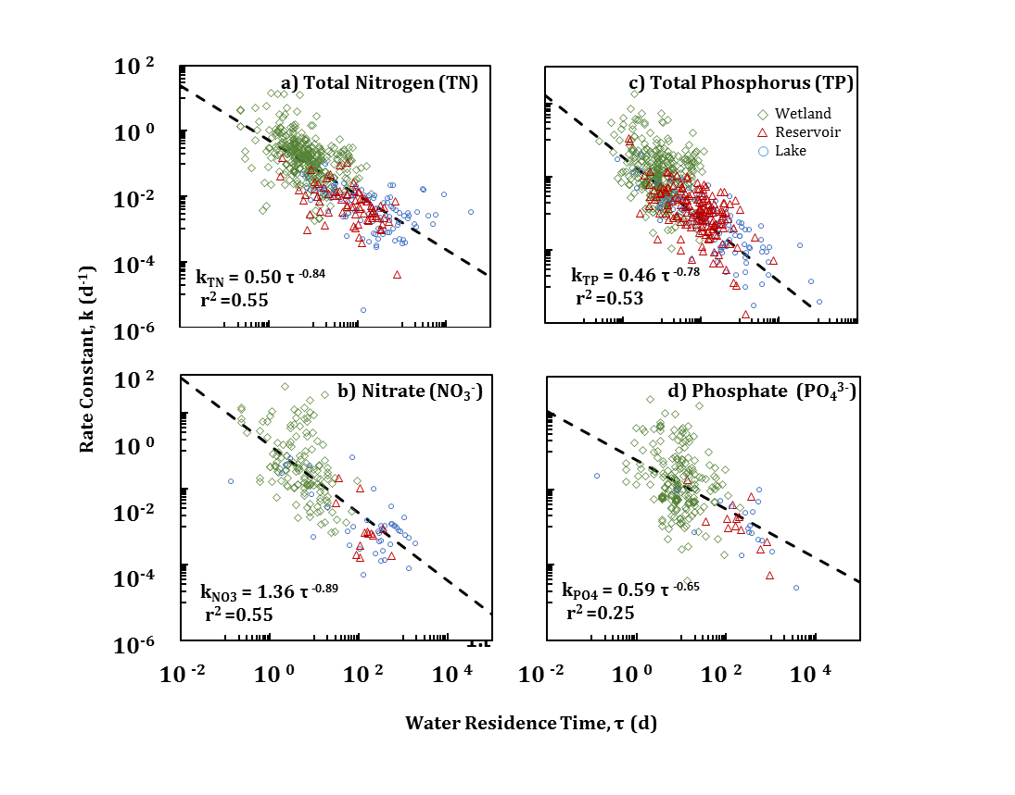

Figure S1. Removal rate constant (*kv,c*) – hydraulic residence time relationships (*τ*) for a) total nitrogen (TN), b) nitrate (NO3-), c) total phosphorus (TP), d) phosphate (PO43-). Same as Figure 3 but with CSTR model.

Supplementary Analysis: Exploring Dominant Controls on the Observed Inverse *k-SA* Relationship

Both the data and model results reveal an inverse relationship between the water residence time (or surface area) and the effective nutrient removal rate constant (Section 3.1 and 3.3). The cause of this behaviour can likely be attributed to the higher ratio of wetted sediment area and the volume of water (*WA:V* ratio) in small water bodies. As discussed previously, the sediment zone is a critical part of the nitrogen and phosphorus cycles where denitrifying bacteria can remove nitrogen and is the storage zone for sediment bound P. Here, the relationship between the *WA:V* ratio and size using an analytical expression is shown.

The model described above assumes a cylindrical bathymetry for ease of calculations. The wetted area term serves as a link between the bathymetry and the removal processes in the system. To determine a relationship between the size of a water body and wetted area, the bathymetric relationship developed by Hayashi and van der Kamp [2000] was used:

$\frac{y}{y_{o}}= {\left(\frac{r}{r_{o}}\right)}^{p}$ (S1)

where *y* and *r* are the maximum depth and radius of the water body [L], *yo* and *ro* are the depth and radius at a reference depth [L ] and *p* is a shape factor. The shape factor describes the slope of the water body where *p*=1 creates a cone and *p* approaching infinity creates a cylinder (**Figure S2**). Surface area-wetted area-volume relationships were developed by integrating the bathymetric equation (i.e. the slope profile) around the vertical axis.

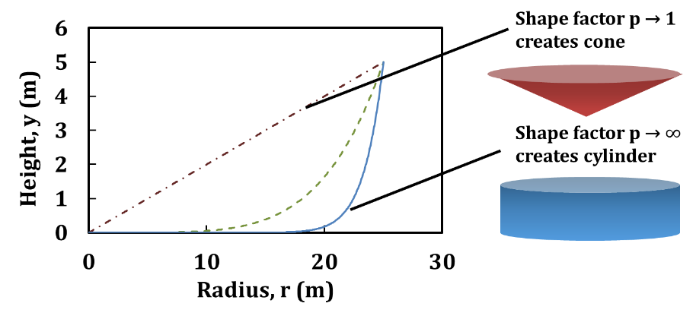

**Figure S2.** Example slope profile of symmetric basin following y = yo(r/ro)p

The effect of varying bathymetry was explored by calculating the wetted area – volume ratio of the water body. As such, the wetted contact area (*Sy*) and volume (*V*) were calculated using **Equations S2 and S3** respectively:

$S_{y}=2π\int_{y_{1}}^{y_{2}}{r(y)\sqrt{1+{\left(\frac{dr}{dy}\right)}^{2}}dy}$ (S2)

$V= π\int_{y1}^{y2}{y{(r)}^{2}}dy$ (S3)

where *Sy*, which represents the wetted contact area and is the surface of revolution along the y-axis, *r* is the radius as a function of depth (based on **Equation S1**), *V* is the volume of the solid of revolution along the y-axis.

A common metric for the biological richness and diversity of a wetland is the perimeter-area ratio [*Helzer and Jelinski*, 1999; *Fairbairn and Dinsmore*, 2001]. The same metric can also be used in determining wetland hydrological behaviour. Studies such as those by *Millar* [1971]and *Hayashi and Rosenberry* [2002] found that the water level recession in wetlands are highly dependent on the perimeter-area ratio which accounts for the higher surface areas allowing for evapotranspiration or groundwater exchange. Thus, it should follow that nitrogen and phosphorus removal dynamics in lentic systems, which are greatly dependent on the hydrological processes and pathways, should also be dependent to analogous metrics such as the wetted area-volume ratio.

The wetted contact area-volume ratio, regardless of the shape of the system, is higher for smaller systems (**Figure S3**). This relationship supports the hypothesis that a controlling factor to the overall reactivity of the system is dependent on size due to the contact area-volume ratio. The effect is most apparent for small water bodies: accounting for system bathymetry will be more important when modelling the biogeochemical processes for small systems. However, this relationship tends to converge at larger scales where the wetted area approaches unity with volume due to the relatively small magnitude of depth.

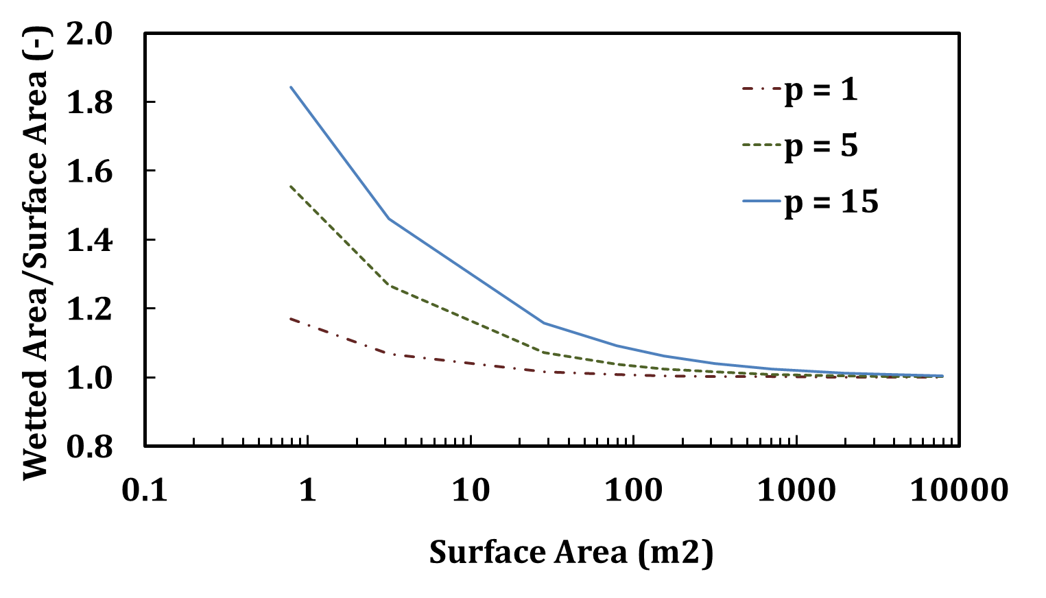

**Figure S3.** Decreasing wetted area-volume ratio as a function surface area

The shape of the water body is another factor that can affect the wetted area-volume ratio. Systems that are more conical in shape tend to have a higher ratio when compared to cylindrical systems. However, the conical and cylindrical are end members of likely scenarios with most systems having concave bathymetries but the negative relationship between the wetted area-volume ratio and surface area still holds true.

**References Used in Supplemental Information**

Fairbairn, S. E., and J. J. Dinsmore (2001), Local and landscape-level influences on wetland bird communities of the prairie pothole region of Iowa, USA, *Wetlands*, *21*(1), 41–47, doi:10.1672/0277-5212(2001)021[0041:LALLIO]2.0.CO;2.

Hayashi, M., and G. van der Kamp (2000), Simple equations to represent the volume–area–depth relations of shallow wetlands in small topographic depressions, *J. Hydrol.*, *237*(1–2), 74–85, doi:10.1016/S0022-1694(00)00300-0.

Hayashi, M., and D. O. Rosenberry (2002), Effects of ground water exchange on the hydrology and ecology of surface water, *Ground Water*, *40*(3), 309–316, doi:10.1111/j.1745-6584.2002.tb02659.x.

Helzer, C. J., and D. E. Jelinski (1999), The relative importance of patch area and perimeter-area ratio to grassland breeding birds, *Ecol. Appl.*, *9*(4), 1448–1458, doi:10.1890/1051-0761(1999)009[1448:TRIOPA]2.0.CO;2.

Millar, J. B. (1971), Shoreline-area ratio as a factor in rate of water loss from small sloughs, *J. Hydrol.*, *14*(3–4), 259–284, doi:10.1016/0022-1694(71)90038-2.