Documentation – wetlandP_v2.1

Adrian Wiegman

30 October, 2021

Table of Contents

About 2

Funding 2

Buildnotes 2

Getting Started 3

Running the Model 3

File Structure 3

Dependacies 4

Documentation Folder 4

Scripts Folder 5

Inputs Folder 6

Outputs Folder 8

Model Variables 8

State variables 10

Processes 10

Forcings (Hydroclimatic Inputs) 14

Parameters 15

Differential Equations 24

Mass balance 24

Numerical Stability Checks 26

References 30

Online Data Sources 30

Scientific Literature 30

Software Dependancies 31

**Note this project is still under development**

## About

The wetlandP_v2.1 model is an ordinary differential equation model developed for decadal phosphorus (P) retention simulations in riparian wetlands with a range of soil and hydrologic conditions.

### Funding

**Quantifying phosphorus retention in restored riparian wetlands of the Lake Champlain Basin**

EPA Grant: LC00A00394

Job Cost Code: 995-002-001

#### Project Team:

Eric D. Roy, Ph.D., University of Vermont (Principle Investigator)

Breck Bowden, Ph.D., University of Vermont (Investigator)

Kristin Underwood, Ph.D., University of Vermont (Investigator)

Adrian Wiegman, M.S., University of Vermont (PhD Candidate)

#### Granting Agency:

Lake Champlain Basin Program

54 West Shore Road

Grand Isle, VT 05458

### Buildnotes

Model version: wetlandP_v2.1

The data for this project are hosted at the authors private github repository: <https://github.com/arhwiegman/wetlandP>

The current version of the model is available within the wetlandP repository: <https://github.com/arhwiegman/wetlandP/tree/master/model_versions/wetlandP_v2/wetlandP_v2.1>

This repository will be made public upon publication of this work.

#### Status (of this version)

1. Switches have been added to toggle process flow rates see IO_ in parameters.
2. All hydroclimatic variabels are read in as input data then fit to an approxfun so that values can be interpolated at any discrete time point. See scripts/preprocssing for preparation of hydroclimatic input table.
3. Moved away from the use of langmuir model of adsorption, instead DIP_E can either be entered as a constant, or calculated using a power model fit to final intact core SRP and (Ex_max - Ex)/(PSR).
4. New script added to keep track of and, when needed, install dependancies.
5. Packrat is no longer being used pacman is being used to install load packages.
6. Revised biomass growth equations to include temperature effects on growth rate and mortality, and omit water level and self crowding effects on growth rate.

#### Potential Next steps (for future versions)

1. Incorporate subroutine that takes raw climate data from weather stations and water level data and prepares a proper input table.
2. Add subroutines for P flows due to periphyton, bioturbation
3. Add subroutine to toggle aerobic/anearobic sediments and associated changes in DIP_E
4. Improve computational efficiency (decrease simulation time).
5. Add option to use NRCS Soil Survey Data and/or Farming Frequency and/or Years since farming to initialize state variables.
6. Add the ability to take hydrologic parameters such as inundation frequency and depth, and produce a synthetic flood hydrograph.
7. Add subroutines for management including: fertilizer additon, biomass harvest, ditch plugging, and berm removal
8. Implement the wetlandP_v2.1 R project with packrat to avoid compatability issues among local R package versions (Ushey et al. 2018).
9. Add subroutines for freeze/thaw

## Getting Started

The wetlandP_v2.1 model is written in R version 4.0.1 (2020-06-06) – “See Things Now” using Rstudio (v. 1.2.1). An R project file (.Rpoj) is the user interface.To run the model, click on the wetlandP.Rproj file. This will open up Rstudio with the wetlandP_v2.1 working directory.

### Running the Model

Read the remainder of this section for details on how to edit parameters and run the model and view model outputs.

### File Structure

A current list of the working directory is given below.

## [1] "documentation" "Documentation – wetlandP_v2.1.pdf"  
## [3] "inputs" "outputs"   
## [5] "ReadMe.docx" "ReadMe.html"   
## [7] "ReadMe.Rmd" "ReadMe.tex"   
## [9] "Rplot.pdf" "Rplot01.pdf"   
## [11] "Rplot02.pdf" "scripts"   
## [13] "scripts - 2021-10-25" "wetlandP.Rproj"

The sections below describe the documentation, scripts, inputs, and outputs in more detail.

### Dependacies

A script called dependancies.R uses pacman to check for and install required R packages. The wetlandP_v2.1 simulations are implemented with the deSolve package (Soetaert et al. 2010), data management and plotting is implemented with the tidyverse packages (Wickham et al. 2019). For more details on the packages used see the scripts/dependancies.R file.

Upon running this file you will see the following console output

## successfully loaded dependant R packages:  
## [1] "ggrepel" "ecolMod" "diagram"   
## [4] "shape" "rootSolve" "rlang"   
## [7] "Evapotranspiration" "soiltexture" "zoo"   
## [10] "diffeqr" "deSolve" "pacman"   
## [13] "forcats" "stringr" "dplyr"   
## [16] "purrr" "readr" "tidyr"   
## [19] "tibble" "ggplot2" "tidyverse"

The dependancies.R script also creates an object called depedancy_citations. You can print this and copy it to add the package citations to a bibliography.

### Documentation Folder

Currently the most detailed documentation of the model is within the model scripts. However this folder contains tables that document model variables, values, assumptions, etc… for major varaible types in the model.

## [1] "fig1_states_W0_B0_G0.png"   
## [2] "fig2_states_W0_B0_G1.png"   
## [3] "fig3_states_W0_B1_G0.png"   
## [4] "fig4_states_W0_B1_G1.png"   
## [5] "fig5_hydroclimate_static_W1_B0_G0.png"  
## [6] "fig6_hydroclimate_W1_B0_G0.png"   
## [7] "fig7_states_W1_B1_G1.png"   
## [8] "fig8_DIP_A_W1_B1_G1.png"   
## [9] "function_tests.xlsx"   
## [10] "generate_documentation_tables.R"   
## [11] "parameters.csv"   
## [12] "parameters.md"   
## [13] "parameters_local.csv"   
## [14] "parameters_local.md"   
## [15] "parameters_local.R"   
## [16] "parameters_simulation.csv"   
## [17] "parameters_simulation.md"   
## [18] "parameters_simulation.R"   
## [19] "parameters_stochastic.csv"   
## [20] "parameters_stochastic.md"   
## [21] "parameters_stochastic.R"   
## [22] "parameters_table.R"   
## [23] "parameters_universal_constant.csv"   
## [24] "parameters_universal_constant.md"   
## [25] "parameters_universal_constants.R"   
## [26] "processes.csv"   
## [27] "processes.md"   
## [28] "stochastic.csv"   
## [29] "stochastic.md"   
## [30] "stoicheometry.xlsx"   
## [31] "stoicheometry_complex.xlsx"   
## [32] "superceded"   
## [33] "wetlandP_v2.1_Conceptual_Diagram.png"

### Scripts Folder

## [1] "_implementations" "_postprocessing" "_preprocessing" "_sourcecode"   
## [5] "dependancies.R" "fns" "functions.R" "initialize.R"   
## [9] "model.R" "parameters.R" "subroutines.R" "xecute.R"

In addition to the files above the scripts folder holds four folders. _implementations contains high level scripts used to call the model and edit inputs and outputs. _preprocessing contains scripts to conduct statistical analysis to general parameter estimates or to calculate the hydroclimate forcing tables. _postprocessing contains scripts to analyze model outputs. _sourcecodes contains copies of the model source codes in the main scripts folder. These are kept in case the user makes manual edits to the source codes that cause errors.

The table below provides a description of each of the source codes used by the model.

|  |  |
| --- | --- |
| name | description |
| xecute.R | High level script to load source code, execute simulation and manage data outputs. This script must be run to implement the model. To run the file: in Rstudio with the xecute.R file open press cmd/crtl + shift + enter |
| parameters.R | The main way to manipulate outputs. This includes both nurmerical constants to be used in model calculations as well as model run specifications (e.g. static or dynamic, simulation time) see fn_edit_parameter_values to change individual parameters for before a given run. |
| model.R | Contains the high level functions that controling flow of subroutines in the wetlandP_v2.1 model. See subroutines for details of model calculations. |
| initialize.R | initializes the model state variables based on the parameter values and functions provided. |
| subroutines.R | a series of subroutines that calculate new values of variables in the model based on functions, parameters and variable values in the model environment. |
| functions.R | a high level script that sources other functions. |
| functions/fns_X.R | functions pertaining to X aspect of the model (such as “processes”) |
| dependancies.R | checks for and installs required R packages |

### Inputs Folder

Inputs are taken as .csv (comma separated values) files and read in using the function readr::read_csv(). There are two kinds of input file, df.hydroclimate...csv and df.parameters...csv.hydroclimate files provide a time series of forcing data with the top row as the variable name and each column containing the values for the variable at time t, at least one column must be named t. parameters files are tables with the columns from left to right variable name, default value, units, description, assumptioms, random distribution function name and inputs.

## [1] "CH3_simulation_vars.Rmd"   
## [2] "coreflux"   
## [3] "df.climate.subdaily.csv"   
## [4] "df.hydroclimate.1m.LC.0.csv"   
## [5] "df.hydroclimate.1m.LC.0.Rdata"   
## [6] "df.hydroclimate.1m.LC.0x1p2.csv"   
## [7] "df.hydroclimate.1m.LC.0x1p2.Rdata"   
## [8] "df.hydroclimate.1m.LC.1.csv"   
## [9] "df.hydroclimate.1m.LC.1.Rdata"   
## [10] "df.hydroclimate.1m.LC.1x1p2.csv"   
## [11] "df.hydroclimate.1m.LC.1x1p2.Rdata"   
## [12] "df.hydroclimate.1m.LC.2.csv"   
## [13] "df.hydroclimate.1m.LC.2.Rdata"   
## [14] "df.hydroclimate.1m.LC.2x1p2.csv"   
## [15] "df.hydroclimate.1m.LC.2x1p2.Rdata"   
## [16] "df.hydroclimate.1m.LC.3.csv"   
## [17] "df.hydroclimate.1m.LC.3.Rdata"   
## [18] "df.hydroclimate.1m.LC.3x1p2.csv"   
## [19] "df.hydroclimate.1m.LC.3x1p2.Rdata"   
## [20] "df.hydroclimate.1m.LC.4.csv"   
## [21] "df.hydroclimate.1m.LC.4.Rdata"   
## [22] "df.hydroclimate.1m.LC.4x1p2.csv"   
## [23] "df.hydroclimate.1m.LC.4x1p2.Rdata"   
## [24] "df.hydroclimate.1m.OCD.0.csv"   
## [25] "df.hydroclimate.1m.OCD.0.Rdata"   
## [26] "df.hydroclimate.1m.OCD.0x1p2.csv"   
## [27] "df.hydroclimate.1m.OCD.0x1p2.Rdata"   
## [28] "df.hydroclimate.1m.OCD.1.csv"   
## [29] "df.hydroclimate.1m.OCD.1.Rdata"   
## [30] "df.hydroclimate.1m.OCD.1x1p2.csv"   
## [31] "df.hydroclimate.1m.OCD.1x1p2.Rdata"   
## [32] "df.hydroclimate.1m.OCD.2.csv"   
## [33] "df.hydroclimate.1m.OCD.2.Rdata"   
## [34] "df.hydroclimate.1m.OCD.2x1p2.csv"   
## [35] "df.hydroclimate.1m.OCD.2x1p2.Rdata"   
## [36] "df.hydroclimate.1m.OCD.3.csv"   
## [37] "df.hydroclimate.1m.OCD.3.Rdata"   
## [38] "df.hydroclimate.1m.OCD.3x1p2.csv"   
## [39] "df.hydroclimate.1m.OCD.3x1p2.Rdata"   
## [40] "df.hydroclimate.1m.OCD.4.csv"   
## [41] "df.hydroclimate.1m.OCD.4.Rdata"   
## [42] "df.hydroclimate.1m.OCD.4x1p2.csv"   
## [43] "df.hydroclimate.1m.OCD.4x1p2.Rdata"   
## [44] "df.hydroclimate.1m.OCSP.0.csv"   
## [45] "df.hydroclimate.1m.OCSP.0.Rdata"   
## [46] "df.hydroclimate.1m.OCSP.0x1p2.csv"   
## [47] "df.hydroclimate.1m.OCSP.0x1p2.Rdata"   
## [48] "df.hydroclimate.1m.OCSP.1.csv"   
## [49] "df.hydroclimate.1m.OCSP.1.Rdata"   
## [50] "df.hydroclimate.1m.OCSP.1x1p2.csv"   
## [51] "df.hydroclimate.1m.OCSP.1x1p2.Rdata"   
## [52] "df.hydroclimate.1m.OCSP.2.csv"   
## [53] "df.hydroclimate.1m.OCSP.2.Rdata"   
## [54] "df.hydroclimate.1m.OCSP.2x1p2.csv"   
## [55] "df.hydroclimate.1m.OCSP.2x1p2.Rdata"   
## [56] "df.hydroclimate.1m.OCSP.3.csv"   
## [57] "df.hydroclimate.1m.OCSP.3.Rdata"   
## [58] "df.hydroclimate.1m.OCSP.3x1p2.csv"   
## [59] "df.hydroclimate.1m.OCSP.3x1p2.Rdata"   
## [60] "df.hydroclimate.1m.OCSP.4.csv"   
## [61] "df.hydroclimate.1m.OCSP.4.Rdata"   
## [62] "df.hydroclimate.1m.OCSP.4x1p2.csv"   
## [63] "df.hydroclimate.1m.OCSP.4x1p2.Rdata"   
## [64] "df.hydroclimate.day.LC.csv"   
## [65] "df.hydroclimate.day.LC.Rdata"   
## [66] "df.hydroclimate_dynamic.csv"   
## [67] "df.hydroclimate_dynamic.csv.xlsx"   
## [68] "df.hydroclimate_static.csv"   
## [69] "df.hydroclimate_static.csv.xlsx"   
## [70] "df.hydroclimate_steady_state_sensitivity.csv"   
## [71] "df.hydroclimate_steady_state_sensitivity.csv.xlsx"  
## [72] "df.pred.csv"   
## [73] "df.stage_volume_discharge.csv"   
## [74] "df.stage_volume_discharge.Rdata"   
## [75] "hydrosummary.txt"   
## [76] "lcbp_sites"   
## [77] "readme.txt"   
## [78] "simulation_steps.txt"

### Outputs Folder

The model saves outputs with a prefix then the simulation then a timestamp. wetlandP_v2.1 produces three types of output:

|  |  |  |
| --- | --- | --- |
| prefix | extension | description |
| sim_ | .Rdata | an image of the R environment objects saved upon execution of the model run. Use load("sim_[run name].Rdata") in R to load the environment objects for the simulation. |
| fig_ | .png | time series plots of variables |
| outputs_ | .csv | a comma delimited data table of variable values along the time series the model run |

A snapshot of the outputs folder is given below:

## [1] "df.obs_vs_simpars_lcbp_siphon (2).csv"   
## [2] "df.obs_vs_simpars_lcbp_siphon (2)_OCSP.4.csv"   
## [3] "df.obs_vs_simpars_lcbp_siphon (2)_OCSP.4.xlsx"   
## [4] "df.sim.outs_steady_state_sensitivity_nsims10_2021-10-14.csv"   
## [5] "df.sim.outs_steady_state_sensitivity_nsims1000_2021-10-14.csv"   
## [6] "df.sim.outs_steady_state_sensitivity_nsims10000_2021-10-16.csv"

## Model Variables

This section contains summary tables defining the major variables of wetlandP_v2.1. A conceptual diagram of model domain, compartments, state variables, and processes is given below. Flows of phosphorus are represented by lines with arrows, the associated process for each flow is labeled in italics. State variables are represented in boxes with rounded edges. See the sections below for detailed definitions of states, processes, etc.

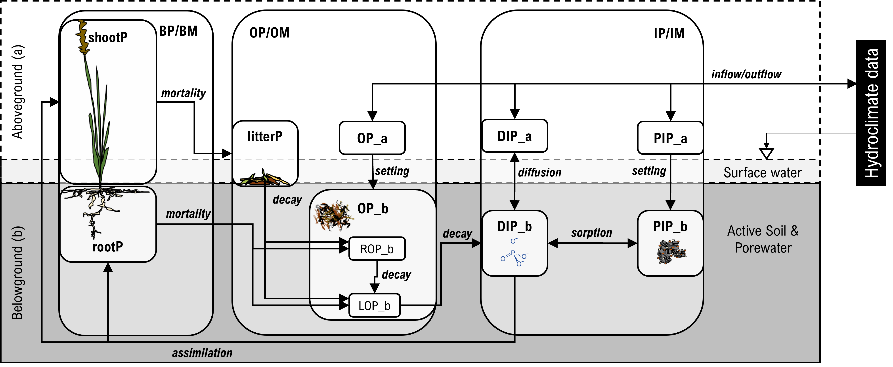

The figure below shows a time series plot of the model state variables.

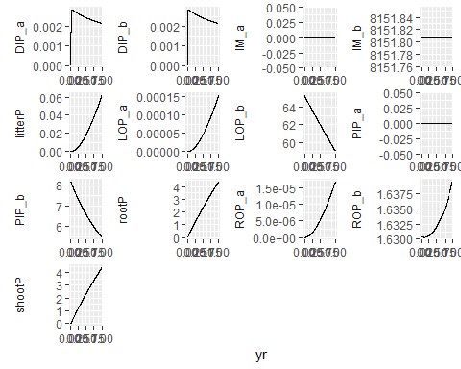

The default parameters for wetlandP_v2.1 currently produce state variable values close to what has been observed in the field. This includes dissolved inorganic P concentrations (see plot below)

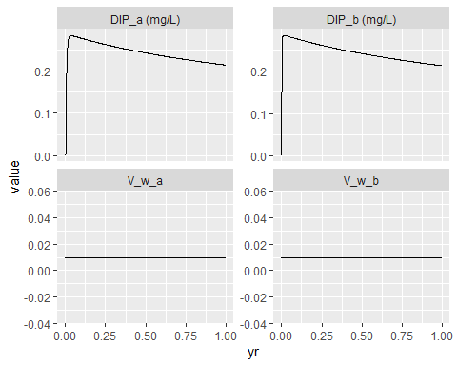

### State variables

state variables calculated with ordinary differential equations

|  |  |  |
| --- | --- | --- |
| name | unit | description |
| IM_a | g d.w | inorganic matter aboveground |
| IM_b | g d.w | inorganic matter belowground |
| shootP | g P | aboveground live shoot P |
| rootP | g P | belowground live root P |
| litterP | g P | aboveground litter P |
| ROP_a | g P | refractory OP aboveground |
| LOP_a | g P | labile OP aboveground |
| PIP_a | g P | particulate IP aboveground |
| DIP_a | g P | dissolved IP aboveground |
| ROP_b | g P | refractory OP belowground |
| LOP_b | g P | labile OP belowground |
| PIP_b | g P | particulate IP belowground |
| DIP_b | g P | dissolved IP belowground |

### Processes

#### Flows

process flows (adding or subtracting from state variables)

|  |  |  |  |  |
| --- | --- | --- | --- | --- |
| Name | Value | Unit | Description | Assumptions |
| Q_in | IO_Q_in*Q_in | m^3/d | surface water lateral inflow | note all hydrologic should be positive magnitude values, they are then multiplied by 1, 0, -1 in differential equaitions |
| Q_out | IO_Q_out*Q_out | m^3/d | surface water lateral outflow |  |
| Q_ground | IO_Q_ground*Q_ground | m^3/d | net vertical flow from groundwater (percolation - infiltration) |  |
| Q_precip | IO_Q_precip*Q_precip | m^3/d | direct precipitation |  |
| Q_ET | IO_Q_ET*Q_ET | m^3/d | evapotranspiration precipitation |  |
| assim_shootP | IO_assim_shootP*r_assim*BM*k_BM2P*k_f_G_shoot | g P/d | assimilation of shoot P |  |
| assim_rootP | IO_assim_rootP*r_assim*BM*k_BM2P*(1-k_f_G_shoot) | g P/d | growth of root P |  |
| mort_shootP2litterP | IO_mort_shootP2litterP*r_mort_shoot*shootP | g P/d | growth of root P |  |
| mort_rootP2LOP | IO_mort_rootP2LOP*r_mort_root*rootP*(k_f_labile_root) | g P/d | mortality of shoot P to LOP |  |
| mort_rootP2ROP | IO_mort_rootP2ROP*r_mort_root*rootP*(1-k_f_labile_root) | g P/d | mortatlity of root P |  |
| sed_IM | IO_sed_IM*r_sed_IM*IM_a | g d.w./d | sedimentation of inorganic matter |  |
| sed_PIP | IO_sed_IM*r_sed_IM*PIP_a | g P/d | sedimentation of inorganic P |  |
| sed_LOP | IO_sed_OM*r_sed_OM*LOP_a | g P/d | sedimentation of labile organic P |  |
| sed_ROP | IO_sed_OM*r_sed_OM*ROP_a | g P/d | sedimentation of refractory organic P |  |
| dec_litter2LOP_a | IO_decay_litter*r_decay_litter*litterP*(k_f_labile_litter) |  | decomposition of litter P to labile organic P |  |
| dec_litter2ROP_a | IO_decay_litter*r_decay_litter*litterP*(1-k_f_labile_litter) |  | decomposition of litter P to refractory organic P |  |
| dec_LOP_a | IO_decay_LOP*r_decay_LOP*LOP_a | g P/d | decomposition of labile OP to DIP |  |
| dec_ROP_a | IO_decay_ROP*r_decay_ROP*ROP_a | g P/d | decomposition of refractory OP to labile OP |  |
| dec_LOP_b | IO_decay_LOP*r_decay_LOP*LOP_b | g P/d | decomposition of labile OP to DIP |  |
| dec_ROP_b | IO_decay_ROP*r_decay_ROP*ROP_b | g P/d | decomposition of refractory OP to labile OP |  |
| diff_DIP_b2a | IO_diffus*r_diffus*DIP_b | g P/d | diffusion of DIP from b to a |  |
| sorp_DIP2PIP_b | IO_adsorp*r_adsorp*V_w_b | g P/d | adsorption of DIP onto PIP |  |
| in_IM | IO_in_IM*Q_in*ISS | g d.w./d | inflow of inorganic matter as ISS |  |
| in_PIP | IO_in_PIP*(in_IM*k_ISS2P + Q_in*SRP*k_SRP2PIP) | g P/d | inflow of PIP |  |
| in_LOP | IO_in_LOP*Q_in*OSS*k_BM2P*(k_f_labile) | g P/d | inflow of labile organic P |  |
| in_ROP | IO_in_ROP*Q_in*OSS*k_BM2P*(1-k_f_labile) | g P/d | inflow of recalcitrant organic P |  |
| in_DIP | IO_in_DIP*Q_in*SRP | g P/d | inflow of dissolved inorganic P |  |
| out_IM | IO_out_IM*Q_out*IM_a/V_w_a | g P/d | outflow of IM |  |
| out_PIP | IO_out_PIP*Q_out*PIP_a/V_w_a | g P/d | outflow of PIP |  |
| out_LOP | IO_out_LOP*Q_out*LOP_a/V_w_a | g P/d | outflow of LOP |  |
| out_ROP | IO_out_ROP*Q_out*ROP_a/V_w_a | g P/d | outflow of ROP |  |
| out_DIP | IO_out_DIP*Q_out*DIP_a/V_w_a | g P/d | outflow of DIP |  |

#### Rates

process rates (calculated as a function of forcing variables, intermediate variables and state variables)

|  |  |  |  |
| --- | --- | --- | --- |
| name | unit | description | assumptions |
| r_assim | g P/d | amount of DIP_b P (g) assimilated by macrophyte plants as net primary productivity | always affected by temperature, DIP availability, and optionally affected by water level, and self-crowding or shading (Marois & Mitsch 2016; Morris et al. 2002; Wiegman et al. 2019) |
| r_decay_litter | 1/d | proportional rate of litter decomposition | affected by temperature (Wang et al. 2003) |
| r_decay_ROP | 1/d | proportional rate of ROP decomposition | same as r_decay_litter |
| r_decay_LOP | 1/d | proportional rate of LOP decomposition | same as r_decay_litter |
| r_mort_shoot | 1/d | proportional rate of shoot death | affected by temperature, increases as a step function when temp drops below threshold (based on field observations) (Wiegman et al. 2019) |
| r_mort_root | 1/d | proportional rate of root death | affected by temperature (Morris et al. 2002) |
| r_adsorp_b | g P/d | ammount of DIP adsorbed to PIP belowground | affected by temperature and equilibrium DIP (Wang et al. 2003); equilibrium DIP can be set as a parameter, or calculated as a function from maximum P storage capacity (Ex_max, variable or constant), and the currently adsorbed P (Ex = PIP_b). |
| r_diffus | g P/d | amount of diffusion of DIP_b to DIP_a | affected by temperature, viscosity of water, concentration gradient, distance, and tortuosity of fluid matrix (Wang et al. 2003; Reddy & Delaune 2008) |
| r_sed_IM | 1/d | proportional rate of sedimentation of IM_a to IM_b | affected by settling velocity (temperature, viscosity of water, particle radius, particle density) and water depth, set equal to 1 when depth is less than settling velocity (Reddy & Delaune 2008) |
| r_sed_OM | 1/d | proportional rate of sedimentation of OM_a to OM_b | same as r_sed_OM |

### Forcings (Hydroclimatic Inputs)

The table below gives the variable names and assumptions for the forcing variables used in the model. The model was forced with water level data collected in situ and meteorological data from Burlington Int’l Airport (NOAA NCDC). Water level was measured at field sites by HOBO MX2001 pressure and temperature sensors placed just below the soil surface. Data was corrected for variation in local barometric pressure, also measured by HOBO MX2001s. Any gaps in the water level sensor record were filled via time lag regression with other sensors in the area or with USGS guages (USGS NWIS, r^2>0.9). Water temperature was modeled from air temperature based using a statistical fit to with miniDOT sensors at the soil water interface (r^2>0.9). Precipitation was taken as the daily totals from meteorological data. Evapotranspiration rate was estimated using the penman monteith method via the R package evapotranspiration, substituting sunshine hours for solar radiation. Water volume were calculated from area, porosity (assumed = 1), and water depth. We caclulated the first derivative in the time of water volume, and used this to solve for net surface flow. Surface inflow and outflow were deduced from net surface flow by adjusting for through flow. Through flow was calculated as the volume of water divided by the days hydraulic residence time (HRT or ).

$$

\ V_w = A*aH_w\ dV*{w} = V_{w,t} - V_{w,t+1} \ Q_{net}= dV_w - A(ip - ET) \  *> 0: \ Q*{in} = Vw/+ Qnet \ Q_{in} = - V_w/\ \ Q_{in} = V_w/\ Q_{out} = V_w/- Q_{net} \

$$

## Rows: 14 Columns: 4

## -- Column specification --------------------------------------------------------  
## Delimiter: "|"  
## chr (4): Symbol , Units , Definition , Assumptions and Sources

##   
## i Use `spec()` to retrieve the full column specification for this data.  
## i Specify the column types or set `show_col_types = FALSE` to quiet this message.

## Warning: One or more parsing issues, see `problems()` for details

Table 1. Hydroclimate variables

|  |  |  |  |
| --- | --- | --- | --- |
| Symbol | Units | Definition | Assumptions and Sources |
| Zs | (m, NAD’83) | elevation of sediment surface | estimated from LiDAR 0.5m DEM (VCGI), corrected with Emlid Reach RS+ RTK/GNSS survey (centimeter level accuracy) |
| Hw | (m) | height of water above sediment surface | measured with HOBO MX2001 water level logger |
| Zw | (m, NAD’83) | elevation of water | Hw + Zs |
| A | (m^2) | wetland surface area | interpolated from stage table as f(Hw) |
| Vw | (m^3) | Water volume of wetland surface water | calculated from A and H_w |
| ET | (cm/day) | Evapotranspiration rate | Calculated at daily intervals with penman monteith equation via the Evapotranspiration package, weather data from BURLINGTON INTERNATIONAL AIRPORT, VT US (WBAN:14742) (NOAA NCDC) |
| ip | (cm/day) | Precipitation rate | totals derived from sub-hourly weather observations from BURLINGTON INTERNATIONAL AIRPORT, VT US (WBAN:14742)(NOAA NCDC) |
| Qnet | (m^3) | net surface flow | deduced from dVw, and A(ip - ET) |
| Qin | (m^3/day) | Volumetric inflow rate | modeled with HydroCAD and/or solved from water balance |
| Qout | (m^3/day) | Wetland discharge (outflow) rate | Modeled as a f(Hw) based on site observations |
| Qg | (m^3/day) | Groundwater discharge (negative for infiltration) | assumed = 0 |
| Uw | (m/s) | Wind speed | mean derived from sub-hourly data from BURLINGTON INTERNATIONAL AIRPORT, VT US (WBAN:14742) | used in evapotranspiration calculation |
| Tair | (<U+00B0>C) | Daily air temperature | mean derived from sub-hourly data BURLINGTON INTERNATIONAL AIRPORT, VT US (WBAN:14742) | |
| TW | (<U+00B0>C) | Daily water average temperature | Modeled from Tair using equation from linear model fit to temperature measured with PME miniDOT. IF(Tair > 0): TW = 2.5+0.8Tair ELSE: TW = 0 |

### Parameters

local (measured) parameters

|  |  |  |  |  |
| --- | --- | --- | --- | --- |
| Name | Value | Unit | Description | Assumptions |
| area | 1 | m^2 | wetland surface area | uniform flat surface |
| H_b | 0.1 | m | height of belowground compartment (sediment column) | NA |
| k_HRT | 1e3 | d | hydraulic residence time of wetland surface water | calculated by dividing total system water volume (m3) by outlfow rate (m3/d), often changes as function of system water volume |
| k_TSS | 15 | g/m^3 | total suspended solids of inflow | based on field data, median of observations, 3.5 at prindle, 23.8 at union st, 12.25 at swamp rd |
| k_TP | 0.05 | g P/m^3 | TP concentration (mg P /L) in inflow | 0.071 at prindle, 0.059 at union, 0.056 at swamp |
| k_LOI | 0.20 | g/g | initial fraction of organic matter in total mass of below ground compartment | measured as soil loss-on-ignition |
| k_PSR | 0.20 | mol/mol | P Saturation Ratio | molar ratio of oxalate extractable P/(Al + Fe) (Nair et al. 2004), fit to field data, prindle 0.09 - 0.15, union 0.08 - 0.13, swamp rd 0.11 - 0.26 |
| k_Ex_max | 4 | g/kg | maximum P storage capacity | 31*(Al/27 + Fe/56), where Al and Fe are determined by acid ammonium oxalate extraction, fit to field data, ranging from 3.3 - 5.5 prindle, 5.0 - 6.4 union, 3.44 - 5.1 swamp |
| k_clay | 0.1 | g/g | clay content of inorganic matter, used for particle settling velocity | from soil textural analysis OR from NRCS soil survey units texture class, .11 to 0.35, .0875 to 0.15 union, 0.075 - .15 swamp |
| k_f_fines | 0.90 | g/g | silt + clay, fine sediment fraction of incoming total suspended solids used for particle setting velocity | fit to field data and 0.627 - .84 prindle, 0.84 - 0.97 union, 0.75 - 0.985 swamp rd. |
| k_f_OSS | 0.5 | g/g | organic matter fraction of incoming total suspended solids | fit to field data, %65 at prindle rd, 23% at union st, 54% swamp rd. |
| k_f_SRP | 0.3 | g SRP /g TP | fraction of TP as SRP in influent water | based on field data 0.404 at prindle, 0.25 at union, 0.27 at swamp rd. |
| k_DIP_E | 0.05 |  | equilibrium DIP concentration | used if IO_variable_DIP_E = F, set equal to final intact SRP for aerobic treatments |
| k_rp_i | fn_particle_radius(sand |  | average radius of inorganic particles | calculated based on soil texture see fn_particle_radius |

stochastic (unmeasured/calibrated) parameters

|  |  |  |  |  |
| --- | --- | --- | --- | --- |
| Name | Value | Unit | Description | Assumptions |
| k_T_STD | 13.75 | deg C | standard temperature for metabolic processes | calibrated to make actual NPP match ANPPmax, since experiments were conducted under field conditions this parameter is equal to the (maximum daily average temp - minimum daily average temp)/2 + minimum daily average temp ~ 15 - 17 degrees |
| k_SRP2PIP | 0.98 | g P/d.w. | ratio of LOP to SRP | 8.9e-1 for prindle, 1.42 for swamp rd, 6.2e-1 for union st |
| k_ISS2P | 0.0013 | g P/d.w. | P content of inorganic suspended sediments | site data 0.002 for prindle rd, 0.0009 for union st, 0.00094 for swamp rd |
| k_shootM | 0 | g dw/m2 | shoot live biomass | need to set up a way to get this to vary based on start time |
| k_rootM | 1000 | g dw/m2 | shoot live biomass | need to set up a way to get this to vary based on start time |
| k_BM2P | 0.001 | g/g P/d.w. | P content of biomass | McJannet et al. 1996 .001 - 0.003; Morris & Bowden 1986 0.002; Wiegman Ch 2 data 0.001 to 0.003 |
| k_f_G_shoot | 0.5 | fraction | fraction of NPP allocated to shoot growth (shoot_NPP/total_NPP) | Morris et al 1984 0.2 - 0.5 |
| k_NPP | 1500 | g m-2 y-1 | combined annual rate of NPP for above and below ground biomass | Morris et al. 1984 1000 to 4000 |
| k_ADNPP | k_NPP/365 | g m-2 d-1 | average daily rate of NPP | divide k_NPP by 365 |
| k_M | 0.001 | 1/day | rate of baseline biomass mortality | calibrated to root mass ~1000 - 2000 g m-2 and peak shootM ~300-800 g m-2 at use 0.003 for k_ANPPmax = 3000, with guidance from Morris et al 1984 0.003 to 0.007; Marois & Mitsch 2016 0.0005 - 0.007 |
| k_M_shoot_T_mult | 50 | factor | multiplier for shoot mortality after temp drops below threshold | calibrated to field observations |
| k_T_thresh_M_shoot | 6 | deg C | temperature at which shoot mortality increases | calibrated to field observations |
| k_whc | 1e-3 |  | a small volume of water to prevent errors associated with empty compartments | best guess based on fit of oven dry verses air dry moisture content |
| k_diff_STD | 1e-1 | m^2/d | effective diffusion coefficient | calibrated to intact core data; Marois & Mitsch 2016 calibrated value was 2e-5 m2 d-1 |
| k_ad | 1.75 | 1/d | adsorption first order rate coefficient | Wang et al. 2003 1.75, Marois & Mitsch 2016 used |
| k_E | .56 | m^3/g | langmuir constant of adsorption (bond energy) | Calibrated to intact core data this value depends on what metric is used to define Ex_max, Wang et al. 2003 2.75 m3 kg-1 |
| k_PIP2Ex | 1 | g/g | ratio of exchangeable P to particulate inorganic P | Wang et al. 2003 0.8 |
| k_f_labile | 0.8 | g/g | labile fraction organic matter | Morris & Bowden 1986 refractory fraction of 0.2 k_f_LOM_OSS = k_f_labile # g/g |
| k_decay_litter | 0.01 | 1/d | litter decomposition rate coefficient at STD temp | Morris & Bowden, Wiegman Ch 3, # Longhi et al. 2008 k = ranged from 0.01 1/d to 0.0027 1/d |
| k_decay_LOP | 0.01 | 1/d | LOP decomposition rate coefficient at STD temp | Marois & Mitsch 2016 DOP rate is 0.01, while LPOP rate is 0.003, since we do not model DOP LOP decay should be between 0.001 - 0.01 |
| k_decay_ROP | 1e-5 | 1/d | ROP decomposition rate coefficient at STD temp when soils are unsaturated and aerobic(H_w < 0) | Morris & Bowden 1986 assume refractory OM does not decompose, however this is assuming saturated soils, so we assume that when H_w < 0 that ROP decomposes at between 1e-5 and 5e-5 based on value from Marois & Mitsch 2016 of 2.5e-5 |
| k_rp_o | 4.5e-7 | m | average radius of organic particles | Marois & Mitsch 2016 |

universal constant parameters

|  |  |  |  |  |
| --- | --- | --- | --- | --- |
| Name | Value | Unit | Description | Assumptions |
| k_dp_i | 2.65e6 | g/m^3 | particle density of inorganic matter | Delaune et al. 1983 g/cm^3 * 10^6 cm3/m3 |
| k_dp_o | 1.14e6 | g/m^3 | particle density of inorganic matter | Delaune et al. 1983 g/cm^3 * 10^6 cm3/m3 |
| k_db_i | 1.99e6 | g/m^3 | bulk density of inorganic matter | Morris et al. 2016 |
| k_db_o | 0.085e6 | g/m^3 | bulk density of organic matter | Morris et al. 2016 |
| k_pi | 3.141593 |  | arc length of a circle |  |
| k_g | 7.32e10 | m/d^2 | acceleration due to gravity | constant |
| k_mew | 86.4e3 | g/m/d | viscosity of water | standard value |
| k_dw | 1e6 | g/m^3 | density of water | 1e6 for 0 salinity, 1.025e6 for 34 ppm salinity water |
| k_diff | 1.931741e-05 | m^2/d | effective diffusion coefficient | standard tempurature and pressure see fn_kDiff |

run specifications parameters

|  |  |  |  |  |
| --- | --- | --- | --- | --- |
| Name | Value | Unit | Description | Assumptions |
| version | “wetlandPv02” | chr | name of the model version |  |
| simname | “default” | chr | name of the model simulation |  |
| simtype | “static” | chr | charater string indicating the objective of the model run used | “static” for steady sate, “forecast” for projections and scenario analysis, and “calibration” for training/calibration |
| startday | 0 | d | julian day (0-365) of simulation start | based period of forcing data |
| simyears | 14/365 | y | number of years in simulation | "" |
| increment | 1 | d | number of days in each time step of model | if not equal to 1 then accuracy of simulation needs to be verified |
| extended_outputs | T | logical | True/False indicating if the purpose of the run is to debug | if so writes extended outputs, this significantly slows the run time |
| IO_Q_in | T | logical | toggles surface inflow | T/F or 1/0 |
| IO_Q_precip | T | logical | toggle precipitation |  |
| IO_Q_ground | T | logical | toggles net groundwater flow (percolation - infiltration) |  |
| IO_Q_ET | T | logical | toggles evapotranspiration |  |
| IO_Q_out | T | logical | toggles surface outflow |  |
| IO_assim_shootP | T | logical | toggles assimilation of shoot P |  |
| IO_assim_rootP | T | logical | toggles growth of root P |  |
| IO_mort_shootP2litterP | T | logical | toggles mortality of shoots |  |
| IO_mort_rootP2LOP | T | logical | toggles mortality of root P to LOP |  |
| IO_mort_rootP2ROP | T | logical | toggles mortatlity of root P |  |
| IO_sed_IM | T | logical | toggles sedimentation of inorganic matter |  |
| IO_decay_litter | T | logical | toggles decomposition of litter P to refractory organic P |  |
| IO_decay_LOP | T | logical | toggles decomposition of labile OP |  |
| IO_decay_ROP | T | logical | toggles decomposition of refractory OP |  |
| IO_diffus | T | logical | toggles diffusion of DIP from b to a |  |
| IO_adsorp | T | logical | toggles adsorption of DIP onto PIP |  |
| IO_in_IM | T | logical | toggles inflow of inorganic matter as ISS |  |
| IO_in_PIP | T | logical | toggles inflow of PIP |  |
| IO_in_LOP | T | logical | toggles inflow of labile organic P |  |
| IO_in_ROP | T | logical | toggles inflow of recalcitrant organic P |  |
| IO_in_DIP | T | logical | toggles inflow of dissolved inorganic P |  |
| IO_out_IM | T | logical | toggles outflow of IM |  |
| IO_out_PIP | T | logical | toggles outflow of PIP |  |
| IO_out_LOP | T | logical | toggles outflow of LOP |  |
| IO_out_ROP | T | logical | toggles outflow of ROP |  |
| IO_out_DIP | T | logical | toggles outflow of DIP |  |
| IO_DIP_E_langmuir | F | logical | turns on the use of langmuir model for caclulating DIP_E |  |
| IO_variable_k_E | T | logical | toggles variable calculation of k_E |  |
| IO_variable_k_Ex_max | F | logical | toggles on variable calculation of Ex_max using statistical fit to fines and LOI |  |
| IO_anoxic | F | logical | toggles anaerobic conditions for DIP_E concentration |  |
| IO_variable_DIP_E | F | logical | toggles variable calculation of DIP_E | if = F, then k_DIP_E is used |
| IO_Q_net | T | logical | toggles calculation of inflow and outflow from Qnet, Vw and HRT | see hydrology subroutine |
| IO_HRT_power_model | F | logical | toggles calculation HRT from a power model | if Zw > 0, HRT = a*Zw^b, where Zw is elevation relative to lowest elevation in the wetland, and b<0 |

### Differential Equations

Differential Equations for the model are generated from stoicheometry matrix of the **state variables** and **process flows** (see **“mass balance”**).

Differential equations for model states

|  |  |
| --- | --- |
| Name | Value |
| d_IM_a | -1 * sed_IM + 1 * in_IM + -1 * out_IM |
| d_IM_b | 1 * sed_IM |
| d_shootP | 1 * assim_shootP + -1 * mort_shootP2litterP |
| d_rootP | 1 * assim_rootP + -1 * mort_rootP2LOP + -1 * mort_rootP2ROP |
| d_litterP | 1 * mort_shootP2litterP + -1 * dec_litter2LOP_a + -1 * dec_litter2ROP_a |
| d_ROP_a | -1 * sed_ROP + 1 * dec_litter2ROP_a + -1 * dec_ROP_a + 1 * in_ROP + -1 * out_ROP |
| d_LOP_a | -1 * sed_LOP + 1 * dec_litter2LOP_a + -1 * dec_LOP_a + 1 * dec_ROP_a + 1 * in_LOP + -1 * out_LOP |
| d_PIP_a | -1 * sed_PIP + 1 * in_PIP + -1 * out_PIP |
| d_DIP_a | 1 * dec_LOP_a + 1 * diff_DIP_b2a + 1 * in_DIP + -1 * out_DIP |
| d_ROP_b | 1 * mort_rootP2ROP + 1 * sed_ROP + -1 * dec_ROP_b |
| d_LOP_b | 1 * mort_rootP2LOP + 1 * sed_LOP + -1 * dec_LOP_b + 1 * dec_ROP_b |
| d_PIP_b | 1 * sed_PIP + 1 * sorp_DIP2PIP_b |
| d_DIP_b | -1 * assim_shootP + -1 * assim_rootP + 1 * dec_LOP_b + -1 * diff_DIP_b2a + -1 * sorp_DIP2PIP_b |

### Mass balance

Differential Equations for the model are generated from stoicheometry matrix of the **state variables** (state or states for short) and **process flows** (see stoicheometry.xlsx). In this matrix the modeler enters a value of 1 (adding to a state), -1 (subtracting from state) or blank (not interacting with a state) for each combination of a state variable and a process flow. The table below contains the stoicheometry matrix for the current model. Note the column balance is the row sum for a given process, values above or below than zero indicates that a process adds/removes mass from the model domain, while a balance of zero indicates that a process is conservative (does not affect the total mass in the domain).

parameters (numeric constants and run specifications)

|  |  |  |  |  |  |  |  |  |  |  |  |  |  |  |
| --- | --- | --- | --- | --- | --- | --- | --- | --- | --- | --- | --- | --- | --- | --- |
| balance | variables (right) processes (below) | IM_a | IM_b | shootP | rootP | litterP | ROP_a | LOP_a | PIP_a | DIP_a | ROP_b | LOP_b | PIP_b | DIP_b |
| 0 | assim_shootP |  |  | 1 |  |  |  |  |  |  |  |  |  | -1 |
| 0 | assim_rootP |  |  |  | 1 |  |  |  |  |  |  |  |  | -1 |
| 0 | mort_shootP2litterP |  |  | -1 |  | 1 |  |  |  |  |  |  |  |  |
| 0 | mort_rootP2LOP |  |  |  | -1 |  |  |  |  |  |  | 1 |  |  |
| 0 | mort_rootP2ROP |  |  |  | -1 |  |  |  |  |  | 1 |  |  |  |
| 0 | sed_IM | -1 | 1 |  |  |  |  |  |  |  |  |  |  |  |
| 0 | sed_PIP |  |  |  |  |  |  |  | -1 |  |  |  | 1 |  |
| 0 | sed_LOP |  |  |  |  |  |  | -1 |  |  |  | 1 |  |  |
| 0 | sed_ROP |  |  |  |  |  | -1 |  |  |  | 1 |  |  |  |
| 0 | dec_litter2LOP_a |  |  |  |  | -1 |  | 1 |  |  |  |  |  |  |
| 0 | dec_litter2ROP_a |  |  |  |  | -1 | 1 |  |  |  |  |  |  |  |
| 0 | dec_LOP_a |  |  |  |  |  |  | -1 |  | 1 |  |  |  |  |
| 0 | dec_ROP_a |  |  |  |  |  | -1 | 1 |  |  |  |  |  |  |
| 0 | dec_LOP_b |  |  |  |  |  |  |  |  |  |  | -1 |  | 1 |
| 0 | dec_ROP_b |  |  |  |  |  |  |  |  |  | -1 | 1 |  |  |
| 0 | diff_DIP_b2a |  |  |  |  |  |  |  |  | 1 |  |  |  | -1 |
| 0 | sorp_DIP2PIP_b |  |  |  |  |  |  |  |  |  |  |  | 1 | -1 |
| 1 | in_IM | 1 |  |  |  |  |  |  |  |  |  |  |  |  |
| 1 | in_PIP |  |  |  |  |  |  |  | 1 |  |  |  |  |  |
| 1 | in_LOP |  |  |  |  |  |  | 1 |  |  |  |  |  |  |
| 1 | in_ROP |  |  |  |  |  | 1 |  |  |  |  |  |  |  |
| 1 | in_DIP |  |  |  |  |  |  |  |  | 1 |  |  |  |  |
| -1 | out_IM | -1 |  |  |  |  |  |  |  |  |  |  |  |  |
| -1 | out_PIP |  |  |  |  |  |  |  | -1 |  |  |  |  |  |
| -1 | out_LOP |  |  |  |  |  |  | -1 |  |  |  |  |  |  |
| -1 | out_ROP |  |  |  |  |  | -1 |  |  |  |  |  |  |  |
| -1 | out_DIP |  |  |  |  |  |  |  |  | -1 |  |  |  |  |

### Numerical Stability Checks

The following figures verify the performance of the model under increasing complexity of simulation.

#### 1. all stocks should be constant through time

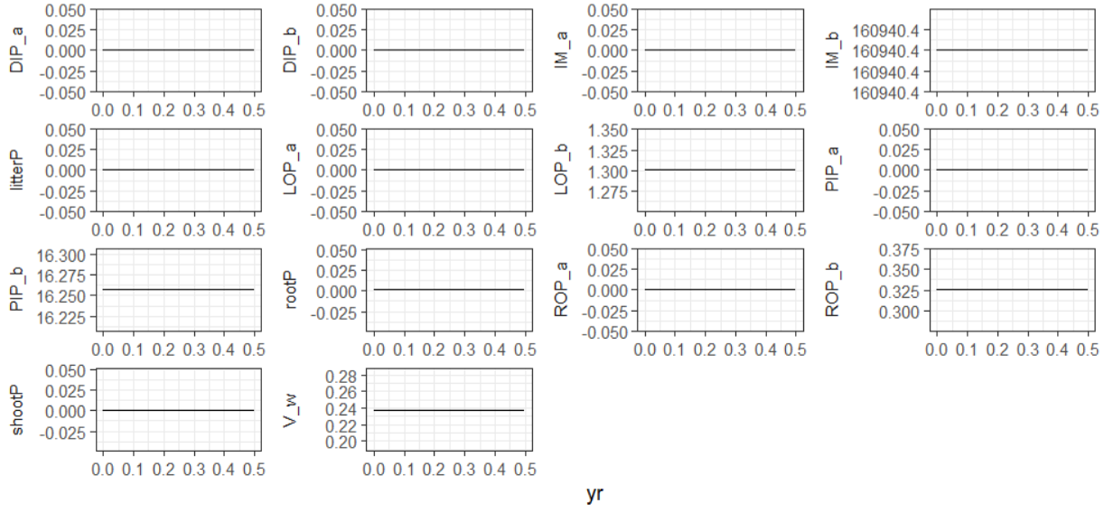

1. all stocks should be constant through time

#### 2. DIP and PIP should equilibrate, no other stocks should change

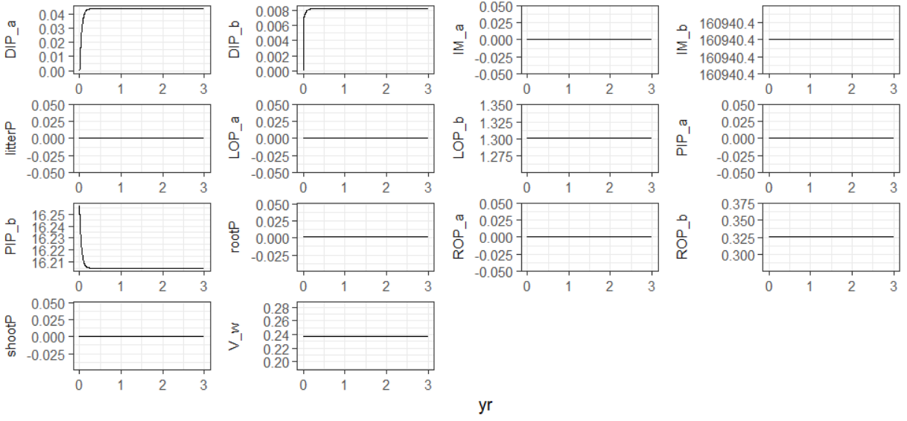

2. DIP and PIP should equilibrate, no other stocks should change

#### 3. shootP, rootP, LOP, ROP should fluctuuate, DIP and PIP should be constant

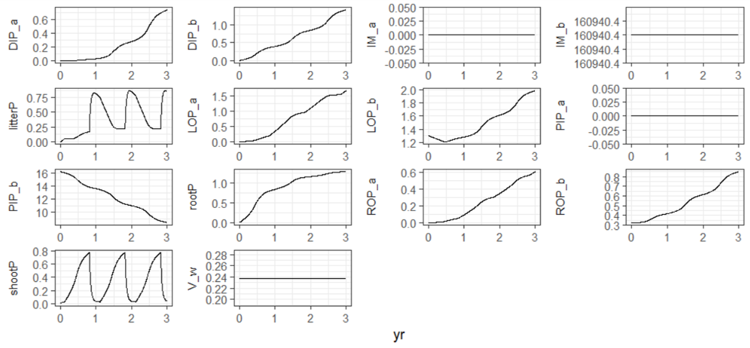

3. shootP, rootP, LOP, ROP should fluctuuate, DIP and PIP should be constant

#### 4. all state variables should fluctuate

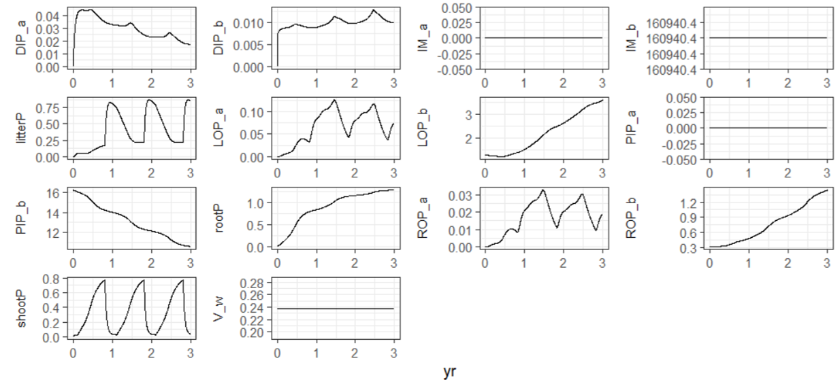

4. all state variables should fluctuate

#### 5. volume of water should be constant through time

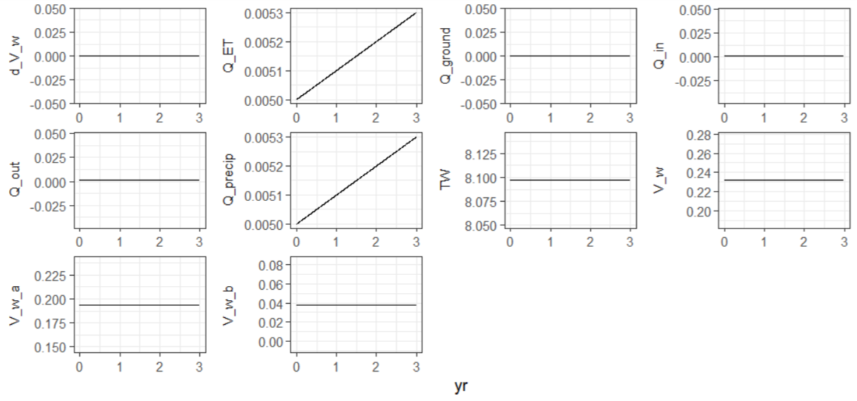

5. volume of water should be constant through time

#### 6. hydrocliamte data being forced on the model

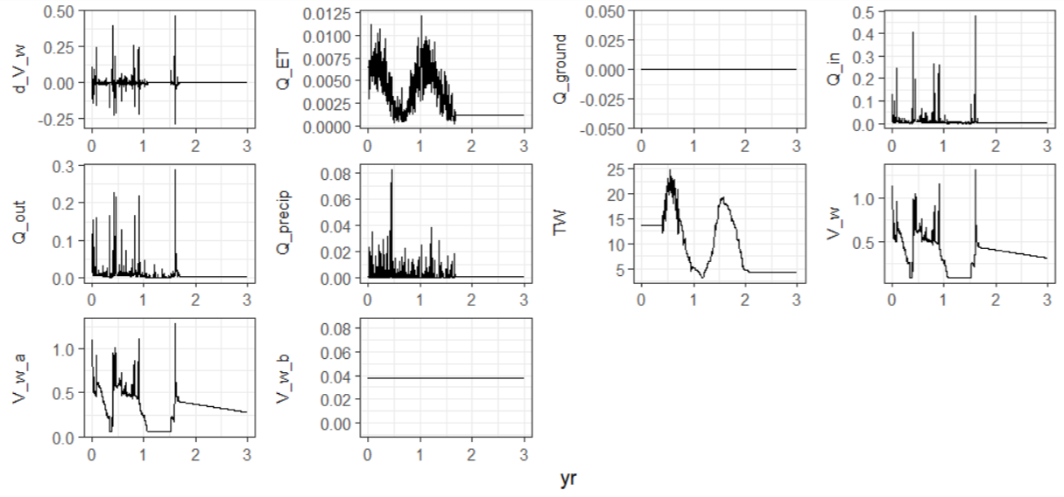

6. hydrocliamte data being forced on the model

#### 7. all states should fluctuate but there should be no discontinuities, or negative values, inorganic matter compartment should be constant since TSS = 0

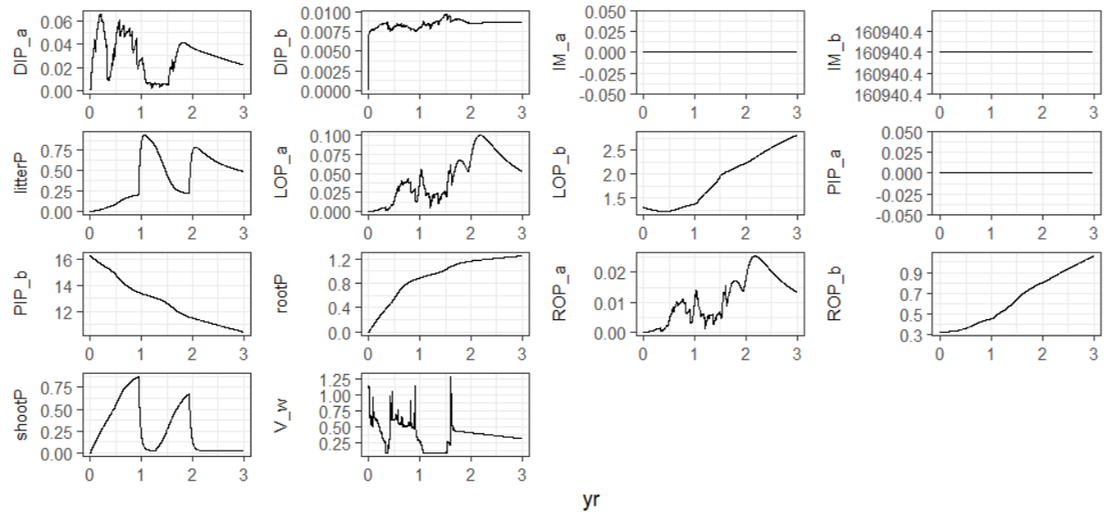

7. all states should fluctuate but there should be no discontinuities, or negative values, inorganic matter compartment should be constant since TSS = 0

#### 8. concentrations shoudl fluctuate but have no sharp discontinuities, or negative values

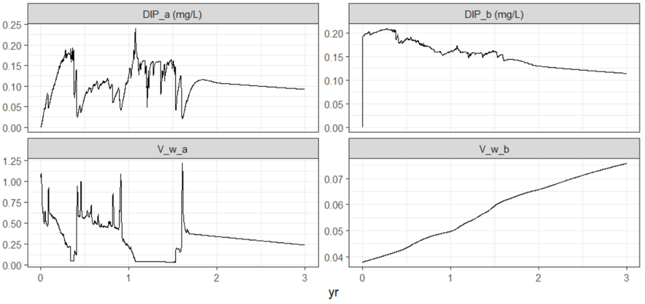

8. concentrations shoudl fluctuate but have no sharp discontinuities, or negative values

## References

### Online Data Sources

NOAA NCDC. National Oceanographic and Atmospheric Administration, National Centers for Environmental Information, National Climatic Data Center. United States Department of Commerce. URL: www.noaa.ncdc.gov (accessed on 2021-10-25).

USGS NWIS. United States Geologic Survey, National Water Information System. United States Department of the Interior. URL: www.waterdata.usgs.gov (accessed on 2021-10-25).

VCGI. Vermont Open Geodata Portal, Vermont Center for Geographic Information. AGENCY OF DIGITAL SERVICES. URL: www.geodata.vermont.gov (acessed on 2021-10-25)

### Scientific Literature

DeLaune, R. D., Baumann, R. H., & Gosselink, J. G. (1983). Relationships among Vertical Accretion, Coastal Submergence, and Erosion in a Louisiana Gulf Coast Marsh. SEPM Journal of Sedimentary Research, 53(1), 147–157. <https://doi.org/10.1306/212F8175-2B24-11D7-8648000102C1865D>

Hantush, M. M., Kalin, L., Isik, S., & Yucekaya, A. (2013). Nutrient Dynamics in Flooded Wetlands. I: Model Development. Journal of Hydrologic Engineering, 18(12), 1709–1723. <https://doi.org/10.1061/(ASCE)HE.1943-5584.0000741>

Marois, D. E., & Mitsch, W. J. (2016). Modeling phosphorus retention at low concentrations in Florida Everglades mesocosms. Ecological Modelling, 319, 42-62.

Morris, J. T., Houghton, R. A., & Botkin, D. B. (1984). Theoretical limits of belowground production by Spartina alterniflora: An analysis through modelling. Ecological Modelling, 26(3–4), 155–175. <https://doi.org/10.1016/0304-3800(84)90068-1>

Morris, J. T., & Bowden, W. B. (1986). A Mechanistic, Numerical Model of Sedimentation, Mineralization, and Decomposition for Marsh Sediments1. Soil Science Society of America Journal, 50(1), 96. <https://doi.org/10.2136/sssaj1986.03615995005000010019x>

Morris, J. T., Sundareshwar, P. V., Nietch, C. T., Kjerfve, B., & Cahoon, D. R. (2002). Responses of coastal wetlands to rising sea level. Ecology, 83(10), 2869-2877.

Morris, J. T., Barber, D. C., Callaway, J. C., Chambers, R., Hagen, S. C., Hopkinson, C. S., … Wigand, C. (2016). Contributions of organic and inorganic matter to sediment volume and accretion in tidal wetlands at steady state. Earth’s Future, 4(4), 110–121. <https://doi.org/de>

Reddy, K. R., & Delaune, R. D. (2008). Biochemistry of wetland science and application. CRC Press Taylor & Francis Group, Boca Raton FL. ISBN 978-1-56670-678-0

Wang, N., & Mitsch, W. J. (2000). A detailed ecosystem model of phosphorus dynamics in created riparian wetlands. Ecological Modelling, 126(2–3), 101–130. <https://doi.org/10.1016/S0304-3800(00)00260-X>

Wang, H., Appan, A., & Gulliver, J. S. (2003). Modeling of phosphorus dynamics in aquatic sediments: I - Model development. Water Research. <https://doi.org/10.1016/S0043-1354(03)00304-X>

Wiegman, A. R. H., Day, J. W., D’Elia, C. F., Rutherford, J. S., Morris, J. T., Roy, E. D., … Snyder, B. F. (2018). Modeling impacts of sea-level rise, oil price, and management strategy on the costs of sustaining Mississippi delta marshes with hydraulic dredging. Science of the Total Environment, 618, 1547–1559. <https://doi.org/10.1016/j.scitotenv.2017.09.314>

### Software Dependancies

$R

To cite R in publications use:

R Core Team (2020). R: A language and environment for statistical computing. R Foundation for Statistical Computing, Vienna, Austria. URL <https://www.R-project.org/>.

A BibTeX entry for LaTeX users is

@Manual{, title = {R: A Language and Environment for Statistical Computing}, author = {{R Core Team}}, organization = {R Foundation for Statistical Computing}, address = {Vienna, Austria}, year = {2020}, url = {<https://www.R-project.org/>}, }

We have invested a lot of time and effort in creating R, please cite it when using it for data analysis. See also ‘citation(“pkgname”)’ for citing R packages.

$ggrepel

To cite package ‘ggrepel’ in publications use:

Kamil Slowikowski (2021). ggrepel: Automatically Position Non-Overlapping Text Labels with ‘ggplot2’. R package version 0.9.1. <https://CRAN.R-project.org/package=ggrepel>

A BibTeX entry for LaTeX users is

@Manual{, title = {ggrepel: Automatically Position Non-Overlapping Text Labels with ‘ggplot2’}, author = {Kamil Slowikowski}, year = {2021}, note = {R package version 0.9.1}, url = {<https://CRAN.R-project.org/package=ggrepel>}, }

$ecolMod

To cite package ‘ecolMod’ in publications use:

Karline Soetaert and Peter MJ Herman (2014). ecolMod: “A practical guide to ecological modelling - using R as a simulation platform”. R package version 1.2.6. <https://CRAN.R-project.org/package=ecolMod>

A BibTeX entry for LaTeX users is

@Manual{, title = {ecolMod: “A practical guide to ecological modelling - using R as a simulation platform”}, author = {Karline Soetaert and Peter MJ Herman}, year = {2014}, note = {R package version 1.2.6}, url = {<https://CRAN.R-project.org/package=ecolMod>}, }

ATTENTION: This citation information has been auto-generated from the package DESCRIPTION file and may need manual editing, see ‘help(“citation”)’.

$diagram

To cite package ‘diagram’ in publications use:

Karline Soetaert (2020). diagram: Functions for Visualising Simple Graphs (Networks), Plotting Flow Diagrams. R package version 1.6.5. <https://CRAN.R-project.org/package=diagram>

A BibTeX entry for LaTeX users is

@Manual{, title = {diagram: Functions for Visualising Simple Graphs (Networks), Plotting Flow Diagrams}, author = {Karline Soetaert}, year = {2020}, note = {R package version 1.6.5}, url = {<https://CRAN.R-project.org/package=diagram>}, }

ATTENTION: This citation information has been auto-generated from the package DESCRIPTION file and may need manual editing, see ‘help(“citation”)’.

$shape

To cite package ‘shape’ in publications use:

Karline Soetaert (2021). shape: Functions for Plotting Graphical Shapes, Colors. R package version 1.4.6. <https://CRAN.R-project.org/package=shape>

A BibTeX entry for LaTeX users is

@Manual{, title = {shape: Functions for Plotting Graphical Shapes, Colors}, author = {Karline Soetaert}, year = {2021}, note = {R package version 1.4.6}, url = {<https://CRAN.R-project.org/package=shape>}, }

ATTENTION: This citation information has been auto-generated from the package DESCRIPTION file and may need manual editing, see ‘help(“citation”)’.

$rootSolve

To cite package ‘rootSolve’ in publications use:

Soetaert K. and P.M.J. Herman (2009). A Practical Guide to Ecological Modelling. Using R as a Simulation Platform. Springer, 372 pp.

Soetaert K. (2009). rootSolve: Nonlinear root finding, equilibrium and steady-state analysis of ordinary differential equations. R-package version 1.6

rootSolve was created to solve the examples from chapter 7 of our book - please cite this book when using it, thank you! To see these entries in BibTeX format, use ‘print(, bibtex=TRUE)’, ‘toBibtex(.)’, or set ‘options(citation.bibtex.max=999)’.

$rlang

To cite package ‘rlang’ in publications use:

Lionel Henry and Hadley Wickham (2021). rlang: Functions for Base Types and Core R and ‘Tidyverse’ Features. R package version 0.4.11. <https://CRAN.R-project.org/package=rlang>

A BibTeX entry for LaTeX users is

@Manual{, title = {rlang: Functions for Base Types and Core R and ‘Tidyverse’ Features}, author = {Lionel Henry and Hadley Wickham}, year = {2021}, note = {R package version 0.4.11}, url = {<https://CRAN.R-project.org/package=rlang>}, }

$Evapotranspiration

To cite package ‘Evapotranspiration’ in publications use:

Danlu Guo, Seth Westra and Tim Peterson (2020). Evapotranspiration: Modelling Actual, Potential and Reference Crop Evapotranspiration. R package version 1.15. <https://CRAN.R-project.org/package=Evapotranspiration>

A BibTeX entry for LaTeX users is

@Manual{, title = {Evapotranspiration: Modelling Actual, Potential and Reference Crop Evapotranspiration}, author = {Danlu Guo and Seth Westra and Tim Peterson}, year = {2020}, note = {R package version 1.15}, url = {<https://CRAN.R-project.org/package=Evapotranspiration>}, }

ATTENTION: This citation information has been auto-generated from the package DESCRIPTION file and may need manual editing, see ‘help(“citation”)’.

$soiltexture

To cite package ‘soiltexture’ in publications use:

Julien Moeys (2018). soiltexture: Functions for Soil Texture Plot, Classification and Transformation. R package version 1.5.1. <https://CRAN.R-project.org/package=soiltexture>

A BibTeX entry for LaTeX users is

@Manual{, title = {soiltexture: Functions for Soil Texture Plot, Classification and Transformation}, author = {Julien Moeys}, year = {2018}, note = {R package version 1.5.1}, url = {<https://CRAN.R-project.org/package=soiltexture>}, }

$zoo

To cite zoo in publications use:

Achim Zeileis and Gabor Grothendieck (2005). zoo: S3 Infrastructure for Regular and Irregular Time Series. Journal of Statistical Software, 14(6), 1-27. <doi:10.18637/jss.v014.i06>

A BibTeX entry for LaTeX users is

@Article{, title = {zoo: S3 Infrastructure for Regular and Irregular Time Series}, author = {Achim Zeileis and Gabor Grothendieck}, journal = {Journal of Statistical Software}, year = {2005}, volume = {14}, number = {6}, pages = {1–27}, doi = {10.18637/jss.v014.i06}, }

$diffeqr

Rackauckas C, Nie Q (2017). “DifferentialEquations.jl – A Performant and Feature-Rich Ecosystem for Solving Differential Equations in Julia.” *The Journal of Open Source Software*, *5*(1). doi: 10.5334/jors.151 (URL: <https://doi.org/10.5334/jors.151>), R package version 1.1.1, <URL: <https://openresearchsoftware.metajnl.com/articles/10.5334/jors.151/>>.

A BibTeX entry for LaTeX users is

@Article{, doi = {10.5334/jors.151}, journal = {The Journal of Open Source Software}, title = {DifferentialEquations.jl – A Performant and Feature-Rich Ecosystem for Solving Differential Equations in Julia}, author = {Chris Rackauckas and Qing Nie}, year = {2017}, volume = {5}, number = {1}, url = {<https://openresearchsoftware.metajnl.com/articles/10.5334/jors.151/>}, note = {R package version 1.1.1}, }

$deSolve

To cite package ‘deSolve’ in publications use:

Karline Soetaert, Thomas Petzoldt, R. Woodrow Setzer (2010). Solving Differential Equations in R: Package deSolve. Journal of Statistical Software, 33(9), 1–25. URL <http://www.jstatsoft.org/v33/i09/> DOI 10.18637/jss.v033.i09

A BibTeX entry for LaTeX users is

@Article{, title = {Solving Differential Equations in {R}: Package de{S}olve}, author = {Karline Soetaert and Thomas Petzoldt and R. Woodrow Setzer}, journal = {Journal of Statistical Software}, volume = {33}, number = {9}, pages = {1–25}, year = {2010}, coden = {JSSOBK}, issn = {1548-7660}, url = {<http://www.jstatsoft.org/v33/i09>}, doi = {10.18637/jss.v033.i09}, keywords = {ordinary differential equations, partial differential equations, differential algebraic equations, initial value problems, R, FORTRAN, C}, }

$pacman

To cite pacman in publications, please use:

Rinker, T. W. & Kurkiewicz, D. (2017). pacman: Package Management for R. version 0.5.0. Buffalo, New York. <http://github.com/trinker/pacman>

A BibTeX entry for LaTeX users is

@Manual{, title = {{pacman}: {P}ackage Management for {R}}, author = {Tyler W. Rinker and Dason Kurkiewicz}, address = {Buffalo, New York}, note = {version 0.5.0}, year = {2018}, url = {<http://github.com/trinker/pacman>}, }

$forcats

To cite package ‘forcats’ in publications use:

Hadley Wickham (2021). forcats: Tools for Working with Categorical Variables (Factors). R package version 0.5.1. <https://CRAN.R-project.org/package=forcats>

A BibTeX entry for LaTeX users is

@Manual{, title = {forcats: Tools for Working with Categorical Variables (Factors)}, author = {Hadley Wickham}, year = {2021}, note = {R package version 0.5.1}, url = {<https://CRAN.R-project.org/package=forcats>}, }

$stringr

To cite package ‘stringr’ in publications use:

Hadley Wickham (2019). stringr: Simple, Consistent Wrappers for Common String Operations. R package version 1.4.0. <https://CRAN.R-project.org/package=stringr>

A BibTeX entry for LaTeX users is

@Manual{, title = {stringr: Simple, Consistent Wrappers for Common String Operations}, author = {Hadley Wickham}, year = {2019}, note = {R package version 1.4.0}, url = {<https://CRAN.R-project.org/package=stringr>}, }

$dplyr

To cite package ‘dplyr’ in publications use:

Hadley Wickham, Romain François, Lionel Henry and Kirill Müller (2021). dplyr: A Grammar of Data Manipulation. R package version 1.0.7. <https://CRAN.R-project.org/package=dplyr>

A BibTeX entry for LaTeX users is

@Manual{, title = {dplyr: A Grammar of Data Manipulation}, author = {Hadley Wickham and Romain François and Lionel Henry and Kirill Müller}, year = {2021}, note = {R package version 1.0.7}, url = {<https://CRAN.R-project.org/package=dplyr>}, }

$purrr

To cite package ‘purrr’ in publications use:

Lionel Henry and Hadley Wickham (2020). purrr: Functional Programming Tools. R package version 0.3.4. <https://CRAN.R-project.org/package=purrr>

A BibTeX entry for LaTeX users is

@Manual{, title = {purrr: Functional Programming Tools}, author = {Lionel Henry and Hadley Wickham}, year = {2020}, note = {R package version 0.3.4}, url = {<https://CRAN.R-project.org/package=purrr>}, }

$readr

To cite package ‘readr’ in publications use:

Hadley Wickham and Jim Hester (2021). readr: Read Rectangular Text Data. R package version 2.0.1. <https://CRAN.R-project.org/package=readr>

A BibTeX entry for LaTeX users is

@Manual{, title = {readr: Read Rectangular Text Data}, author = {Hadley Wickham and Jim Hester}, year = {2021}, note = {R package version 2.0.1}, url = {<https://CRAN.R-project.org/package=readr>}, }

$tidyr

To cite package ‘tidyr’ in publications use:

Hadley Wickham (2021). tidyr: Tidy Messy Data. R package version 1.1.3. <https://CRAN.R-project.org/package=tidyr>

A BibTeX entry for LaTeX users is

@Manual{, title = {tidyr: Tidy Messy Data}, author = {Hadley Wickham}, year = {2021}, note = {R package version 1.1.3}, url = {<https://CRAN.R-project.org/package=tidyr>}, }

$tibble

To cite package ‘tibble’ in publications use:

Kirill Müller and Hadley Wickham (2021). tibble: Simple Data Frames. R package version 3.1.4. <https://CRAN.R-project.org/package=tibble>

A BibTeX entry for LaTeX users is

@Manual{, title = {tibble: Simple Data Frames}, author = {Kirill Müller and Hadley Wickham}, year = {2021}, note = {R package version 3.1.4}, url = {<https://CRAN.R-project.org/package=tibble>}, }

$ggplot2

To cite ggplot2 in publications, please use:

H. Wickham. ggplot2: Elegant Graphics for Data Analysis. Springer-Verlag New York, 2016.

A BibTeX entry for LaTeX users is

@Book{, author = {Hadley Wickham}, title = {ggplot2: Elegant Graphics for Data Analysis}, publisher = {Springer-Verlag New York}, year = {2016}, isbn = {978-3-319-24277-4}, url = {<https://ggplot2.tidyverse.org>}, }

$tidyverse

Wickham et al., (2019). Welcome to the tidyverse. Journal of Open Source Software, 4(43), 1686, <https://doi.org/10.21105/joss.01686>

A BibTeX entry for LaTeX users is

@Article{, title = {Welcome to the {tidyverse}}, author = {Hadley Wickham and Mara Averick and Jennifer Bryan and Winston Chang and Lucy D’Agostino McGowan and Romain François and Garrett Grolemund and Alex Hayes and Lionel Henry and Jim Hester and Max Kuhn and Thomas Lin Pedersen and Evan Miller and Stephan Milton Bache and Kirill Müller and Jeroen Ooms and David Robinson and Dana Paige Seidel and Vitalie Spinu and Kohske Takahashi and Davis Vaughan and Claus Wilke and Kara Woo and Hiroaki Yutani}, year = {2019}, journal = {Journal of Open Source Software}, volume = {4}, number = {43}, pages = {1686}, doi = {10.21105/joss.01686}, }