Software Requirements Specification
for
Dotted Chart Visualizer
Version 1.0 approved
Prepared by Elisabeth Buttkus, Ariane Chu, Samir Majeri, Pieter Patonedi, Victor Férnandez
Chair of Process Mining and Data Science, RWTH
02.5.2021
Table of Contents
Table of Contents ii
Revision History ii
1. Introduction 1
1.1 Purpose 1
1.2 Document Conventions 1
1.3 Intended Audience and Reading Suggestions 1
1.4 Product Scope 1
1.5 References 1
2. Overall Description 2
2.1 Product Perspective 2
2.2 Product Functions 2
2.3 User Classes and Characteristics 2
2.4 Operating Environment 2
2.5 Design and Implementation Constraints 2
2.6 User Documentation 2
2.7 Assumptions and Dependencies 3
3. External Interface Requirements 3
3.1 User Interfaces 3
3.2 Hardware Interfaces 3
3.3 Software Interfaces 3
3.4 Communications Interfaces 3
4. System Features 4
4.1 System Feature 1 4
4.2 System Feature 2 (and so on) 4
5. Other Nonfunctional Requirements 4
5.1 Performance Requirements 4
5.2 Safety Requirements 5
5.3 Security Requirements 5
5.4 Software Quality Attributes 5
5.5 Business Rules 5
6. Other Requirements 5
Appendix A: Glossary 5
Appendix B: Analysis Models 5
Appendix C: To Be Determined List 6

Revision History
Name | Date | Reason For Changes | Version

Introduction

Purpose
Our product is a visualizing tool that allows the user to extract data points from an event log file in either the XES or CSV format. The visualization is realized as a dotted chart visualizer which allows the user to display the information as a dotted chart and to save the visualizations to their device. The dotted chart visualizer is provided as a web application which can be embedded into further process mining tools to aid with the process mining process.

Document Conventions
TBD

Intended Audience and Reading Suggestions
open source software intended for use for public

Product Scope
Process mining is an important practice in the fields of data science and business process management. The results can be used to solve problems or optimize performance of process-driven systems and is therefore highly valued in companies and institutions. Companies aiming to identify and model process activities require a comprehensive tool that caters to this task and that allows them to create an expressive and accurate model of the activities in such a system. The first step in this process is visualizing the information available which is necessary during the process discovery phase.
The process information needed for this task is extracted from event logs. Our finished tool will be available as a web application. It supports the import of event logs in both the CSV and XES format which are the most important formats in which event data is available. The data can then be visualized as a dotted chart and customized by the user for the individual purpose. Each of the created visualizations can be saved by the user and downloaded to their device for further use.

References
In the following we provide a list of the referenced framework, libraries and tools:

Django UI framework using pm4py: https://github.com/madhubs08/UIFramework_pm4py
ProM: http://www.promtools.org/doku.php?id=prom69
Pm4py: https://pm4py.fit.fraunhofer.de/documentation#discovery

Overall Description

Product Perspective
One of the tools for process mining that is currently being used by researchers around the globe is ProM. ProM is an open-source java based framework that among other functionalities provides a dotted chart visualization of event log data. ProM is provided as a desktop application and its functionality has proven to be highly dependent on the operating system of the device. Our dotted chart visualizer aims to offer an alternative visualization tool that is more flexible and can be easily integrated into pre-existing python based process mining applications, such as the Tool for Process Mining created by PADS, RWTH Aachen.

Product Functions
Use case: different axis with attributes
- Import CSV/XES files
  - Converting one type file into the other
- Provide dotted chart visualization
  - X-y-coordinate sytem needs to be created (value range adjusted to possible values)
  - Points need to be drawn into the coordinate system (x axis equals date/time)
  - Points are assigned a color/shape based on their type (8 shape maximum in ProM)
  - User can change the purpose of the x- and y-axis
  - User can change the color and shape attribute
- Provide legend for the chart
  - Name the value type for x- and y-axis and add values along the axis
  - Legend for the different colors/shapes of points
- Allow to save images of the different visualizations
  - „Taking a picture of the image“ (jpg?, pdf?, png?)
  - Storing the images

<Summarize the major functions the product must perform or must let the user perform. Details will be provided in Section 3, so only a high level summary (such as a bullet list) is needed here. Organize the functions to make them understandable to any reader of the SRS. A picture of the major groups of related requirements and how they relate, such as a top level data flow diagram or object class diagram, is often effective.>

User Classes and Characteristics
<Identify the various user classes that you anticipate will use this product. User classes may be differentiated based on frequency of use, subset of product functions used, technical expertise, security or privilege levels, educational level, or experience. Describe the pertinent characteristics of each user class. Certain requirements may pertain only to certain user classes. Distinguish the most important user classes for this product from those who are less important to satisfy.>

Operating Environment
-Operating system independent since web app
-users needs to enable java script
-dockerize software independent

Design and Implementation Constraints
- Django is a web framework and therefore needs to run as a client server application and opened inside a web browser
- allows/demands web based languages for visualization and interaction, namely HTML, CSS and Javascript

User Documentation
Manual
<List the user documentation components (such as user manuals, on-line help, and tutorials) that will be delivered along with the software. Identify any known user documentation delivery formats or standards.>

Assumptions and Dependencies

TBD when we work out the details (assumptions for example: not all attributes can be displayed on the x-axis)
No external dependencies.
PM4Py 2.2.4 will be used. To build the app desing and the
client/server interaction, Django 3.2 was chosen as a framework. The visualization of data will be
achieved by use of the Python Pandas 1.2.4 library.

<List any assumed factors (as opposed to known facts) that could affect the requirements stated in the SRS. These could include third-party or commercial components that you plan to use, issues around the development or operating environment, or constraints. The project could be affected if these assumptions are incorrect, are not shared, or change. Also identify any dependencies the project has on external factors, such as software components that you intend to reuse from another project, unless they are already documented elsewhere (for example, in the vision and scope document or the project plan).>

External Interface Requirements

User Interfaces
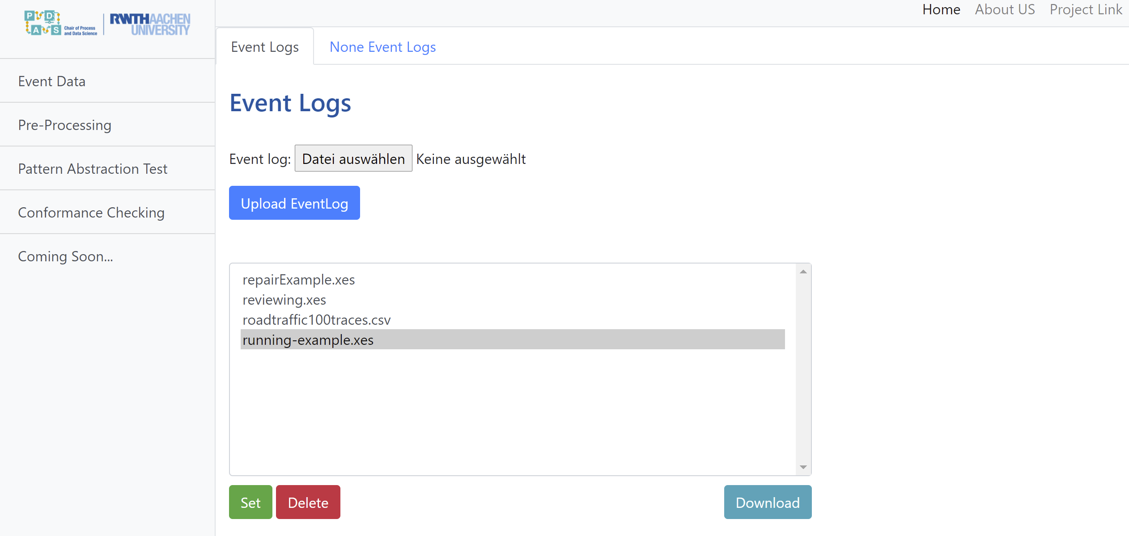
Specific urls

<Describe the logical characteristics of each interface between the software product and the users. This may include sample screen images, any GUI standards or product family style guides that are to be followed, screen layout constraints, standard buttons and functions (e.g., help) that will appear on every screen, keyboard shortcuts, error message display standards, and so on. Define the software components for which a user interface is needed. Details of the user interface design should be documented in a separate user interface specification.>

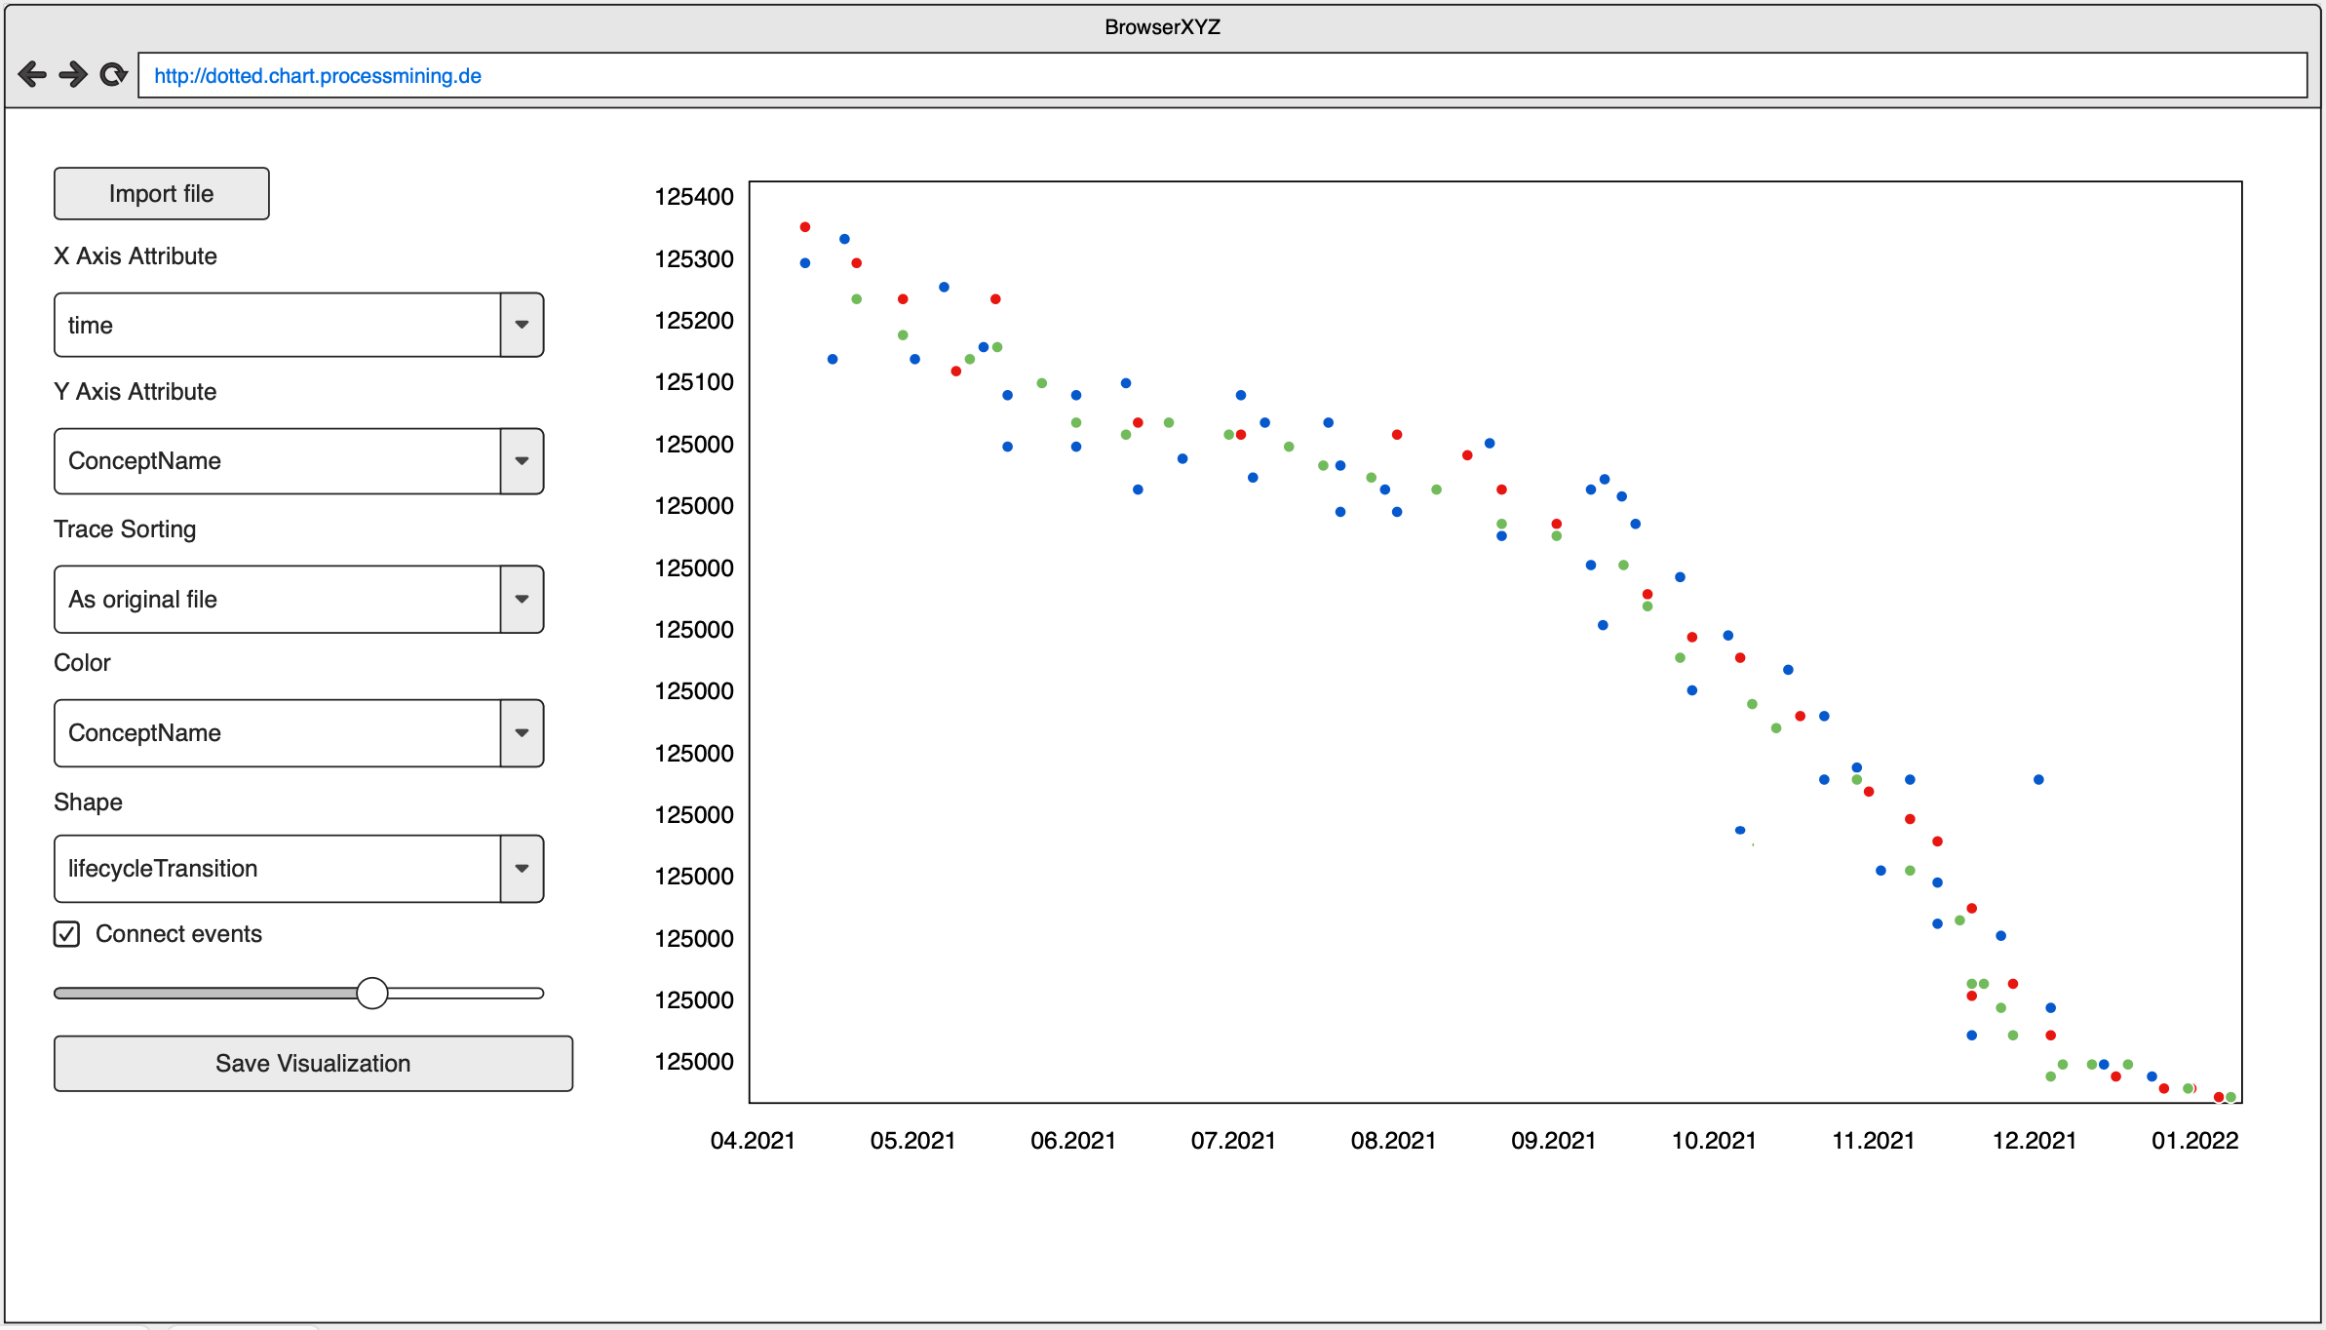

Hardware Interfaces
<Describe the logical and physical characteristics of each interface between the software product and the hardware components of the system. This may include the supported device types, the nature of the data and control interactions between the software and the hardware, and communication protocols to be used.>

Software Interfaces
Modules in a framework count as software-components?
<Describe the connections between this product and other specific software components (name and version), including databases, operating systems, tools, libraries, and integrated commercial components. Identify the data items or messages coming into the system and going out and describe the purpose of each. Describe the services needed and the nature of communications. Refer to documents that describe detailed application programming interface protocols. Identify data that will be shared across software components. If the data sharing mechanism must be implemented in a specific way (for example, use of a global data area in a multitasking operating system), specify this as an implementation constraint.>

Communications Interfaces
<Describe the requirements associated with any communications functions required by this product, including e-mail, web browser, network server communications protocols, electronic forms, and so on. Define any pertinent message formatting. Identify any communication standards that will be used, such as FTP or HTTP. Specify any communication security or encryption issues, data transfer rates, and synchronization mechanisms.>

System Features
In the following, the system features will be explained. We start with the user’s perspective to give a detailed high-level overview over the requirements regarding the system features. In the second part, we will give an insight from the system’s perspective going into more technical details regarding feature requirements.

User Perspective
In this section, the system features from a user’s perspective are described along with detailed system requirements.

Importing log files (already in the provided framework)
Picked up from repository, no details
This feature is of high priority as the user needs to be able to work with their own event log files. Importing the log files entails choosing the desired file from the devices file system and uploading it into the framework’s database. The primary formats are XES and CSV, however technically the needed functions of the pm4py liberary can be applied to all pandas supported file formats.

On the GUI the user can click on the “Datei auswählen” button and is presented with a file nagivator. Using the navigator the user can choose their desired file. By clicking “Upload EventLog” uploading the XES or CSV file to the database. The file name then appears in the overview and management section below, where the user is able to delete files and choose a file as input for tool of choice. When setting a file as input basic information about the log file is displayed.

REQ-1: Allow user to navigate through their device’s file system to choose file to be uploaded
REQ-2: Upload file from device to database
(REQ-3: Check if file is valid (event log format, minimal attributes) already implemented?)
REQ-4: Extract and display number of traces and total number of events
REQ-5: Choose file for further use and set it as input

Basic visualization as dotted chart with default attributes
For each requirement one class diagram
Mock UI put here

This feature is of high priority as the visualization of an event log is the key feature of our product. By applying this feature the user can initiate the visualization.

Once the user has chosen a file to visualize (see 4.1.1- REQ-5) by clicking the “Dotted Chart” button (assuming: Preprocessing-> Visualization->Dotted Chart hierarchy) the user is presented a basic dotted chart based on default settings for the x- and y-axes. The basic chart maps the two minimal attributes concept:name (event-level) and time:timestamp against each other. The data is displayed as round dots of uniform color.

REQ-6: Provide “Dotted Chart” button
REQ-7: Extract event:concept:name and time:timestamp as default attributes
REQ-8: Display basic dotted chart visualizing chosen event log

Manipulation of the dotted chart
This feature is of medium priority by comparison. It allows the user to create a “4D”-visualization of the event log data by introducing dot colors and geometric shapes. Each color and shape corresponds to an attribute value.

The user is offered four drop down menus, one of each axis, one for the colors and one for the shapes. Using the menu, the user can choose which attribute they want to visualize at the same time. After choosing the attribute, the dotted chart is updated and a legend labelling the colors and shapes is created or updated.

REQ-9: Extract all attributes from event log for configuration
REQ-10: Drop down menus for configuration of x-axis, y-axis, dot colors and dot shapes
REQ-11: Update/display chart with up to 4 attributes
REQ-12: Create and update legend
(REQ-12: Chart saves automatically (version control/return function?))

Exporting the dotted chart visualization
This is of high priority as requested by the costumer. The user can save the created chart to a local folder and then choose to export it in the desired format (formats TBD).

If the user plans to download the dotted chart, they can first save it using the “Save to App” button ? and then download by using the “Download As” Button. The user is presented with a file manager which allows them to choose the designated location as well as the format.

REQ-13: Allow storage and access of visualization in app database
REQ-14: Provide download as function including file manager
REQ-15: Support download as different formats
REQ-16: Download file to device

System Perspective

Import/Export

Visualization
In order to visualize the event log data, the event log needs to be filtered according to the required attributes and converted to a pandas.dataframe first.

Depending on whether the uploaded file is in the XES or CSV format, the file is first converted to an pm4py event log object. (TBA whether stays event log object or converted to pandas.df). In order to extract attribute information, the traces contained in the log file are filtered using the pm4py filter function creating a new log object/dataframe. If the the filtering is executed on the event log object, a conversion using the pm4py TO_DATA_FRAME method is undertaken. The resulting dataframe is the input for the pandas.DataFrame.plot.scatter function.

REQ-17: Execute filtering on file in database
REQ-18: Store original dataframe/event log object
REQ-19: Store resulting dataframe/event log object and apply plotting method
REQ-20: Create scatter graph object and display it

Other Nonfunctional Requirements

Performance Requirements
<If there are performance requirements for the product under various circumstances, state them here and explain their rationale, to help the developers understand the intent and make suitable design choices. Specify the timing relationships for real time systems. Make such requirements as specific as possible. You may need to state performance requirements for individual functional requirements or features.>

Safety Requirements no
<Specify those requirements that are concerned with possible loss, damage, or harm that could result from the use of the product. Define any safeguards or actions that must be taken, as well as actions that must be prevented. Refer to any external policies or regulations that state safety issues that affect the product’s design or use. Define any safety certifications that must be satisfied.>

Security Requirements no
<Specify any requirements regarding security or privacy issues surrounding use of the product or protection of the data used or created by the product. Define any user identity authentication requirements. Refer to any external policies or regulations containing security issues that affect the product. Define any security or privacy certifications that must be satisfied.>

Software Quality Attributes no
<Specify any additional quality characteristics for the product that will be important to either the customers or the developers. Some to consider are: adaptability, availability, correctness, flexibility, interoperability, maintainability, portability, reliability, reusability, robustness, testability, and usability. Write these to be specific, quantitative, and verifiable when possible. At the least, clarify the relative preferences for various attributes, such as ease of use over ease of learning.>

Business Rules no
<List any operating principles about the product, such as which individuals or roles can perform which functions under specific circumstances. These are not functional requirements in themselves, but they may imply certain functional requirements to enforce the rules.>

Other Requirements
<Define any other requirements not covered elsewhere in the SRS. This might include database requirements, internationalization requirements, legal requirements, reuse objectives for the project, and so on. Add any new sections that are pertinent to the project.>
Appendix A: Glossary
<Define all the terms necessary to properly interpret the SRS, including acronyms and abbreviations. You may wish to build a separate glossary that spans multiple projects or the entire organization, and just include terms specific to a single project in each SRS.>
Appendix B: Analysis Models
<Optionally, include any pertinent analysis models, such as data flow diagrams, class diagrams, state-transition diagrams, or entity-relationship diagrams.>
Appendix C: To Be Determined List
<Collect a numbered list of the TBD (to be determined) references that remain in the SRS so they can be tracked to closure.>

