Block Model Compression – Development Report
This report summarises how we built a streaming, tile‑bounded compressor for the Maptek 2025 Block Model challenge. It explains the input/output format, the compression method (X‑runs → Y‑rectangles → Z‑prisms), key debugging steps, typical errors, and how we moved from simple printing to a full working program.

What the rules require (short)
• Process in slices no thicker than the parent Z (don’t load the whole model).
• Every input voxel must appear once in the output; no wrong labels.
• Blocks must not cross parent boundaries (PX×PY×PZ).
• Output lines are: x,y,z,x_size,y_size,z_size,label.

Input & Output in one page
Input stream:
1) Header: x_count,y_count,z_count,parent_x,parent_y,parent_z
2) Tag table: lines “char, label”, then a blank line
3) Slices: z_count slices, each has y_count rows of x_count characters; blank line between slices
Output stream: one line per block → x,y,z,x_size,y_size,z_size,label

How the compressor works (simple)
Inside each parent tile:
1) Merge equal chars left→right into X‑runs.
2) Merge identical runs on adjacent rows into Y‑rectangles.
3) Stack identical rectangles across consecutive slices (≤PZ) into Z‑prisms.
Emit a block when it stops extending or when the slab ends. Always clamp to the parent tile.

Diagram
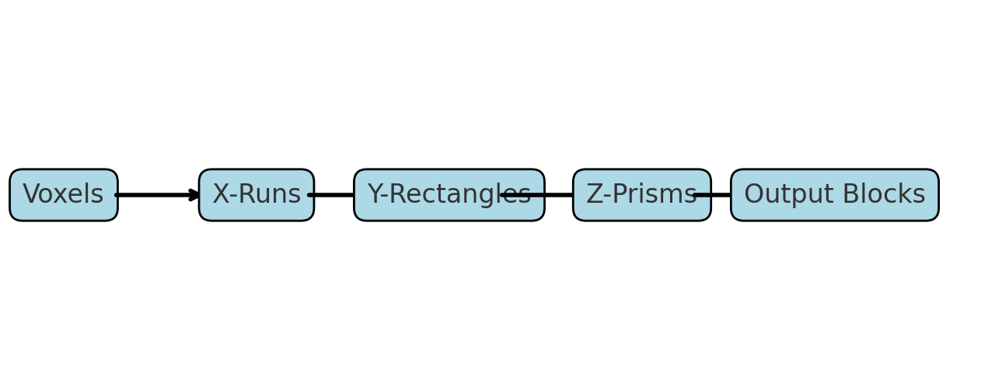

Tiny worked example
Model: 3×2×2, parent 3×2×2, tags: a=Air, b=Stone.
Slices z=0 and z=1 are identical:
y=1 a b b
y=0 a a a
Compression result lines:
0,0,0,1,2,2,Air
1,0,0,2,1,2,Air
1,1,0,2,1,2,Stone

Debugging & fixes
• Memory access violation on large tests → stream by PZ‑thick slabs; keep only current slice(s) and per‑tile state.
• Tag/label mismatches from whitespace → trim lines; reject unknown tags; enforce exact row width X.
• CRLF rows (Windows) made lines length X+1 → strip trailing '\r' after getline.
• Y‑axis confusion → confirm rows are bottom→top; remove accidental Y‑flip in final implementation.
• Parent boundary leaks → clamp merges to PX×PY×PZ; Z‑stack only identical footprints.

From prints to a full working program
Start: print raw rows to verify parsing and tag mapping.
Then: print X‑runs to check parent clamping.
Then: print per‑slice rectangles (x,y,w,h,tag).
Then: log Z‑stack state (opened at z0, current depth).
Finish: emit CSV only when a prism ends; remove all debug prints.

Build & run (Windows exe from macOS)
x86_64-w64-mingw32-g++ -std=c++17 -O3 -pipe -s -static -static-libgcc -static-libstdc++ fullCompCG5.cpp -o fullCompCG5.exe
fullCompCG5.exe < input.txt > output.txt

Results & readiness
We meet the rules: stream in parent‑depth, no colour changes, no overlaps, and no block crosses a parent. Compression is strong on layered geology because rectangles repeat across slices.

