Block Model Compression – Algorithm Summary

Overview
The full compression algorithm aggregates geological block model voxels into larger axis-aligned prisms, bounded by parent block dimensions. It is a greedy, streaming approach designed for memory efficiency and compliance with competition rules.

Compression Pipeline
The algorithm processes data in three main merging stages:
- 1. X-Runs – Consecutive voxels of the same label along rows are merged into runs.
- 2. Y-Rectangles – Identical runs on adjacent rows are merged vertically into rectangles.
- 3. Z-Prisms – Identical rectangles on consecutive slices are stacked into 3D prisms (up to PZ).
This pipeline ensures that each voxel is represented exactly once, no block crosses parent boundaries, and memory usage is minimal by streaming slice-by-slice.

Diagram
The diagram below illustrates the compression pipeline:
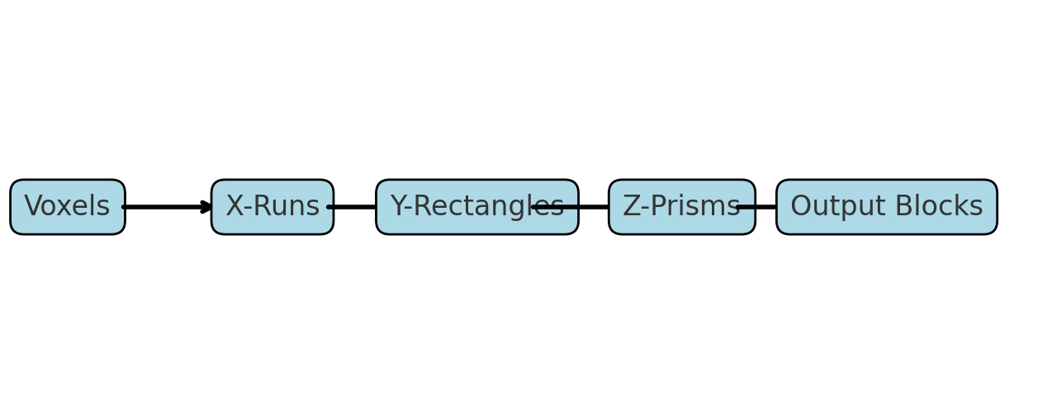

Key Characteristics
• Streaming – Processes data slice by slice, avoiding large memory use.
• Greedy Merging – Always forms the largest possible prisms within parent limits.
• Parent Compliance – No block extends beyond its PX×PY×PZ parent tile.
• Lossless – All input voxels are preserved with correct labels.

