Software Engineering & Project
Snapshot Week 5 - BLOCK UG-16
Maptek, Block Model Compression Algorithm



Name | Student ID
Adam Dao | a1797499
Calvin McCann | a1860428
Hamidur Rahim Mahir | a1914792
Izak Stentiford | a1822100
Mohammed Ali Rezaei | a1714717
Pezhman Beheshtian | a1661736
Tyler McKinley | a1716769
Yuzhe Ma | a1918429

Product Backlog and Task Board
Product Backlog
Task | Description
Titan Initial Submission | Create a file in C++ that implements the stream processor as well as a compression algorithm and submit to Titan
Snapshot 2.1 | Create snapshot 2.1
Snapshot 2.2 | Create snapshot 2.2
Snapshot 3.1 | Create snapshot 3.1
Snapshot 3.2 | Create snapshot 3.2
Snapshot 4.1 | Create snapshot 4.2
Snapshot 4.2 | Create snapshot 4.2
Snapshot 5.1 | Create snapshot 5.1
Snapshot 5.2 | Create snapshot 5.2
Improved Submission | Create a file in C++ that improves on the initial submission through a faster algorithm or a more efficient algorithm

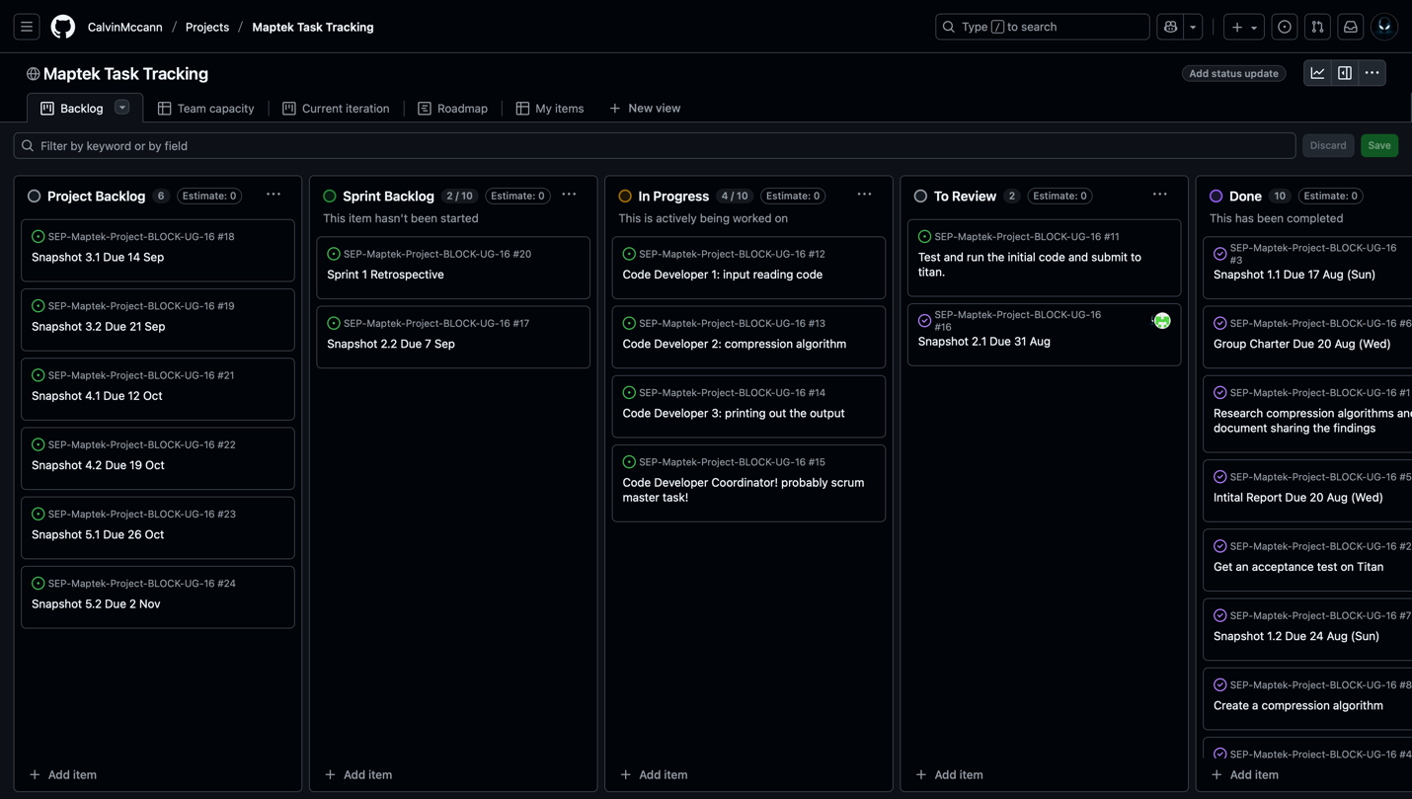

Sprint Backlog and User Stories
Sprint Backlog
Task | Description
Titan Initial Submission | Create a file in C++ that implements the stream processor as well as a compression algorithm and submit to Titan
Code Developer Series | Create, test, improve, and submit code along the way on Titan which includes input reading, compression algorithm, printing output
Sprint Retrospective 1 | Create sprint retrospective 1
Snapshot 2.1 | Create snapshot 2.1
Snapshot 2.2 | Create snapshot 2.2

User Stories (Sprint 2)

To ensure functionality and integrity, we have decided to divide and conquer when it comes to coding. Each section is being worked on and discussed by team members as we go to ensure the project is being built on solid foundation rather than having different ideas and designs for different sections as it could lead to potential errors and compatibility problems.

As the Product Owner (TA), I have discussed deadlines and milestones with the team members as well as code implementation and role modelling to ensure deadlines have met and milestones achieved.

Definition of Done
Starting on the compression algorithm and allocate roles to the team members to begin planning and initiating the project backlog and algorithm.

Summary of Changes
This week marked the project backlog and code algorithm initiation. The group started on discussing strategy in completing the project. Roles were allocated and group decided to meet 1 to 2 days a week for a few hours to write the code and discuss designs and any potential problems that we could encounter when trying to compile and run on Titan. We have decided that this method could prove useful when ensuring quality and performance speed to enable us to stay in competition and on track.

