Software Engineering & Project
Snapshot Week 6 - BLOCK UG-16
Maptek, Block Model Compression Algorithm



Name | Student ID
Adam Dao | a1797499
Calvin McCann | a1860428
Hamidur Rahim Mahir | a1914792
Izak Stentiford | a1822100
Mohammed Ali Rezaei | a1714717
Pezhman Beheshtian | a1661736
Tyler McKinley | a1716769
Yuzhe Ma | a1918429

Product Backlog and Task Board
Product Backlog
Task | Description
Titan Initial Submission | Create a file in C++ that implements the stream processor as well as a  compression algorithm and submit to Titan
Axis aware  Transforms | Create a task for delta/RLE per axis and palette/dictionary per tile
Codec Plugins &  selector | Create a task for LZ4/Zstd/RLE + Huff behind one API
Auto Tune on 1-2%  sample | Create a task to pick parameters and automatically tune
Streaming I/O | Create a task to buffer read and prefetch input and output

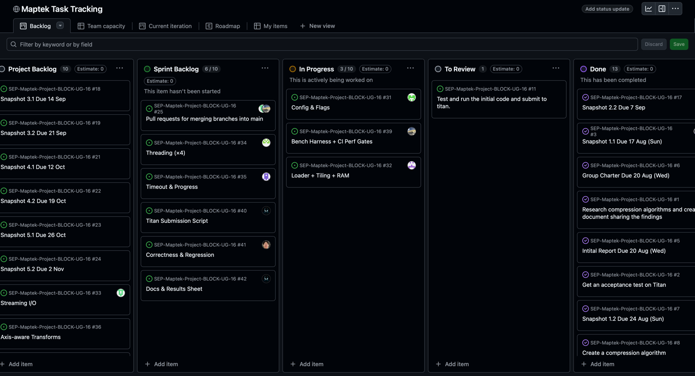

Sprint Backlog and User Stories
Sprint Backlog
Task | Description
Threading | Create a task to add a thread pool and a thread safe queue of tiles
Timeout & progress | Create a task for program timeout and optimisation
Titan Submission Script | Create a task to retry transient failures
Correctness &  Regression | Create a task to run old comps to verify no breakage
Docs & Results Sheet | Create a task to design note assumptions and limits
Snapshot 2.1 | Create snapshot 2.1
Snapshot 2.2 | Create snapshot 2.2

User Stories (Sprint 2)

To ensure functionality and integrity, we have decided to divide and conquer when it comes to coding. Each section is being worked on and discussed by team members as we go to ensure the project is being built on solid foundation rather than having different ideas and designs for different sections as it could lead to potential errors and compatibility problems.

As the Product Owner (TA), I have discussed deadlines and milestones with the team members as well as code implementation and role modelling to ensure deadlines have met and milestones achieved.

Definition of Done
Starting on the compression algorithm and allocate roles to the team members to begin planning and initiating the project backlog and algorithm.

Summary of Changes

The team began to set up the new config (14×10×12, 90-min limit) and split work across the team. Baseline infrastructure is underway: streamed loader targeting less than 7 GB RAM, a thread worker with periodic progress logs, and a that switches to a fast mode or exits cleanly before the limit. We began to add a TITAN submission script with richer logs and simple retry. Quality gates include a tile round-trip correctness test and regressions on the earlier competitions. Next focus areas are faster input and output to improve optimisation, each owned by assigned team members.

