Software Engineering & Project
Snapshot Week 11 - BLOCK UG-16
Maptek, Block Model Compression Algorithm



Name | Student ID
Adam Dao | a1797499
Calvin McCann | a1860428
Hamidur Rahim Mahir | a1914792
Izak Stentiford | a1822100
Mohammed Ali Rezaei | a1714717
Pezhman Beheshtian | a1661736
Tyler McKinley | a1716769
Yuzhe Ma | a1918429

Product Backlog and Task Board
Product Backlog
Task | Description
Draft final report and assign sections to team members | Each member of the team to start working on the section of the final report they have been assigned
Prepare presentation slides and schedule rehearsal | Start work on the slides for the final presentations and schedule rehearsal times

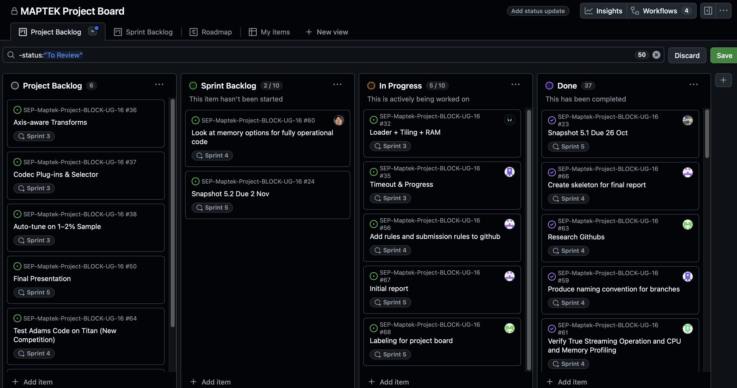

Sprint Backlog and User Stories
Sprint Backlog
Task | Description
Prepare Streaming One submission | Submit working code to the competition ‘The Streaming One’ on Titan
Review GitHub branches and pull requests | Review all branches other than main for the repository and submit pull requests when they are ready
Add branching rules and settings | Create branching rules in the settings for the repository
Labelling for project board | Assign labels to tasks on the project board to make it more clear what tasks are related to

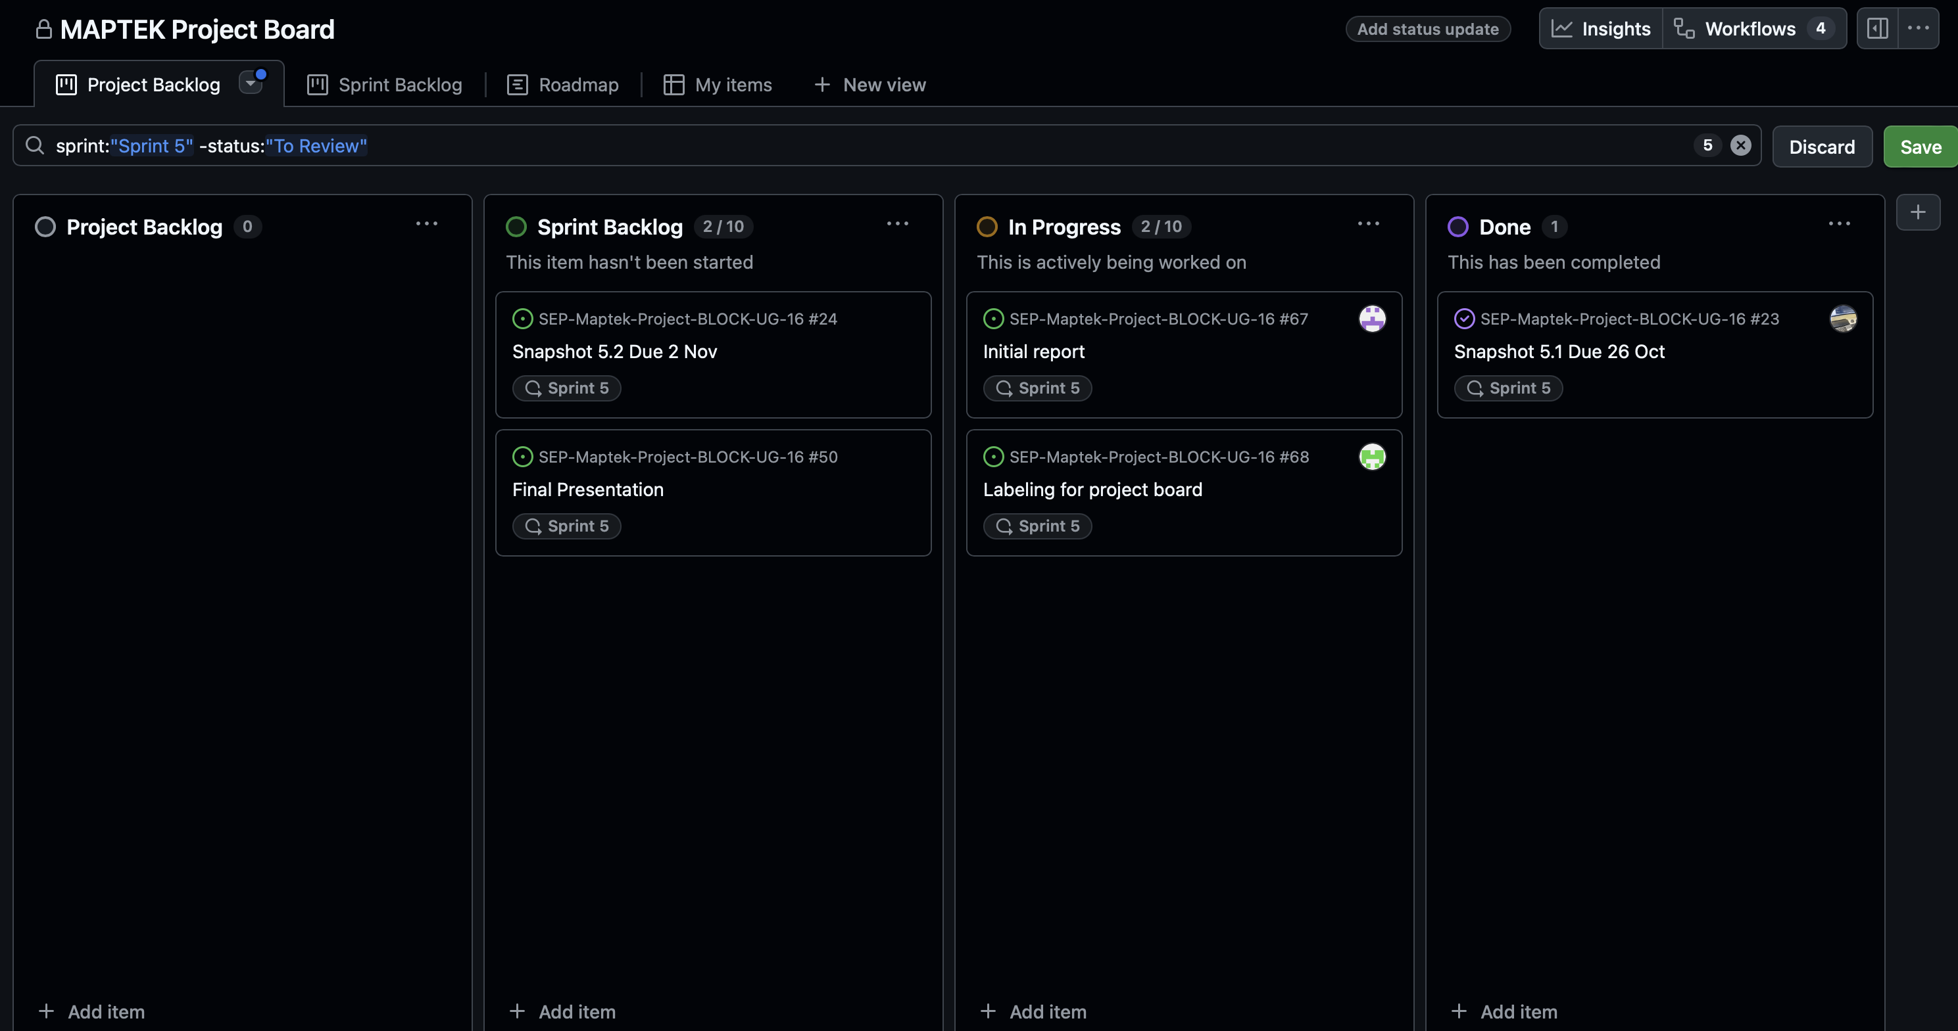

User Stories (Sprint 5)
As a competitor, I want our streaming algorithm to process data without pre-loading so that it qualifies for The Streaming One competition.
As a developer, I want clear branching and labelling rules in GitHub so that merges remain organized.
As a team, we want a polished final report and presentation to clearly communicate our results and methods.

Definition of Done
• Streaming One submission prepared and validated for true streaming operation.
• GitHub branching rules added, and review process defined.
• Pull requests checked by Scrum Master and awaiting final branch owner approval.
• Final report draft under development (due 2 Nov 2025).
• Presentation slides and rehearsal scheduled for next sprint meeting.
• Team meetings held 20 and 22 Oct to review progress and assign roles.

Summary of Changes

During Sprint 5, the team shifted focus to final competition preparation and documentation. Work centred on the Streaming One submission, ensuring the algorithm operated as a true stream processor with no pre-compression caching. Branching rules were added to the GitHub settings and pull request labels were introduced to improve workflow clarity. The team also began writing the final report and assigning sections among members, with the submission deadline set for 2 Nov 2025. A presentation meeting was scheduled to rehearse slides and final delivery plans.

As Scrum Master, Mohammad coordinated team meetings, verified repository branches, and ensured that tasks were tracked before the competition closure.
He oversaw communication between developers and documentation contributors to keep the project on schedule.

