Improvements:

- Hod should not create activity
- Campus dept mapping id should not be required, automate it.
- Pdf insertion
- Rejection with remarks
- Clarification
- Start date and end date quarter synchronization
- Is active quarter field should be added
- Get started on analytics workflow.

Frontend:
- Remove the create activity page for hod
- Remove selection of dept and campus for faculty and hod but keep it for admin.
- 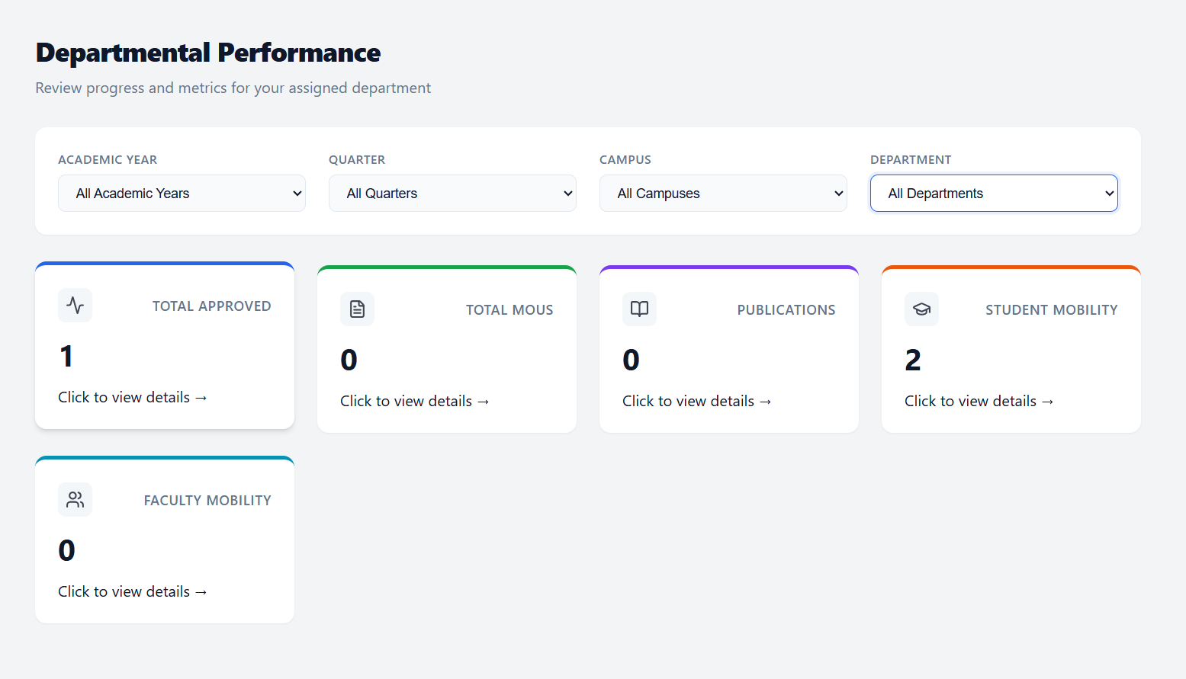
- Here the faculty and hod shouldn’t be able to choose the dept or the campus. It should automatically show their data right. However admin can view everything.
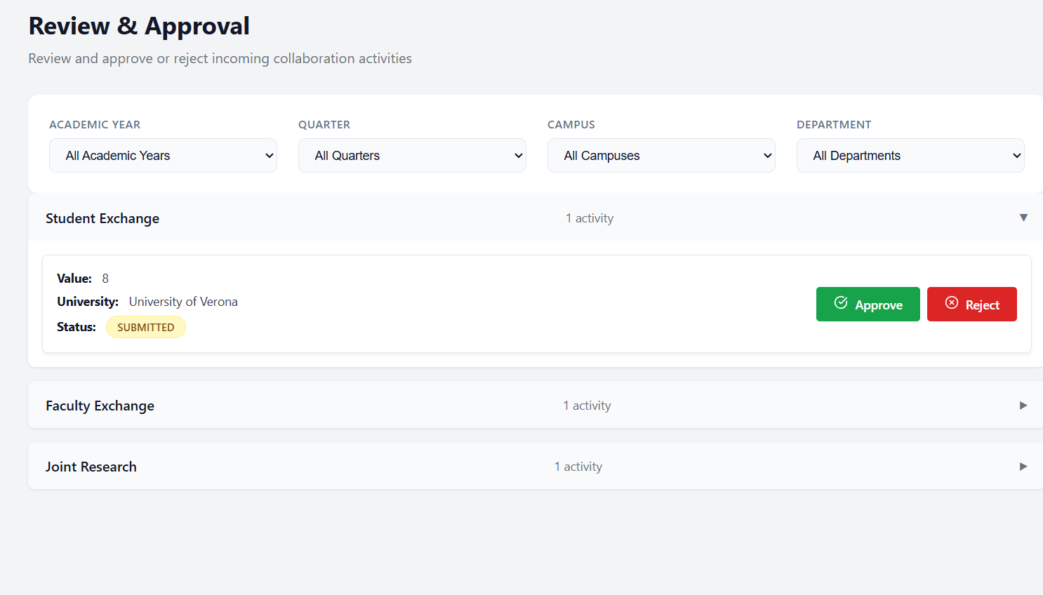
In review and approval also, hod and faculty shouldn’t have the option of choosing campus or department. Only admin can have that.

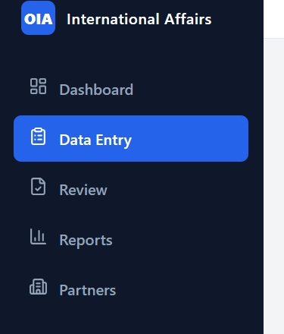
Remove data entry option for hod. Keep it only for faculty and admin

keycloak

