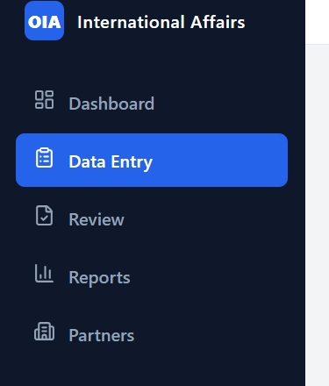
Remove data entry option for hod. Keep it only for faculty and admin

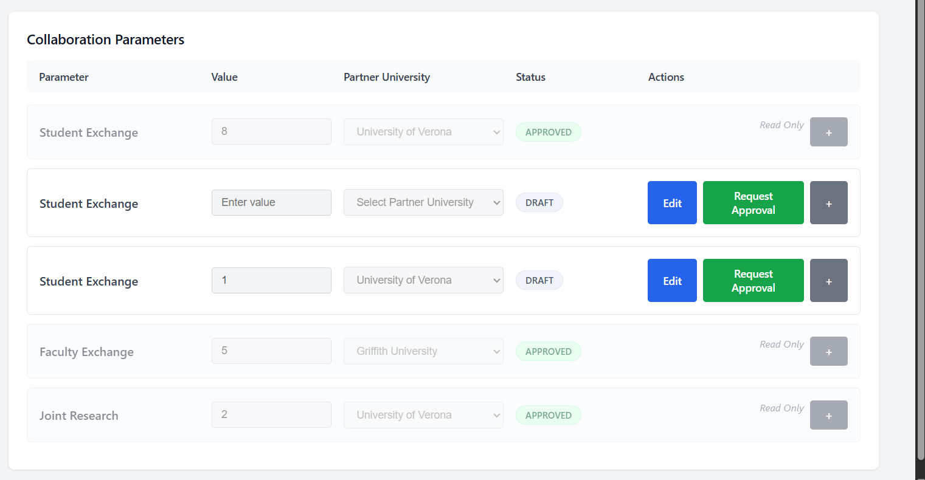
Once data is entered don’t keep it there if its approved. Only keep it if its draft.

