XPATH

# 1. Definition:

* Són una manera d’especificar parts d’un document XML.
* S'utilitzen en altres llenguatges XML com XSLT i XQuery.
* Per obtenir més informació, visiteu: enllaç. Especificació W3C <http://www.w3.org/TR/xpath>

# 2. How it works:

* Indica camins per obtenir els valors que volem de XML. L’expressió s’executa per XML i s’obtenen dades, atributs, nodes o fins i tot resultats de la funció.
* Expressar camins a XPath és similar als sistemes operatius que fins i tot utilitzen caràcters similars.

**XPath is based on expressions.** Cada "expressió" s'avalua i s'obté un resultat que pot ser:

* A list of nodes.
* A boolean (true or false)
* A float.
* A chain.

XPath also offers some **utility functions** that are similar to some **programming languages** (count, sum, avg…).

## online tools for xPaths:

* <https://codebeautify.org/Xpath-Tester>
* <https://www.freeformatter.com/xpath-tester.html>
* <http://www.qutoric.com/xslt/analyser/xpathtool.html>

## Recommended tools for xPaths:

Mozilla Firefox:

* ChroPath
* SelectorsHub

Amb aquestes eines podem trobar amb molta més facilitat les rutes dels nodes en mode gràfic i no gràfic, però no s’admeten certes funcionalitats.

## 3. xPath format

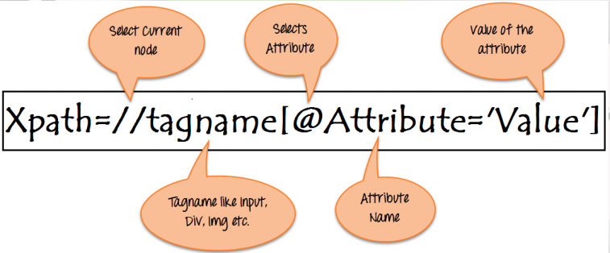

Exemple:

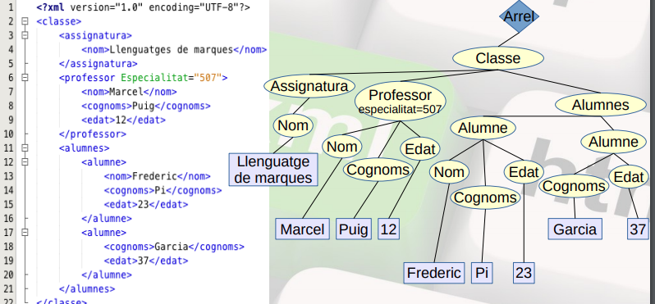

## 

## 4. xPath Syntax

* Els **camins absolut**s sempre comencen a l'arrel de l'arbre de fitxers; es poden identificar perquè el primer caràcter de l’expressió sempre serà l’arrel “/”.*Els absoluts comencen sempre en el root - /*
* Els **camins relatius** comencen des del node en què ens trobem.  *Si vull canviar de arbre, haurem d’anar cap endarrere o cap endavant.*
* **The expression** indicated by the xpath is **evaluated in the XML** document and can return more than one **value.**  *Retorna un valor si està ben escrita o té resultats.*
* If in repeated nodes we want to obtain a specific node, we must indicate the index (as in the arrays). But it is not recommended.

**Ex: /classe/alumnes/alumne[1]**

* If we want the **content** of an element we have to perform: /classe/professor/nom**/text().**
* **Wildcards** (as in OS):  *Caracteres comodin.*

**[*]** The asterisk is used to indicate all the coincidences.  *Indicar totes les coincidencies*

**[.]** As in OS directories, the dot serves to indicate the current node.  *Indica el node actual, on estem.*

**[..]** It is used to indicate the parent node.  *Indica el node pare, anar un enrere.*

**[//]** They indicate that we search with anything from the node we are on.  *Comença desde el inici fins que trobi l’element que coincideixi.*

**Example: //nom**

* An (predicate) xPath **condition** is expressed between brackets **[ ]** and acts in a manner very similar to **where** in DDBB queries.

Ex. This only takes teacher nodes that have a child name: **/classe/professor[nom].**  *Selecciona els profesors de classe que tinguin un nom.*

* This one only takes the teacher nodes that have students **/classe/professor[../alumnes/alumne].**  *seleccionara els professor sempre que alumnes tingui alumne dintre. El [] és una condició.*
* This one only takes the teacher with name "Ismael" **/classe/professor[nom="Ismael"]**  *Que el nom sigui igual que Ismael. podriem posar també* ***/classe/professor/nom[.=”Ismael”]***

We may use it with attributes too.

We may use **not** To select the opposite result. Ex. **/classe/professor[not(nom="Ismael")].**  *Per negar el resultat. Que no sigui Ismael*

* **|** or: Joins the xPath results rfom different operations.  *Una cosa o l’altre*

**//professor/nom | //alumne/nom** gives us all the teacher and student names. In this specific case, it’s equals to //nom

* We may do mathematical operations with the results **+ , -, *, div.** Ans compare results with: **=, !=, <, <=, >, >=, or, and, mod.**  *el contingut de l’element*
* We may do with the functions:
  + **Manipulate nodes:** Ex. get the name, work with the positions, count them.
  + **Work with strings**: allow you to extract characters, concatenate, compare.
  + **Numerical operations**: you can convert the results to numeric values, count the nodes, perform operations on them.
  + **Boolean operations** on nodes Operations on dates on nodes.

<http://www.w3.org/TR/xpath-functions>

## 5. xPath Functions

* **name**() - Element name
* **sum**() Add a sequence
* **count**() -Nodes quantity
* **avg**() Values average
* **max**() - Sequence maximum
* **min**() Sequence minimum
* **position**() - Position where the current node is located
* **last**() - Says if current node is the last
* **distinct-values**()- Check for duplicates elements
* **concat**() - Joins strings contains() -Check if the constant is present
* **starts-with**() - Checks the string begginning
* **string-length**() - Gives us the character quantity
* **substring**() - Extracts a part of a string
* **string-join**() - Joins a sequence with separator
* **current-date**() - Gives us the actual time
* **not**() - Change the boolean values

*CONTAINS*

***//movie[contains(., Lord of the rings’)]***

***//movie[contains(./Title,'Lord')]***