**Madeline Starr Homework #1 – Kickstarter Data – Due 4/27/19**

1. **What are three conclusions we can make about Kickstarter campaigns given the provided data?**
2. Overall, more campaigns are successful than fail or are canceled, with theater and music being the most common categories Kickstarted. Music campaigns have a higher likelihood of being successful than theater campaigns.

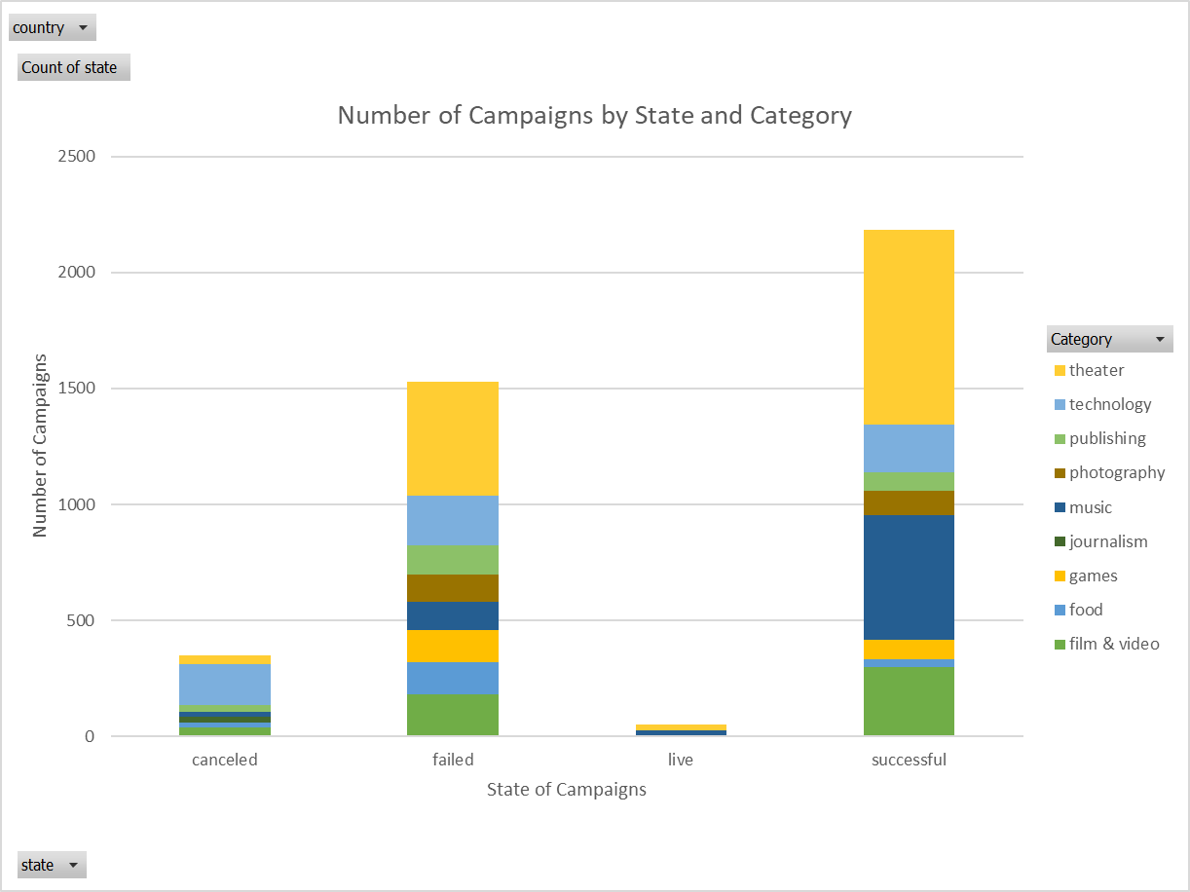

1. Before March of 2017 (end of data collection), food trucks were never successful – they either failed or were canceled. Similarly, all of the audio journalism campaigns were canceled. From this data, Kickstarter does not appear to be an ideal platform for funding either food trucks or audio journalism

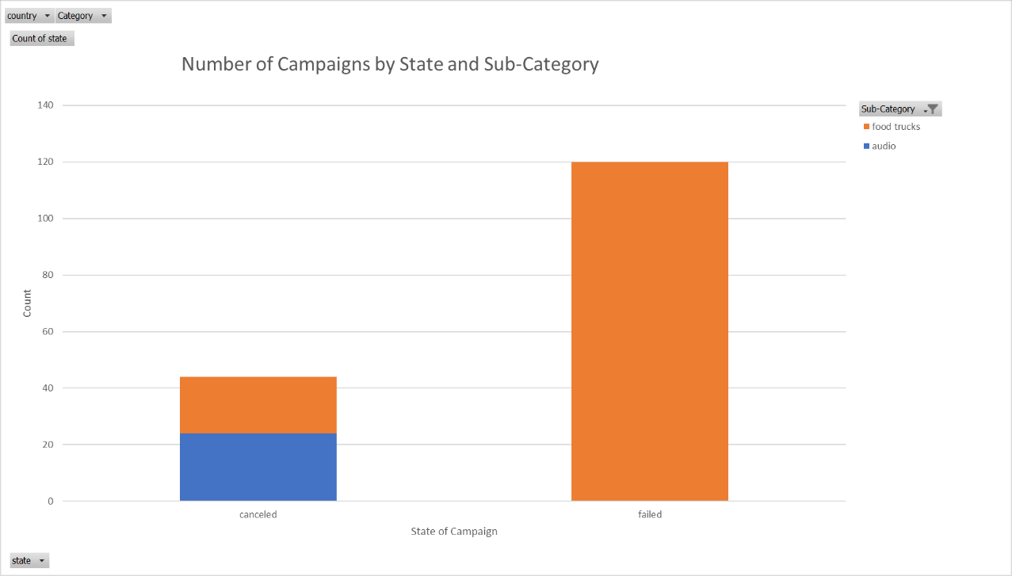

1. Kickstarter campaigns became more popular in general in 2014, peaking in 2015, and beginning to decline in 2016. Because data was not collected for all of 2017, no conclusions can be drawn about whether or not a downward trend continued. The ratios of successful, failed, and canceled campaigns remained mostly steady, except in 2012, when successful campaigns made a jump in frequency, but failed and canceled campaigns did not.

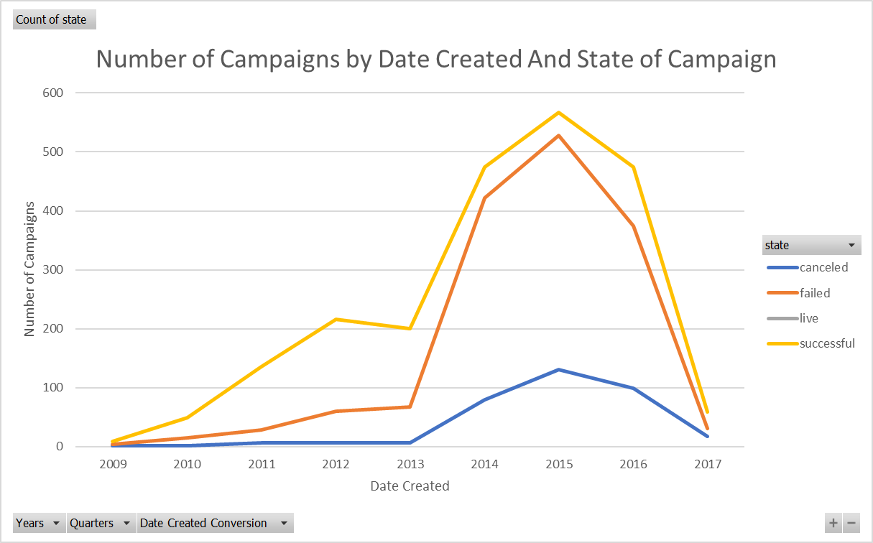

1. **What are some of the limitations of this dataset?**

Because internet trends can change so quickly, a Kickstarter dataset that was collected over 2 years ago is relevant to what was happening at the time and is limited in predicting future trends. As shown in the last chart provided (Number of Campaigns by Date Created And State of Campaign), the overall number of campaigns made a huge jump in 2014, but we cannot draw conclusions from this data set about whether or not that trend has continued.

While the data contains information about whether or not a campaign was a “Staff Pick,” there is no information about whether or not a campaign was heavily promoted by outside sources (“went viral”) or had any advertising money behind it. This would likely have a huge impact on the success of the campaign. This could potentially be addressed by including data on the number of views each campaign’s page received.

1. **What are some other possible tables/graphs that we could create?**

It would be interesting to examine the relationship between the average donation size and the overall goal amount of the campaign as well as the category. This would illustrate if people are willing to spend more either based on the type of campaign and/or how large the goal is. A line graph similar to the one created in the bonus exercise, using the same delineations for size of campaign, but showing the average donation size and filterable by category.

Additionally, it would be helpful to people looking to create campaigns to know if they had a visualization on length of campaign vs. state. This would require creating an additional column subtracting the Date Ended from the Date Created for the number of days a campaign was “live” and comparing it to the final state, again, filterable by category. A stacked column pivot chart would be helpful for this metric

**Bonus:**

