How whitelist ArvanCloud CDN Service IP Addresses To your FortiGate Firewall

There are different solutions for this purpose. One of them which I personal use it is this which I gone explain it . Since you config it one time and after that it will update automatically for you.

First of all you should login to your FortiGate with GUI ( I will share CLI one later) and select the VDOM which you are use it and go the following path

Security Fabric 🡺 External Connectors

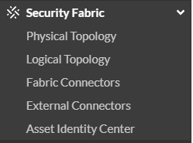

Then you should select “IP Address” from following list

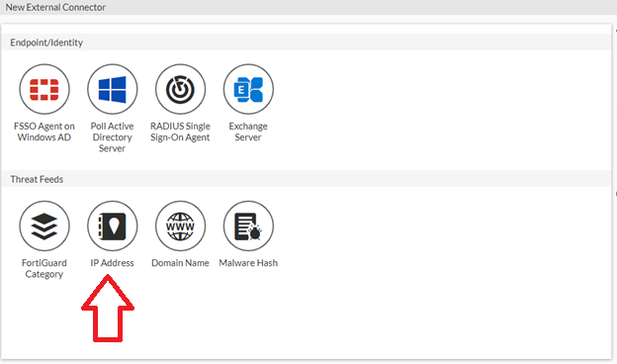

So, you should fill the fields like following example

|  |  |
| --- | --- |
| Example | Field Name |
| ArvanCloud CDN IP Addresses (Or any other name) | Name |
| https://www.arvancloud.com/fa/ips.txt | URI of External Resource |
| 1440(Daily) | Refresh Rate |
| ArvanCloud CDN IP Addresses | Comments |
| Enable | Status |

For the final step you should check that your device is start Syncing with the ArvanCloud Servers or not. If it starts you will see something like this

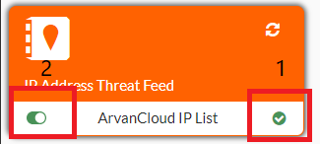

And if your right click on this filed you can see the IP Addresses which is synced (click “View Entries”)

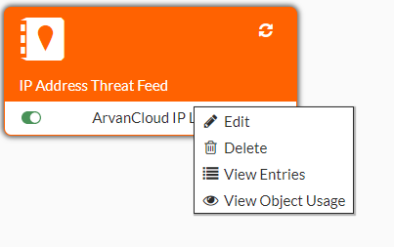

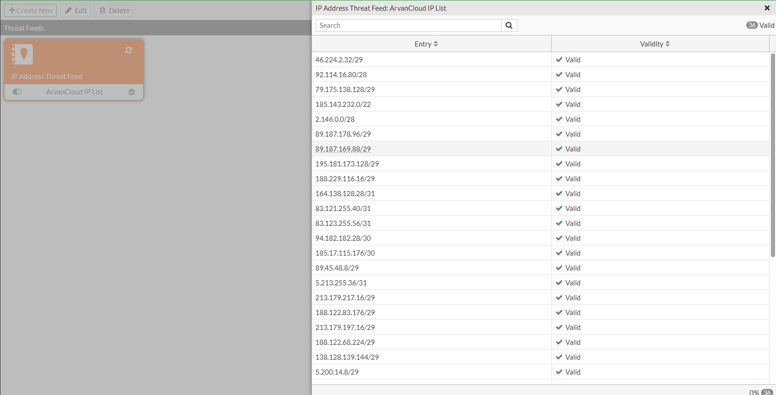

So, now you can create a firewall policy and use this dynamic list which is update daily