

**FACULTY OF AUTOMATION AND COMPUTER SCIENCE**

**COMPUTER SCIENCE DEPARTMENT**

**SOFTWARE DESIGN**

**Laboratory Assignment 1**

**TRAVELLING AGENCY**

**“Your Perfect Vacation”**

Student: Horvath Ariana-Cristine

Group: 30431

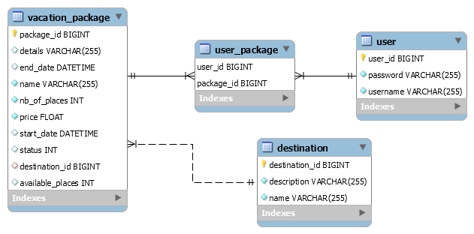**Database Diagram**

**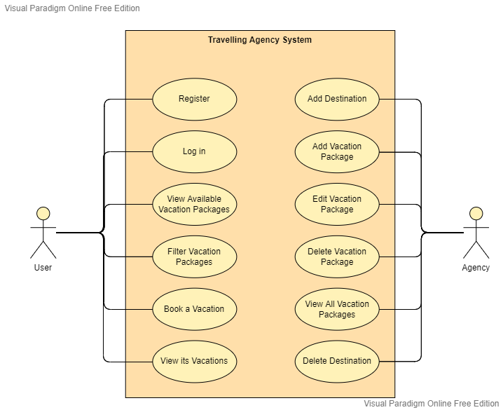****Use Case Diagram**

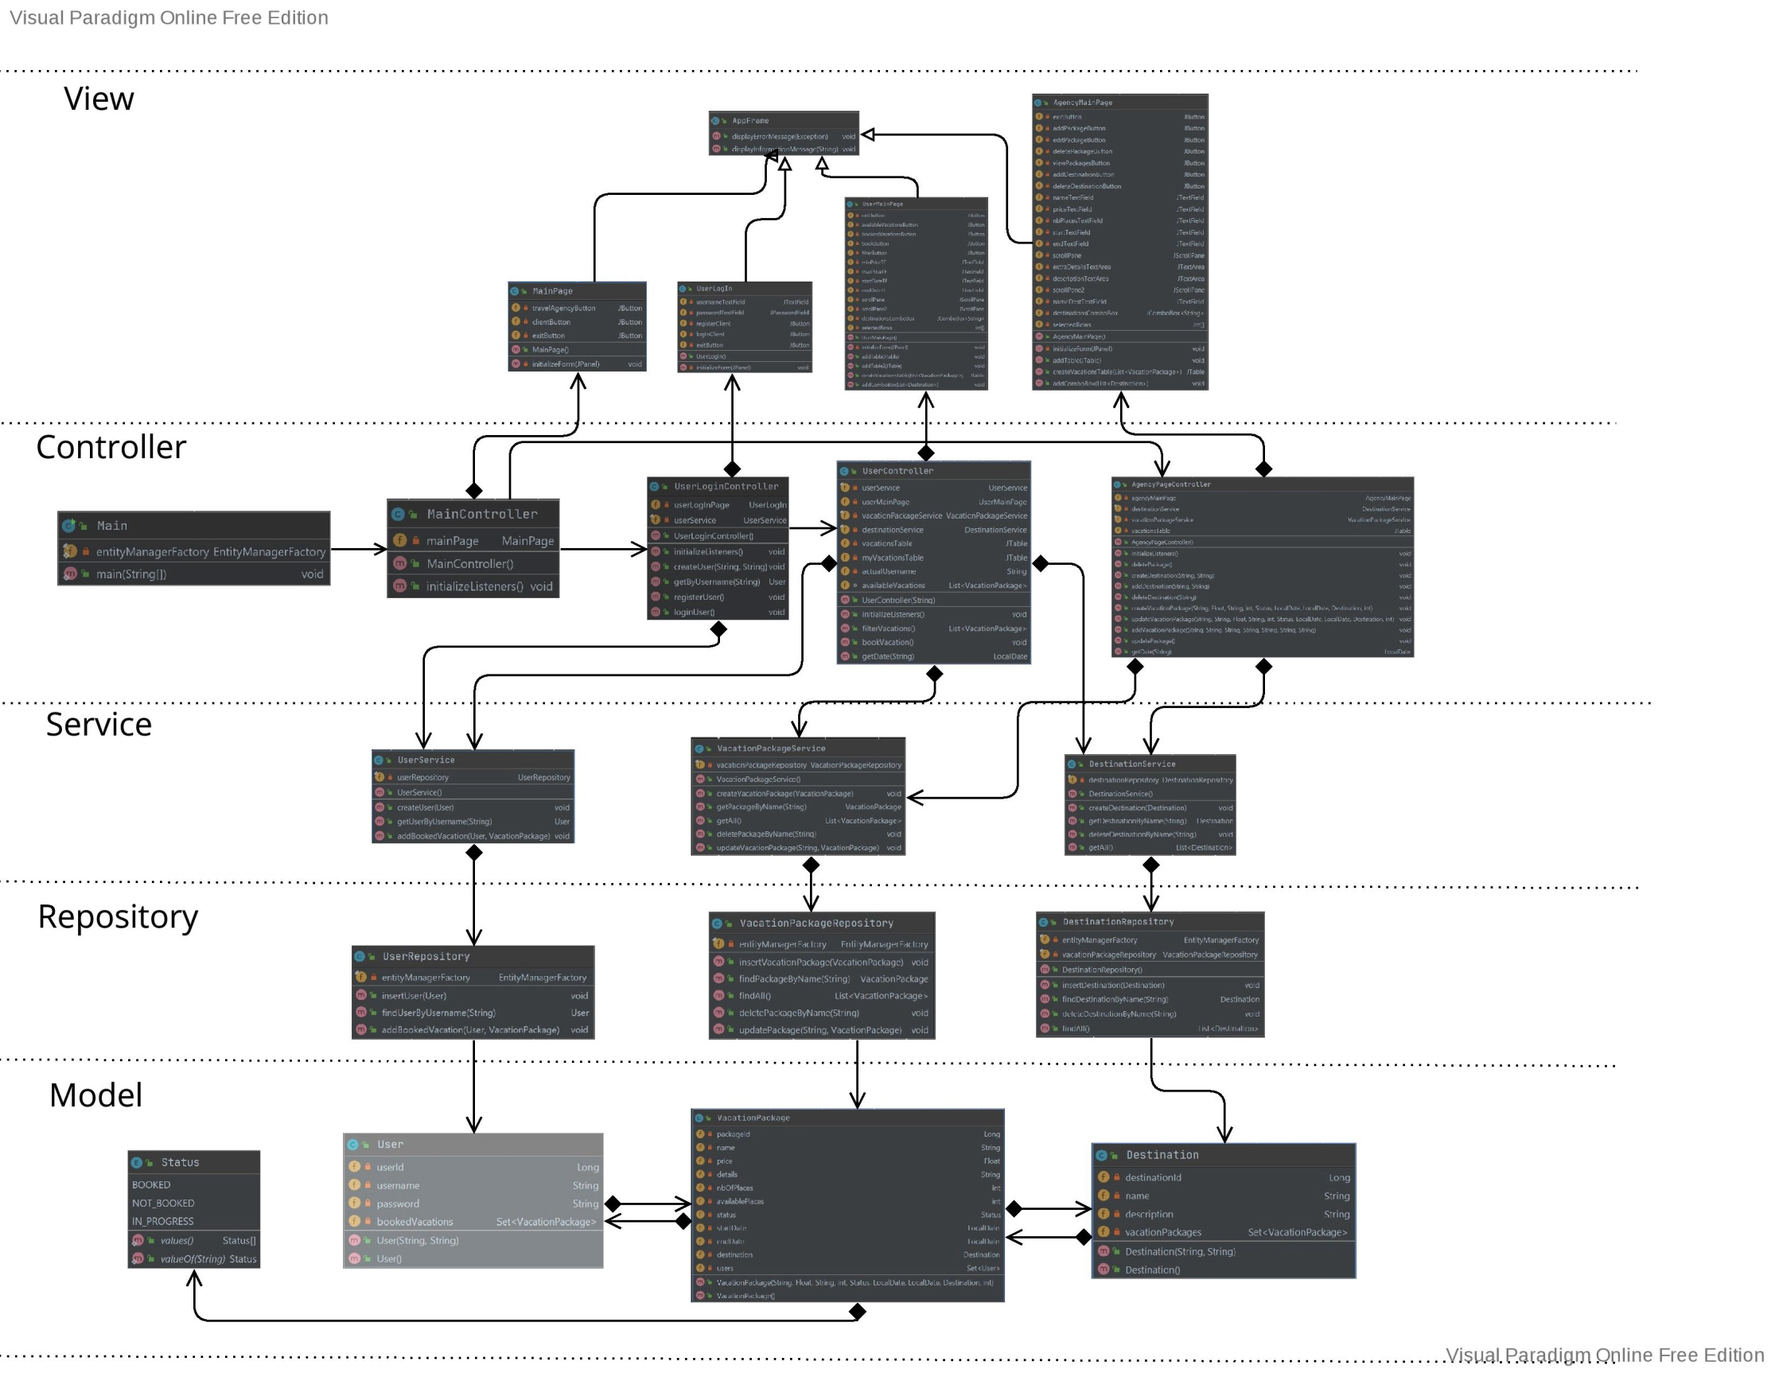**Class Diagram**