Beauty Salon Management System

Table of contents:
- Introduction
1.1 Project Overview
1.2 Objectives
- Proposed vs Implemented
- Database Design and Implementation
3.1 Database Overview
3.2 Tables and Relationships
3.3 Sample Queries / Reports
- Instructions for Running the Application
- Implementation Overview
5.1 Design and Approach
5.2 Challenges and Solutions
5.3 Features I’m Proud Of
- References

1.Introduction
1.1 Project Overview
The Beauty Salon Management System is designed to simplify and automate the operations of a beauty salon. It allows administrators to manage staff, services, and appointments efficiently, while clients can easily view available services, choose staff, and book appointments. The system features role-based access, appointment validation to prevent double bookings, and a JavaFX-based graphical user interface for easy navigation. The database stores all relevant information, including users, staff, services, and schedules. This project improves scheduling accuracy, reduces manual work, and enhances the overall customer experience.
Project Architecture Overview
The application follows a layered architecture consisting of a UI layer, service layer, repository layer, and model layer.
- Model Layer defines the data structures that represent database tables.
- Repository Layer handles all database operations using JDBC and SQL.
- Service Layer contains business logic, validation, and coordination between repositories.
- UI Layer handles user interactions and delegates processing to the service layer.
This architecture improves maintainability, separates responsibilities, and ensures that business logic is centralized and reusable across the system.
Properties:
- Username must be unique
- Staff cannot be double-booked
- Service price > 0
- Appointment in the future

- MODELS
Model Layer interacts with ALL other layers, because all layers use the same data objects.
Purpose of the models Layer
- Represents database tables as Java objects
- Makes application data easy to store, pass, and modify
- Ensures consistency between Java code and the database
- Used by repositories, services, and controllers
- Each model includes fields, constructors, getters, setters
- These objects are used to transfer data between the database, the repository layer, and the service/controller layers.
Directory: src/model
Classes:
- User
- Role
- ServiceCategory
- Service
- Staff
- StaffWorkingHours
- Appointment

- REPOSITORY
Communicate with the database using SQL.
Each repository handles one table:
- user_repository -> app_user table
- staff_repository -> staff table
- service_repository -> service table
- etc.
Purpose of the repository Layer
- Open database connections
- Run SQL queries (INSERT, SELECT, UPDATE, DELETE)
- Convert ResultSet rows into model objects (mapRow)
- Return model objects or lists of them
They hide SQL from the rest of the application.
- role_repository
- user_repository
- category_repository
- service_repository
- staff_repository
- working_hours_repository
- appointment_repository

- SERVICE
The service package contains classes that implement the business logic of the application.
Service classes validate inputs, apply business rules, and coordinate repository operations.
They act as the intermediary between controllers and repositories, ensuring that data is processed correctly before being stored or retrieved from the database.
Purpose of the Service Layer
- Separates business logic from controllers and repositories
- Validates and processes input before saving to the database
- Coordinates multiple repositories when needed
- Ensures clean, maintainable, reusable code
- Provides higher-level operations for controllers to call
- RoleService
- UserService
- CategoryService
- ServiceService
- StaffService
- WorkingHoursService
- AppointmentService

- UI
Handle requests & show responses. UI never contains SQL or business logic.
Example:
User clicks button -> Controller handles event -> Controller calls Service -> Service calls Repository -> Repository talks to Database -> Result goes back up -> UI updates screen

1.2 Objectives
What I Wanted to Build
The main goal of this project was to take the headache out of running a beauty salon by building a smart, easy-to-use management system. I wanted to move away from old-school paper planners and create a digital space where everything—from staff schedules to client bookings—just works smoothly together.
Helping Out the Admins
I focused a lot on making life easier for admins. My goal was to give salon owners a “mission control” where they can quickly add new services, update prices, and manage their team without breaking a sweat. I wanted to make sure they have a clear view of the day so the salon stays organized and profitable.
Making it Easy for Clients
For the customers, I wanted the booking process to feel as easy as scrolling through social media. Instead of having to call during business hours, they can just hop online, pick the service they want, choose their favorite stylist, and grab a spot that works for them. It’s all about making the salon accessible 24/7.
Why This Matters
By building this system, I’m tackling three big problems:
- Less Paperwork: It cuts down on the boring manual work so the staff can focus on making people look great.
- No More Messy Calendars: The system handles the logic, which means no more double-booked stylists or confusing overlaps.
- Happy Customers: A modern, professional interface makes a great first impression and keeps clients coming back.

2. Proposed vs Implemented
The Beauty Salon Management System was designed with a set of key features aimed at improving salon operations for both clients and administrators. The proposed features included a user registration and login system, online appointment booking for various beauty services, a service catalog displaying prices and durations, employee or stylist selection during booking, appointment management functionalities (create, edit, cancel), and an admin panel for managing services, staff, and appointments.
In the implemented system, the core functionalities of these proposed features were successfully developed and tested. The system supports user registration and login, providing role-based access to differentiate between administrators and clients. Clients can browse the full list of services with detailed information on prices and estimated durations and can book appointments by selecting a service, preferred staff member, and available time slot. The system automatically validates appointments to prevent double bookings and ensures that all times are within staff working hours.
Administrators can efficiently manage the salon operations through the implemented admin panel. This includes adding, updating, and removing services, managing staff schedules, viewing all client appointments, and generating basic reports or statistics. Both clients and administrators have the ability to create, modify, or cancel appointments as needed, ensuring flexibility and smooth operation. While some advanced features, such as graphical interfaces or detailed analytics, were proposed, the implemented system focuses on delivering a reliable, fully functional, and user-friendly interface.
3.Database Design and Implementation
The database is a critical component of the Beauty Salon Management System, serving as the backbone for storing and managing all information related to users, staff, services, and appointments. The database is designed to ensure data integrity, efficient access, and smooth integration with the Java application.
3.1 Database Overview
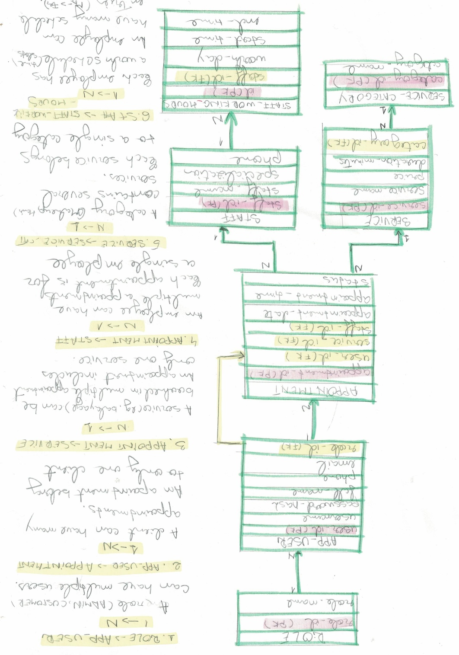

The system uses a relational database to store all relevant data. It includes tables for users, roles, services, service categories, staff, staff working hours, and appointments. The database is designed to maintain relationships between these entities and support queries required by both clients and administrators.
Key features of the database include:
- Centralized storage for all salon operations
- Referential integrity between related tables
- Support for role-based access control
- Efficient queries to support booking and reporting

3.2 Tables and Relationships
1. User & Access Management
- Role Table: Manages the different types of users allowed in the app.
- App User Table: Stores user login credentials and contact information. Each user is assigned a specific role.
2. Service Catalog
- Service Table: Lists everything the salon offers, including how much it costs and how long it takes.
- Service Category: Groups services together (like 'Hair', 'Nails', or 'Skincare') to make them easier for clients to find.
3. Scheduling & Staffing
- Staff Table: Individual profiles for every professional working at the salon.
- Working Hours: This is the staff's digital calendar. It tells the system exactly when a stylist is clocked in and ready to work.
- Appointment Table: This is where the magic happens. it connects the Client, the Staff member, and the Service into one single event.

3.3 Sample Queries / Reports
The system supports several SQL queries to manage and retrieve data efficiently:
- List all appointments:
SELECT * FROM Appointment;
- List all services with prices:
SELECT name, price, duration FROM Service;
- View staff working hours:
SELECT staffId, day, startTime, endTime FROM StaffWorkingHours;
- Generate report of upcoming appointments for a specific staff member:
SELECT * FROM Appointment WHERE staffId = ? AND date >= CURDATE();
These queries form the basis for application functions, including listing available services, checking staff availability, and generating basic reports.

4.Instructions for Running the Application
This section provides step-by-step guidance for setting up and running the Beauty Salon Management System. Following these instructions ensures that the application connects correctly to the database and functions as intended.
- Set Up the Database:
  - Create a new database (e.g., beauty_salon_db).
  - Run the SQL scripts provided to create tables: User, Role, ServiceCategory, Service, Staff, StaffWorkingHours, and Appointment
  - Insert any necessary sample data
- Configure Database Connection in Java:
  - Update the database URL, username, and password to match your DBMS configuration.
  - Example JDBC URL:
- String url = "jdbc:mysql://localhost:3306/beauty_salon_db";
- String user = "root";
- String password = "your_password";
- Compile and Run the Application
- Using the Application:
  - Client Login: Browse services, choose staff, select a date, view available time slots, and book appointments.
  - Admin Login: View, modify, or cancel appointments; manage services and staff schedules; generate basic reports.

5.Implementation Overview
5.1 Design and Approach
The Beauty Salon Management System was designed using a layered architecture to ensure clarity, maintainability, and separation of responsibilities within the application. The system follows a structured approach that divides the application into distinct layers: model, data access, service logic, and user interface.
The service layer contains the business logic of the system, such as user login validation, role verification, appointment validation, and availability checks. This layer ensures that rules like preventing double bookings, validating user roles, and checking working hours are enforced consistently.
UI layer will be JavaFX and the architecture becomes:
JavaFX UI -> Service Layer -> Repository Layer -> Database-> Models
JAVAFX SCREENS
- Authentication
- login.fxml
- register.fxml
- Customer Screens
- customer_home.fxml
- service_list.fxml
- book_appointment.fxml
- my_appointments.fxml
- Admin Screens
- admin_dashboard.fxml
- manage_users.fxml
- manage_staff.fxml
- manage_services.fxml
- manage_categories.fxml
- manage_appointments.fxml
BOOKING AN APPOINTMENT IN JAVAFX
- book_appointment.fxml -> BookAppointmentController -> appointment_service

5.2 Challenges and Solutions
During the development of the Beauty Salon Management System, several technical and design challenges were encountered.
One of the main challenges was designing an efficient database structure that could handle users, staff, services, and appointments while maintaining data integrity. This was solved by carefully defining relationships between tables and using foreign keys to enforce consistency. Separating staff working hours into a dedicated table helped ensure accurate scheduling and availability checks.
Another challenge involved preventing double bookings and ensuring valid appointment times. This was addressed by implementing validation logic in the service layer that checks staff availability, working hours, and existing appointments before allowing a new booking to be created or updated.
Role-based access control was also a challenge, as different users require different permissions. This issue was resolved by introducing user roles and validating them during login, ensuring that administrators and clients only have access to features relevant to their roles.
Finally, designing a user-friendly console interface required careful planning to ensure ease of navigation. This was achieved by creating clear menu structures and logical workflows tailored separately for administrators and clients.

5.3 Features I’m Proud Of
One of the features I am particularly proud of is the appointment scheduling and validation logic. The system successfully prevents double bookings by checking staff availability, working hours, and existing appointments before confirming a reservation. This ensures accurate scheduling and reflects real-world salon operations.
Additionally, the database integration was implemented efficiently, allowing real-time data updates and reliable communication between the application and the database. This ensured consistency across all operations and improved overall system stability.
Finally, the console-based user interface effectively supports all core functionalities with clear menus and prompts. Despite its simplicity, it provides a smooth and logical user experience, allowing users to interact with the system without difficulty.

6. References
- Oracle. Java SE Documentation.
https://docs.oracle.com/en/java/
- MySQL. MySQL 8.0 Reference Manual.
https://dev.mysql.com/doc/
- GeeksforGeeks. Java Programming Tutorials.
https://www.geeksforgeeks.org/java/
- Course materials and lecture notes provided during lectures.

