Smart Emergency Command Center
Project documentation

1. Overview
The problem. In a medical emergency every minute counts, but the information is usually spread between several people. The dispatcher does not always know which ambulance is free and closest, several emergencies arrive at the same time and must be handled in the right order, the ambulance crew arrives without knowing the allergies or the medication of the patient, and the hospital learns about the patient only when the ambulance is at the door. SECC solves this by putting all the participants in the same system: the location of the patient, the priority of every case, the position of every ambulance, the Medical Card and the measurements made on the way are visible, in real time, to everyone who needs them.
Smart Emergency Command Center (SECC) is a client-server web application that coordinates a medical emergency from the moment a patient asks for help until the patient is treated in a hospital and the medical history is updated. It connects five types of users - patient, dispatcher, ambulance crew, doctor and administrator - and gives each of them only the information needed for their role.
Main scenario: the patient presses SOS and the GPS location is sent → the incident is created and receives a priority score → the nearest available ambulance is assigned automatically → the crew reads the patient's Medical Card, treats the patient and records the vital signs → the patient is transported and handed over to the hospital → the doctor consults the Medical Card, administers the treatment and finalizes the case (the Medical History is updated) → the dispatcher closes the incident and the resources become available again.
Objectives: fast reaction (automatic assignment of the nearest ambulance), correct order of handling (priority score 0-100), safe treatment (allergies visible to the crew and to the doctor) and traceability (statuses with time stamps and an audit log of every operation).

2. Users and features
User | Main features
Patient | SOS button with GPS location; cancel a request sent by mistake (before the crew arrives); view the emergency status if the doctor permits; read the Medical Card and Medical History; manage up to 5 emergency contacts.
Dispatcher | Dashboard with the incidents ordered by priority and a live map; create incidents reported by phone and update them; Smart Dispatch recommendation of resources; assign resources; manage ambulances, fire teams, fire trucks and police units; close incidents.
Ambulance crew | See the assigned emergency and the patient's Medical Card (allergies in red); update the transport status step by step; record vital signs, medication and interventions (abnormal values in red); hand the patient over to the hospital.
Doctor | List of incoming patients with estimated arrival time; Medical Card, history, transport timeline and vital signs; record diagnosis and treatment (warning if a medication matches an allergy); allow the patient to view the status; finalize the case.
Administrator | Create, edit and disable user accounts; link crew accounts to ambulances and doctors to hospitals; system status; audit log with filters and CSV export.

3. How the application works
The application runs in the browser at http://localhost:5173. After login, every user is taken to the home page of the role and the top menu shows only the pages of that role; the name and the role of the user are displayed in the upper-right corner, next to the Log out button. The operational pages (emergency status, dashboard, assigned emergency, incoming patients) refresh by themselves every 5 seconds, so nobody has to reload the page to see a new incident or a status change.
The same conventions are used everywhere: the priority is a coloured badge (red ≥ 80, orange 50-79, green < 50), every status has its own colour, and abnormal vital signs and allergies are written in red. The layout also works on phones and tablets.

3.1 A complete emergency, step by step
The table follows one emergency through the system and shows what each user does and what the others see as a result.
Step | User | Action in the application | Result visible to the others
1 | Patient | Presses SOS on My emergency | Incident appears on the dispatcher dashboard; crew gets NEW EMERGENCY
2 | Crew | Reads the Medical Card, presses En route and On scene | Dispatcher sees the transport status; incident IN_PROGRESS
3 | Crew | Records vital signs, starts the transport to a hospital | Patient appears in the doctor's Incoming patients with ETA
4 | Crew | Arrived at hospital, Hand over to hospital | Ambulance AVAILABLE again; patient marked Arrived
5 | Doctor | Checks the card, saves diagnosis and treatment, allows status, finalizes | Patient sees the status and the new history entry
6 | Dispatcher | Opens the incident marked Ready to close and closes it | Incident CLOSED; all resources released

3.2 Patient
The patient uses the application only when help is needed, so the home page is reduced to one big action. All the screenshots in this chapter were taken in the running application; the red numbers are explained under each picture.
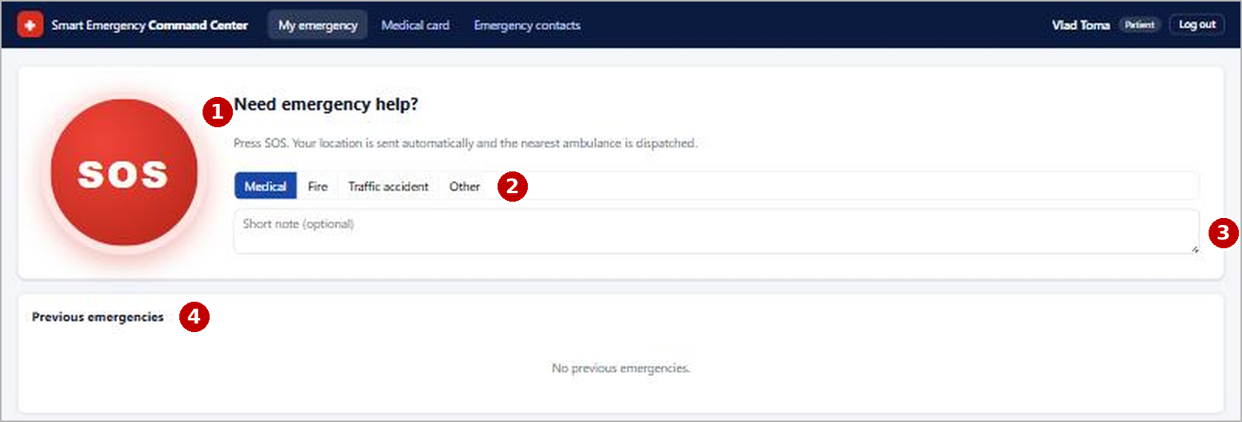
Figure 1. Patient - home page "My emergency" before an emergency
- SOS button - one click sends the request; the browser adds the GPS location automatically. The server creates the incident, calculates its priority and reserves the nearest free ambulance.
- Type of emergency - optional (Medical, Fire, Traffic accident, Other); it changes the priority and the resources that are recommended.
- Short note - optional text for the crew, for example "chest pain" or "third floor, no elevator".
- Previous emergencies - the list of the patient's earlier requests with their final status.
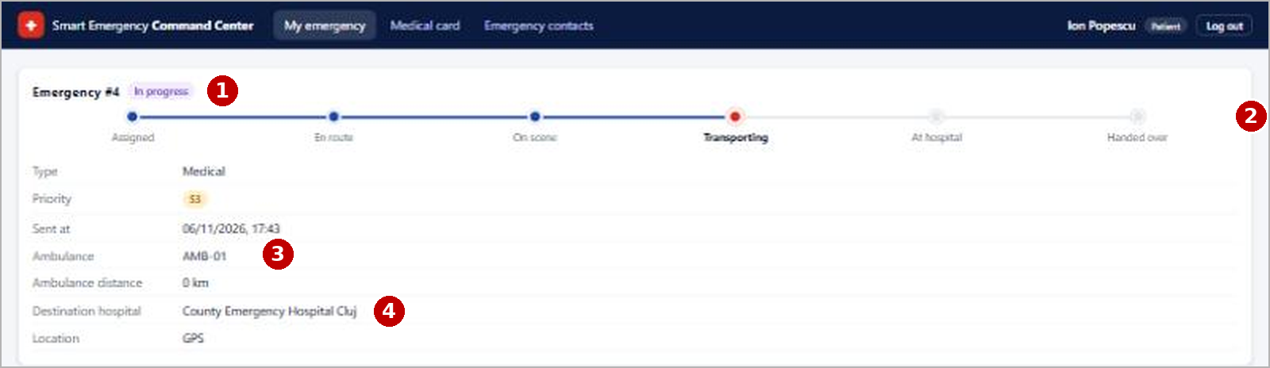
Figure 2. Patient - the same page during the emergency of Ion Popescu
- Emergency number and status - here incident #4, status "In progress".
- Progress bar - Assigned → En route → On scene → Transporting → At hospital → Handed over; the red dot is the current step (the ambulance is transporting the patient). It is shown only if the doctor permits.
- Ambulance - code of the ambulance sent (AMB-01) and its distance to the patient.
- Destination hospital - chosen by the crew when the transport starts. Until the crew arrives, a "Cancel request" button is also available for false alarms.

3.3 Dispatcher
The dispatcher works mostly on two screens: the dashboard, which shows the whole situation, and the incident page, where resources are sent.
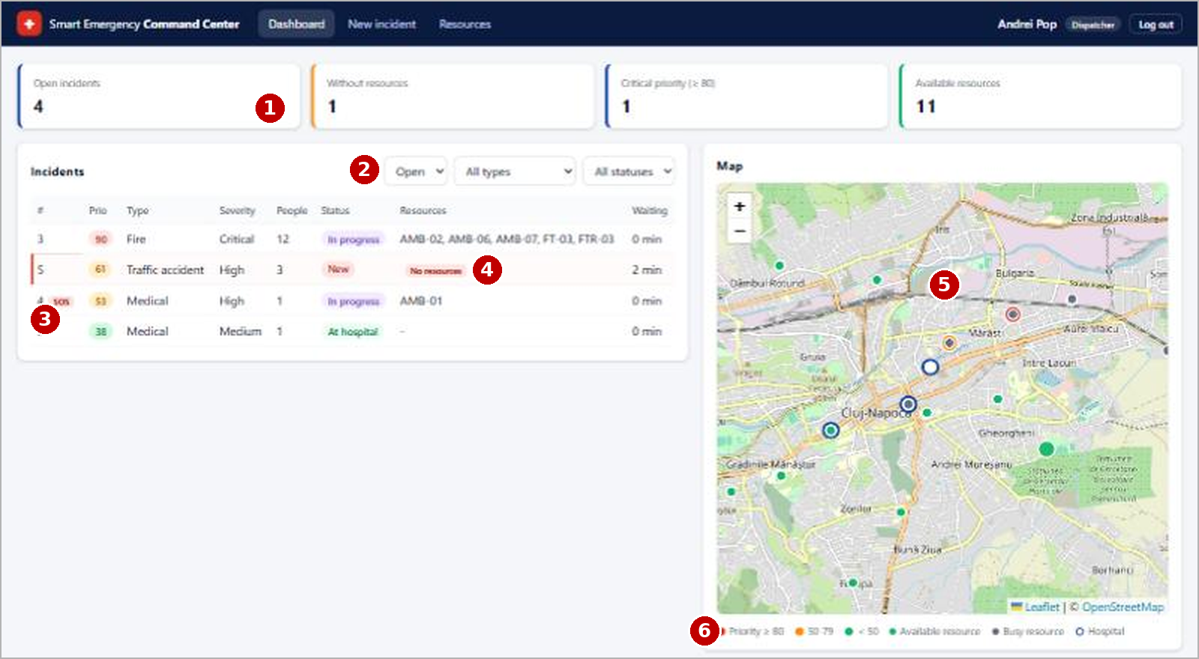
Figure 3. Dispatcher - dashboard with four real incidents in Cluj-Napoca
- Counters - open incidents, incidents without resources, critical incidents (priority ≥ 80) and available resources.
- Filters - open / all incidents, type and status.
- SOS mark - incident #4 was sent by a patient with the SOS button; the others were reported by phone.
- No resources - incident #5 (traffic accident) is still waiting, so it is highlighted with a red line. The table is ordered by priority: the critical fire (90) is first.
- Live map - incidents coloured by priority, resources (green = available, grey = busy) and hospitals (blue circles). Clicking a marker opens the incident.
- Legend of the map colours.
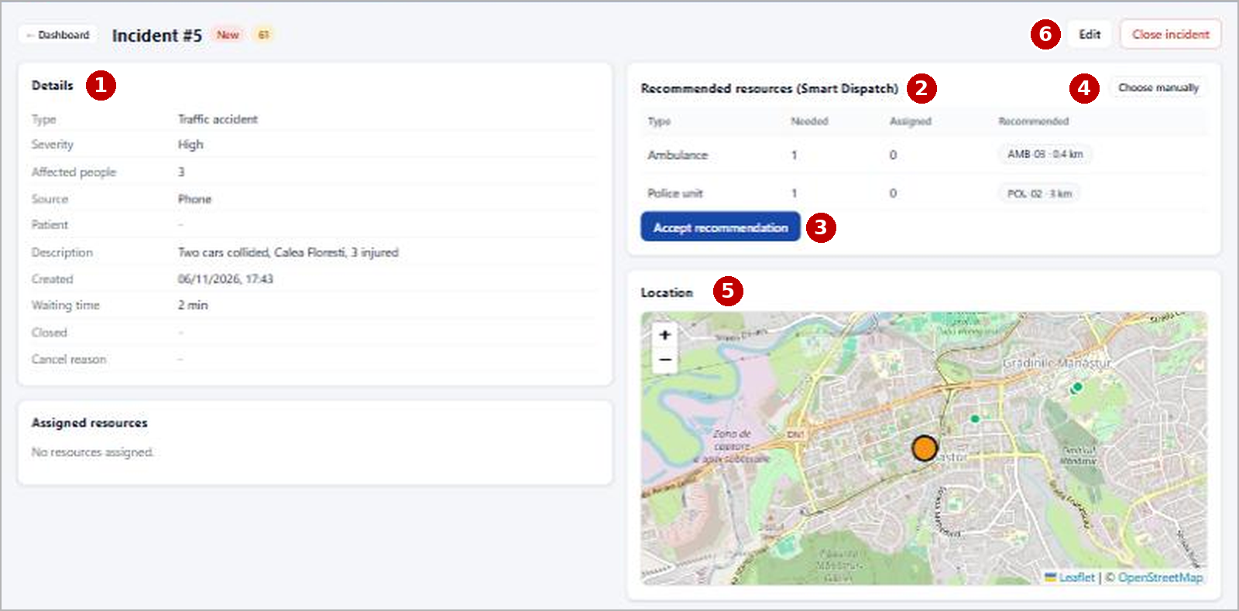
Figure 4. Dispatcher - incident #5 with the Smart Dispatch recommendation
- Details of the incident: type, severity, affected people, source, description and waiting time.
- Recommended resources - for a traffic accident with 3 injured the system needs 1 ambulance and 1 police unit and proposes the closest free ones (AMB-03 at 0.4 km, POL-02 at 3 km).
- Accept recommendation - assigns all the proposed units with one click; the crew of AMB-03 is notified immediately.
- Choose manually - shows all the free units with checkboxes, if the dispatcher prefers other ones.
- Location of the incident on the map.
- Edit / Close incident - change the data (the priority is recalculated) or close the incident when the patient was handed over.

3.4 Ambulance crew
The crew page is made for a tablet or phone in the ambulance: big buttons, one action at a time, and the patient's medical data visible before the crew arrives.
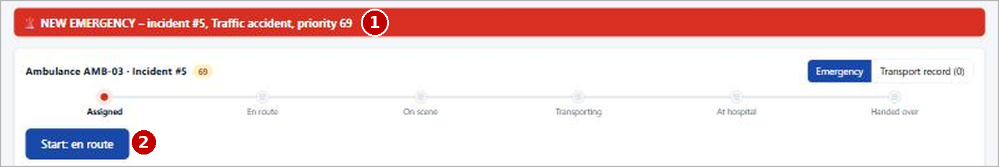
Figure 5. Ambulance crew - a new assignment arrives (AMB-03, incident #5)
- NEW EMERGENCY banner - appears by itself (the page refreshes every 5 seconds) with the incident number, type and priority.
- Next-step button - the only action needed now is "Start: en route".
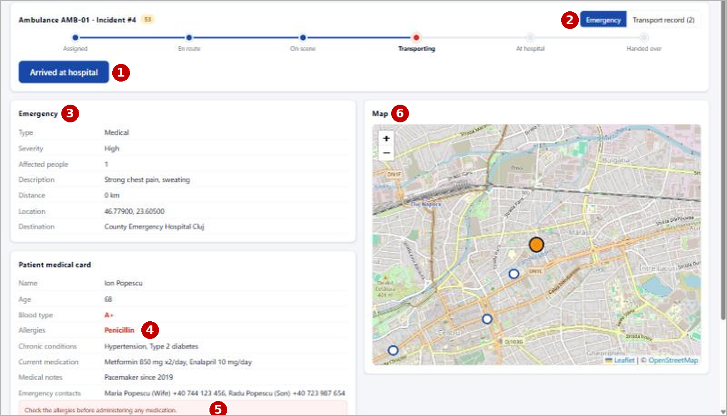
Figure 6. Ambulance crew - AMB-01 transporting Ion Popescu
- Next-step button - changes with the progress: Start: en route → Arrived on scene → Start transport (the hospital is chosen, the nearest is pre-selected) → Arrived at hospital → Hand over.
- Tabs - "Emergency" (this view) and "Transport record" with the measurements (2 recorded).
- Emergency - type, severity, description ("Strong chest pain, sweating"), distance and destination hospital.
- Allergies in red - Ion Popescu is allergic to penicillin; the crew sees it before giving any medication.
- Warning - reminds the crew to check the allergies before administering medication.
- Map with the patient (orange) and the hospitals (blue).
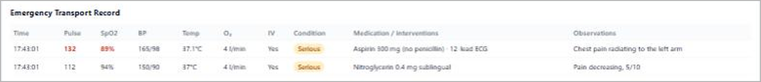
Figure 7. Ambulance crew - Emergency Transport Record of Ion Popescu
In the transport record the first measurement shows pulse 132 and SpO2 89 % in red (outside the normal range); after aspirin and nitroglycerin the second measurement is better. Values outside the allowed ranges cannot be saved. When the crew presses "Hand over to hospital" the record is locked and the ambulance becomes available.

3.5 Doctor
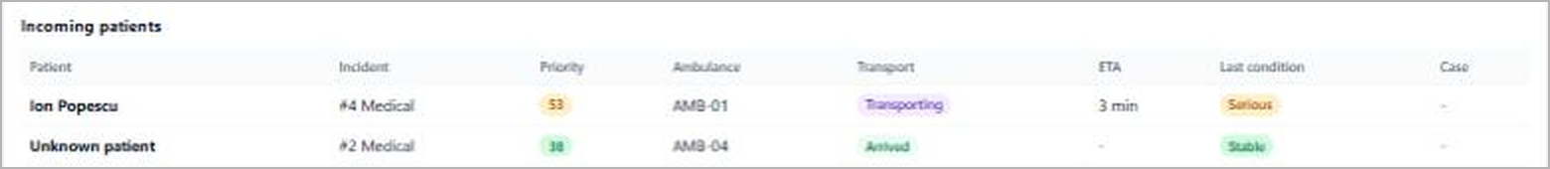
Figure 8. Doctor - incoming patients of the County Emergency Hospital
The doctor sees the patients before they arrive: Ion Popescu is transported by AMB-01 (ETA 3 min, condition Serious) and an unknown patient has already arrived with AMB-04. Opening a patient shows everything on one page:
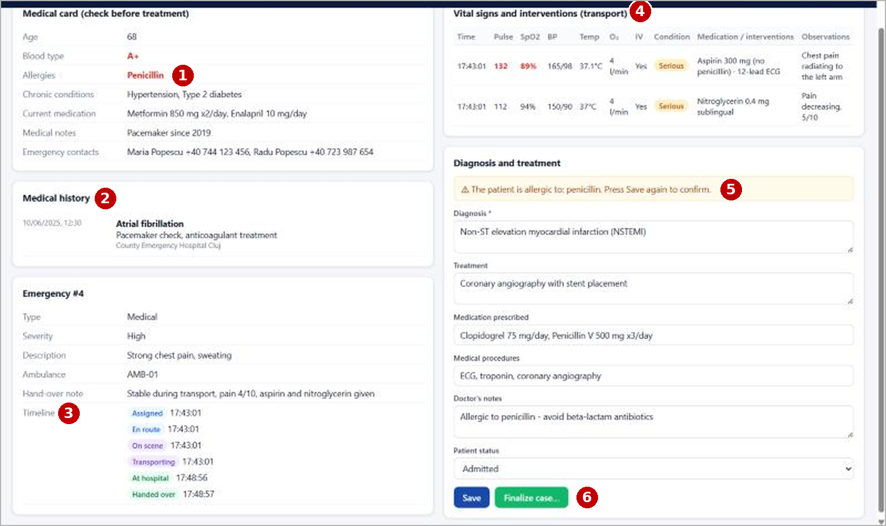
Figure 9. Doctor - patient page of Ion Popescu with the allergy warning
- Medical card - checked before treatment; the allergy to penicillin is in red.
- Medical history - earlier events (atrial fibrillation in 2025).
- Emergency and timeline - every transport step with its time and the hand-over note of the crew.
- Vital signs measured in the ambulance, abnormal values in red.
- Allergy warning - the doctor typed "Penicillin V" in the prescribed medication; the application detects the conflict with the allergy and asks for confirmation before saving.
- Save / Finalize case - Save keeps a draft; Finalize adds the case to the medical history, can update the Medical Card and makes the incident ready to close.

3.6 Administrator
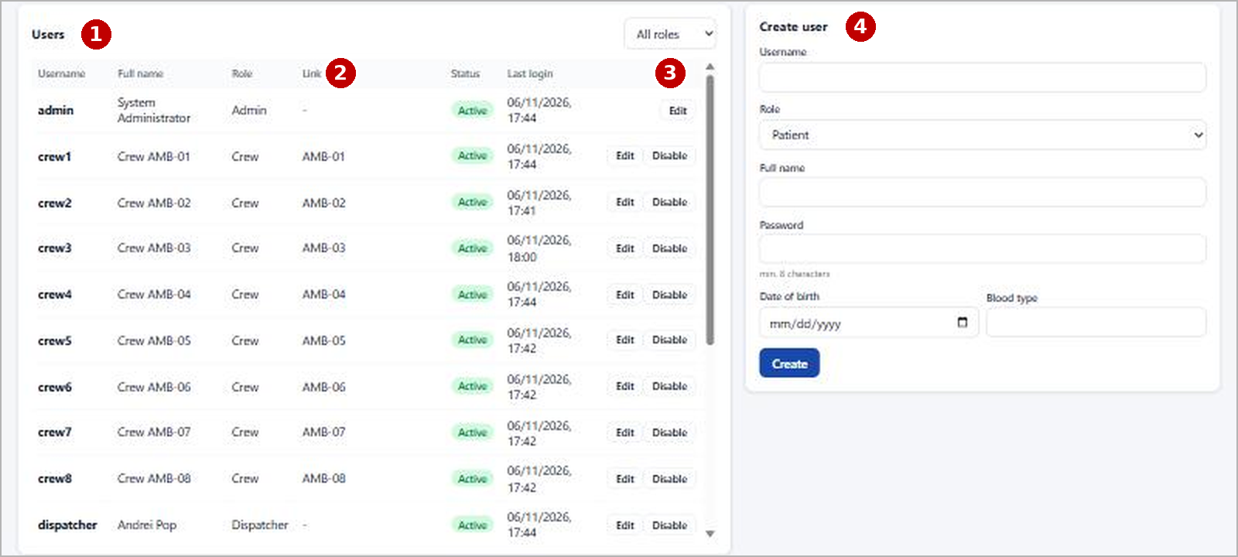
Figure 10. Administrator - user accounts
- Users - all the accounts with role, status (Active / Disabled) and last login.
- Link - each crew account is linked to one ambulance and each doctor to one hospital; this decides what they see.
- Edit / Disable - reset the password or disable an account; a disabled user is logged out at the next request.
- Create user - new account with role and password; for a patient an empty Medical Card is created.
System status confirms that the server and the database work and shows the incidents and resources per status; Audit log lists every login and request and can export them to CSV.

4. Use cases
The use case diagrams below summarize what each user can do; chapter 3 showed how these use cases look in the application.
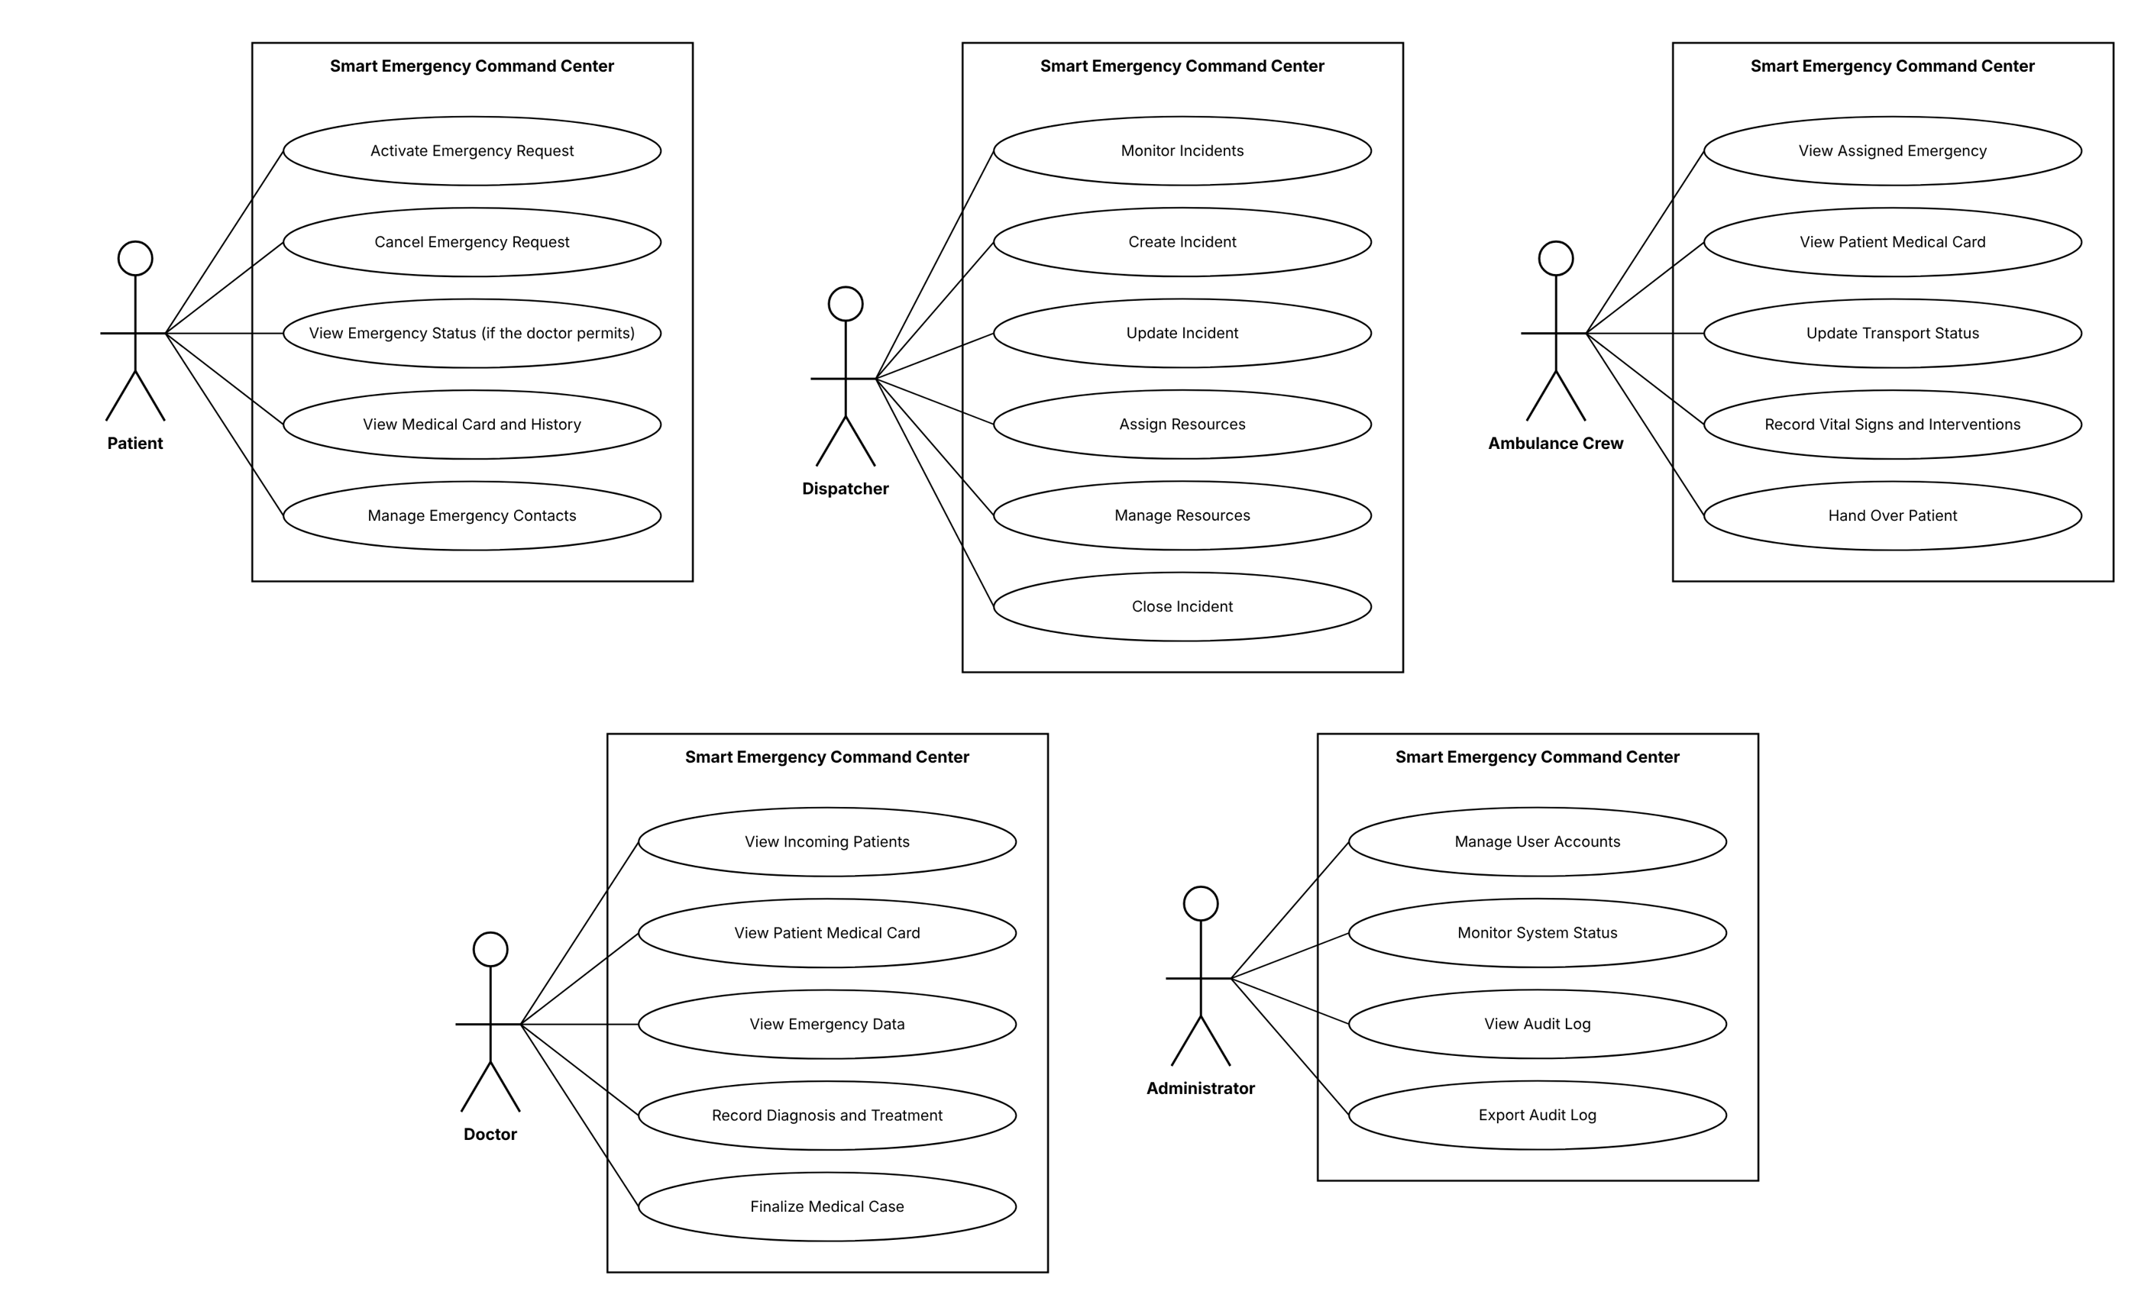
Figure 11. Use case diagrams: Patient, Dispatcher, Ambulance Crew (top), Doctor, Administrator (bottom)
What to notice: each user has a separate set of functions; the Medical Card appears for the patient (read), the crew and the doctor (read and use for treatment), which is the link between the three roles.

5. Architecture and technologies
The system has a three-tier architecture: the web client (React single page application in the browser), the application server (Java / Spring Boot REST API) and the database (Microsoft SQL Server). The client communicates with the server only through HTTP/JSON requests that carry a JWT token; operational screens are refreshed automatically every 5 seconds.
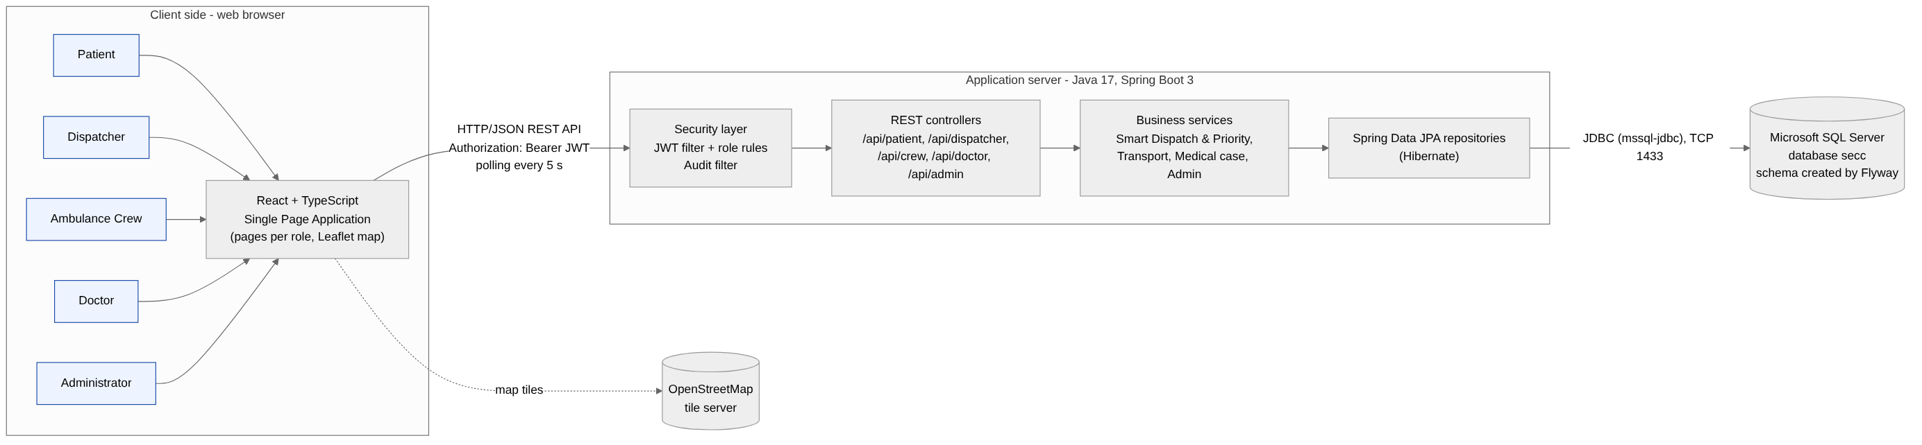
Figure 12. General system architecture
What to notice: the browser never talks to the database directly - every request passes through the security layer of the server, which checks the token and the role before any data is read or written.
- Presentation tier - pages for each role, REST client that adds the JWT token, Leaflet map with OpenStreetMap tiles; no business rules.
- Application tier - security filters (JWT authentication, role rules, audit) → REST controllers (one per role) → services (Smart Dispatch & Priority, transport, medical case, administration) → JPA repositories.
- Data tier - SQL Server database with 13 tables; schema versioned with Flyway and created automatically at the first start.
Layer | Technology | Role in the project
Frontend | React 18 + TypeScript 5 | Single page application, typed access to the API
Frontend | Vite 5 on Node.js, React Router 6 | Development server / build, navigation and route protection by role
Frontend | Leaflet + OpenStreetMap | Map with incidents, resources, hospitals; location selection
Backend | Java 17, Spring Boot 3.3 | REST API, dependency injection, transactions, validation
Backend | Spring Security, JJWT, BCrypt | Login, JWT tokens (8 h), role-based access, password hashing
Backend | Spring Data JPA / Hibernate, Flyway | Object-relational mapping, versioned database schema
Database | Microsoft SQL Server 2022 + SSMS | Persistent storage and administration
Build / tools | Maven, npm, IntelliJ IDEA / VS Code, Git | Build, dependencies, development

Processing of a request
The browser sends the request with Authorization: Bearer <JWT> → the JWT filter loads the user and rejects disabled accounts → the security rules check the role for the path (/api/patient, /api/dispatcher, /api/crew, /api/doctor, /api/admin) → the controller validates the data → the service applies the business rules in a transaction → the result is returned as JSON (errors as 400 / 403 / 404 / 409) → the audit filter writes the request in the log.

6. Flow chart of the emergency process
The flow chart shows the complete handling of an emergency, with the decisions taken by the system (location available, ambulance available) and by the users (cancel, transport needed).
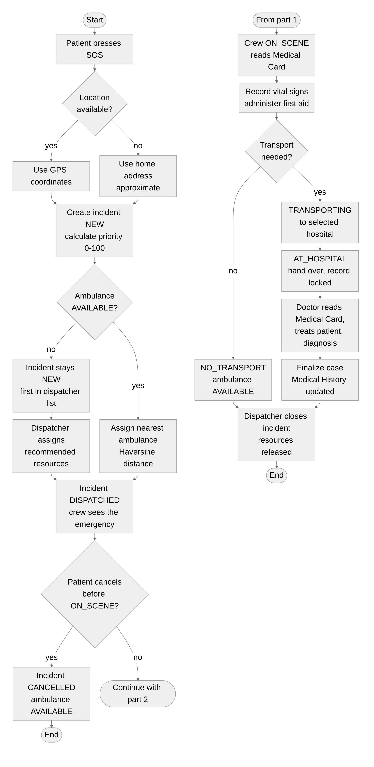
Figure 13. Flow chart: part 1 - request and dispatch (left), part 2 - response, hospital and closing (right)
What to notice: the system decides automatically only where it is safe (location, nearest ambulance); every medical decision - transport, treatment, closing - is taken by a person.

7. Design

7.1 Class diagram
An Incident has several Assignments, each linking it to a Resource. An ambulance Assignment owns the TransportEvents (status timeline), the VitalSigns (Emergency Transport Record) and at most one MedicalCase. A patient User has one MedicalCard, up to five EmergencyContacts and the MedicalHistoryEntries. DispatchService and PriorityCalculator contain the Smart Dispatch logic.
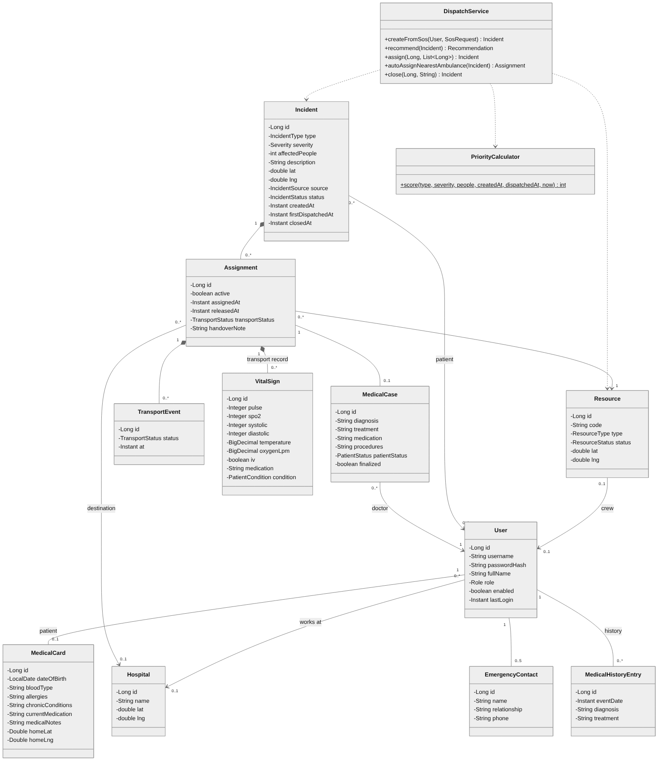
Figure 14. Class diagram
What to notice: Assignment is the central class - it links an incident to a resource and, for an ambulance, holds the whole transport: status timeline, vital signs and the medical case.

7.2 State transitions
The server accepts only the transitions shown below; for example a crew cannot go from ASSIGNED directly to ON_SCENE.
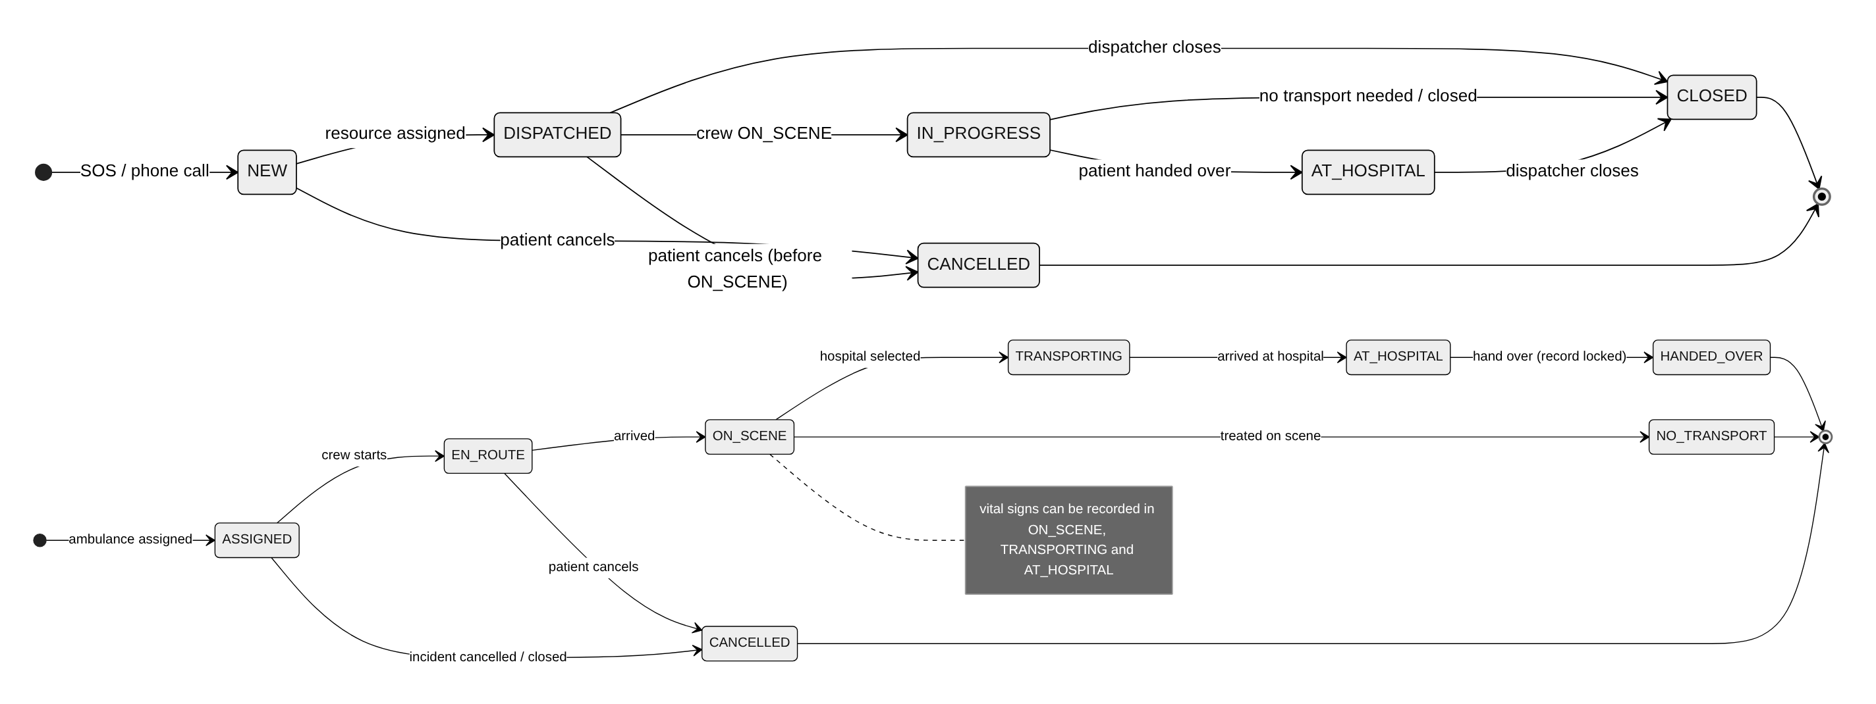
Figure 15. States of an incident (top) and of an ambulance transport (bottom)
What to notice: the two state machines are connected - ON_SCENE moves the incident to IN_PROGRESS and HANDED_OVER moves it to AT_HOSPITAL.

8. Database
The relational schema is normalized: each fact is stored once and the tables are linked through primary and foreign keys. The Medical Card is stored once and read by the patient, the crew and the doctor; the audit_log table records every login and request.
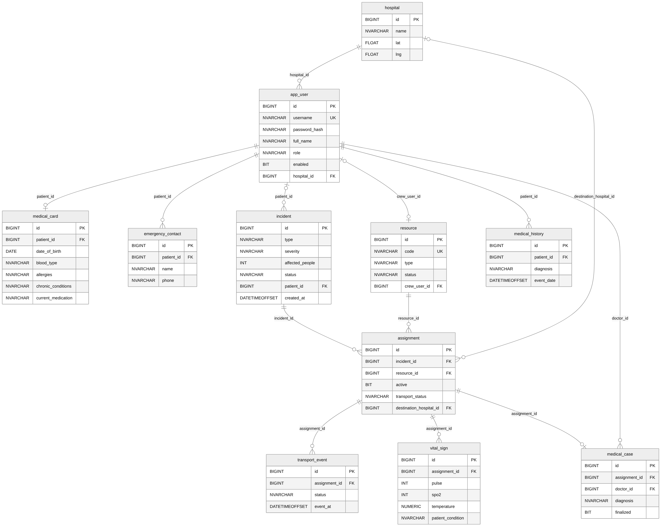
Figure 16. Relational diagram of the database
What to notice: assignment is the table with the most relations; incident, resource, transport_event, vital_sign and medical_case all meet there.

9. Business rules and security
Rule | Definition
Priority score (0-100) | Severity (Low 15, Medium 30, High 45, Critical 60) + 2 points per affected person (max 20) + type (Fire / Building collapse 10, Traffic / Flood 8, Medical 6, Other 4) + 1 point per minute without resources (max 10). Example: critical fire, 12 people, 4 min = 94.
Nearest unit | Straight-line distance with the Haversine formula (R = 6371 km); an SOS request gets the nearest AVAILABLE ambulance automatically.
Recommended resources | Ambulances = people / 4 rounded up (1-3); Fire +1 fire team +1 fire truck; Traffic accident +1 police unit; Building collapse +1 fire team +1 police; Flood +1 fire team.
Concurrency | Selected resources are locked in the database; if another dispatcher took one meanwhile, the assignment is rejected (409).
Vital signs | Accepted ranges: pulse 20-250, SpO2 50-100, systolic 50-260, diastolic 30-160, temperature 30-45. Shown in red: pulse < 50 or > 120, SpO2 < 92, systolic < 90 or > 180, temperature > 38.5.
Security | BCrypt password hashes; JWT token (HMAC-SHA256, 8 h); each /api/<role> path reserved to one role; the user id is taken from the token, never from the request; disabled accounts rejected immediately; every request written in the audit log.

Access rights
Data | Patient | Dispatcher | Crew | Doctor | Admin
Emergency status | R (if permitted) | R | R (assigned) | R (incoming) | -
Incidents, resources | - | R/W | R (own) | R | -
Medical Card | R (own) | - | R | R/W | create empty
Medical History | R (own) | - | - | R/W | -
Vital signs, transport | R (status) | R (status) | R/W | R | -
Diagnosis, medical case | - | - | - | R/W | -
Users, audit log | - | - | - | - | R/W

10. Installation and running
- Requirements: JDK 17+, Maven, Node.js 18+, Microsoft SQL Server and SQL Server Management Studio.
- In SSMS run backend/sql/create_database.sql (creates the database secc and the login secc). Enable SQL Server authentication and TCP/IP on port 1433 (SQL Server Configuration Manager), then restart SQL Server.
- Double-click start.bat: it starts the backend (mvn spring-boot:run, port 8080) and the frontend (npm run dev, port 5173) and opens http://localhost:5173. The tables and the demo data are created automatically.
- Log in with patient1, dispatcher, crew1, doctor1 or admin (password password123).
Portability: the client runs in any modern browser on computers, tablets and phones; the backend is a standard Java application that runs on Windows, Linux or macOS; all connection settings can be changed through environment variables (DB_URL, DB_USER, DB_PASSWORD, JWT_SECRET). Limitations: the map needs internet access and the real-time refresh uses polling every 5 seconds.

11. Glossary
Term | Meaning
Incident | One emergency handled by the system (type, location, severity, people, status).
Priority score | Number from 0 to 100 that tells which incident must be handled first.
Smart Dispatch | The part of the server that calculates the priority and recommends the closest suitable resources.
Resource | A unit that can be sent: ambulance, fire team, fire truck or police unit.
Assignment | The link between an incident and a resource; for an ambulance it also contains the transport.
Medical Card | Emergency medical data of a patient: blood type, allergies, chronic conditions, medication, notes, contacts.
Emergency Transport Record | Vital signs and interventions recorded by the crew; locked at the hand-over.
Haversine formula | Formula that calculates the distance between two GPS points on the Earth.
REST API | The set of web addresses (/api/...) through which the browser talks to the server, using JSON.
JWT token | Signed "digital pass" received at login and sent with every request; it says who the user is and which role he has.
Role-based access | Each user can use only the functions and data of his role.
Flyway | Tool that creates and updates the database tables automatically when the server starts.
Polling | The page asks the server for new data every 5 seconds, so changes appear without reloading.

