SMART EMERGENCY
COMMAND CENTER
Project documentation
Web platform for the coordination of medical emergencies: SOS requests with location, smart dispatch of ambulances, transport records, hospital hand-over and medical history.
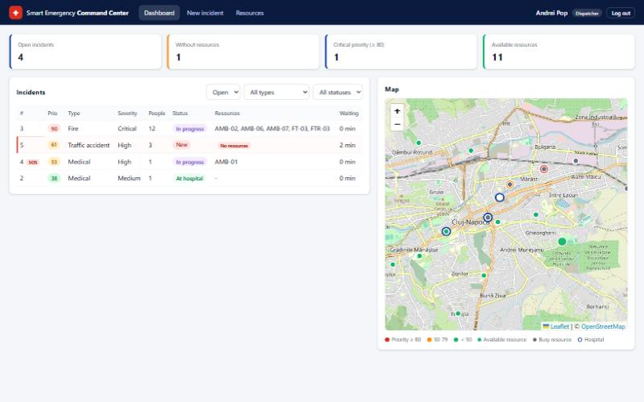
Figure 1. Dispatcher dashboard
Version | 1.0
Date | 06.11.2026
Author | Ariana Daboc
Technologies | React + TypeScript, Java 17 / Spring Boot 3, Microsoft SQL Server
Contents
1 Introduction 4
1.1 Purpose of the system 4
1.2 Overview 4
1.3 Main scenario 4
2 Main features 5
2.1 Emergency request 5
2.2 Medical records 5
2.3 Incident management and Smart Dispatch 5
2.4 Ambulance transport 5
2.5 Hospital 5
2.6 Administration and security 6
3 Users and access rights 7
3.1 User roles 7
3.2 Access rights 8
4 Use cases 10
4.1 Use cases of the Patient 10
4.2 Use cases of the Dispatcher 13
4.3 Use cases of the Ambulance Crew 16
4.4 Use cases of the Doctor 18
4.5 Use cases of the Administrator 20
5 System architecture 22
5.1 Processing of a request 22
6 Flow charts 23
6.1 Main emergency flow 23
6.2 Authentication and authorization 24
6.3 Resource assignment (Smart Dispatch) 25
7 Design (UML diagrams) 27
7.1 Class diagram 27
7.2 Object diagram 28
7.3 Sequence diagram 28
7.4 Activity diagram 29
7.5 State transition diagrams 30
7.6 Package diagram 30
7.7 Communication diagram 31
7.8 Component diagram 31
7.9 Deployment diagram 31
8 Database 33
9 Business rules 35
9.1 Prioritization (triage) - the priority score 35
9.2 Geographic distance and nearest-unit selection 35
9.3 Medical data 35
9.4 Recommended resources 35
9.5 Statuses 35
10 Technologies 36
10.1 Client-server architecture and REST 36
10.2 Authentication, authorization and auditing 36
10.3 Relational databases, ORM and concurrency 37
11 Installation and running 38
11.1 Requirements 38
11.2 Database 38
11.3 Starting the application 38
11.4 Demo accounts 38
12 User guide 39
12.1 Login 39
12.2 Patient 39
12.3 Dispatcher 40
12.4 Ambulance Crew 42
12.5 Doctor 43
12.6 Administrator 44
13 REST API 46
14 Portability and limitations 47
14.1 Client 47
14.2 Server 47
14.3 Database 47
14.4 Limitations 47
15 Glossary 48

1 Introduction

1.1 Purpose of the system
The Smart Emergency Command Center (SECC) is a client-server web application that manages a medical emergency from the moment a patient asks for help until the patient has been treated in a hospital and the medical history has been updated. It connects five types of users - patient, dispatcher, ambulance crew, doctor and administrator - and gives each of them exactly the information needed for their role.
The main objectives are: a fast reaction to every request (automatic assignment of the nearest available ambulance), a correct order of handling (priority score), safe treatment (the crew and the doctor see the Medical Card with the allergies of the patient) and full traceability (statuses with time stamps and an audit log of every operation).

1.2 Overview
The application is a web-based client-server system. The client is a single-page web application written in React and TypeScript (built and served with Node.js/Vite) and runs in the browser. The server is a Java 21 Spring Boot application that exposes a REST API (HTTP + JSON). Every request carries a JWT token that identifies the user and his role. A Microsoft SQL Server database, managed with SQL Server Management Studio, is used for the persistent storage of users, incidents, resources, medical data, transport records and audit logs. The client refreshes the operational screens (incident list, map, emergency status, incoming patients) automatically every 5 seconds.
The application is used by five types of users - patient, dispatcher, ambulance crew, doctor and administrator - each through the same web client, which shows only the screens and data allowed for the user's role. The demonstration data describes the city of Cluj-Napoca: 3 hospitals, 8 ambulances, 3 fire teams, 3 fire trucks and 3 police units.

1.3 Main scenario
The main emergency scenario, in which all the users take part, is:
- Patient presses the SOS button
- GPS location recorded → Incident created → Priority score calculated
- Nearest available ambulance assigned automatically
- Crew views the emergency → En route → On scene
- Vital signs and interventions recorded during transport
- Patient handed over to the hospital
- Doctor views emergency data → Diagnosis and treatment recorded
- Medical case finalized → Medical history updated → Dispatcher closes the incident

2 Main features
The features of the system, grouped by module, are:

2.1 Emergency request
- SOS button that sends the GPS location of the patient (or the home address when location is not available).
- Automatic creation of the incident, calculation of the priority score and assignment of the nearest available ambulance.
- Cancellation of a request sent by mistake, before the crew reaches the scene.
- Emergency status (transport progress, ambulance, distance, hospital), visible to the patient if the doctor permits.

2.2 Medical records
- Medical Card of the patient (blood type, allergies, chronic conditions, medication, notes, contacts).
- Medical History with all the finalized medical cases.
- Management of up to 5 emergency contacts with validation of the phone number.

2.3 Incident management and Smart Dispatch
- List of open incidents ordered by priority, with filters, and map with incidents, resources and hospitals.
- Creation of incidents reported by phone and update of their data (the priority is recalculated).
- Recommendation of resources by incident type and number of affected people (ambulances, fire teams, fire trucks, police units), closest units first.
- Assignment of the recommended or manually selected resources, with protection against double assignment.
- Management of the resources (add, available / out of service) and closing of incidents with release of the resources.

2.4 Ambulance transport
- Display of the assigned emergency and of the patient's Medical Card, with the allergies highlighted.
- Update of the transport status in a fixed order, selection of the destination hospital (nearest pre-selected).
- Emergency Transport Record: vital signs with range validation, interventions, medication, condition; abnormal values in red.
- Hand-over of the patient to the hospital, which locks the record and makes the ambulance available.

2.5 Hospital
- List of incoming patients with estimated arrival time and last recorded condition.
- Consultation of the Medical Card, Medical History, transport timeline and vital signs.
- Recording of the diagnosis and treatment, with a warning when a prescribed medication matches an allergy.
- Option that allows the patient to view the emergency status.
- Finalization of the case, which adds an entry to the Medical History and can update the Medical Card.

2.6 Administration and security
- Management of the user accounts (create, edit, reset password, disable / enable, link to ambulance or hospital).
- System status: uptime, database status and response time, active users, incidents and resources per status.
- Audit log with filters and export to CSV.
- Login with JWT, role-based access to every endpoint, BCrypt password hashing.

3 Users and access rights

3.1 User roles
The use cases of the system are grouped by actor. The patient activates or cancels an emergency, follows its status, consults the medical card and history and manages the emergency contacts. The dispatcher monitors the incidents on a list and on a map, creates and updates incidents, assigns the recommended resources, manages the resources and closes the incidents. The ambulance crew views the assigned emergency and the patient's Medical Card, updates the transport status, records the vital signs and hands the patient over to the hospital. The doctor views the incoming patients and their emergency data, consults the Medical Card, records the diagnosis and treatment and finalizes the medical case, which updates the medical history. The administrator manages the user accounts, monitors the system status, views and exports the audit log.

Patient
The patient is the person who needs emergency medical assistance and uses the web client (computer or phone browser). By pressing the SOS (Emergency/Panic) button, the patient sends his GPS location to the server, which creates an incident and automatically assigns the nearest available ambulance.
Each patient has a Medical Card (personal information, blood type, allergies, chronic conditions, current medication, emergency contacts and medical notes) and a Medical History. The patient can read them, but the medical fields are modified only by doctors. The patient manages his own emergency contacts and can cancel a request sent by mistake.
Use cases:
- Activate Emergency Request
- Cancel Emergency Request
- View Emergency Status (if the doctor permits)
- View Medical Card and History
- Manage Emergency Contacts

Dispatcher
The dispatcher coordinates the emergencies from the command center. He sees all open incidents ordered by priority, both in a table and on a map, creates incidents reported by phone, corrects incident data, assigns ambulances and other resources and closes the finished incidents.
The dispatcher is supported by the Smart Dispatch and Priority System, which calculates a priority score (0-100) for every incident and recommends the closest available resources of the required types. The dispatcher can accept the recommendation or choose the resources manually.
Use cases:
- Monitor Incidents
- Create Incident
- Update Incident
- Assign Resources
- Manage Resources
- Close Incident

Ambulance Crew
The ambulance crew is the medical team of one ambulance; every crew account is linked to exactly one ambulance. The crew sees the emergency assigned to its ambulance and the Medical Card of the patient (blood type, allergies, chronic conditions, current medication, medical notes, emergency contacts), so that it knows what it can safely administer. The crew updates the transport status step by step.
From the moment the crew is on scene it fills the Emergency Transport Record: pulse, SpO2, blood pressure, temperature, oxygen and IV administration, medication administered, other interventions, patient condition and observations. At the hospital the crew hands the patient over, which locks the record and makes the ambulance available again.
Use cases:
- View Assigned Emergency
- View Patient Medical Card
- Update Transport Status
- Record Vital Signs and Interventions
- Hand Over Patient

Doctor
The doctor works at a hospital; every doctor account is linked to one hospital. The doctor sees the patients that are being transported to his hospital and, for each of them, all the data collected during the emergency: Medical Card and History, incident details, transport timeline, vital signs and interventions.
Before treating the patient, the doctor consults the Medical Card (allergies, chronic conditions, current medication) and then administers the necessary treatment. After the patient arrives, the doctor records the diagnosis, treatment, medication, procedures, notes and patient status, and finalizes the case. Finalizing adds an entry to the patient's Medical History and can update the medical fields of the Medical Card.
Use cases:
- View Incoming Patients
- View Patient Medical Card
- View Emergency Data
- Record Diagnosis and Treatment
- Finalize Medical Case

Administrator
The administrator is responsible for the technical administration of the system. He creates, modifies and disables user accounts, links crew accounts to ambulances and doctor accounts to hospitals, monitors the system status and consults and exports the audit log.
The administrator does not take part in the emergency process itself; he only ensures that the right people have the right accounts and that the system works correctly.
Use cases:
- Manage User Accounts
- Monitor System Status
- View Audit Log
- Export Audit Log

3.2 Access rights
The access rights of every actor are summarized below (R = read, W = write/modify, - = no access). The rights are enforced by the server, not only by the user interface.
Data / function | Patient | Dispatcher | Ambulance Crew | Doctor | Admin
SOS request, cancel own request | R/W (own) | - | - | - | -
Emergency status | R (own, if the doctor permits) | R (all) | R (assigned) | R (incoming) | -
Incidents (create, update, close) | - | R/W | R (assigned) | R (incoming) | -
Resources | - | R/W | R (own ambulance) | - | R (link crew)
Assign resources | - | W | - | - | -
Medical Card | R (own) | - | R (assigned patient) | R/W (incoming patient) | W (empty card at account creation)
Medical History | R (own) | - | - | R/W (add entry) | -
Emergency contacts | R/W (own) | - | R | R | -
Transport status | R | R | R/W | R | -
Vital signs / transport record | - | - | R/W (until hand-over) | R | -
Diagnosis, treatment, medical case | - | - | - | R/W | -
User accounts | - | - | - | - | R/W
System status, audit log, CSV export | - | - | - | - | R

- The identity of the user is always taken from the JWT token, never from a request parameter, so a patient cannot request another patient's card.
- A crew account is linked to exactly one ambulance and sees only the emergency assigned to it; a doctor is linked to one hospital and sees only the patients transported there.
- A disabled account is rejected at the next request, even if its token has not expired.

4 Use cases
For each user role a use case diagram is presented, followed by the description of every use case: precondition, postcondition, main flow and alternative flows (exceptions).

4.1 Use cases of the Patient
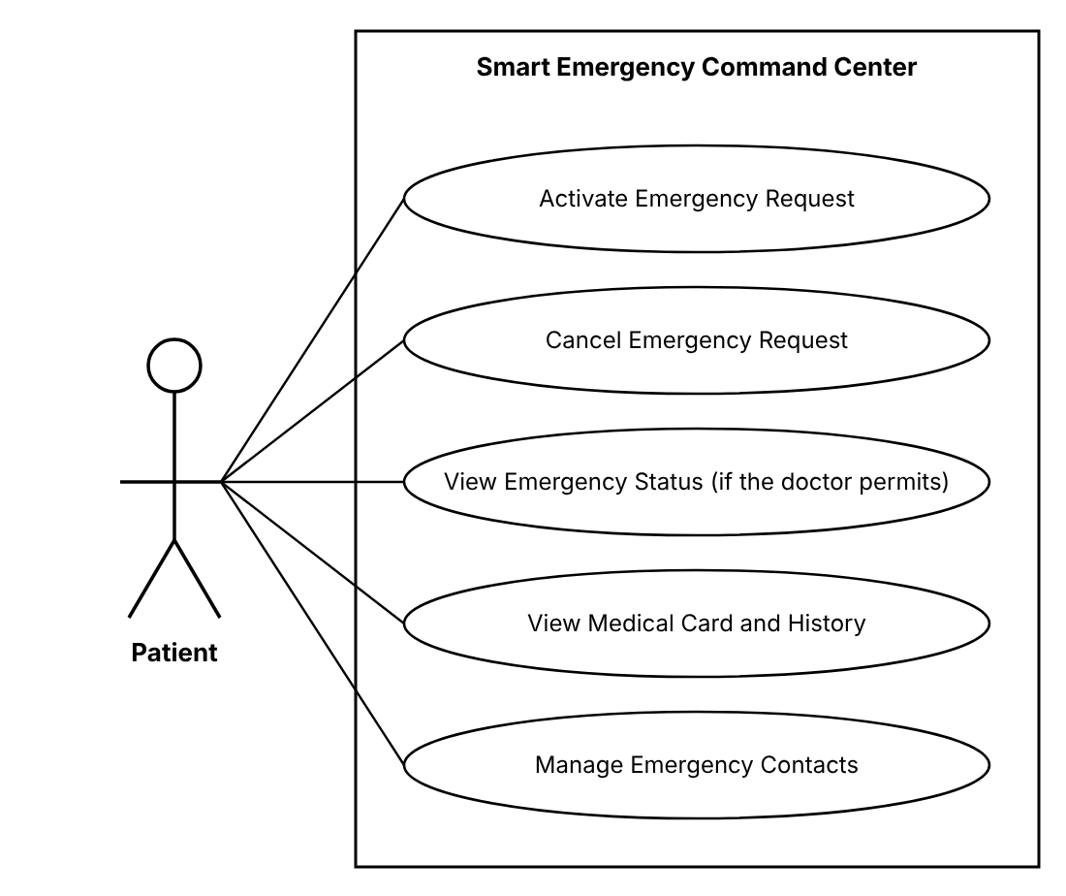
Figure 2. Use case diagram - Patient

Activate Emergency Request
Actor | Patient
Precondition | The patient is logged in and has no other open emergency (status NEW, DISPATCHED or IN_PROGRESS).
Postcondition | An incident with source SOS exists, containing the patient's location and the priority score. If an ambulance was available, it is assigned to the incident and its crew sees the emergency.
Main flow:
- The patient presses the red SOS button on the home screen. Optionally, he selects the emergency type (Medical, Fire, Traffic accident, Other) and writes a short note (max. 500 characters).
- The client reads the current location (latitude, longitude) from the browser geolocation service and sends the request to the server.
- The server creates the incident with status NEW, severity HIGH, 1 affected person and links it to the patient.
- The server calculates the priority score of the incident (see Priority score in the Glossary).
- The server selects, from the ambulances with status AVAILABLE, the one with the smallest distance to the patient and assigns it: the ambulance becomes BUSY, the transport status becomes ASSIGNED and the incident becomes DISPATCHED.
- The patient sees a confirmation screen with the incident number, the assigned ambulance and its distance in km.
Alternative flows / exceptions:
- Location access denied by the browser: the server uses the home location saved in the patient's profile and marks the location as approximate.
- No ambulance available: the incident remains NEW, appears at the top of the dispatcher's list marked "No resources", and the patient is informed that a dispatcher will handle the request.
- The patient already has an open emergency: the request is rejected and the patient is redirected to View Emergency Status (if the doctor permits).

Cancel Emergency Request
Actor | Patient
Precondition | The patient has an open emergency and the crew has not reached the scene yet (transport status ASSIGNED or EN_ROUTE, or no ambulance assigned).
Postcondition | The incident has status CANCELLED and the assigned ambulance is AVAILABLE again.
Main flow:
- On the emergency status screen the patient presses "Cancel request".
- The client asks for confirmation and for a reason (False alarm / Help no longer needed).
- The server sets the incident status to CANCELLED, stores the reason and the time, and releases the assigned ambulance (status AVAILABLE).
- At the next refresh, the dispatcher and the crew see the incident as cancelled.
Alternative flows / exceptions:
- The crew is already on scene (ON_SCENE or later): the button is not displayed and the server rejects the request with the message "The emergency can no longer be cancelled".

View Emergency Status (if the doctor permits)
Actor | Patient
Precondition | The patient is logged in and the doctor who handles the case has allowed the patient to view the emergency status.
Postcondition | -
Main flow:
- The patient opens the "My emergency" screen; the client refreshes the data every 5 seconds.
- The server checks that the doctor has allowed the access (the "Patient can view status" option of the case).
- The server returns the open emergency of the patient: incident number, status, priority score, creation time, assigned ambulance, transport status, distance of the ambulance to the patient and destination hospital (after the transport has started).
- The client displays the transport progress: Assigned → En route → On scene → Transporting → At hospital → Handed over.
Alternative flows / exceptions:
- The doctor has not allowed the access yet: the screen shows only the message "Your request was received. The status will be available after the doctor allows it."
- The patient has no open emergency: the screen shows the SOS button and the list of previous emergencies with their final status.

View Medical Card and History
Actor | Patient
Precondition | The patient is logged in.
Postcondition | -
Main flow:
- The patient opens the "Medical card" screen.
- The server identifies the patient from the JWT token (not from a parameter of the request), so a patient can only read his own card.
- The client displays the Medical Card: full name, date of birth, blood type, allergies, chronic conditions, current medication, emergency contacts and medical notes.
- Below the card, the Medical History is displayed as a list ordered by date (newest first). Each entry contains the date, hospital, doctor, diagnosis, treatment and the related incident number.
Alternative flows / exceptions:
- No medical history yet: the message "No medical events recorded" is displayed.
- The card is read-only for the patient; the medical fields are changed only by a doctor (Finalize Medical Case).

Manage Emergency Contacts
Actor | Patient
Precondition | The patient is logged in.
Postcondition | The emergency contacts of the patient are updated in the database.
Main flow:
- The patient opens the "Emergency contacts" screen, which lists the contacts (name, relationship, phone).
- Add: the patient fills in name, relationship and phone number and presses Save.
- Edit: the patient changes the fields of a contact and presses Save.
- Delete: the patient presses Delete and confirms.
- The server validates the data (name not empty, phone with 8-15 digits, optional leading +, at most 5 contacts) and saves the change.
Alternative flows / exceptions:
- Invalid data: the wrong field is highlighted with an error message and nothing is saved.
- 5 contacts already exist: the Add button is disabled.

4.2 Use cases of the Dispatcher
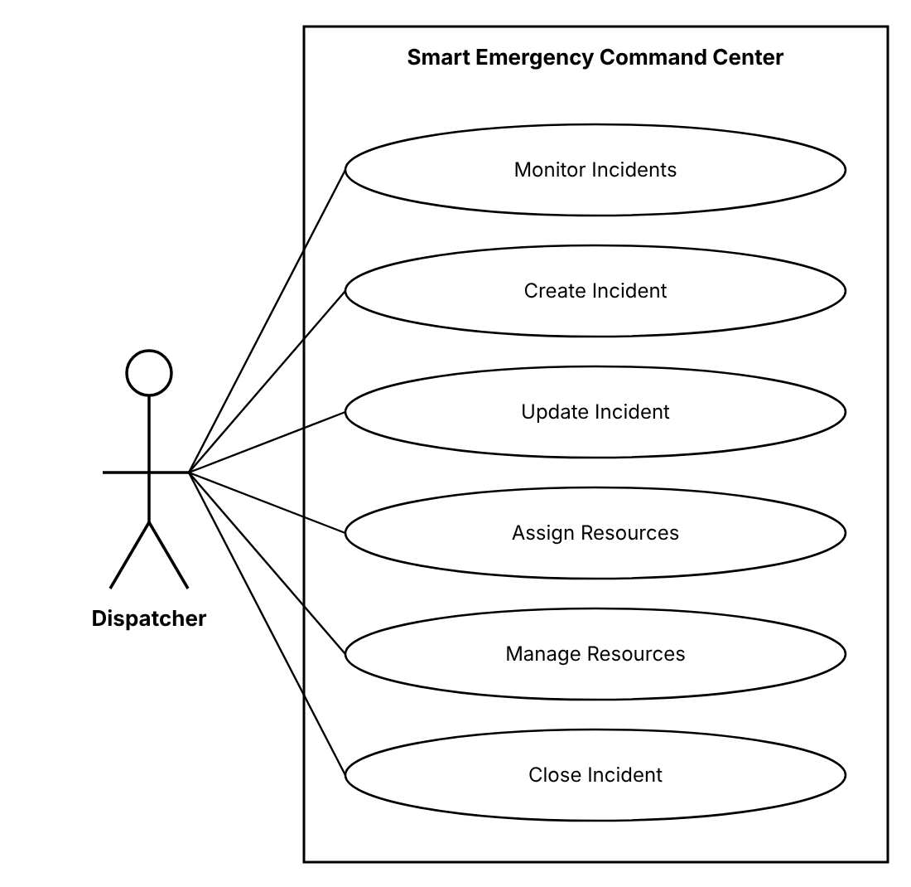
Figure 3. Use case diagram - Dispatcher

Monitor Incidents
Actor | Dispatcher
Precondition | The dispatcher is logged in.
Postcondition | -
Main flow:
- The dispatcher opens the Dashboard; the client refreshes it every 5 seconds.
- The left side shows the table of open incidents ordered by priority score (descending): number, type, severity, affected people, priority score (red ≥ 80, orange 50-79, green < 50), status, assigned resources and waiting time.
- The right side shows the map with the incidents (colored by priority), the resources (green = available, grey = busy) and the hospitals.
- The dispatcher can filter the table by status and type and can click an incident (row or marker) to open its details.
Alternative flows / exceptions:
- Incidents without assigned resources are marked "No resources" so that they are handled first.

Create Incident
Actor | Dispatcher
Precondition | The dispatcher is logged in. The emergency was reported outside the SOS button (e.g. by phone).
Postcondition | A new incident with status NEW, a priority score and a list of recommended resources exists in the database.
Main flow:
- The dispatcher presses "New incident" and fills in: type (Medical, Fire, Traffic accident, Building collapse, Flood, Other), severity (Low, Medium, High, Critical), number of affected people, description and location (click on the map).
- Optionally, he links a registered patient by searching his name.
- The server validates the data and saves the incident with status NEW and source PHONE.
- The server calculates the priority score and the recommended resources.
- The client opens the incident details, where the dispatcher can continue with Assign Resources.
Alternative flows / exceptions:
- Missing type, severity or location, or affected people < 1: the client shows the validation errors and nothing is saved.

Update Incident
Actor | Dispatcher
Precondition | The incident exists and its status is not CLOSED or CANCELLED.
Postcondition | The new incident data is saved and the priority score is recalculated.
Main flow:
- The dispatcher opens the incident and presses Edit.
- He changes the type, severity, number of affected people, description or location.
- The server validates the data, saves it, recalculates the priority score and the recommended resources.
- The change is written in the audit log (user, time).
Alternative flows / exceptions:
- The incident is closed or cancelled: the Edit button is disabled and the server rejects the change.

Assign Resources
Actor | Dispatcher
Precondition | The incident is open (NEW, DISPATCHED or IN_PROGRESS) and at least one resource is AVAILABLE.
Postcondition | The selected resources are BUSY and linked to the incident, the incident is DISPATCHED and the crew of every assigned ambulance sees the emergency.
Main flow:
- In the incident details the system displays the recommendation of the Smart Dispatch and Priority System:
  - number of ambulances = affected people / 4, rounded up, minimum 1, maximum 3;
  - Fire: + 1 fire team and 1 fire truck; Traffic accident: + 1 police unit; Building collapse: + 1 fire team and 1 police unit; Flood: + 1 fire team;
  - for every needed type, the AVAILABLE resources of that type closest to the incident.
- Every recommended resource is shown with its code, type and distance in km.
- The dispatcher presses "Accept recommendation" or selects other resources manually and presses "Assign".
- The server checks again that every selected resource is still AVAILABLE, sets them to BUSY, creates the assignments (ambulances receive transport status ASSIGNED) and sets the incident status to DISPATCHED.
- Example: Incident #1042 (Fire, Critical, 12 affected people, priority 94/100) - recommended: 3 ambulances (AMB-12, AMB-08, AMB-15), Fire Team FT-03 and Fire Truck FTR-04.
Alternative flows / exceptions:
- A selected resource was taken by another dispatcher in the meantime: the server rejects the assignment and the client reloads the recommendation.
- Not enough resources of a type: the recommendation shows what is missing (e.g. "missing: 1 fire truck"); the dispatcher can assign what is available.

Manage Resources
Actor | Dispatcher
Precondition | The dispatcher is logged in.
Postcondition | The resource data or status is updated.
Main flow:
- The dispatcher opens the "Resources" screen: code, type (Ambulance, Fire team, Fire truck, Police unit), status (AVAILABLE, BUSY, OUT_OF_SERVICE), location and current incident.
- Add: he enters a unique code (e.g. AMB-16), the type and the base location (click on the map).
- Change status: he switches a resource between AVAILABLE and OUT_OF_SERVICE (e.g. for maintenance).
Alternative flows / exceptions:
- The resource is BUSY: it cannot be set OUT_OF_SERVICE; the message shows the incident it is assigned to.
- The code already exists: the resource is not saved.

Close Incident
Actor | Dispatcher
Precondition | The incident is open and no ambulance of the incident is still in an active transport status (EN_ROUTE, ON_SCENE, TRANSPORTING, AT_HOSPITAL). Normally the patient has been handed over (incident status AT_HOSPITAL).
Postcondition | The incident is CLOSED, the closing time is saved and all resources still assigned to it are AVAILABLE.
Main flow:
- The dispatcher opens the incident, presses Close and optionally writes a closing note.
- The server checks that no transport is still active.
- The server sets the status CLOSED, saves the closing time and note and releases all remaining resources.
Alternative flows / exceptions:
- A transport is still active: the server rejects the request with the message "Patient transport in progress".

4.3 Use cases of the Ambulance Crew
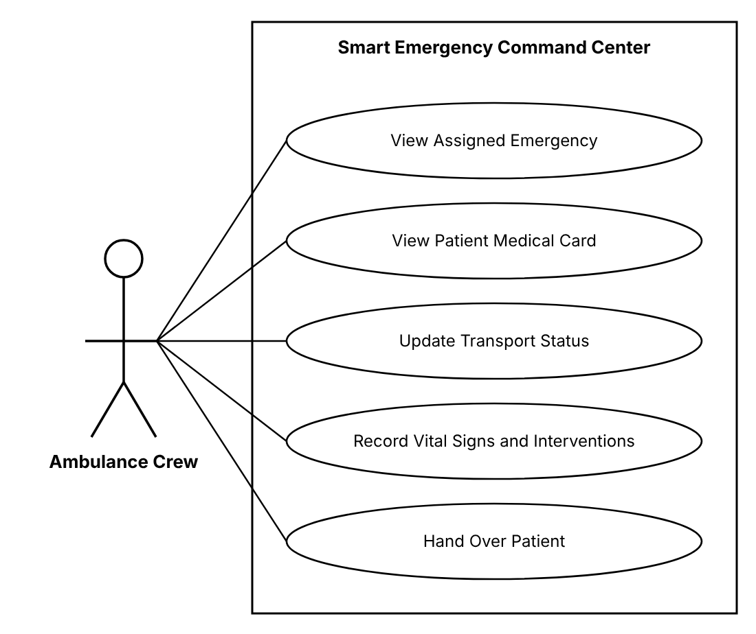
Figure 4. Use case diagram - Ambulance Crew

View Assigned Emergency
Actor | Ambulance Crew
Precondition | The crew member is logged in and his account is linked to an ambulance.
Postcondition | -
Main flow:
- The home screen of the crew refreshes every 5 seconds. When a new assignment appears, a highlighted "NEW EMERGENCY" card is displayed.
- The card contains: incident number, type, severity, priority score, description, location on the map and distance from the ambulance.
- If the incident is linked to a registered patient, the card shows the patient's name and age and a "Medical card" button (see View Patient Medical Card).
Alternative flows / exceptions:
- No active assignment: the screen shows "No active emergency" and the ambulance status.
- Unknown patient (incident created by phone without patient): only the incident data is shown.

View Patient Medical Card
Actor | Ambulance Crew
Precondition | The ambulance has an active assignment for an incident linked to a registered patient.
Postcondition | -
Main flow:
- The crew presses "Medical card" on the assigned emergency (on the way to the patient or on scene).
- The server checks that the ambulance of the crew is assigned to the incident of this patient and returns the Medical Card: full name, age, blood type, allergies, chronic conditions, current medication, medical notes and emergency contacts.
- The allergies are displayed highlighted in red, so that the crew does not administer a medication the patient is allergic to.
- The crew uses this information to decide the first-aid treatment and the medication it administers (recorded in Record Vital Signs and Interventions).
Alternative flows / exceptions:
- The ambulance is not (or no longer) assigned to the incident: the server refuses the access.
- Unknown patient: the message "No medical card - unknown patient" is displayed and the crew treats the patient without it.
- The Medical History is not shown to the crew; it is visible only to doctors.

Update Transport Status
Actor | Ambulance Crew
Precondition | The ambulance has an active assignment.
Postcondition | The new transport status and its time are saved and are visible to the patient, the dispatcher and the doctor.
Main flow:
- The crew presses the button for the next step. The allowed order is: ASSIGNED → EN_ROUTE → ON_SCENE → TRANSPORTING → AT_HOSPITAL (HANDED_OVER is set only by Hand Over Patient).
- When choosing TRANSPORTING, the crew selects the destination hospital; the nearest hospital is pre-selected.
- The server checks that the new status is the next one in the order, saves it with the current time, sets the incident to IN_PROGRESS (from ON_SCENE on) and updates the ambulance location (incident location at ON_SCENE, hospital location at AT_HOSPITAL).
Alternative flows / exceptions:
- Skipping or going back a step: the server rejects the change with "Invalid status transition".
- On scene the patient does not need transport: the crew presses "No transport needed"; the assignment ends, the ambulance becomes AVAILABLE and the dispatcher closes the incident.

Record Vital Signs and Interventions
Actor | Ambulance Crew
Precondition | The transport status is ON_SCENE, TRANSPORTING or AT_HOSPITAL and the record is not locked.
Postcondition | A new measurement is added to the Emergency Transport Record (the record is created automatically at the first measurement).
Main flow:
- Before administering a medication, the crew checks the allergies and the current medication in the patient's Medical Card.
- The crew opens the "Transport record" tab and fills in: pulse (bpm), SpO2 (%), blood pressure (systolic/diastolic, mmHg), temperature (°C), oxygen (l/min, 0 if none), IV (yes/no), medication administered, other interventions, patient condition (Stable, Serious, Critical) and observations.
- The server validates the values (pulse 20-250, SpO2 50-100, systolic 50-260, diastolic 30-160, temperature 30-45) and saves the measurement with the current time.
- The measurements are displayed chronologically; abnormal values are highlighted in red (pulse < 50 or > 120, SpO2 < 92, systolic < 90 or > 180, temperature > 38.5).
Alternative flows / exceptions:
- A value is outside the allowed range: the field is highlighted and nothing is saved.

Hand Over Patient
Actor | Ambulance Crew
Precondition | The transport status is AT_HOSPITAL and at least one measurement was recorded.
Postcondition | The Emergency Transport Record is locked, the transport status is HANDED_OVER, the ambulance is AVAILABLE and the incident status is AT_HOSPITAL. The patient appears as "Arrived" in the doctor's list.
Main flow:
- The crew checks the summary of the transport record and writes a hand-over note for the doctor.
- The crew presses "Hand over to hospital".
- The server locks the record (no further changes), sets the transport status HANDED_OVER, makes the ambulance AVAILABLE and sets the incident status AT_HOSPITAL.
Alternative flows / exceptions:
- No measurement was recorded: the server rejects the hand-over with "Record at least one set of vital signs".

4.4 Use cases of the Doctor
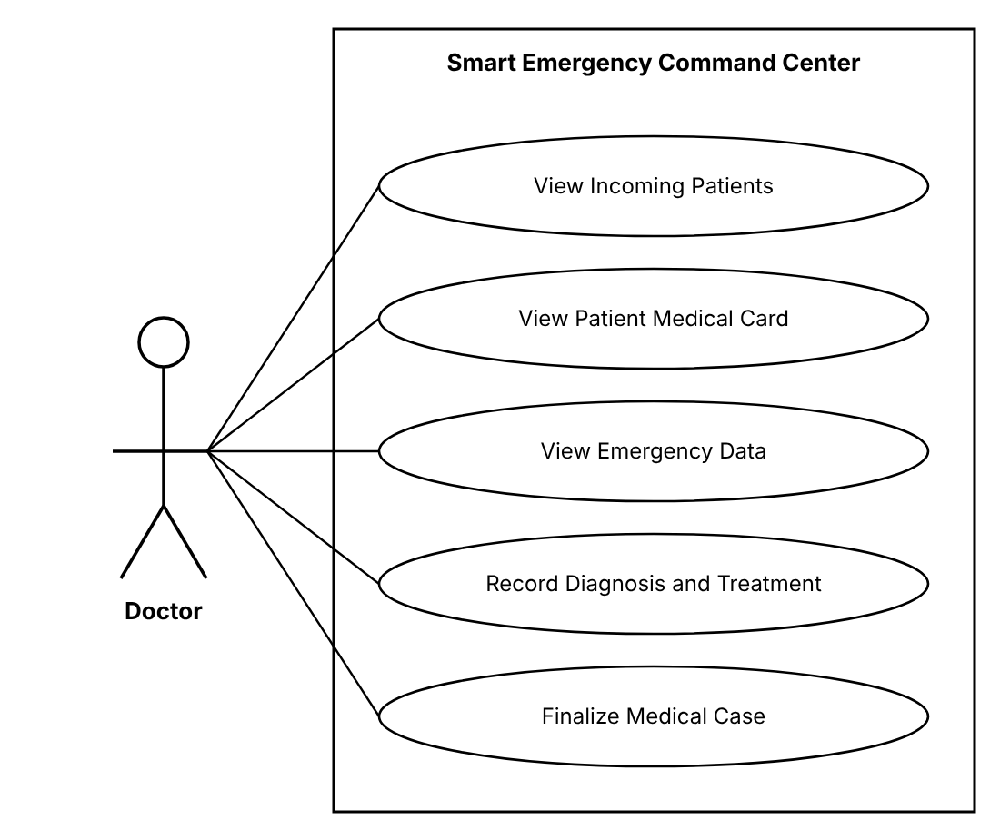
Figure 5. Use case diagram - Doctor

View Incoming Patients
Actor | Doctor
Precondition | The doctor is logged in and his account is linked to a hospital.
Postcondition | -
Main flow:
- The doctor opens the "Incoming patients" screen; the client refreshes it every 5 seconds.
- The server returns the transports whose destination is the doctor's hospital and whose status is TRANSPORTING, AT_HOSPITAL or HANDED_OVER with a medical case that is not finalized.
- Each row shows: patient name (or "Unknown patient"), incident type, priority score, ambulance, transport status, estimated arrival time (distance / 50 km/h) and the last recorded condition.
Alternative flows / exceptions:
- No incoming patients: the message "No incoming patients" is displayed.

View Patient Medical Card
Actor | Doctor
Precondition | The patient is in the incoming list of the doctor's hospital.
Postcondition | -
Main flow:
- The doctor selects a patient from the incoming list and opens the "Medical card" section.
- The server returns the complete Medical Card (date of birth and age, blood type, allergies, chronic conditions, current medication, medical notes, emergency contacts) and the Medical History.
- The allergies are highlighted in red; the doctor uses the card to choose a treatment that is compatible with the allergies, the chronic conditions and the current medication of the patient.
Alternative flows / exceptions:
- Unknown patient: no Medical Card exists; the doctor treats the patient based only on the emergency data.
- A doctor of another hospital tries to open the card: the server refuses the access.

View Emergency Data
Actor | Doctor
Precondition | The patient is in the incoming list of the doctor's hospital.
Postcondition | -
Main flow:
- The doctor selects a patient from the list.
- The server returns: incident details, ambulance and transport status timeline (with times), all vital-sign measurements and interventions and the hand-over note.
- The vital signs are displayed as a table, with abnormal values in red.
Alternative flows / exceptions:
- A doctor of another hospital tries to open the data: the server refuses the access.

Record Diagnosis and Treatment
Actor | Doctor
Precondition | The patient was handed over (transport status HANDED_OVER) and the medical case is not finalized.
Postcondition | The medical case of the incident is saved (it can still be modified).
Main flow:
- Based on the Medical Card and on the emergency data, the doctor examines the patient and administers the necessary treatment.
- The doctor fills in: diagnosis (mandatory), treatment, medication prescribed, medical procedures, doctor's notes and patient status (Admitted, Discharged, Transferred, Deceased).
- The doctor decides whether the patient may see the emergency status and checks or unchecks the "Patient can view status" option (see View Emergency Status (if the doctor permits)).
- The doctor presses Save; the server validates and saves the medical case.
- The case can be modified again until it is finalized.
Alternative flows / exceptions:
- The diagnosis is empty: the case is not saved.
- A prescribed medication appears in the allergies of the patient: the client shows a warning before saving.

Finalize Medical Case
Actor | Doctor
Precondition | The medical case of the patient has a diagnosis.
Postcondition | A new entry exists in the patient's Medical History, the case is read-only and the incident is ready to be closed by the dispatcher.
Main flow:
- Optionally, the doctor updates the medical fields of the Medical Card (allergies, chronic conditions, current medication), which are pre-filled with the current values.
- The doctor presses "Finalize".
- The server creates the Medical History entry (date, hospital, doctor, diagnosis, treatment, incident number), saves the Medical Card changes and marks the case as finalized.
- The patient sees the new entry in his history; the dispatcher sees the incident as ready to close.
Alternative flows / exceptions:
- Unknown patient (no account): no history entry is created; the case remains attached to the incident only.

4.5 Use cases of the Administrator
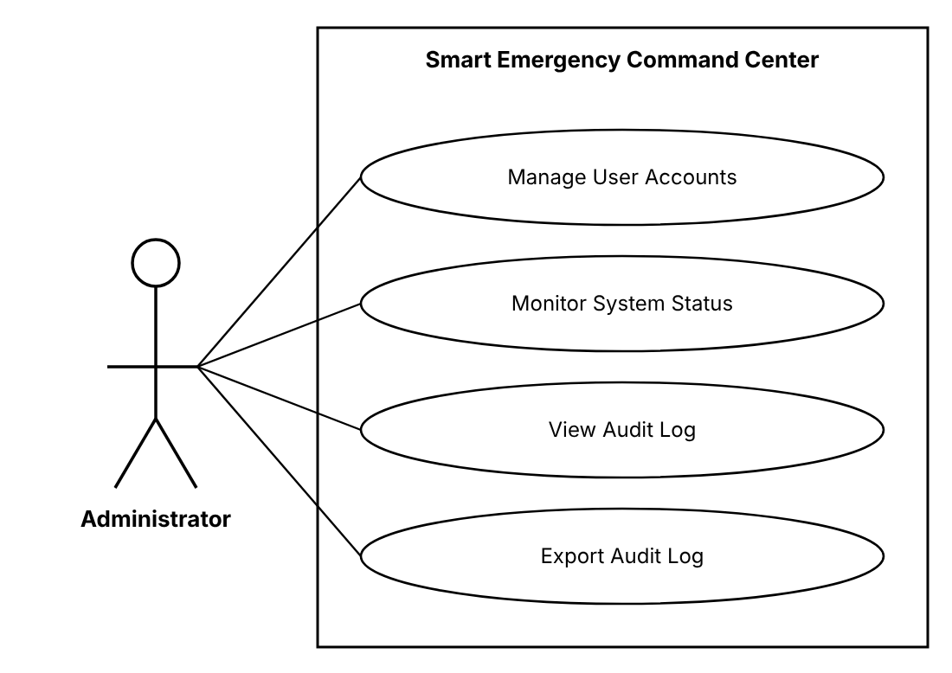
Figure 6. Use case diagram - Administrator

Manage User Accounts
Actor | Administrator
Precondition | The administrator is logged in.
Postcondition | The user accounts are created, modified, disabled or enabled.
Main flow:
- The administrator opens the "Users" screen: username, full name, role, status (Active, Disabled) and last login.
- Create: he enters username, full name, password (min. 8 characters) and role. For a crew account he selects the ambulance, for a doctor the hospital; for a patient an empty Medical Card is created.
- Edit: he changes the full name, the linked ambulance/hospital or resets the password.
- Disable / Enable: a disabled user cannot log in anymore and his current token is rejected at the next request. Accounts are never deleted, so that the history data remains consistent.
Alternative flows / exceptions:
- The username already exists: the account is not created.
- The administrator tries to disable his own account: the request is rejected.

Monitor System Status
Actor | Administrator
Precondition | The administrator is logged in.
Postcondition | -
Main flow:
- The administrator opens the "System status" screen; it is refreshed every 10 seconds.
- The server returns: uptime, application version, database status (OK / ERROR) and response time, number of active users (users with requests in the last 5 minutes), incidents per status and resources per status.
- The client displays the values as cards.
Alternative flows / exceptions:
- The database does not respond: the database card is shown in red with status ERROR.

View Audit Log
Actor | Administrator
Precondition | The administrator is logged in.
Postcondition | -
Main flow:
- The administrator opens the "Audit log" screen.
- The server returns the log entries, newest first, 50 per page: time, username, IP address, action (LOGIN, LOGIN_FAILED, REQUEST), HTTP method and path, response status and duration (ms).
- The administrator can filter by username, action and time interval.
Alternative flows / exceptions:
- No entries match the filter: an empty list is displayed.

Export Audit Log
Actor | Administrator
Precondition | The administrator is on the Audit log screen.
Postcondition | A CSV file with the filtered log entries is downloaded.
Main flow:
- The administrator sets the filters (optional) and presses "Export CSV".
- The server generates a CSV file with a header row and all the entries that match the filters.
- The browser downloads the file audit-log_<date>.csv.
Alternative flows / exceptions:
- No entries match the filters: the file contains only the header row.

5 System architecture
The system has a three-tier architecture: presentation tier (web client), application tier (Spring Boot server) and data tier (SQL Server database).
- Presentation tier: React + TypeScript single page application. It contains a page set for each role, a REST client that adds the JWT token to every request, an authentication context and the map component. It holds no business rules.
- Application tier: Spring Boot application organised in layers - security filters (JWT authentication, audit), REST controllers (one per role), business services (Smart Dispatch and Priority, transport, medical case, administration) and JPA repositories.
- Data tier: SQL Server database secc with 13 tables. The schema is versioned with Flyway and created automatically at the first start; demo data is inserted by the DataSeeder.
- External service: OpenStreetMap tile servers provide the map images directly to the browser.
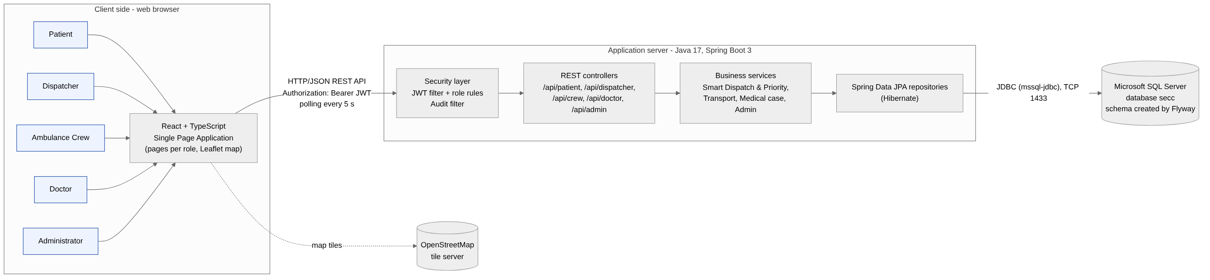
Figure 7. General system architecture

5.1 Processing of a request
- The user performs an action in the browser (for example presses SOS).
- The React client sends an HTTP request with JSON body and the header Authorization: Bearer <JWT>.
- In development, the Vite server forwards every /api request to the backend on port 8080.
- The JWT filter validates the token, loads the user from the database and rejects disabled accounts; the security rules check the role for the requested path.
- The controller validates the request body (Bean Validation) and calls the service.
- The service applies the business rules inside a transaction and uses the repositories to read and write the database.
- The result is converted to a DTO and returned as JSON; errors are returned as {"message": ...} with the proper HTTP status (400, 403, 404, 409).
- The audit filter writes the request in the audit log.

6 Flow charts
The flow charts describe in detail the main flows of the system.

6.1 Main emergency flow
The flow chart shows the complete processing of an emergency, from the SOS request to the closing of the incident, including the decisions taken by the system and by the users.
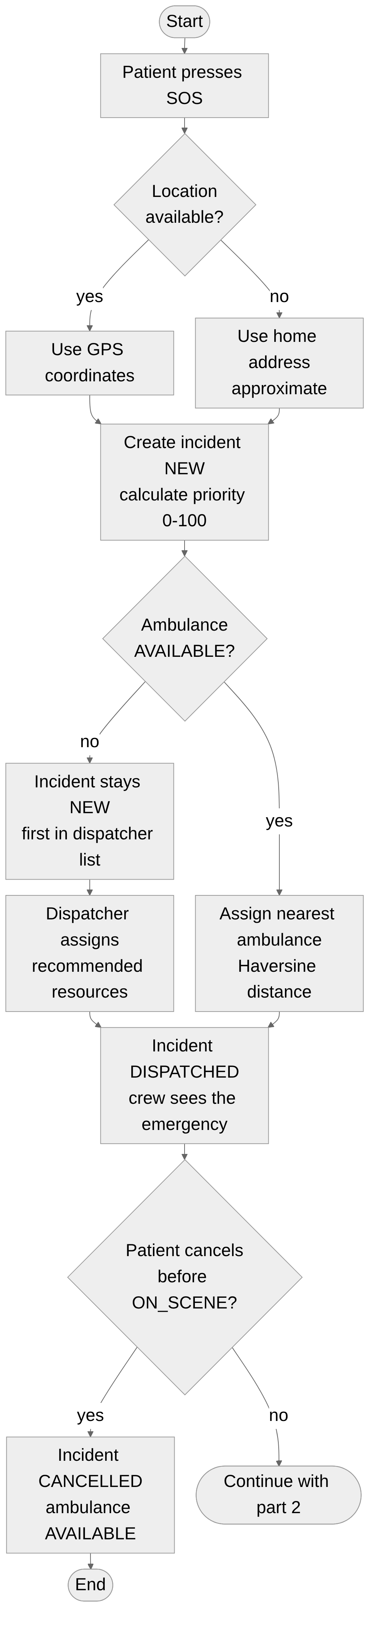
Figure 8. Main flow - part 1: emergency request and dispatch
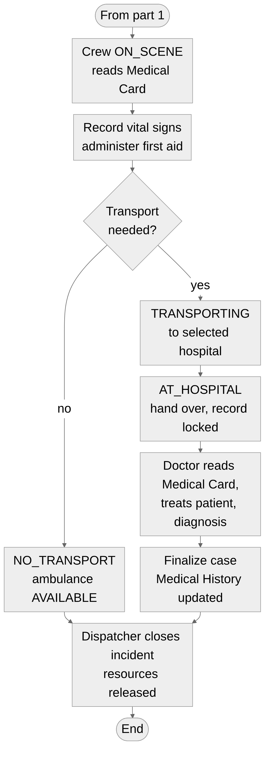
Figure 9. Main flow - part 2: response, hospital and closing

6.2 Authentication and authorization
The flow chart shows how a user enters the application and how every later request is checked: validation of the saved token, login with BCrypt password check, creation of the JWT token, verification of the role for each API path and writing of the audit log.
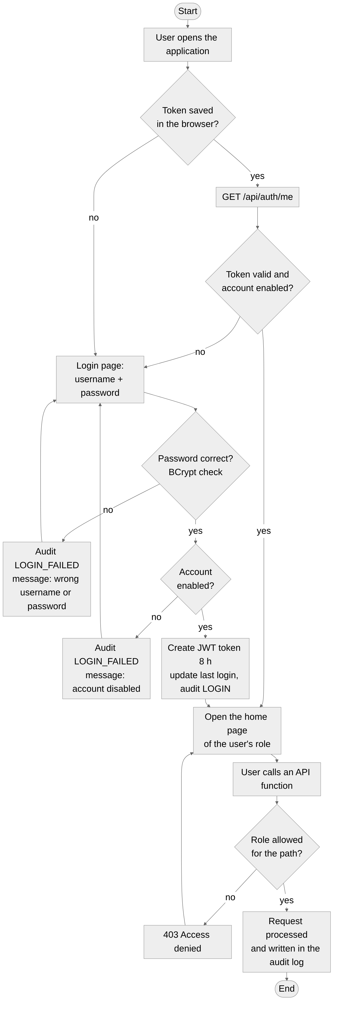
Figure 10. Login and access control

6.3 Resource assignment (Smart Dispatch)
The flow chart details the Smart Dispatch process: calculation of the needed resources, selection of the closest available units, the decision of the dispatcher and the protection against assigning the same resource twice.
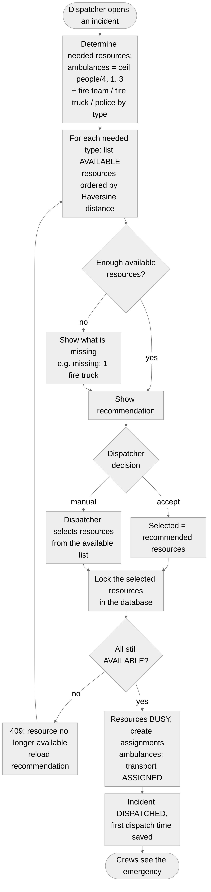
Figure 11. Recommendation and assignment of resources

7 Design (UML diagrams)
The structure and the behaviour of the system are described with the following UML diagrams.

7.1 Class diagram
The class diagram shows the domain entities (mapped to database tables), their attributes and the relations between them, together with the main service classes. An Incident has several Assignments, each linking it to a Resource; an ambulance Assignment owns the TransportEvents (status timeline), the VitalSigns (Emergency Transport Record) and at most one MedicalCase. A patient User has one MedicalCard, up to five EmergencyContacts and the MedicalHistoryEntries.
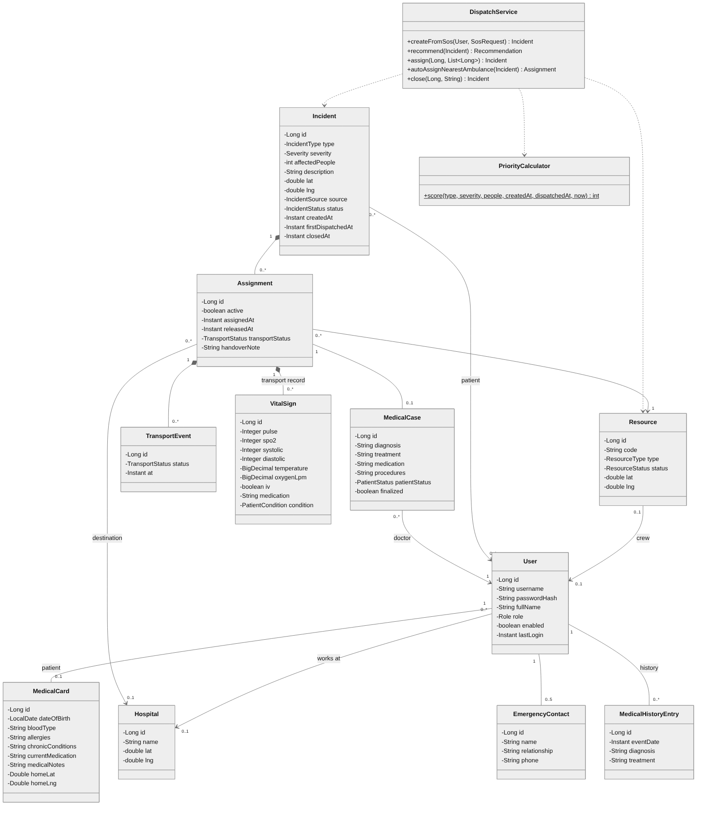
Figure 12. Class diagram

7.2 Object diagram
The object diagram shows a snapshot of the system during the transport of patient Ion Popescu: incident #7 is IN_PROGRESS, ambulance AMB-01 (crew1) is TRANSPORTING the patient to the County Emergency Hospital, where doctor1 works, and a first measurement with abnormal values was recorded.
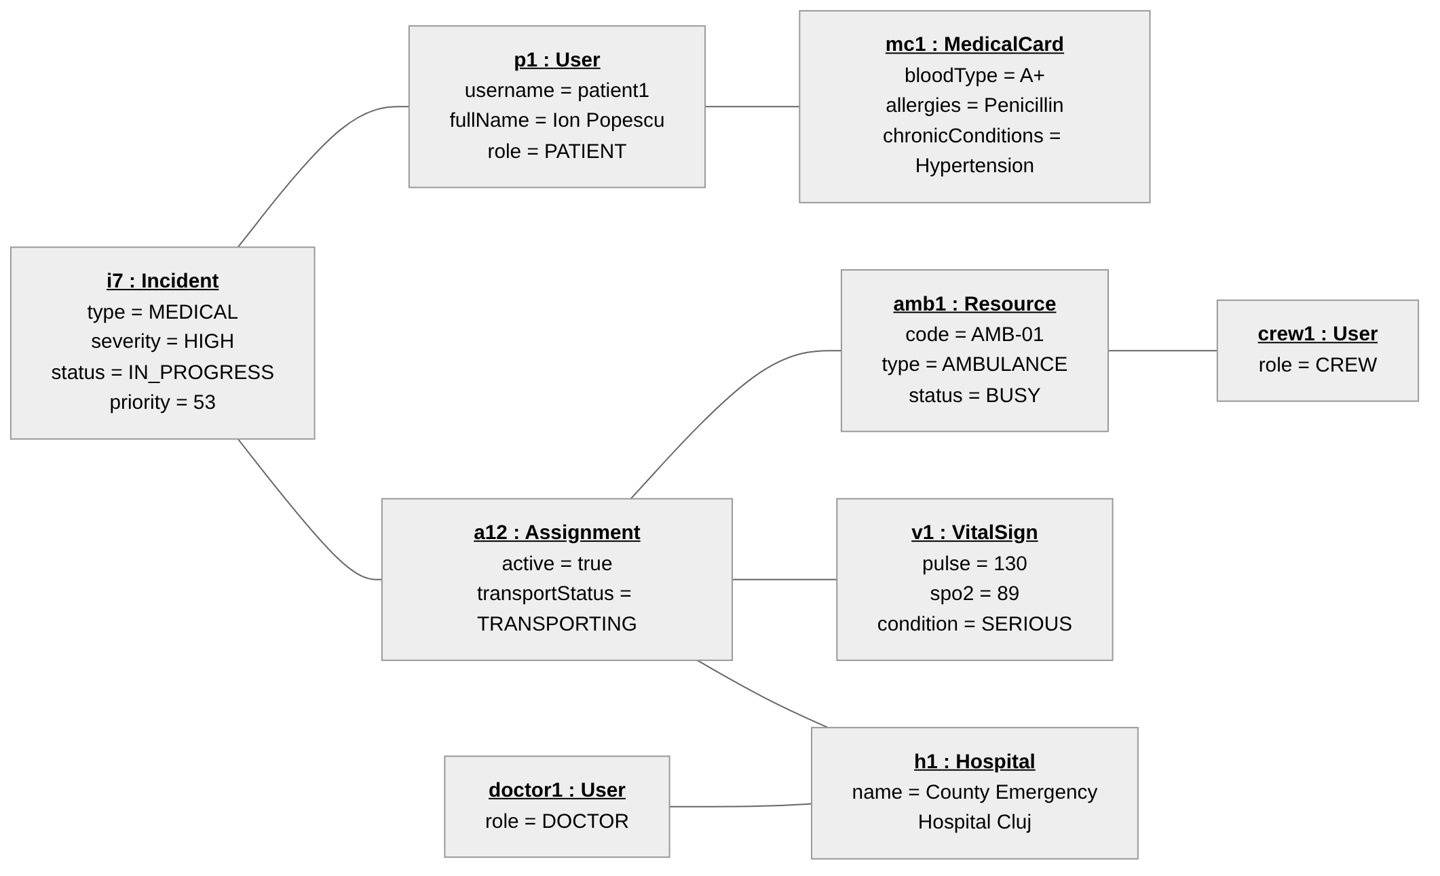
Figure 13. Object diagram - transport of a patient

7.3 Sequence diagram
The sequence diagram describes the use case Activate Emergency Request: the messages exchanged between the patient, the React client, the controller, the dispatch service, the priority calculator, the repositories and the database, until the confirmation is displayed and the crew receives the emergency at its next refresh.
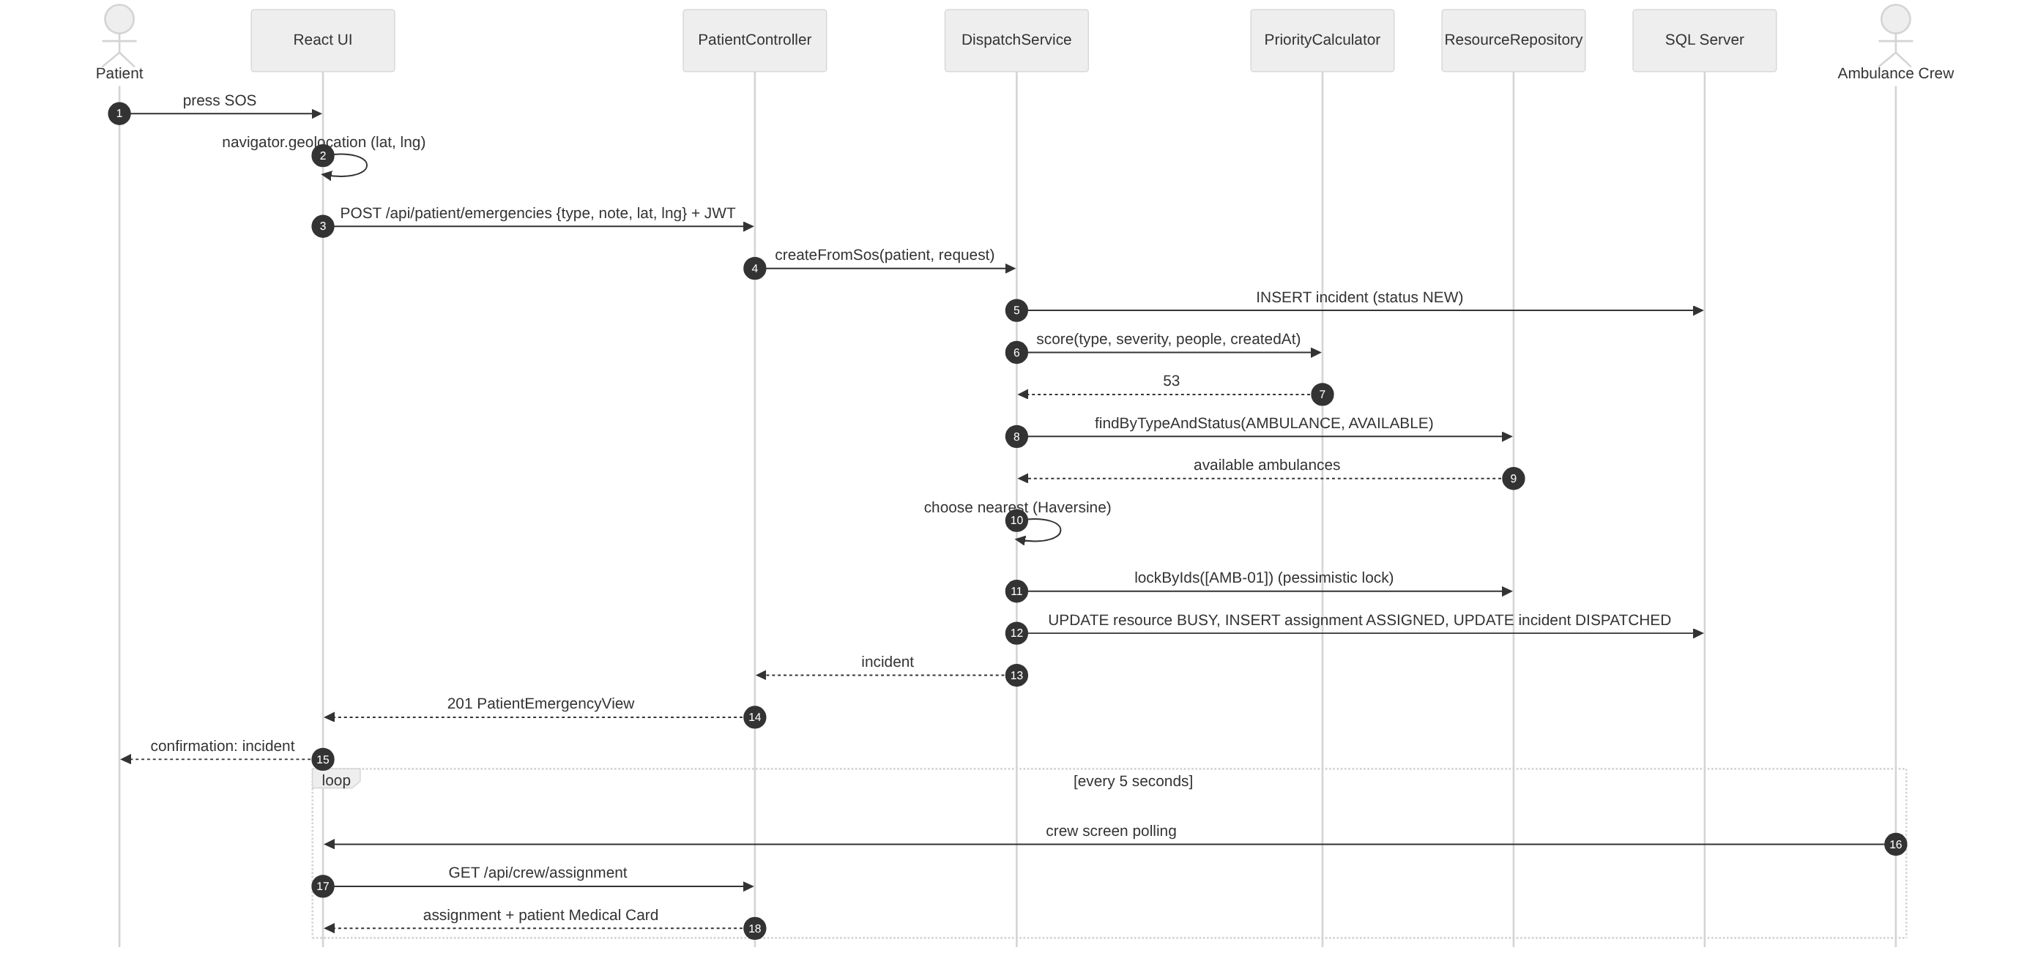
Figure 14. Sequence diagram - Activate Emergency Request

7.4 Activity diagram
The activity diagram presents the activities of the ambulance crew, the doctor and the dispatcher (swim lanes) after an ambulance has been assigned, including the decisions "transport needed?" and "allow the patient to view the status?".
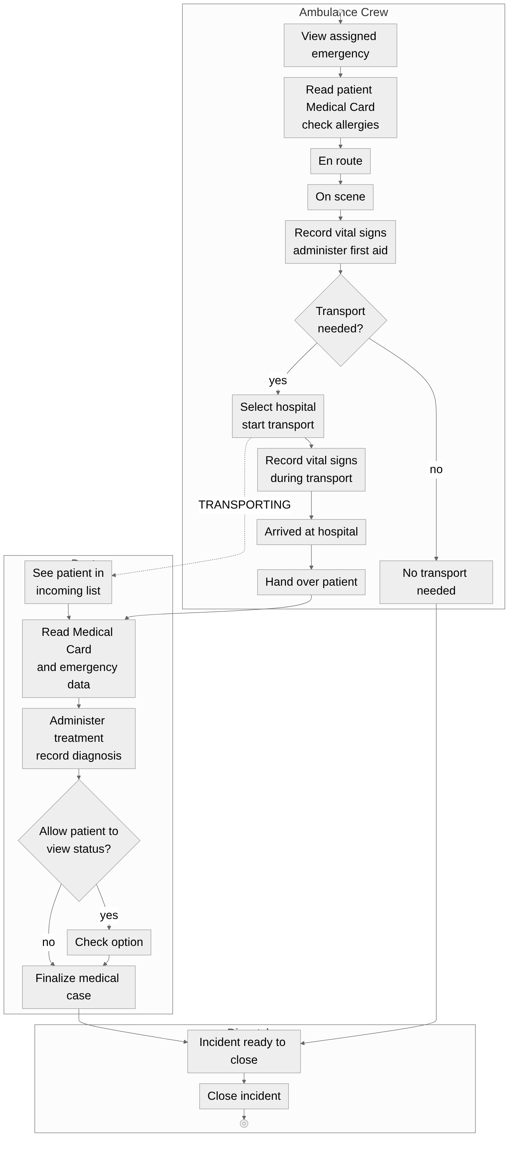
Figure 15. Activity diagram - handling of the patient

7.5 State transition diagrams
The first diagram shows the states of an incident, the second one the states of an ambulance assignment (transport status). The server rejects every transition that is not shown in the diagrams (for example skipping from ASSIGNED directly to ON_SCENE).
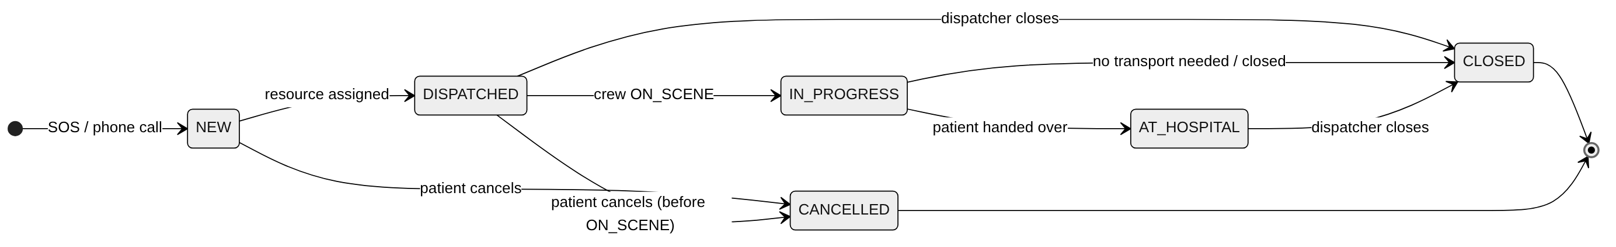
Figure 16. State transition diagram - incident status
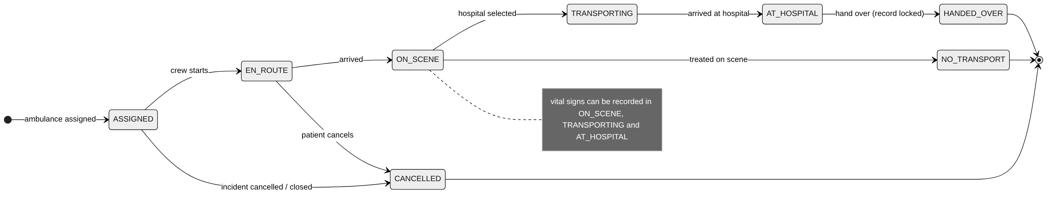
Figure 17. State transition diagram - transport status

7.6 Package diagram
The package diagram shows the organisation of the source code. The backend packages follow the layers web → service → repo → domain; config contains security, JWT, audit and demo data. The frontend is organised in pages, components, the API client and the shared types.
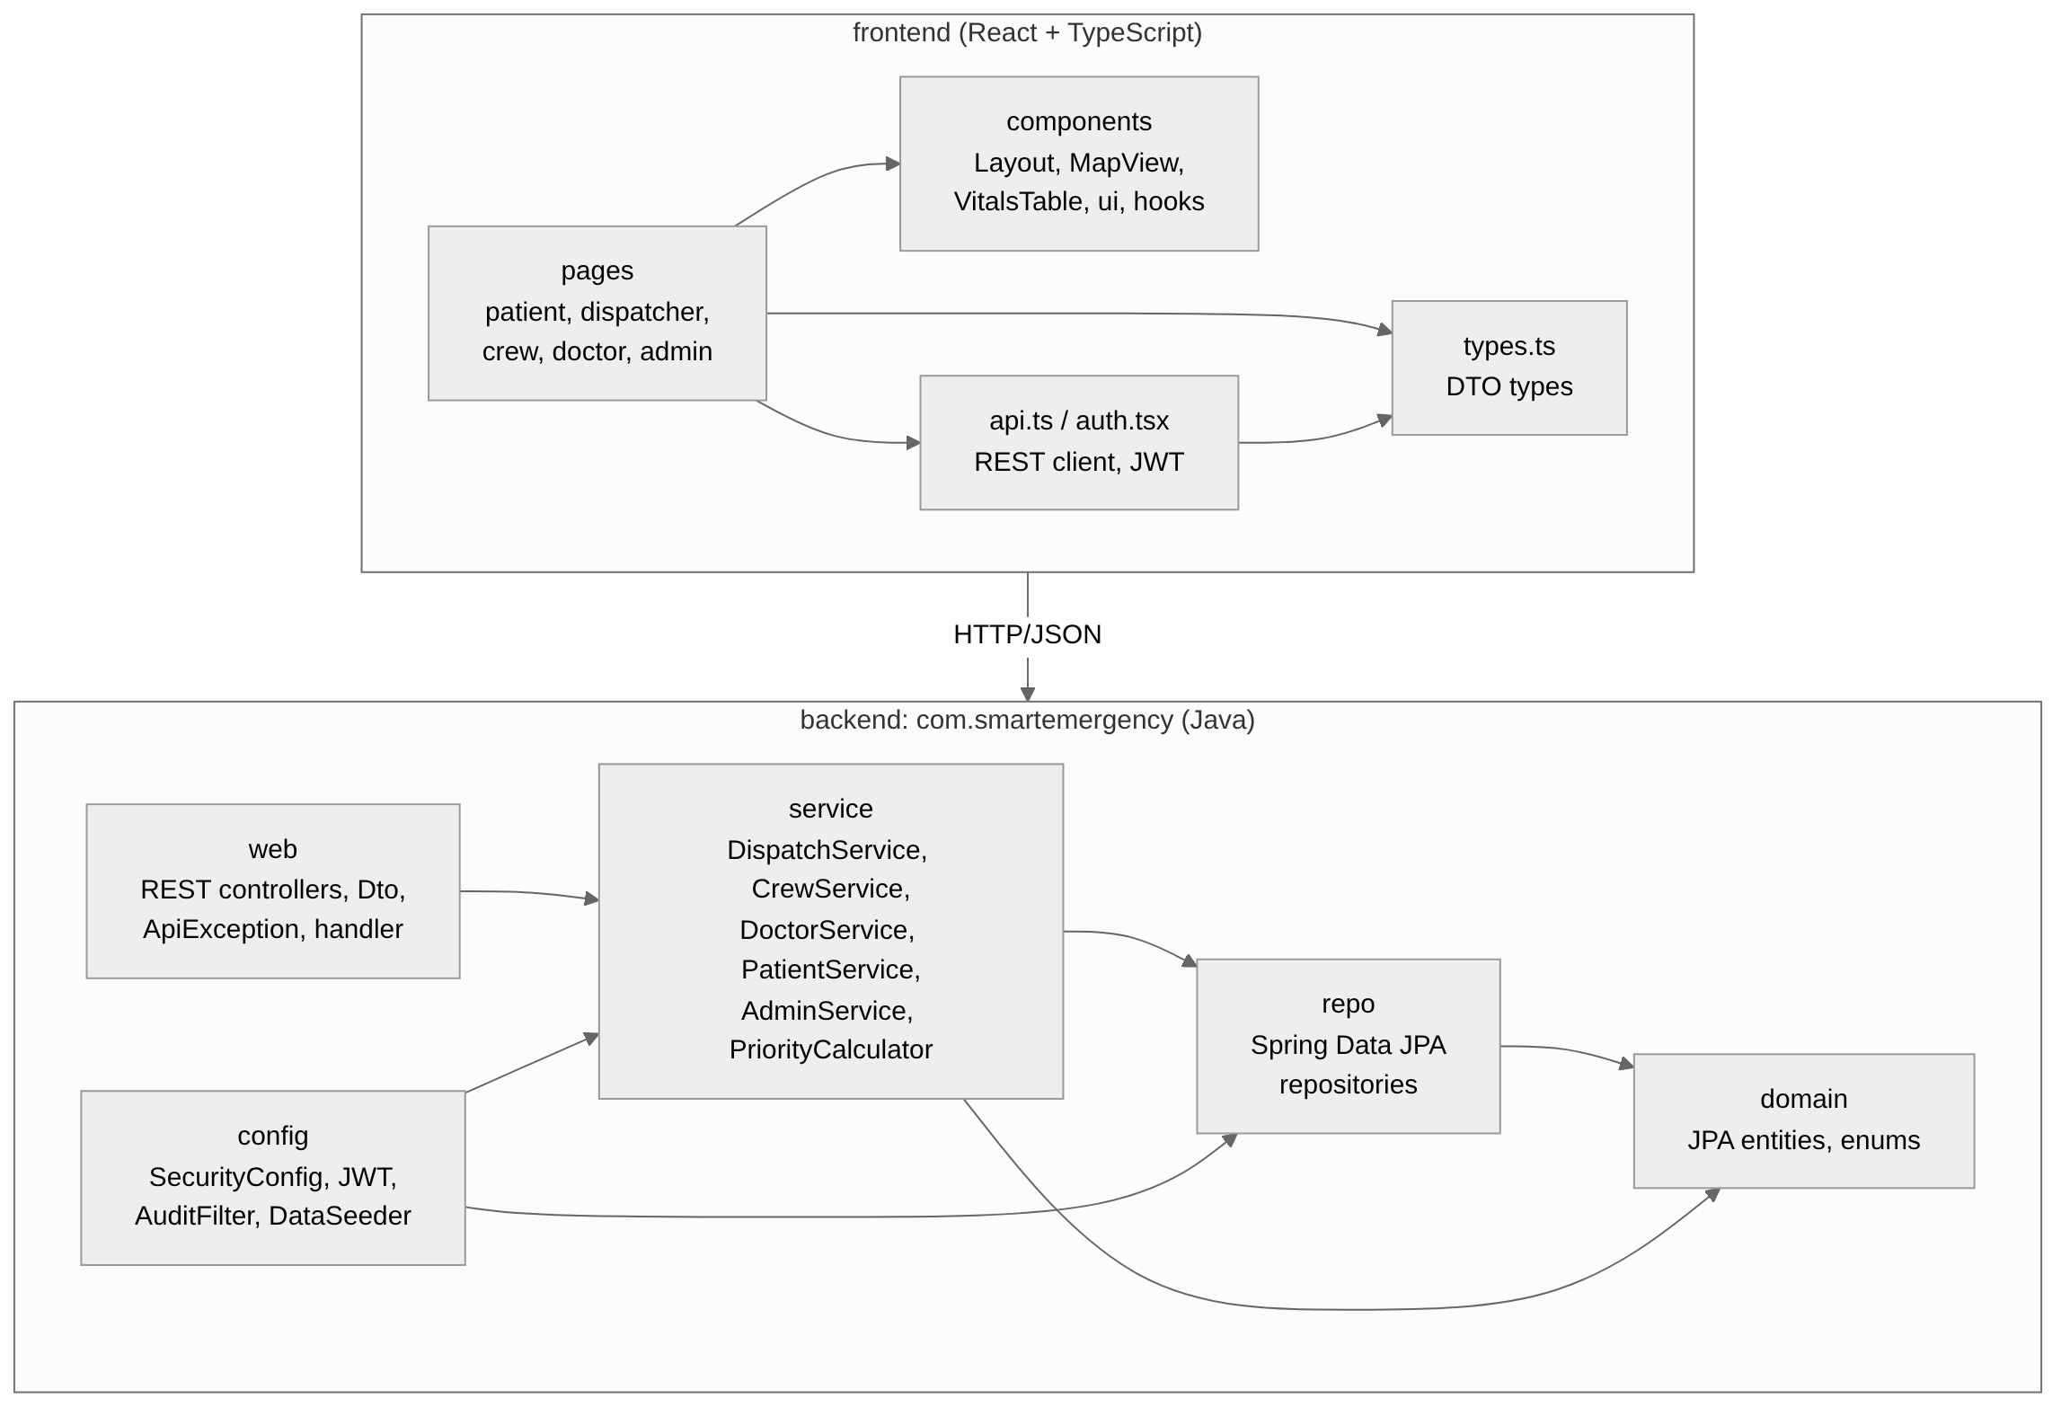
Figure 18. Package diagram

7.7 Communication diagram
The communication diagram shows, with numbered messages, how the objects collaborate in the use case Assign Resources, when the dispatcher accepts the recommendation of the Smart Dispatch system.
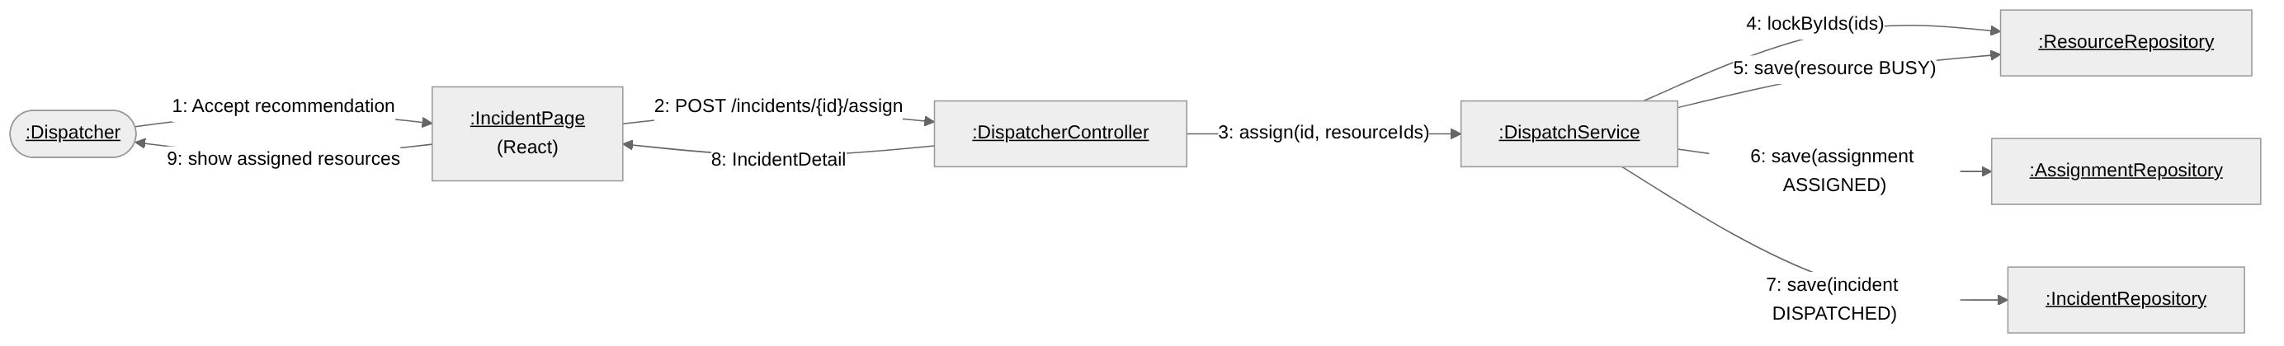
Figure 19. Communication diagram - Assign Resources

7.8 Component diagram
The component diagram shows the main software components and their interfaces: the web client components use the REST interface of the server; the server components (security, REST API, Smart Dispatch, transport, medical case, administration) use the persistence component, which accesses the database through JDBC.
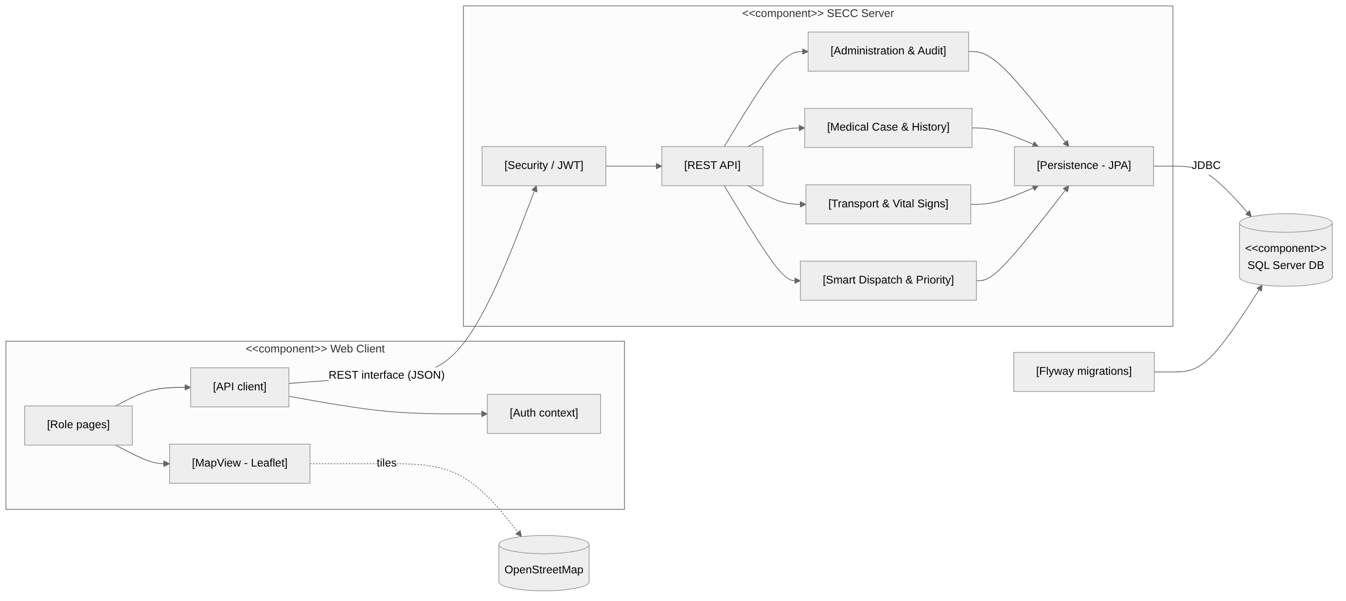
Figure 20. Component diagram

7.9 Deployment diagram
The deployment diagram shows the physical nodes: the user's device with the browser, the application server with Node.js (port 5173) and the JVM with Spring Boot (port 8080), the database server with SQL Server (port 1433) and the external OpenStreetMap servers. In a development or demonstration setup all the nodes except the map servers can run on the same computer.
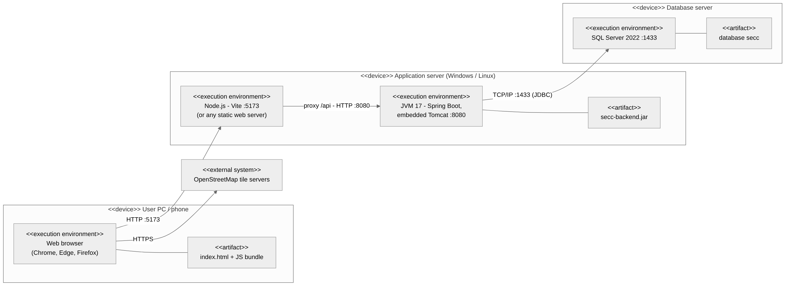
Figure 21. Deployment diagram

8 Database
The relational diagram shows the tables of the database secc, their primary keys (PK), foreign keys (FK) and unique keys (UK) and the cardinality of the relations. The table audit_log (system log) and app_setting (key/value settings) are independent tables.
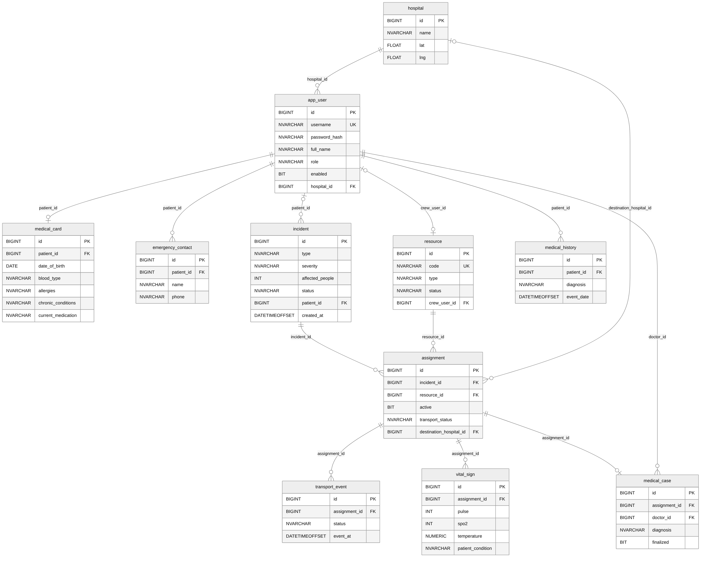
Figure 22. Relational diagram of the database
Table | Content
app_user | Accounts of all users: username, BCrypt password hash, full name, role, enabled flag, hospital (doctors).
hospital | Hospitals with GPS coordinates.
medical_card | Medical Card of a patient: date of birth, blood type, allergies, chronic conditions, medication, notes, home location.
emergency_contact | Up to 5 emergency contacts per patient.
incident | Emergencies: type, severity, affected people, location, source (SOS / PHONE), status, time stamps.
resource | Ambulances, fire teams, fire trucks and police units, with status and location; an ambulance is linked to a crew account.
assignment | A resource assigned to an incident; for ambulances also the transport status and the destination hospital.
transport_event | Timeline of the transport statuses.
vital_sign | Measurements of the Emergency Transport Record.
medical_case | Diagnosis, treatment, medication, procedures and patient status recorded by the doctor.
medical_history | Finalized medical events of a patient.
audit_log | Logins, failed logins and every API request.
app_setting | Key/value settings of the application.

The schema is created automatically by Flyway (backend/src/main/resources/db/migration/V1__schema.sql) when the backend starts for the first time; demo data is inserted afterwards.

9 Business rules

9.1 Prioritization (triage) - the priority score
When several emergencies wait at the same time, the most serious must be handled first. The system calculates for every incident a priority score between 0 and 100:
- severity: Low 15, Medium 30, High 45, Critical 60 points;
- affected people: 2 points per person, at most 20;
- incident type: Fire and Building collapse 10, Traffic accident and Flood 8, Medical 6, Other 4 points;
- waiting time: 1 point per minute without resources, at most 10.
Example: a critical fire with 12 affected people that has been waiting for 4 minutes receives 60 + 20 + 10 + 4 = 94 points. The incident list of the dispatcher is ordered by this score.

9.2 Geographic distance and nearest-unit selection
The positions of the incidents, resources and hospitals are stored as GPS coordinates (latitude, longitude). The straight-line distance between two points is calculated with the Haversine formula:
d = 2 · R · arcsin( √( sin²(Δφ/2) + cos φ1 · cos φ2 · sin²(Δλ/2) ) ), R = 6371 km,
where φ is the latitude and λ the longitude in radians. For an SOS request the system automatically assigns the AVAILABLE ambulance with the smallest distance; for other incidents it recommends, for every needed resource type, the closest available units. The estimated arrival time at the hospital is distance / 50 km/h.

9.3 Medical data
The Medical Card contains the data needed in an emergency: blood type, allergies, chronic conditions, current medication, medical notes and emergency contacts. It is read by the ambulance crew before administering any medication and by the doctor before choosing a treatment. The Emergency Transport Record contains the vital signs measured during the intervention; values outside the normal ranges (pulse < 50 or > 120 bpm, SpO2 < 92 %, systolic pressure < 90 or > 180 mmHg, temperature > 38.5 °C) are highlighted. The Medical History is the list of all finalized medical cases of a patient.

9.4 Recommended resources
- Ambulances: number of affected people / 4, rounded up, minimum 1, maximum 3.
- Fire: + 1 fire team and 1 fire truck. Traffic accident: + 1 police unit. Building collapse: + 1 fire team and 1 police unit. Flood: + 1 fire team.
- For every needed type the AVAILABLE units closest to the incident are recommended; already assigned units are counted.

9.5 Statuses
Object | Statuses (in order)
Incident | NEW → DISPATCHED → IN_PROGRESS → AT_HOSPITAL → CLOSED, or CANCELLED
Transport (ambulance) | ASSIGNED → EN_ROUTE → ON_SCENE → TRANSPORTING → AT_HOSPITAL → HANDED_OVER, or CANCELLED / NO_TRANSPORT
Resource | AVAILABLE, BUSY, OUT_OF_SERVICE
Medical case | draft (editable) → finalized (read-only, added to the Medical History)

10 Technologies
The application is implemented with the following technologies. All of them are free and can be used on Windows, Linux and macOS.
Layer | Technology | Version | Purpose
Frontend | React + TypeScript | 18.3 / 5.6 | Single Page Application; one set of pages for each role; static typing of all API data.
Frontend | Vite on Node.js | 5.4 / 18+ | Development server with hot reload, proxy of /api to the backend, production build.
Frontend | React Router | 6.28 | Navigation between pages and protection of the routes by role.
Frontend | Leaflet + react-leaflet, OpenStreetMap | 1.9 / 4.2 | Interactive map with incidents, resources and hospitals; selection of a location by click.
Backend | Java | 17 | Programming language of the server.
Backend | Spring Boot (Web, Data JPA, Security, Validation) | 3.3 | REST controllers, dependency injection, transactions, validation of the requests, security filter chain.
Backend | Hibernate (JPA) | 6.5 | Object-relational mapping of the entities to SQL Server tables.
Backend | JJWT, BCrypt | 0.12 | Creation and validation of JWT tokens; hashing of the passwords.
Backend | Flyway | 10 | Versioned SQL migrations: creates the database schema at the first start.
Backend | Maven, Lombok | 3.9+ | Build and dependency management; generation of getters/setters.
Database | Microsoft SQL Server + SQL Server Management Studio | 2022 / 22 | Persistent storage; administration and inspection of the data.
Tools | IntelliJ IDEA / VS Code, Git, curl | - | Development, version control, testing of the REST API (scripts/e2e-test.sh).

React was chosen because the application has many interactive screens that refresh periodically; TypeScript catches errors such as a wrong field name at compile time. Spring Boot offers ready-made, well-tested components for REST, security and database access, so the code concentrates on the business rules. SQL Server was chosen because it is a mature relational database that is easy to administer with SQL Server Management Studio.

10.1 Client-server architecture and REST
The application follows the client-server model: the web client (running in the browser) only displays data and sends requests, while the server holds the business rules and the database. The communication uses a REST API: every resource has a URL (for example /api/dispatcher/incidents/8) and the HTTP method expresses the operation (GET read, POST create/action, PUT update, PATCH partial update, DELETE remove). Data is exchanged in JSON format. The server is stateless: every request contains all the information needed to process it, including the authentication token.
Operational screens are refreshed by polling: the client repeats the GET request every 5 seconds, so new incidents, status changes and incoming patients appear without reloading the page.

10.2 Authentication, authorization and auditing
- Password hashing (BCrypt): passwords are never stored in clear text, only as salted BCrypt hashes.
- JWT (JSON Web Token): after login the server returns a token signed with HMAC-SHA256 that contains the user id and role and expires after 8 hours. The client sends it in the header Authorization: Bearer <token>.
- Role-based access control (RBAC): each group of endpoints is reserved to one role, and the services check in addition that the data belongs to the user (own medical card, assigned incident, own hospital).
- Audit log: every request and every login attempt is recorded (user, IP, method, path, HTTP status, duration), which allows tracing who did what.

10.3 Relational databases, ORM and concurrency
The data is stored in a relational database (Microsoft SQL Server). Tables are connected through primary and foreign keys and the schema is normalized, so that each fact is stored only once (for example the Medical Card is stored once and read by the patient, the crew and the doctor). The Java code accesses the database through an Object-Relational Mapping (JPA / Hibernate): entity classes are mapped to tables and repositories generate the SQL queries.
Database operations of one use case run in a transaction (all or nothing). When two dispatchers try to assign the same ambulance at the same time, the resource rows are locked with a pessimistic lock; the second assignment is rejected because the ambulance is no longer AVAILABLE.

11 Installation and running

11.1 Requirements
- JDK 17 or newer and Maven 3.9+ (or IntelliJ IDEA).
- Node.js 18+ with npm.
- Microsoft SQL Server 2019/2022 (Express or Developer) and SQL Server Management Studio.

11.2 Database
- Open SQL Server Management Studio, connect with Windows Authentication, open backend/sql/create_database.sql and execute it (F5). It creates the database secc and the login secc.
- If the script reports windows_auth_only = 1: server Properties → Security → "SQL Server and Windows Authentication mode", then restart the server.
- Open SQL Server Configuration Manager (Win + R → SQLServerManager16.msc) → SQL Server Network Configuration → Protocols → enable TCP/IP; in IP Addresses → IPAll set TCP Port = 1433; restart the SQL Server service.

11.3 Starting the application
- Double-click start.bat in the project folder.
- Two windows start the backend (mvn spring-boot:run, port 8080) and the frontend (npm run dev, port 5173).
- When the backend is ready the browser opens http://localhost:5173.
- Alternatively: run SeccApplication from IntelliJ IDEA and npm install + npm run dev in the frontend folder.

11.4 Demo accounts
All demo accounts use the password password123.
Username | Role | Notes
patient1, patient2, patient3 | Patient | patient1 has a complete Medical Card, contacts and history
dispatcher, dispatcher2 | Dispatcher
crew1 … crew4 | Ambulance crew | linked to AMB-01 … AMB-04
doctor1, doctor2, doctor3 | Doctor | one per hospital
admin | Administrator

12 User guide
This chapter shows how each type of user works with the application. The screenshots show the user interface with demonstration data.

12.1 Login
Every user logs in with username and password. After login the user is redirected to the home page of his role; the menu shows only the pages of that role.
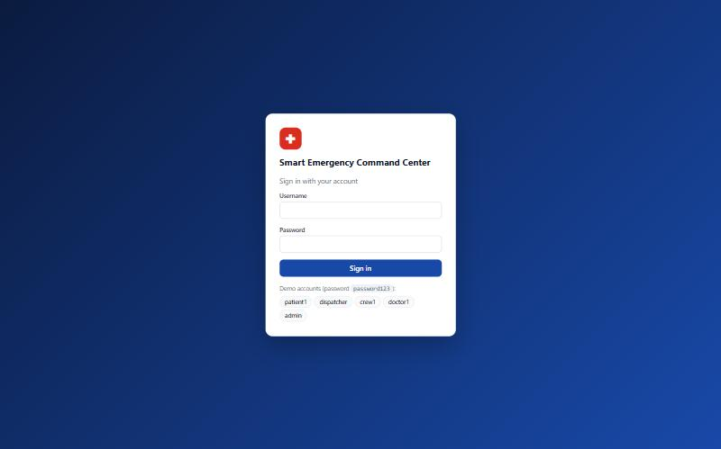
Figure 23. Login page

12.2 Patient
- On "My emergency" the patient presses SOS, optionally selects the type and writes a note; the location is sent automatically.
- The page shows the incident number, the assigned ambulance and the progress Assigned → … → Handed over (when the doctor permits).
- "Cancel request" is available until the crew reaches the scene.
- "Medical card" shows the card and the medical history; "Emergency contacts" allows adding, editing and deleting contacts.
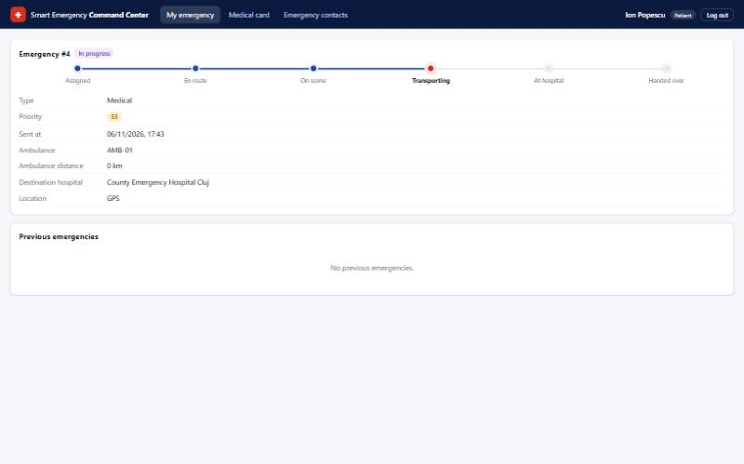
Figure 24. Patient - emergency status
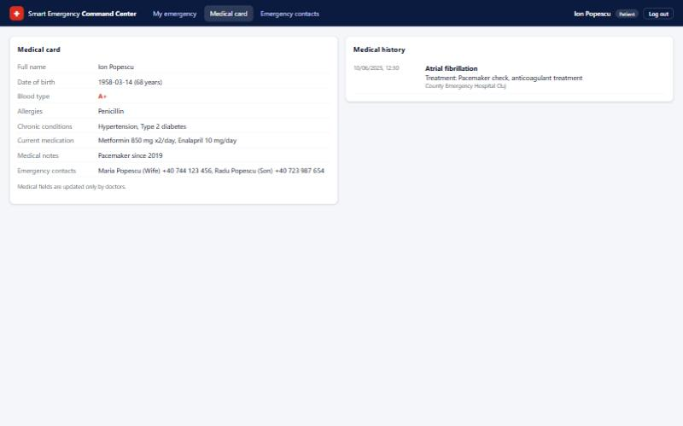
Figure 25. Patient - Medical Card and Medical History

12.3 Dispatcher
- The Dashboard shows the counters, the incidents ordered by priority (SOS requests and incidents without resources are marked) and the map.
- "New incident" opens the form; the location is selected by clicking on the map.
- Clicking an incident opens its details with the recommended resources; "Accept recommendation" assigns them, "Choose manually" allows another selection.
- "Close incident" is used when the patient was handed over (the incident is marked "Ready to close").
- "Resources" lists all the units and allows adding units and setting them out of service.
Figure 26. Dispatcher - dashboard with incident list and map
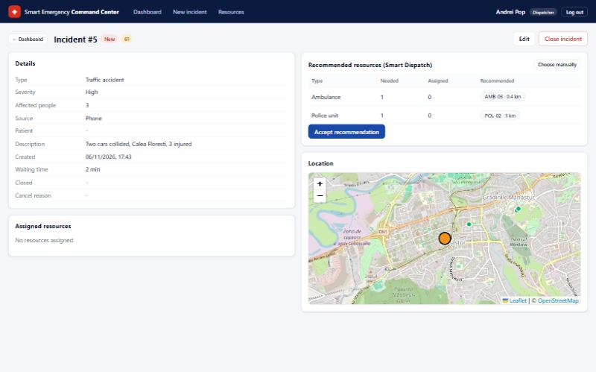
Figure 27. Dispatcher - incident details and Smart Dispatch recommendation

12.4 Ambulance Crew
- A new assignment appears automatically as "NEW EMERGENCY"; the crew reads the emergency data and the patient's Medical Card (allergies in red).
- The large button moves the transport to the next status; at "Start transport" the nearest hospital is pre-selected.
- In the "Transport record" tab the crew records the vital signs and the administered medication; abnormal values are shown in red.
- At the hospital the crew writes a hand-over note and presses "Hand over to hospital".
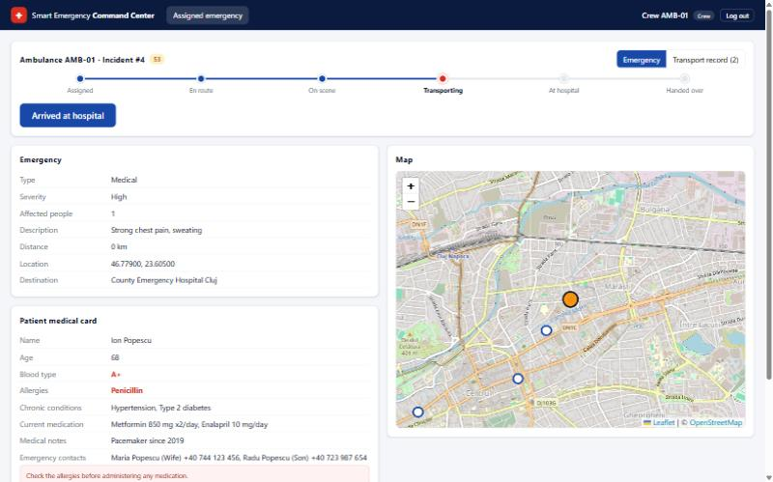
Figure 28. Ambulance crew - assigned emergency and patient Medical Card
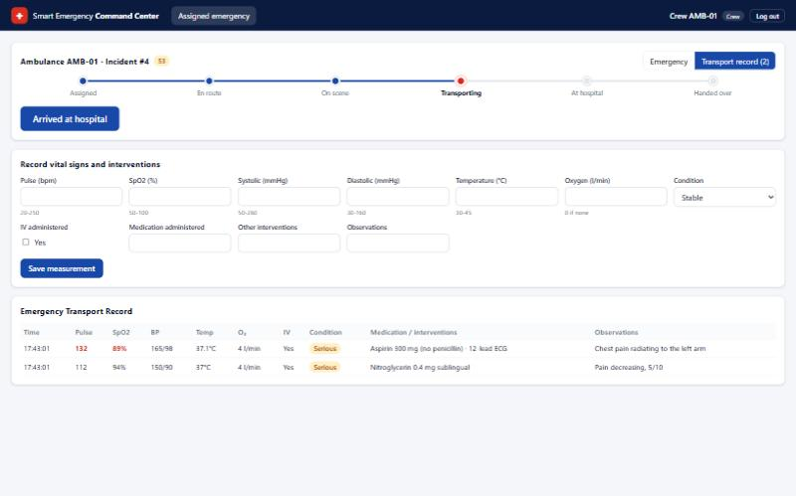
Figure 29. Ambulance crew - Emergency Transport Record

12.5 Doctor
- "Incoming patients" lists the patients transported to the doctor's hospital, with estimated arrival time.
- Opening a patient shows the Medical Card, the history, the emergency data and the vital signs.
- After the hand-over the doctor fills in the diagnosis and treatment (a warning appears if a medication matches an allergy) and saves.
- "Finalize case" adds the case to the Medical History and can update the Medical Card.
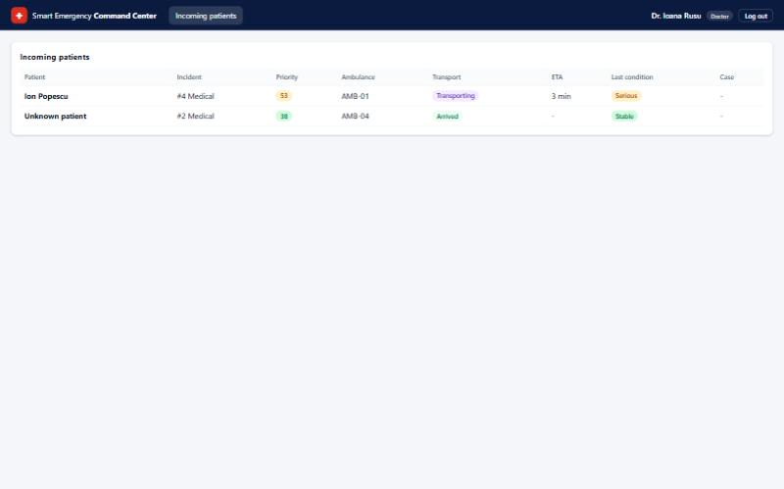
Figure 30. Doctor - incoming patients
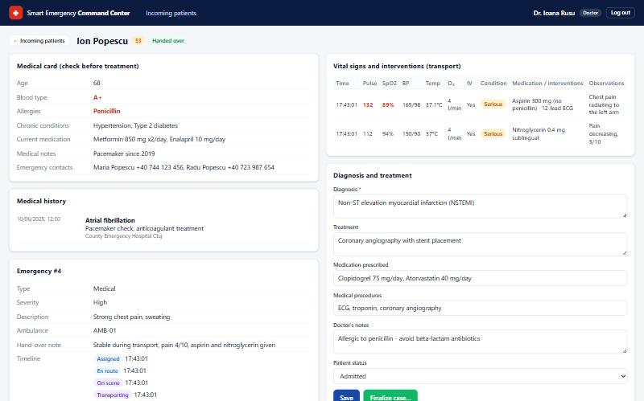
Figure 31. Doctor - patient data, diagnosis and treatment

12.6 Administrator
- "System status" shows the state of the server and of the database and the incidents and resources per status.
- "Users" allows creating accounts, linking crew accounts to ambulances and doctors to hospitals, resetting passwords and disabling accounts.
- "Audit log" lists all the requests and logins with filters; "Export CSV" downloads the filtered entries.
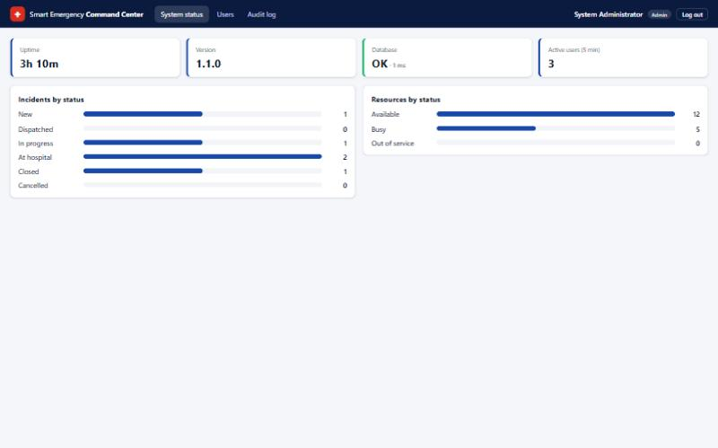
Figure 32. Administrator - system status
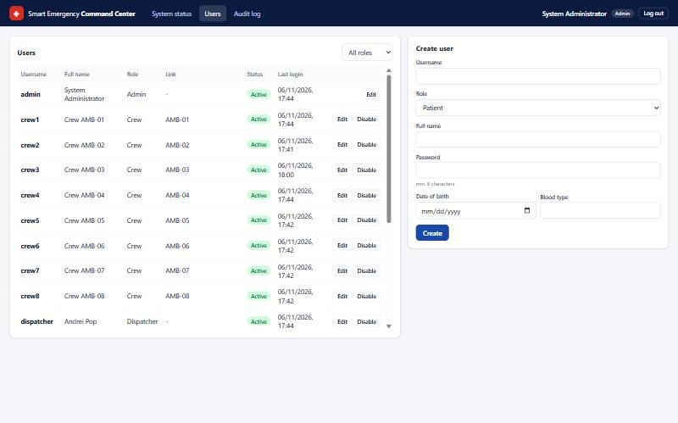
Figure 33. Administrator - user accounts
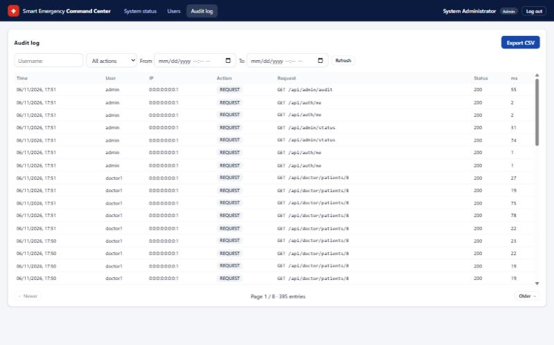
Figure 34. Administrator - audit log

13 REST API
All endpoints are under /api and exchange JSON. Except the login, every request must contain the header Authorization: Bearer <token>. Each group of endpoints is reserved to one role.
Use case | Method and endpoint | Role
Login | POST /api/auth/login | all
Activate emergency request | POST /api/patient/emergencies | Patient
View emergency status | GET /api/patient/emergencies/current | Patient
Cancel emergency request | POST /api/patient/emergencies/{id}/cancel | Patient
Medical card and history | GET /api/patient/medical-card | Patient
Emergency contacts | GET, POST /api/patient/contacts; PUT, DELETE /api/patient/contacts/{id} | Patient
Monitor / create incidents | GET, POST /api/dispatcher/incidents | Dispatcher
Incident details / update | GET, PUT /api/dispatcher/incidents/{id} | Dispatcher
Assign resources | POST /api/dispatcher/incidents/{id}/assign | Dispatcher
Close incident | POST /api/dispatcher/incidents/{id}/close | Dispatcher
Manage resources | GET, POST /api/dispatcher/resources; PATCH /api/dispatcher/resources/{id}/status | Dispatcher
Assigned emergency | GET /api/crew/assignment | Crew
Transport status, vital signs, hand-over | POST /api/crew/assignment/status | vitals | handover | no-transport | Crew
Incoming patients | GET /api/doctor/incoming | Doctor
Patient data | GET /api/doctor/patients/{id} | Doctor
Diagnosis / finalize case | PUT /api/doctor/patients/{id}/case; POST …/case/finalize | Doctor
User accounts | GET, POST /api/admin/users; PUT /api/admin/users/{id}; POST …/enabled | Admin
System status | GET /api/admin/status | Admin
Audit log / export | GET /api/admin/audit; GET /api/admin/audit/export | Admin

14 Portability and limitations

14.1 Client
- The client is a web application and runs in any modern browser (Chrome, Edge, Firefox, Safari) on Windows, Linux, macOS, Android and iOS; nothing is installed on the user's device.
- The layout adapts to small screens (below 1000 px the columns are displayed one under the other), so the patient and the crew can use a phone or a tablet.
- The browser location is available only on localhost or over HTTPS; for a real deployment the application must be served over HTTPS.

14.2 Server
- The backend is a standard Java 17 application packaged as a single executable JAR (mvn package, then java -jar), with embedded Tomcat; it runs on every operating system with a JVM 17+.
- The frontend is built with npm run build into static files (folder dist) that can be served by any web server (nginx, Apache, IIS) or by Spring Boot itself.
- All the settings (database URL, user, password, JWT secret) can be changed through environment variables without recompiling (DB_URL, DB_USER, DB_PASSWORD, JWT_SECRET).

14.3 Database
- SQL Server runs on Windows, on Linux and in Docker containers.
- Because the code uses JPA and standard SQL, the database can be replaced (for example with PostgreSQL or MySQL) by changing the JDBC driver, the connection URL and the Flyway migration script; the Java code does not change.

14.4 Limitations
- The map needs internet access to the OpenStreetMap tile servers.
- The real-time refresh uses polling every 5 seconds; for a large number of users it could be replaced by WebSockets.

15 Glossary
Term | Description
Emergency incident | Record created for each emergency, containing its type, location, severity, number of affected people, priority score, status, source (SOS or PHONE) and assigned resources.
Incident status | Phase of an incident: NEW (no resources), DISPATCHED, IN_PROGRESS (crew on scene), AT_HOSPITAL (patient handed over), CLOSED or CANCELLED.
SOS (Emergency/Panic) Button | Button of the patient's home screen that sends an emergency request with the current GPS location.
Medical Card | Personal information, blood type, allergies, chronic conditions, current medication, emergency contacts and medical notes of a patient.
Medical History | List of the medical events of a patient; a new entry is added each time a doctor finalizes a medical case.
Priority score | Value from 0 to 100 = severity points (Low 15, Medium 30, High 45, Critical 60) + affected people points (2 per person, max. 20) + type points (Fire, Building collapse 10; Traffic accident, Flood 8; Medical 6; Other 4) + waiting points (1 per minute without resources, max. 10). Example: critical fire, 12 people, 4 minutes = 60 + 20 + 10 + 4 = 94.
Smart Dispatch and Priority System | Part of the server that calculates the priority score, determines the needed resource types and recommends the closest available resources.
Resource | Emergency unit that can be assigned to an incident: Ambulance, Fire team, Fire truck or Police unit, with status AVAILABLE, BUSY or OUT_OF_SERVICE.
Distance | Straight-line distance in km between two GPS points, calculated with the Haversine formula; used to choose the nearest resource and hospital.
Map | OpenStreetMap map that shows incidents, resources and hospitals, refreshed every 5 seconds.
Emergency Transport Record | Record created by the ambulance crew at the first measurement, containing the vital signs, interventions, patient condition and observations; locked at hand-over.
Vital signs | Pulse, blood oxygen saturation (SpO2), blood pressure and temperature of the patient.
Transport status | Phase of an ambulance assignment: ASSIGNED, EN_ROUTE, ON_SCENE, TRANSPORTING, AT_HOSPITAL, HANDED_OVER (or CANCELLED / NO_TRANSPORT).
Medical case | Diagnosis, treatment, medication, procedures, notes and patient status recorded by the doctor for one incident.
Role-based access | Access policy by which a user can only call the functions and see the data of his role (PATIENT, DISPATCHER, CREW, DOCTOR, ADMIN).
JWT token | Signed token received at login and sent with every request; it contains the user id and role and expires after 8 hours.
REST API | HTTP/JSON interface of the Spring Boot server used by the React web client.
SQL Server database | Microsoft SQL Server database, managed with SQL Server Management Studio, used for the persistent storage of users, incidents, resources, medical data, transport records and audit logs.
Audit log | Record of the logins, failed logins and requests handled by the server (time, user, IP, method, path, status, duration).

