- Human Microbiome
  - All of the bacteria, fungi, protozoa & viruses that live in a particular environment
    - Refers to unique conditions of the microbiome (temp, pH, salinity, host-,…etc.)
  - Humans have multiple microbiome
    - Gut, skin, mouth,….
  - 10 trillion, microbes, 10x more than host cells, 200x the gene content
- Gut Health & Disease
  - Vast majority of human microflora
    - 10⁹⁻¹¹ cells/cm³
  - Thousands of species, millions of genes (most unknown)
  - Bacteria ferment ingested food
  - Provide nutrients, inhibit pathogens
  - “Educate” the immune system (good vs. bad)
- Big Dats tables: Metagenomics, Metabolomics, Gene Expressions patterns, Codon bias tables… etc.
- Comparing microbial communities
  - How many “species” are there?
    - Alpha diversity (richness, evenness, or both).
      - Per sample
  - How similar are pairs of samples?
    - Beta diversity – two sets of samples to each other
      - Pairwise analysis
  - Who is there?
    - Taxonomic profiling, differential abundance testing
- Alpha diversity metrics
  - operate on a single sample (i.e., within sample diversity)
  - Richness
    - 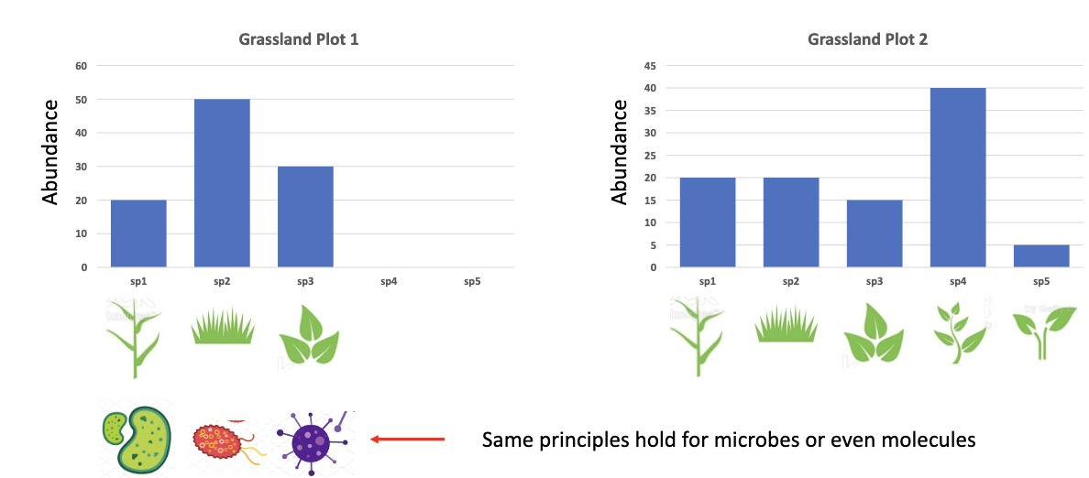
    - How many different species are there
  - Evenness (Pielou)
    - 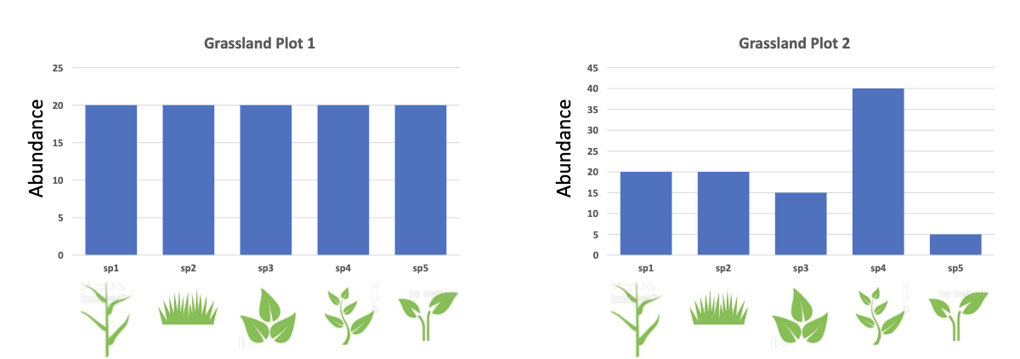
    - Looks at distribution
      - Soils are very even with species
      - Grasslands are not very even
  - Phylogenetics (Faith’s)
    - 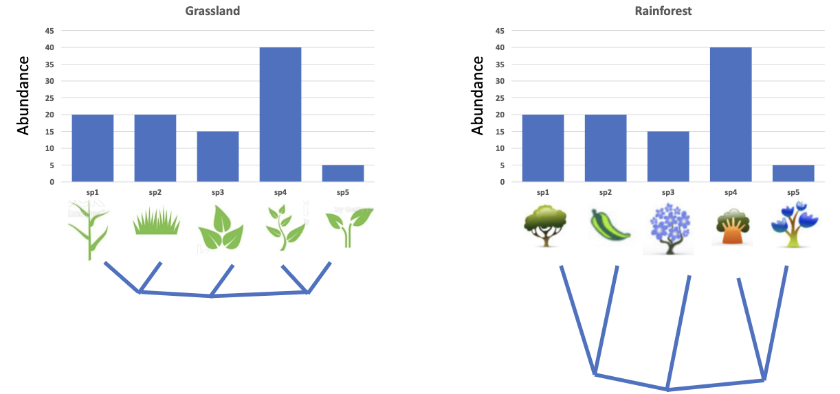
    - Looks at the evolutionary change to see how closely related the species are
- Beta diversity metrics
  - operate on pairs of samples (i.e., between sample diversity)
  - Qualitative
    - 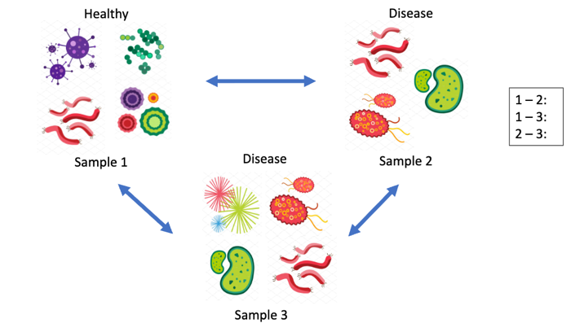
      - 1-2: ¼
      - 1-3: ¼
      - 2-3: ¾
    - Quantitative
      - 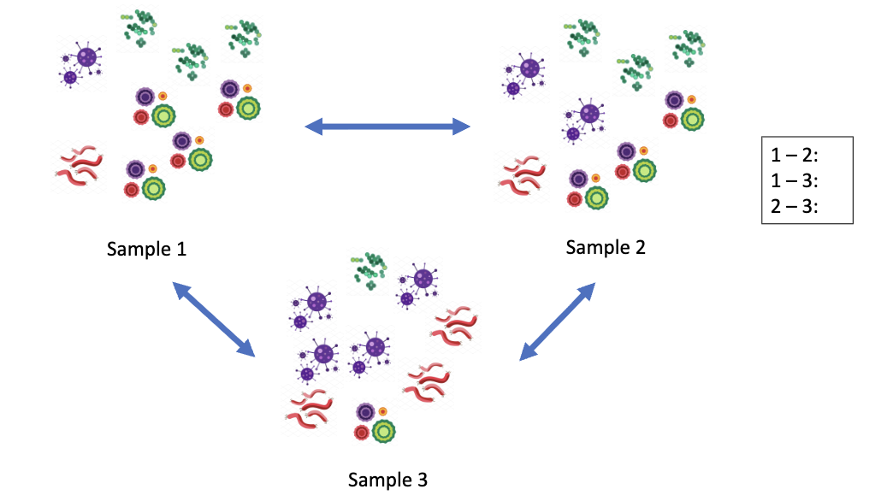
      - No qualitative difference (same types)
      - You can make a distance matrix to look at all pairs and all metrics
- Qualitative diversity metrics only consider the presence/absence of features
- Quantitative diversity metrics consider abundance of features
- ALPHA DIVERSITY
  - Observed OTUs (or Observed Species): a qualitative, non-phylogenetic, alpha diversity metric
    - OTU = operational taxonomic units
      - Based on sequences, but we don’t know what the sequences are yet
    - Count the number of different features in a sample
      - 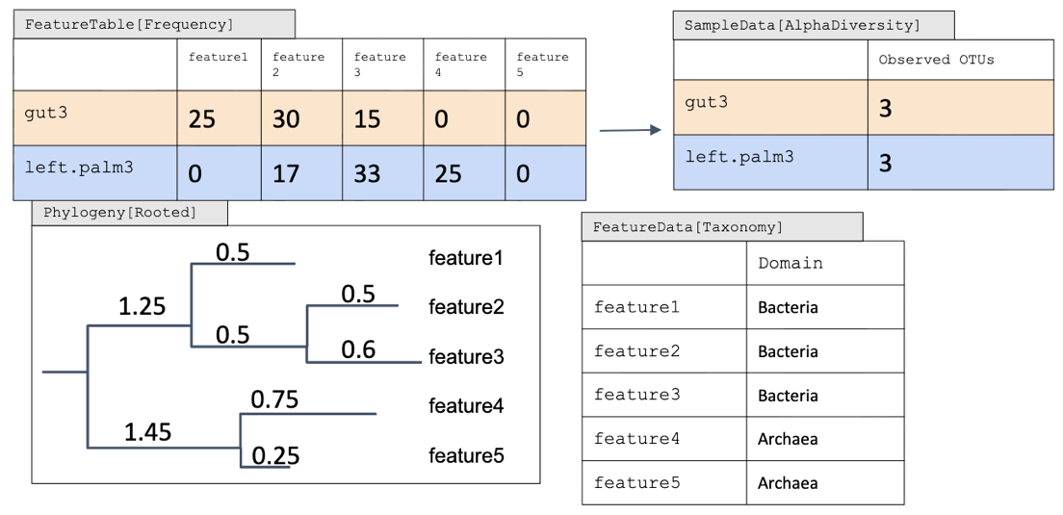
        - Feature1 + Feature2 + Feature3 = 3.35
        - Feature1 + Feature2 + Feature3 + Feature 4 = 5.05
  - Faith’s Phylogenetic Diversity (PD): a qualitative, phylogenetic, alpha diversity metric
    - Sum of branch length covered by a sample
      - 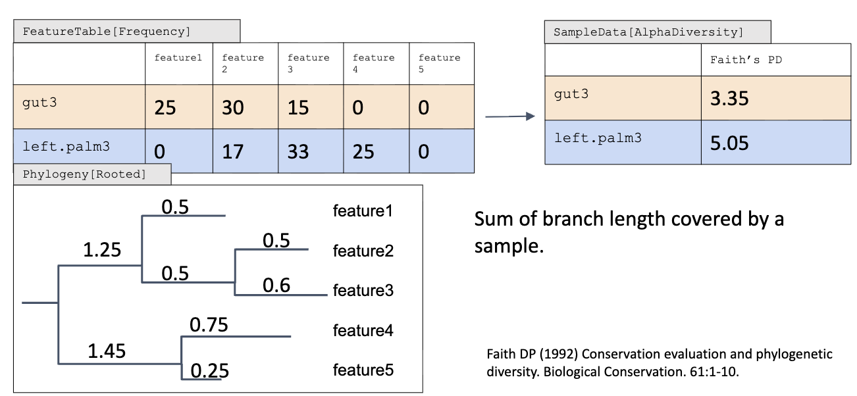
  - Diversity metrics are often impacted by the total frequency observed in samples, such that in this example right.palm2 might look more similar to tongue2 than to left.palm2
    - 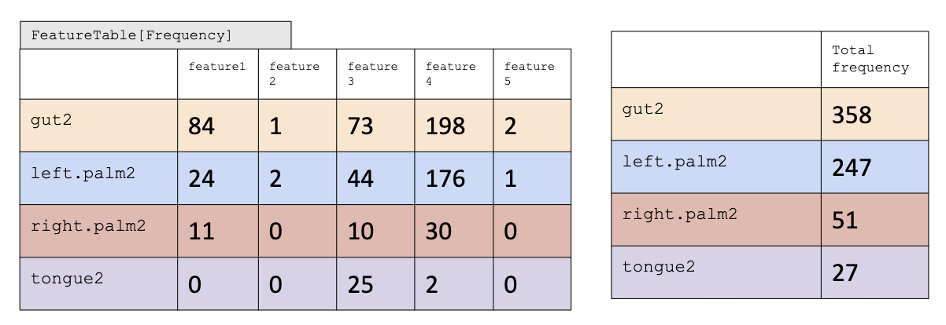
    - This is most commonly handling by rarefaction, which is currently* a necessary evil
    - Frequencies are subsampled without replacement until all samples have the same total. Samples with fewer sequences than your even sampling depth will be filtered out of the feature table.
      - 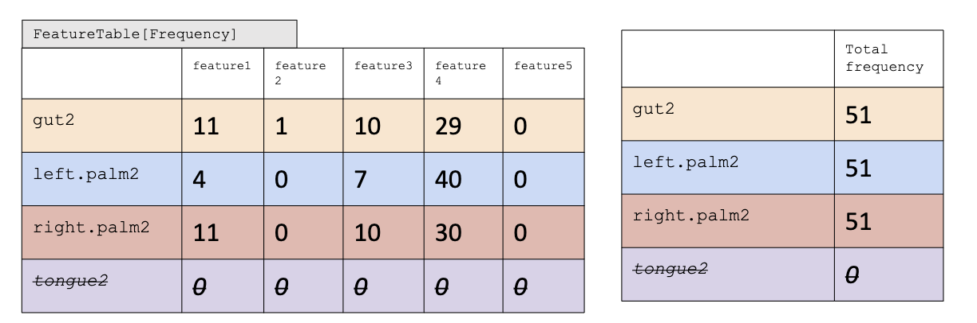
  - Rarefaction curve
    - 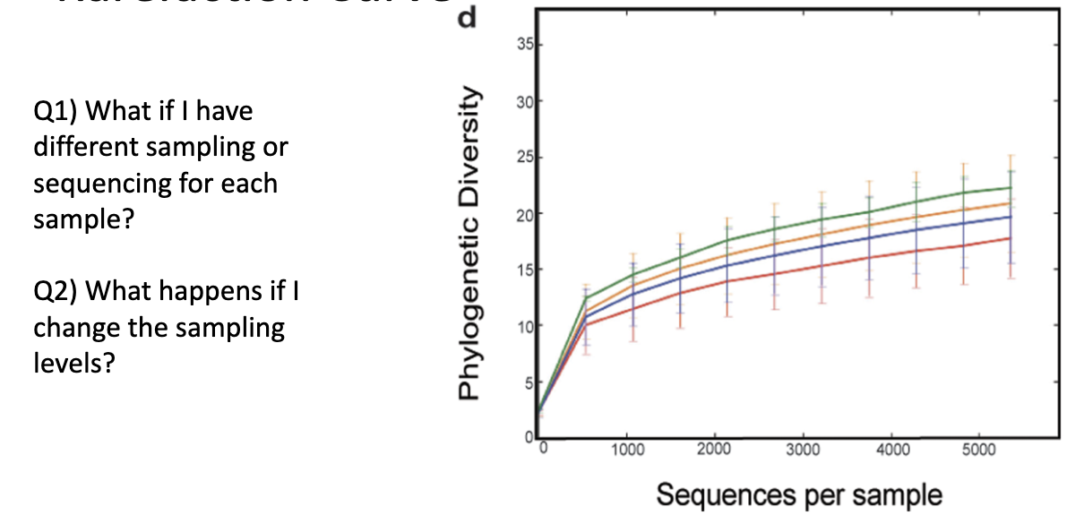
      - Want to go to a point to when it flattens or as far as you can get to
      - Ex: Alpha diversity and the gut microbiome in women with PCOS
        - 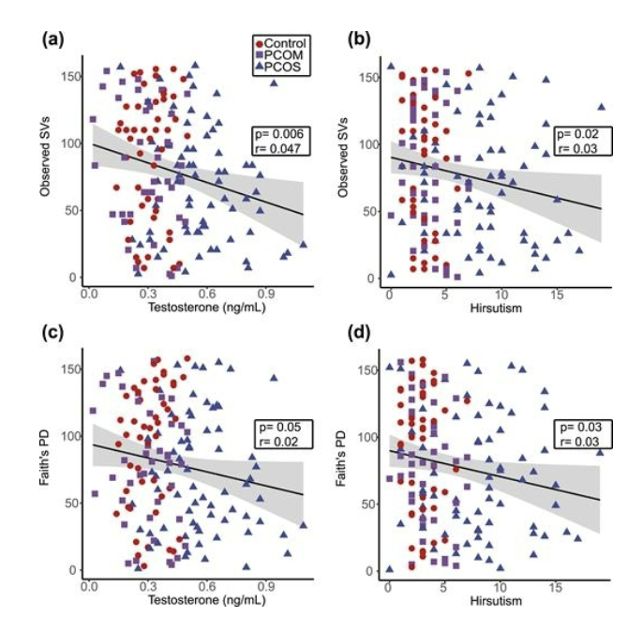
    - Don’t do CLR’s with Alpha diversity bc you’ll end up with negative #’s
- BETA DIVERSITY
  - Jaccard distance: a qualitative, non-phylogenetic beta diversity metric
    - 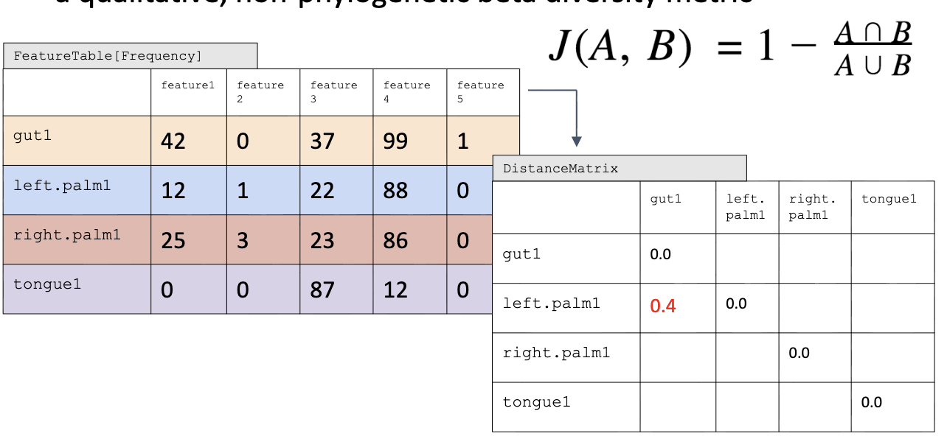
      - Share everything = 0.0
      - Share nothing = 1.0
      - 3/5 = 0.6 -> 1- 0.6 = 0.4
  - Bray-Curtis distance: a quantitative, non-phylogenetic beta diversity metric
    - 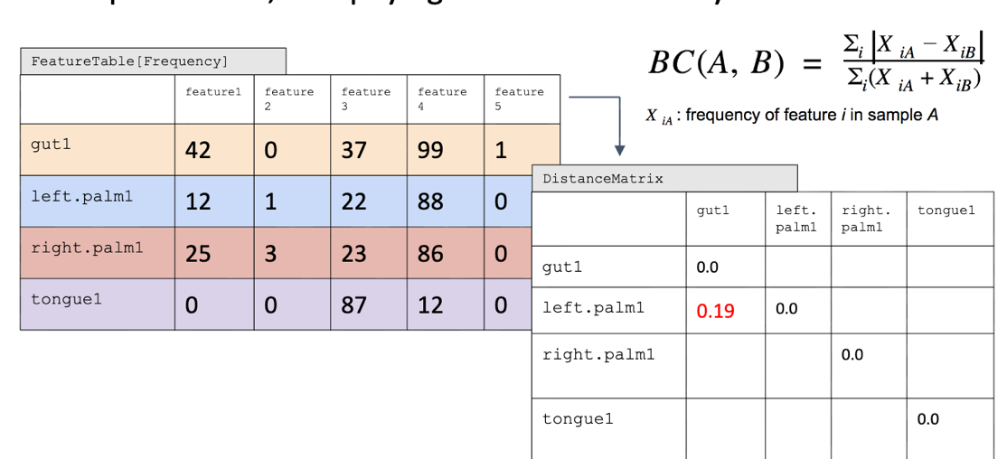
      - Taking the |sum of the diff b/w the samples| / addition of the samples
        - (42-12)+(0-1)+(37-22)+(99-88)+(1-0)/(12+1+22+88+0)+(42+0+37+99+1) = 0.18543046
      - As the difference gets bigger, the number gets bigger
  - Brays Curtis & Jaccard’s do not take account the relationships b/w the species themselves
  - Unweighted UniFrac distance
    - a qualitative, phylogenetic beta diversity metric
    - 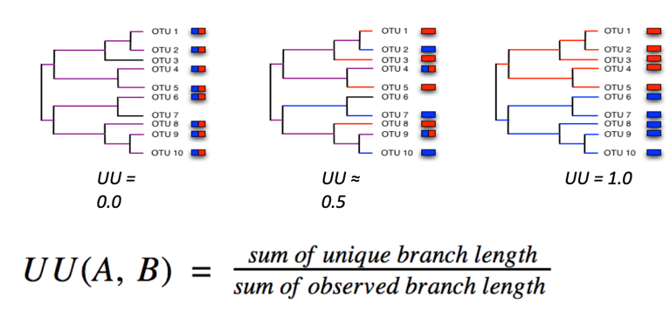
      - 0.0 = all shared b/w species
      - 0.5 = some shared b/w species
      - 1.0 = none shared b/w species
    - 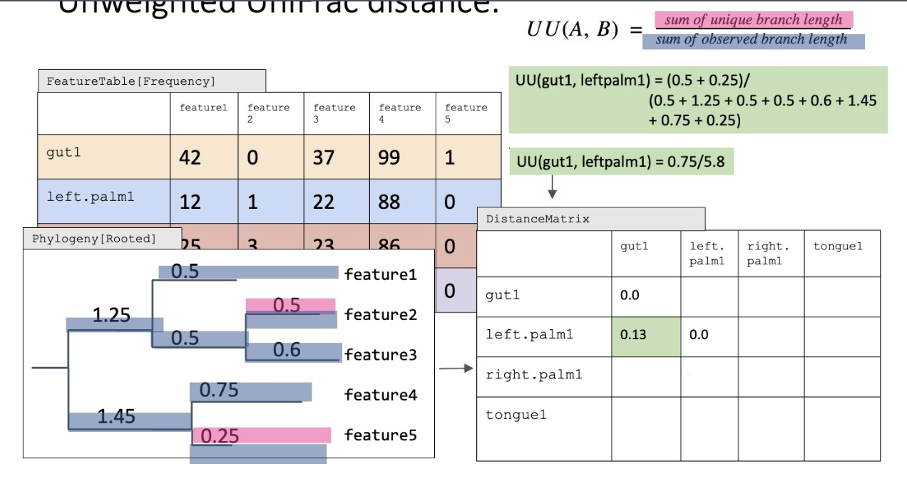
    - We don’t count the amount
    - Gives you information about how different the environment is
- Ordination is a collective term for multivariate techniques which summarize multidimensional dataset in such a way that when it is projected onto a low dimensional space, any intrinsic pattern the data may possess becomes apparent upon visual inspection
  - Ordination summarizes community data (such as species abundance data: samples by species) by producing a low-dimensional ordination space in which similar species and samples are plotted close together, and dissimilar species and samples are placed far apart
    - Ideally and typically, dimensions of this low dimensional space will represent important and interpretable environmental gradients
- Principle Coordinates Analysis
  - PC1 is the number that explains the most variation, and the PC2 is the second most and so on….
  - This is a method of Multidimensional scaling (MDS) but you can think of it as dimension reduction
  - Allows visualization of a multidimensional dataset like a data matrix
  - The points indicate individual microbiome samples. Points nearer each other are more similar in their diversity
  - Allow visualization of clusters and relationship of clusters to specific characteristics
    - 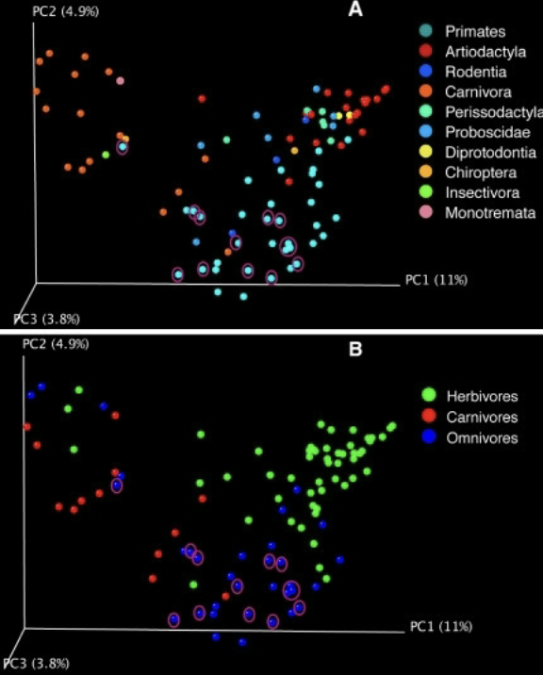
- Beta diversity comparison
  - Beta diversity analysis of 3 different data sets collected from the same mouse gut microbiome samples.
  - Bray-Curtis distances
    - 4 different treatment groups: Can visualize the separation
- PCA & PCoA
  - 
   