Customer Churn Data Gathering and Exploratory Analysis Report
SmartBank Customer Retention Project
Prepared by: Nyayesh Seyf
Task: Data gathering, exploratory data analysis, and data preparation for churn modelling

1. Objective
The aim of this task was to prepare a reliable customer-level data set for predicting customer churn. I combined the provided customer, transaction, service, online activity, and churn data. I then explored the data to understand which patterns may relate to churn and prepared a modelling version of the data set.

2. Data selected and rationale
I selected all five provided sheets because each one adds a different part of the customer story. The demographic data helps describe customer segments, the transaction data shows spending behaviour, the service data shows possible friction points, the online activity data shows engagement, and the churn status gives the target variable.
Data source | Rows | Why it was used
Customer_Demographics | 1,000 | Customer age, gender, marital status and income level.
Transaction_History | 5,054 | Spending volume, transaction count, product category and transaction recency.
Customer_Service | 1,002 | Customer contact volume, unresolved issues and complaints/feedback.
Online_Activity | 1,000 | Login frequency, last login date and preferred digital service.
Churn_Status | 1,000 | Target variable showing whether the customer churned.

3. Exploratory data analysis findings
The final customer-level data set contains 1,000 customers. There are 204 churned customers, which gives an overall churn rate of 20.4%. The reference date used for recency features is 2023-12-31, which is the latest date found in the data.
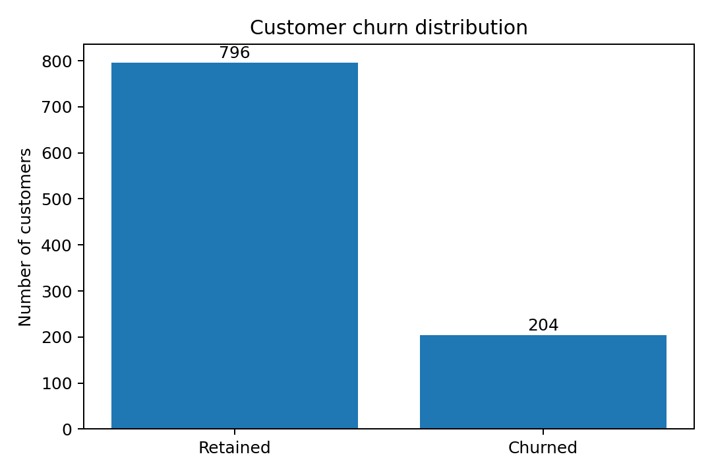
The strongest pattern in the EDA was linked to digital engagement. Customers with 0-9 logins had the highest churn rate at 29.3%, while customers with 30-39 logins had a lower churn rate of 16.5%. This suggests that lower online activity may be an early warning sign.
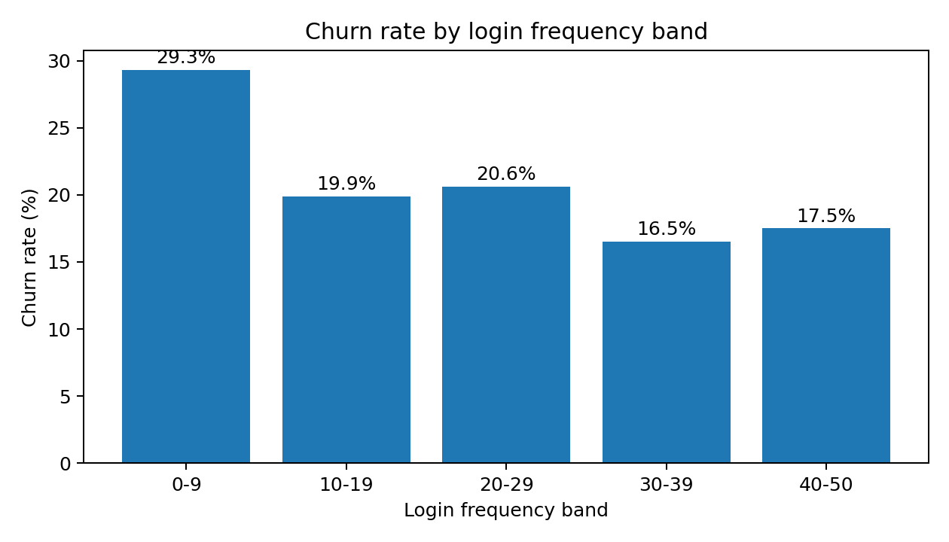
Income level also showed a small difference. Low-income customers had the highest churn rate at 22.2%, compared with 19.9% for medium-income and 19.2% for high-income customers. The gap is not large, but it may still be useful when combined with other features.
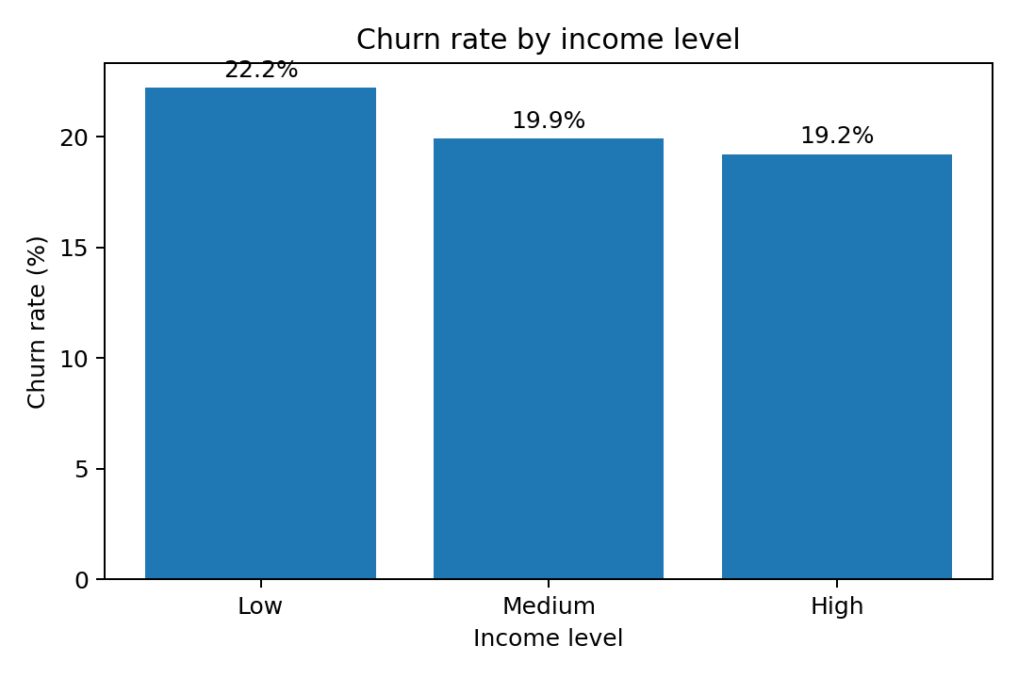
On average, churned customers logged in less often than retained customers. Retained customers had an average login frequency of 26.49, while churned customers had an average of 23.65. The correlation between login frequency and churn was -0.082, which is not strong on its own, but it supports the idea that engagement behaviour should be included in the model.
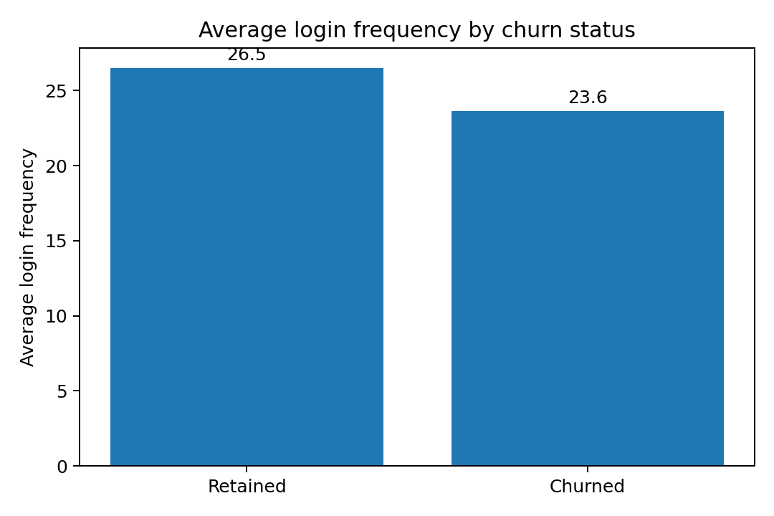
Finding | Evidence | Possible business meaning
Lower digital engagement is linked with churn | 0-9 login band had 29.3% churn | Customers using digital services less often may need earlier contact or support.
Low income customers churned slightly more | Low income churn rate was 22.2% | Retention offers may need to be tailored by customer segment.
Service timing may matter | DaysSinceLastInteraction had the strongest numeric correlation with churn (+0.120) | Older or unresolved service history may still be useful when predicting churn.
Product category differences exist | Furniture was the highest most common category group at 24.9% churn | Product behaviour may add useful model signal.

4. Data cleaning and preparation
The original data had no missing values in the provided columns and no exact duplicate records. The main preparation work was joining the sheets into one customer-level table and creating features suitable for modelling.
Step | What I did | Reason
Merge | Used CustomerID to combine all sources into one customer-level table. | This gives one row per customer for classification modelling.
Aggregation | Summarised transactions into count, total spend, average spend, max spend, last transaction and category features. | Transaction data had multiple rows per customer.
Service features | Created interaction count, unresolved count, unresolved ratio, complaint count and service recency. | Service data can show customer issues linked to churn.
Missing service history | Customers with no service interaction were kept. I added HadServiceInteraction and NoServiceInteractionFlag. | This avoids dropping 332 customers and lets the model learn from the absence of service contact.
Outliers | Checked numerical variables using the IQR rule. Capped AverageAmountSpent and DaysSinceLastTransaction in the modelling data. | This reduces the effect of unusually high values while keeping the customers in the data set.
Encoding | One-hot encoded categorical fields such as Gender, IncomeLevel, ServiceUsage and MostCommonProductCategory. | Machine learning models need numerical input.
Scaling | Standardised numerical features in the modelling sheet. | This keeps large-range variables from having too much weight in scale-sensitive models.

5. Prepared output
The prepared Excel file contains four sheets. Cleaned_Customer_Data keeps the readable engineered features. Encoded_Modelling_Data contains the one-hot encoded and standardised version for model building. EDA_Summary gives the main checks and descriptive summaries. Data_Dictionary explains the created columns.

6. Recommended next step
The next step is to split the encoded data into training and test sets, then build a classification model. I would start with Logistic Regression as a simple baseline and then compare it with a Random Forest model. Because this is a churn problem, recall, precision, F1-score, ROC-AUC and a confusion matrix should be used, not accuracy alone. Recall is especially important because missing a customer who is likely to churn may be costly for the bank.

