Customer Churn Prediction Model Report
Lloyds Banking Group Data Science Job Simulation

Executive summary
This report summarises the model-building stage of the customer churn project. The aim was to use the cleaned customer dataset from Task 1 to identify customers who may be at risk of leaving, and to explain how the model could support retention decisions.
The best hold-out result came from a Random Forest model with feature selection. It achieved a ROC-AUC of 0.632 and an average precision score of 0.299. At the selected threshold, recall was 0.829, meaning the model captured most churned customers in the test set. Precision was lower, so the model is best used for risk ranking and low-cost retention actions rather than automated decisions.

Data and modelling approach
The dataset was built by combining customer demographics, transaction history, customer service interactions, online activity, and churn status. Transaction and service records were aggregated to customer level, so each row represented one customer.
The churn problem was treated as a binary classification task. The data was split into training, validation, and test sets. The validation set was used to choose the decision threshold, while the test set was kept aside for final evaluation.

Model comparison
Several models were compared. Logistic Regression was used as a simple baseline. Gradient Boosting and Random Forest were tested because they can capture non-linear patterns. The final model added feature selection before Random Forest to reduce noise and keep the model more focused.
Model | CV ROC-AUC | Test ROC-AUC | Average Precision | Precision @ 0.50 | Recall @ 0.50 | F1 @ 0.50
Random Forest + Feature Selection | 0.539 | 0.632 | 0.299 | 0.275 | 0.341 | 0.304
Gradient Boosting | 0.564 | 0.575 | 0.259 | 0.500 | 0.073 | 0.128
Random Forest | 0.582 | 0.566 | 0.242 | 0.190 | 0.195 | 0.193
Logistic Regression | 0.562 | 0.558 | 0.220 | 0.202 | 0.415 | 0.272

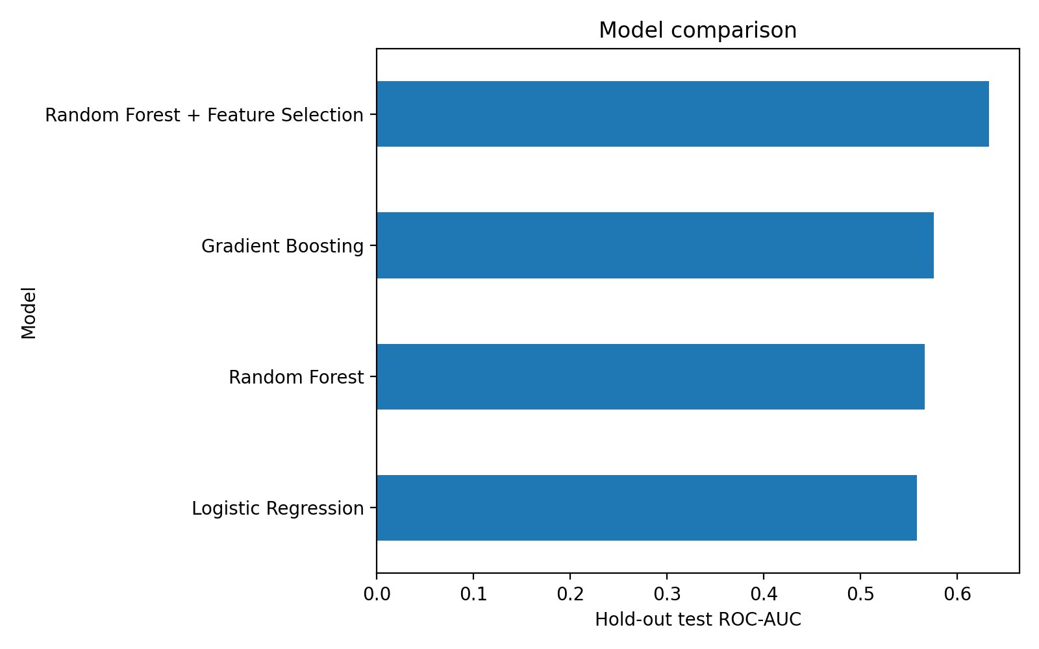
Figure 1. Hold-out ROC-AUC comparison across tested models.

Selected model performance
The selected model was evaluated in two ways: first at the default 0.50 threshold, and then at a threshold chosen using the validation set. For churn prediction, recall is important because the bank wants to find customers who may leave before they actually churn. The selected threshold improved recall, but it also increased false positives.
Threshold Type | Threshold | Accuracy | Precision | Recall | F1 | ROC-AUC | Average Precision | False Positives | False Negatives | True Positives
default | 0.500 | 0.680 | 0.275 | 0.341 | 0.304 | 0.632 | 0.299 | 37 | 27 | 14
validation_selected | 0.391 | 0.520 | 0.276 | 0.829 | 0.415 | 0.632 | 0.299 | 89 | 7 | 34

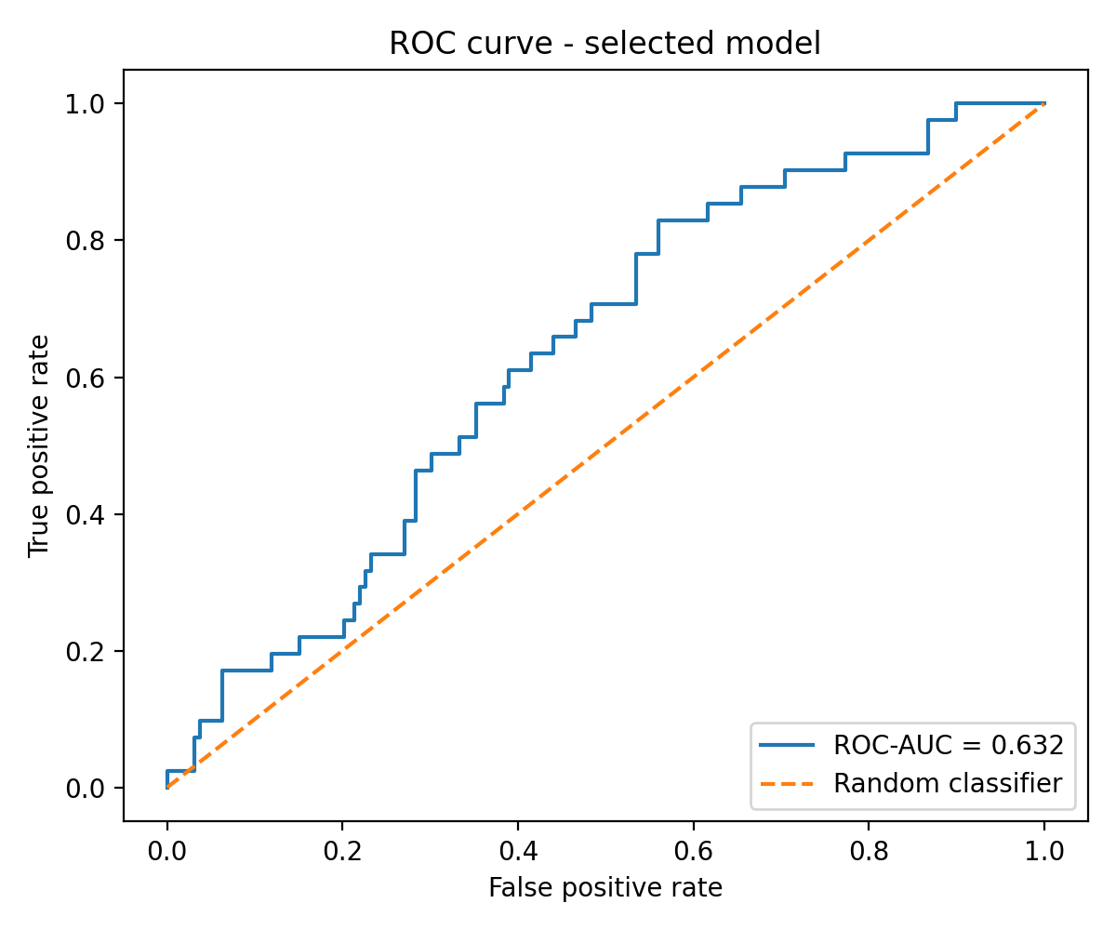
Figure 2. ROC curve for the selected model.
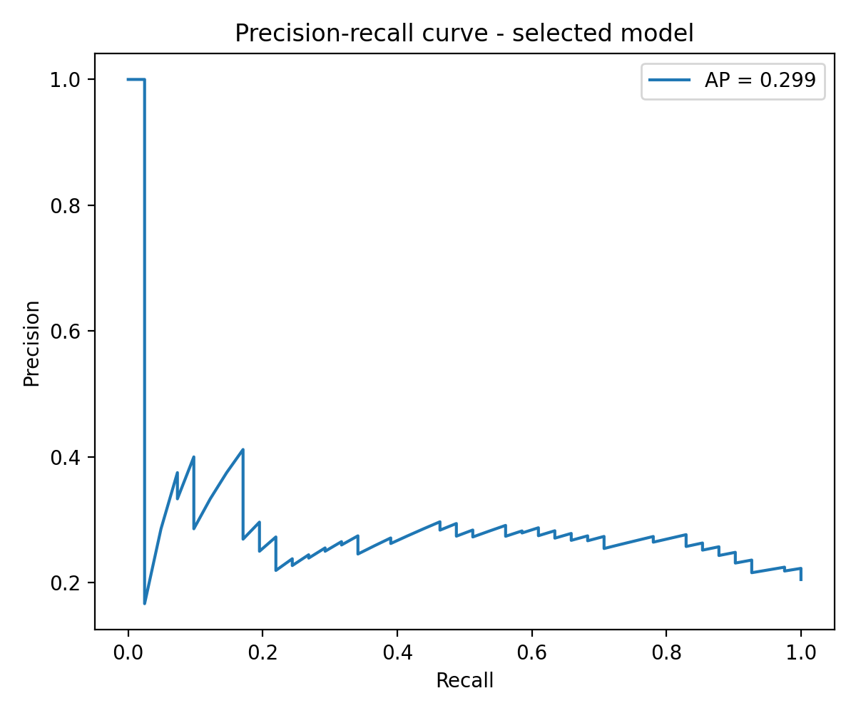
Figure 3. Precision-recall curve for the selected model.
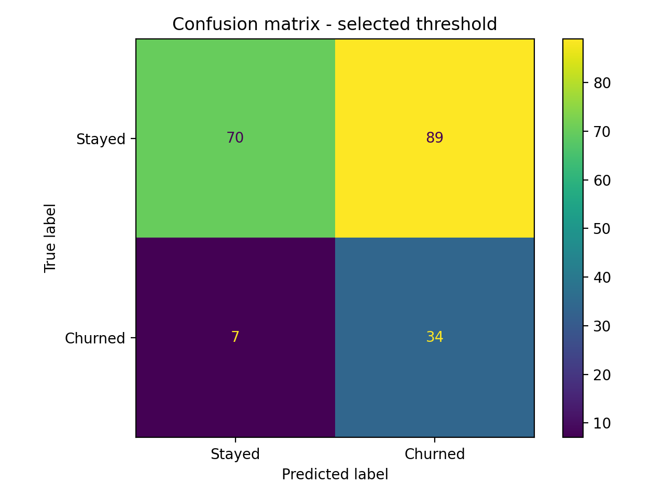
Figure 4. Confusion matrix using the validation-selected threshold.

Feature importance
The most important model features were mainly linked to behaviour rather than demographics. This is useful because behavioural signals can often guide practical retention actions, such as contacting customers with reduced activity or unresolved service issues.
Feature | Importance
service_history_days | 0.144
avg_spend_per_login | 0.117
days_since_last_service_interaction | 0.106
LoginFrequency | 0.097
avg_spent | 0.096
transactions_per_active_day | 0.070
max_spent | 0.068
spend_std | 0.066
tx_category_count_Electronics | 0.036
tx_category_count_Books | 0.035

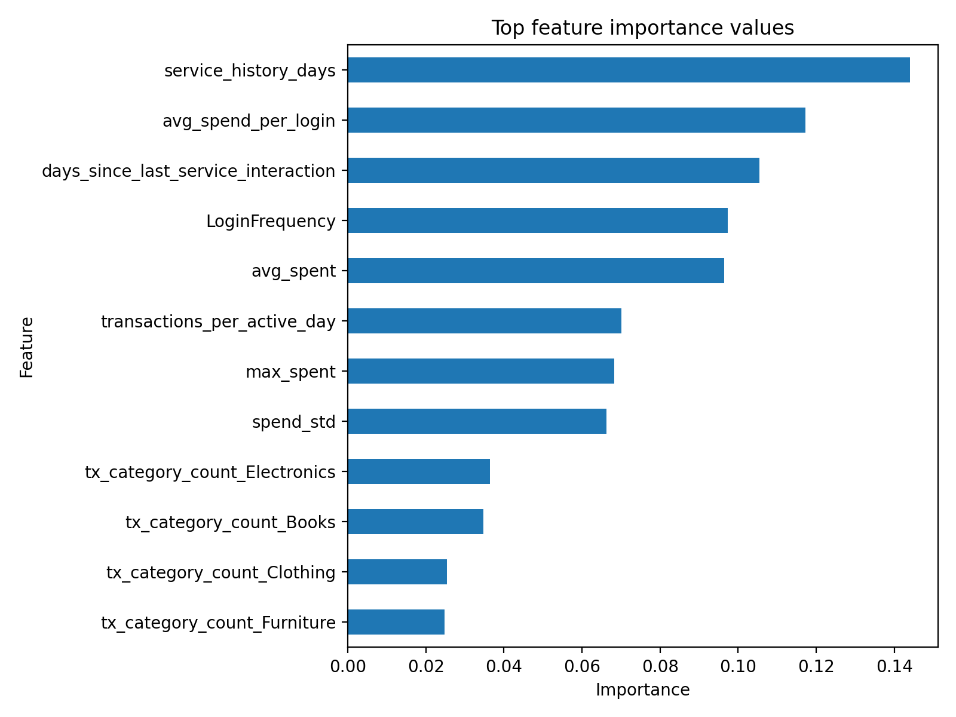
Figure 5. Top feature importance values from the selected model.

Business use
The model output should be treated as a risk score. A practical approach would be to score customers each month and group them into risk tiers. The highest-risk groups can then be reviewed by the retention team. Possible actions include personalised support, checking unresolved service issues, or offering guidance on relevant digital services.
Risk Tier | Customers | Churned Customers | Observed Churn Rate | Average Predicted Probability
Highest risk | 50 | 13 | 0.260 | 0.574
High risk | 50 | 14 | 0.280 | 0.465
Medium risk | 50 | 10 | 0.200 | 0.395
Lowest risk | 50 | 4 | 0.080 | 0.272

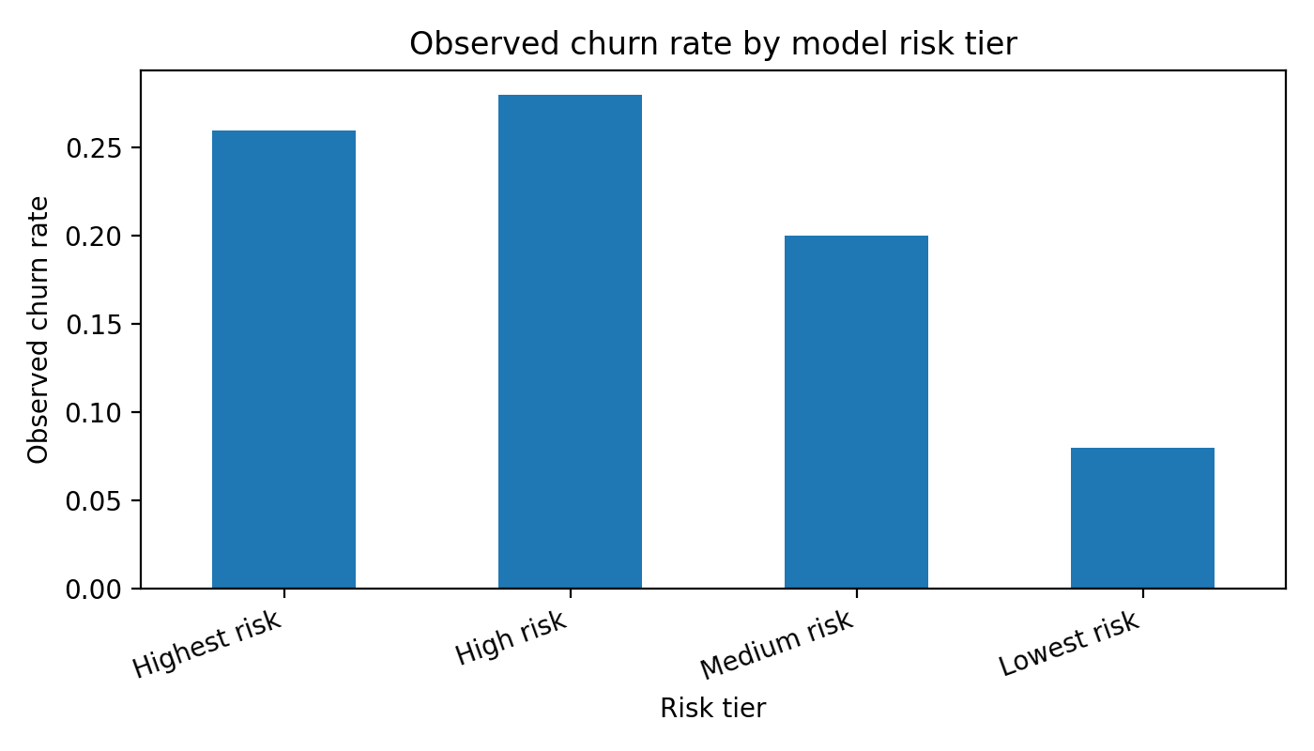
Figure 6. Observed churn rate by model risk tier.

Limitations and next steps
The model performance is moderate, not production-ready. This is expected with a small simulated dataset and limited customer history. Before this type of model could be used in a real bank, it would need richer behavioural data, fairness testing, calibration, monitoring, and review by risk and compliance teams.
The strongest next step would be to add monthly customer history, balance changes, product usage trends, campaign response data, and complaint text. These features would likely give the model a clearer signal and support better customer retention decisions.

