
CORPORATE COMMUNICATIONS TEMPLATE
[DOCUMENT TITLE]
[Document subtitle or outcome-oriented descriptor]
Professional reports, proposals, strategy documents, executive updates, and external communications
AUTHOR | [Author name]
DEPARTMENT | [Department or business unit]
VERSION | [v1.0]
DATE | [Month DD, YYYY]

[CONFIDENTIAL / INTERNAL / PUBLIC]

BRAND SYSTEM
Clear Sky visual system applied in Word
A concise record of the live website cues translated into a stable, print-friendly document system.
[INSTRUCTION] This page documents the template design. It may remain in a shared master template or be removed from final client-facing documents.

Brand personality
Modern, technical, trustworthy, enterprise-focused, and restrained. The template uses high contrast, short statement-led headings, generous white space, precise alignment, and modular information blocks to echo the current site without turning a business document into a webpage.

Core palette
Aa | Aa | Aa | Aa | Aa | Aa
Midnight Navy  #061A2E | Deep Blue  #0A3557 | Clear Sky Lime  #C4CB01 | System Teal  #00758F | Mist  #F3F6F8 | Slate  #465A68

Typography and layout
Headings | Aptos Display, a Microsoft 365-safe substitute for the live site’s contemporary geometric sans-serif character.
Body copy | Aptos with readable 10.5-point sizing, moderate leading, and restrained paragraph spacing.
Layout rhythm | Left-aligned grids, generous margins, thin teal or lime rules, limited use of shaded cards, and no decorative clutter.

NAVIGATION
Table of contents
This field is generated from Heading 1–3 styles and can be updated at any time.
[INSTRUCTION] In Microsoft Word, right-click inside the table of contents and choose Update Field > Update entire table. The keyboard shortcut is Ctrl+A, then F9.
Brand personality 1
Core palette 1
Typography and layout 1
Choose the correct styles 1
Update the table of contents 1
Add, remove, or reorder sections 1
Replace placeholder content 1
Maintain brand consistency 1
Executive context 1
Primary point 1
Supporting evidence 1
Heading 1: Major document section 1
Heading 2: Primary subsection 1
Heading 3: Supporting topic 1
Bulleted list example 1
Numbered list example 1
Example decision table 1
Highlighted statement 1
Usage rules 1
System diagram example 1
Chart example 1
Recommended document-status labels 1
Version-control block 1

QUICK START
Using This Template
Follow these rules to keep documents stable, accessible, and unmistakably Clear Sky.

Choose the correct styles
- Use CS Page Title for the first title on a major page and Heading 1–4 for document structure.
- Use Body Text for normal paragraphs, List Bullet or List Number for lists, and Caption for every image, chart, or table note.
- Use the provided callout tables rather than drawing new text boxes or shapes.

Update the table of contents
Right-click the table of contents and select Update Field, then choose Update entire table. Before issuing a document, use Ctrl+A followed by F9 to refresh all page numbers and fields.

Add, remove, or reorder sections
Duplicate a section divider page when beginning a major new part. Use page breaks for normal page starts and section breaks only when margins, headers, footers, or page orientation must change.

Replace placeholder content
Search for “[” to locate bracketed placeholders. Replace all instructional copy, example data, labels, and image placeholders before final distribution. Delete this guidance page in external deliverables unless it is useful to the recipient.

Maintain brand consistency
Use navy and deep blue as the foundation. Use lime for emphasis and teal for structure or navigation. Avoid using lime for long text on white. Keep typography left aligned, preserve white space, and limit each page to one dominant visual accent.

01
Core document structure
A complete, reusable hierarchy for executive and professional business communications.

STANDARD INTERIOR PAGE
[Page title or section title]
[One-sentence summary that tells the reader why this page matters.]
[INSTRUCTION] Replace bracketed text. Keep the opening summary to one or two lines and use a descriptive, outcome-oriented page title.

Executive context
[Use this opening paragraph to frame the business issue, decision, or opportunity. Lead with the outcome or implication rather than background detail.]

Primary point
[Explain the most important idea in concise, direct language. Break long sections into meaningful headings instead of adding decorative elements.]

Supporting evidence
[Add validated evidence, analysis, examples, or implementation detail. Use citations or source notes where required.]

Operational note
[Use Heading 4 only for short, nested details. Avoid going deeper than four heading levels.]
RECOMMENDATION | Decision requested
[State the specific decision, action, owner, and expected timing.]

CONTENT HIERARCHY
Headings, body text, and lists
A consistent hierarchy makes dense enterprise content easier to scan and act on.

Heading 1: Major document section
Heading 1 introduces a major argument, deliverable section, or topic. Keep it short and make it meaningful in the table of contents.

Heading 2: Primary subsection
Use Heading 2 for the main building blocks within a section.

Heading 3: Supporting topic
Heading 3 is compact and uppercase to create a technical, structured rhythm.

Heading 4: Nested detail
Use sparingly for tactical notes or tightly nested content.

Bulleted list example
- [Lead with the most important point.]
- [Keep bullet structure parallel.]
- [Use no more than five to seven bullets in one group.]

Numbered list example
- [Define the decision or desired outcome.]
- [Describe the sequence of actions.]
- [Identify ownership, timing, and evidence of completion.]

DATA PRESENTATION
Tables that support decisions
Use tables for comparison, accountability, and structured evidence—not as a substitute for layout.
[INSTRUCTION] Duplicate the table, then add or remove rows. Keep column labels short and repeat the header row when a table spans pages.

Example decision table
Workstream | Owner | Status | Next milestone
[Workflow modeling] | [Name] | On track | [Date / milestone]
[Environment readiness] | [Name] | At risk | [Date / milestone]
[Evidence review] | [Name] | Complete | [Date / milestone]
[Executive approval] | [Name] | Not started | [Date / milestone]
Table 1. [Descriptive table title]. Source: [source, date].
INFORMATION | Table guidance
Use a navy header, light row banding, and direct labels. Avoid vertical text, overly narrow columns, or more precision than the decision requires.

02
Emphasis and evidence
Reusable callouts, quotations, imagery, charts, and captions for executive-ready communication.

EMPHASIS
Pull quotes and highlighted statements
Use emphasis to clarify the central message—not to decorate the page.
[INSTRUCTION] Keep pull quotes brief. Attribute external quotations and verify permission or citation requirements.
“[Use one clear, high-value statement that captures the implication of the section.]”
— [Name, title, organization or source]

Highlighted statement
[State the decisive insight in one sentence.]
[Optional one-line explanation or consequence.]

CALLOUT LIBRARY
Information, recommendation, warning, and takeaway
Each callout has a defined purpose and a restrained brand treatment.
[INSTRUCTION] Copy the entire two-column callout table to reuse it. Edit the title and body while preserving the colored rail and tint.
INFORMATION | Context or definition
[Use for supporting context, definitions, scope boundaries, or source notes.]

RECOMMENDATION | Proposed action
[Use for a specific recommendation, expected benefit, owner, and timing.]

WARNING | Material risk
[Use for a risk, constraint, dependency, or condition that could change the decision.]

KEY TAKEAWAY | What the reader should remember
[Use once near the end of a section to reinforce the conclusion or decision.]

Usage rules
- Use no more than two callouts on a typical page.
- Do not rely on color alone; always include the callout label.
- Keep warning language factual and proportionate.

VISUAL EVIDENCE
Images, charts, and captions
Visuals should explain system relationships, performance, trends, or outcomes more clearly than prose alone.

System diagram example
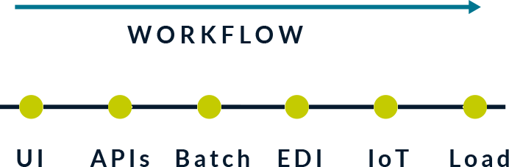
Figure 1. Simplified system-of-systems workflow. Replace or retain only when relevant to the document.

Chart example
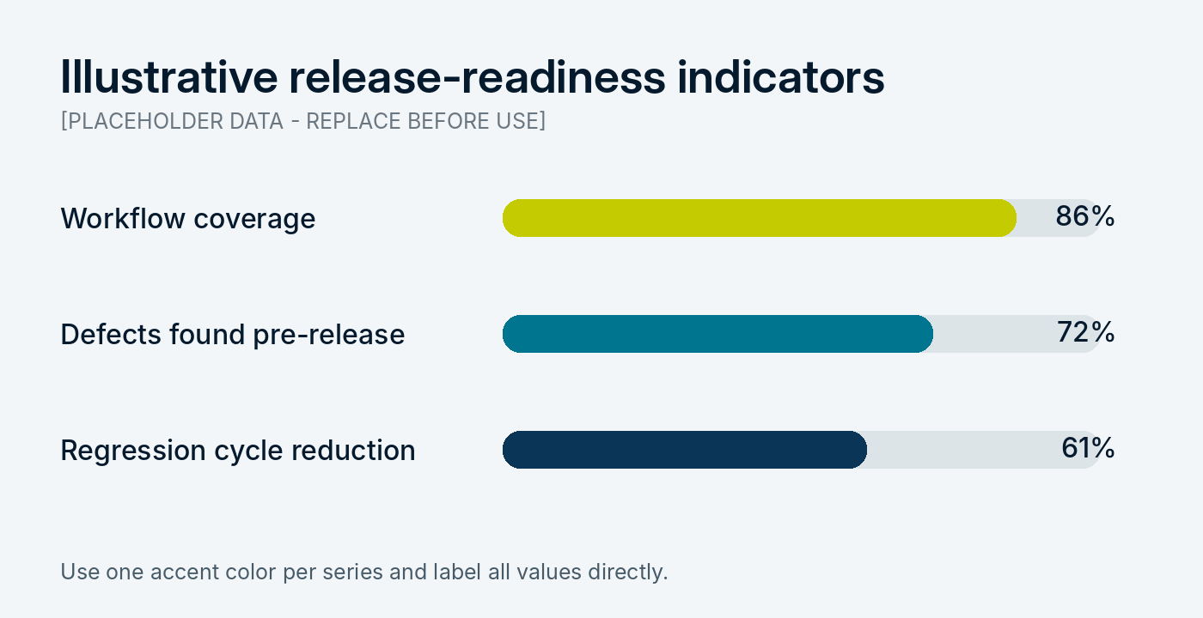
Figure 2. Illustrative metrics only. Replace values, labels, and source before distribution.

DOCUMENT GOVERNANCE
Status labels, versioning, and distribution
Make document ownership and handling requirements visible without overpowering the content.

Recommended document-status labels
Label | Use when | Required action
DRAFT | Content is under active development. | Verify before forwarding or citing.
FOR REVIEW | A defined review or approval is requested. | Include owner and due date.
APPROVED | The named approver has authorized the content. | Lock version and record approval date.
CONFIDENTIAL | Distribution is restricted. | Confirm recipients and handling requirements.
Table 2. Suggested document-status language. Adapt to contractual, legal, or policy requirements.

Version-control block
Version | Date | Owner | Change summary
[v0.1] | [Date] | [Name] | [Initial draft]
[v0.2] | [Date] | [Name] | [Review updates]
[v1.0] | [Date] | [Name] | [Approved issue]


[Closing statement or call to action]
[Use one concise sentence that reinforces the desired next step.]
CLEAR SKY SOLUTIONS
[Contact name] | [Title]
[email@clearskysolutions.com] | [phone]
www.clearskysolutions.com
[CONFIDENTIALITY / COPYRIGHT / LEGAL NOTICE]

